KENYA HIGH
451/ 2
COMPUTER STUDIES
PAPER 2
(PRACTICAL)
MARKING SCHEME
1. (a) (i) Header - Company's name as letter head
- Company's name (1mk)
- As letter head (1mk)
(ii) Footer
- Current date & time (1 mk)
- Left aligned (1mk)
(iii) Insurance will cover (explanation of)
- vehicles and each client dire (1mk)
- car number will not be the same
(iv) Address line
- litre (2mks)
- First name (2mks)
- last name (2mks)
- Address (2mks)
- country (2mks)
- car no. plate (2mks)
- Amount (2mks)
Total=2x7=14mks)
2. (a)√database name (personnel) (1mk)
√Table name (department) (1mk)
√ correct entry (3mks)
(b)(i) Criteria > 32000/= (4mks).Saving (1mk)
(ii) Criteria < 4500/= Am compare from computer department (4mks) saving (1mk)
(iii) Criteria: Married or single (3mks), saving (1mk)
(iv) Criteria: Between 25000 and 50000 (2mks), saving (1mk)
(v) Criteria: name beginning with M or end with S (2mks). Saving (1mk)
(c) (i) √ creating a new column called new salary(2mks)
√Formula New salary: [Basic PAY] *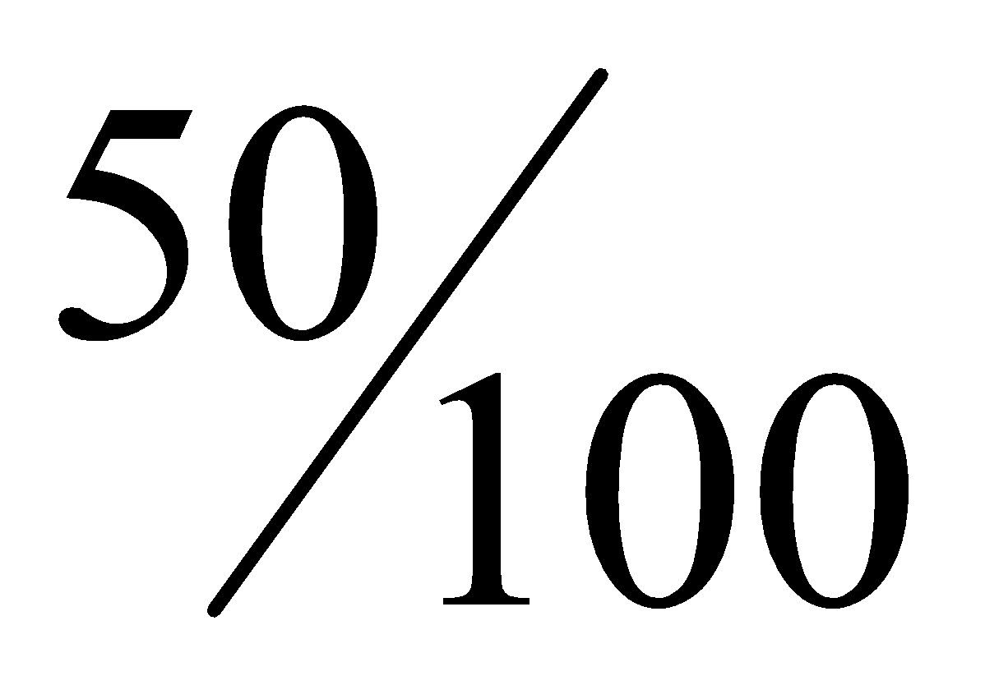+ (BASIC PAY] (4mks) saving (1mk)
(ii) Criteria: earning > 33000/= and eged between 39 and 70 (4mks), saving (1mk)
(d) (i) Creation of a form using form wizard (3mks)
(ii) Creation of form in design view (2mks) calculating the total basic salary (2mks), adding current date and time on the form header (½mk), a\saving (½mk)
(b) (i) Preparation of the table; √ merging of cell (3 mks)
√ text formatting (2mks)
√ correct entry (2mks)
√ saving as MSS (1mk)
(ii) Format table √border line colour red (2mks)
√double line (3mks)
(iii) Shading; √first two rows light green colour (2 ½ mks)
√Rest of the table light blue (2½ mks)
(c) √saving as computer (1mk) √ complete typing (3mks)
(i) Formatting √title as computer program (¹/₂mk)
√change case to upper case
√font style TREBUCHET MS & Size 16(¹/₂mk)
√Font colour (¹/₂mk)
(ii) Find and replace √finding instruction (1mk)
√replacing instruction with its synonym (2mks)
(iii) √ justify paragraph (2mks)
√shading colour (light green) (1mk)

