NAME …………………………..……………….. DATE …………………………

INDEX NO. ……….……….…………………...…..… SIGNATURE ……………..…………..

233/2
CHEMISTRY
PAPER 2
(THEORY)
TIME: 2 HOURS.

KENYA HIGH SCHOOL
POST MOCK EXAMINATIONS
FORM 4
2021
Kenya Certificate of Secondary Education
INSTRUCTIONS TO CANDIDATES
- Write your name and index number in the spaces provided above.
- Sign and write the date of exam in the spaces provided above.
- Answer ALL the questions in the spaces provided.
- Mathematical tables and silent electronic calculators may be used.
- All working MUST be clearly shown where necessary.

FOR EXAMINER’S USE ONLY

Questions | Maximum score | Candidates score
1 | 13
2 | 11
3 | 13
4 | 10
5 | 10
6 | 12
7 | 11
Total score | 80

This paper consists of 10 printed pages.
Candidates should check to ensure that all pages are printed as indicated and no questions are missing

- The grid below shows part of the periodic table. Study it and answer the questions that follow. The letters do not represent the true symbols of the elements.
 |  |  |  |  |  | A
I | B |  | C |  | D |  | E
F | G |  |  |  |  |  | H

- Which element forms an ion of charge - 2? Explain your answer 2marks
………………………………………………………………………………………………………………………………………………………………………………………………………………………………………………………………………………………………………………………………………………
- What is the nature of the oxide formed by element C? 1mark
………………………………………………………………………………………………………………
- How does the reactivity of H compare with that of E? Explain. 2marks
........................................................................................................................................................................................................................................................................................................................................................................................................................................................................................................................
- Write the chemical equation for the reaction between B and chlorine? 1mark
………………………………………………………………………………………………………………………………………………………………………………………………………………………………
- Explain how the atomic radii of the following compare; 2marks
- F and G
………………………………………………………………………………………………………………………………………………………………………………………………………………………………
- B and G
………………………………………………………………………………………………………………………………………………………………………………………………………………………………
- The oxides of B and D are separately dissolved in water. State the effect of each product on litmus paper. 2marks
………………………………………………………………………………………………………………………………………………………………………………………………………………………………………………………………………………………………………………………………………………

- 20cm³ of a solution of a hydroxide of I completely neutralizes 17.5cm³ of 0.5M sulphuric (VI) acid. Calculate the concentration in moles/litre of solution of the hydroxide of I 3marks

- The diagram below shows an experiment set-up to investigate a property of carbon (ii) oxide. Study it and answer the questions that follow.
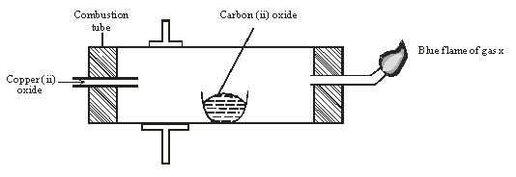

- Name one condition that is missing in the set up that must be present if the experiment to proceed. 1mark
………………………………………………………………………………………………………………………………………………………………………………………………………………………………
- If the experiment was carried out properly. What observation would be made in the combustion tube? 1mark
………………………………………………………………………………………………………………………………………………………………………………………………………………………………
- Give an equation for the reaction that occurs in the combustion tube. 1 ½ mark
………………………………………………………………………………………………………………………………………………………………………………………………………………………………
- Give an equation for the reaction that takes place as gas x burns. 1 ½ marks
………………………………………………………………………………………………………………………………………………………………………………………………………………………………
- Why is it necessary to burn gas x? 1mk
………………………………………………………………………………………………………………………………………………………………………………………………………………………………
- Name the reducing and oxidizing agent. 2marks
- Reducing agent
………………………………………………………………………………………………………………
- Oxidising agent
………………………………………………………………………………………………………………
- Identify any other substance that would have the same effect on copper (ii) oxide as carbon (ii) oxide. 1mark
………………………………………………………………………………………………………………………………………………………………………………………………………………………………
- What would happen if copper (ii) oxide was replaced with sodium oxide? Explain 2mark
………………………………………………………………………………………………………………………………………………………………………………………………………………………………………………………………………………………………………………………………………………
- a) Sulphur occurs naturally in two different forms called allotropes;
- What are allotropes? 1mark
………………………………………………………………………………………………………………
- The two allotropes of sulphur are stable at different temperatures, as shown in the equation below.

Above 95.5⁰C

Rhombic sulphur Monoclinic sulphur
Below 95.5⁰C
Give a name to the temperature 95.5⁰C 1mark
………………………………………………………………………………………………………………
b) Below is a flow chart diagram for the contact process for the manufacture of sulphuric (VI) acid.
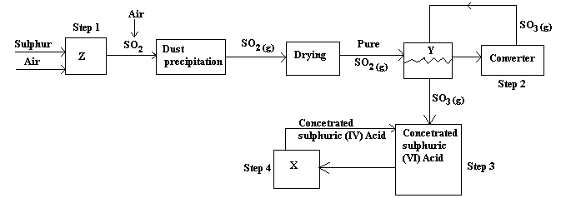

- Give the name of chambers labeled 1 ½ mark
X
………………………………………………………………

Y
………………………………………………………………

Z
……………………………………………………………….
- State the three conditions in the converter. 1 ½ mark
………………………………………………………………………………………………………………………………………………………………………………………………………………………………………………………………………………………………………………………………………………
- Explain why gases are passed through ; 2marks
I – The dust precipitator and drying power
………………………………………………………………………………………………………………………………………………………………………………………………………………………………
II- The chamber labeled Y
………………………………………………………………………………………………………………………………………………………………………………………………………………………………
- Write the balanced equations for the reactions in; 3marks
Step 2:
………………………………………………………………………………………………………………
Step 3:
………………………………………………………………………………………………………………
Step 4:
………………………………………………………………………………………………………………
- Calculate the volume of sulphur (VI) oxide gas in litres that would be required to produce 178kg of Oleum in step 3. (Molar gas volume at s.t.p.=22.4l, H=1, O=16, S=32) 3marks
………………………………………………………………………………………………………………………………………………………………………………………………………………………………………………………………………………………………………………………………………………………………………………………………………………………………………………………………………………………………………………………………………………………………………………
4. a) The scheme below shows various reactions starting with ammonia. Study it and answer the questions that follow.

Compound
J
Ammonia

Nitric (v) acid

Aqueous sodium nitrate

Brown fumes

Solution

K

CuO

Brown Solid L

(i) O_{2(g)} + catalyst
STEP I
(ii) Water
STEP II
S _{(S)} STEP III

Cu_{(S)}
Heat
Step IV
H_{2(g)}

- List the raw materials used in the manufacturer of ammonia gas. 1mark
……………………………………………………………………………………………………………..
- What catalyst is used in step I? 1mark
.......................................................................................................................................................................
- Write an equation for the reaction that occurs between ammonia and oxygen gas in the presence of a catalyst. 1mark
.......................................................................................................................................................................
- Identify the process is step II? 1mark
………………………………………………………………………………………………………………
- Using an appropriate equation, explain how the reaction in step III occurs (1 mark)
………………………………………………………………………………………………………………
(vi) What should be added to solution K to form solid L? (1 mark)
………………………………………………………………………………………………………………

(a) I. Write the formula of compound J.
……………………………………………………………………………………………………………...
II. Calculate the mass of compound J that would contain 14g of nitrogen. (N=14, O=16, H= 1) (2marks)

b) Explain the advantage of using ammonium phosphate fertilizer over the other nitrogenous fertilizers. (1mark)
………………………………………………………………………………………………………………………………………………………………………………………………………………………………
5. Dry chlorine was collected using the set up below.
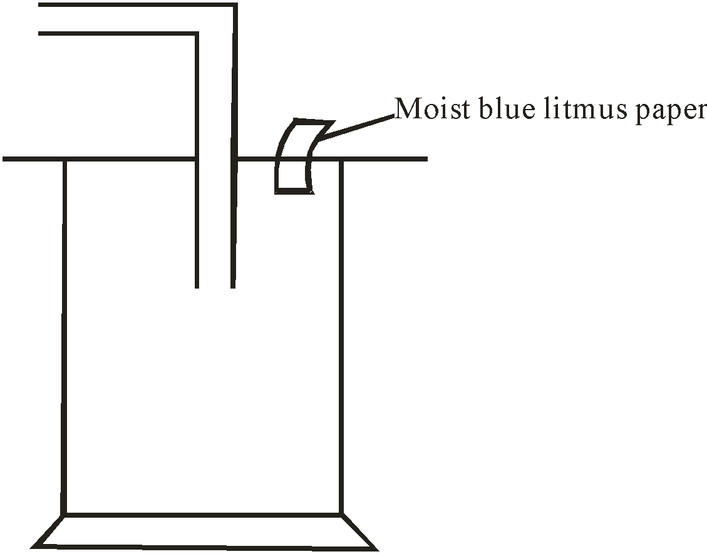

- Name a suitable drying agent for chlorine gas? 1mark
…………………………………………………………………………………………………………….
…………………………………………………………………………………………………………….
- State one property of chlorine gas which facilitates this method of collection. 1mark
…………………………………………………………………………………………………………….
…………………………………………………………………………………………………………….
- State the observations on the moist blue litmus paper. 2marks
………………………………………………………………………………………………………….…..
………………………………………………………………………………………………………………………………………………………………………………………………………………………………
- Chlorine gas was bubbled through distilled water. With aid of an equation show the formation of chlorine water. 1mark
………………………………………………………………………………………………………………………………………………………………………………………………………………………..…….
………………………………………………………………………………………………………………
- Write the formula of the compounds formed when chlorine gas reacts with warm dry phosphorous. 2marks
………………………………………………………………………………………………………………………………………………………………………………………………………………………………
………………………………………………………………………………………………………………
- Chlorine gas is mixed with moist hydrogen sulphide gas, state and explain the observations 2marks
………………………………………………………………………………………………………………………………………………………………………………………………………………………………
………………………………………………………………………………………………………………
- Give one use of chlorine gas. 1mark
………………………………………………………………………………………………………………………………………………………………………………………………………………………………

- Fractional distillation of air is used in the industrial manufacture of oxygen. The diagram below shows the process.

A
B
M
Compressor

R

Fractional distillation
Y
Nitrogen boiling point- 196⁰C
Argon boiling point -186⁰C

Oxygen boiling point - 196⁰C

Substance T

Dry air

Sodium Carbonate solution

Dust particles

Liquid S

Air
D
X

- What processes are taking place in chamber A,B,M and D 2marks
A
…………………………………………………………………………………………..……..…………..

B
…………………………………………………………………………………………….………………..

M
……………………………………………………………………………………………..…....………….

D
…………………………………………………………………………….………………..…...………….

- Name;
- Liquid S
……………………………………………………………………………………….……….……………
- Substance T
…………………………………………………………………………….…….…………………………
- Explain why part Y in chamber D is curved? 1mark
………………………………………………………………………………………………………………………………………………………………………………………………………………………………
- Give two industrial uses of oxygen gas? 2marks
………………………………………………………………………………………………………………………………………………………………………………………………………………………………
- In the laboratory preparation of oxygen, manganese (iv) oxide and hydrogen peroxide are used. Write an equation to show how oxygen gas is formed. 1mark
………………………………………………………………………………………………………………………………………………………………………………………………………………………………
- An investigation was carried out using the set-up below. Study it and answer the questions that follow.
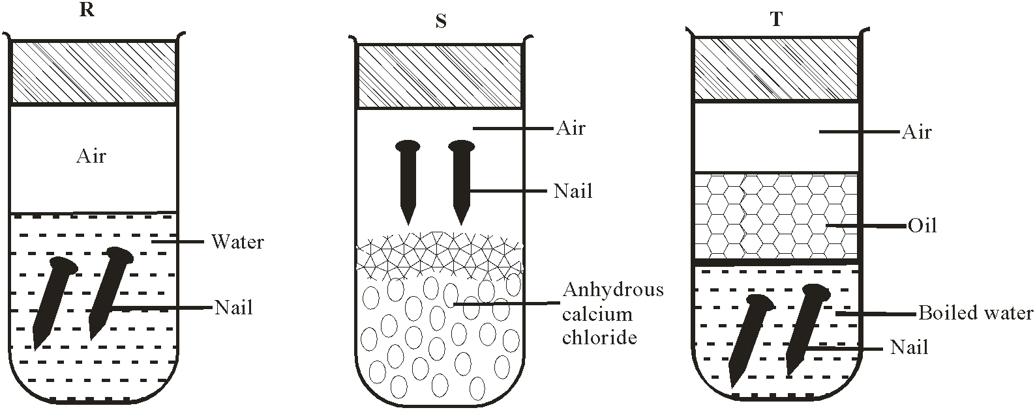

- State and explain what will happen in the three test-tubes R, S and T after seven days. 3marks
………………………………………………………………………………………………………………………………………………………………………………………………………………………………………………………………………………………………………………………………………………
- Give one reason why some metals are electroplated. 1mark
………………………………………………………………………………………………………………
- Below is a scheme of some reactions of propanol. Study it and answer the questions that follow.

Q
Y
Z
CH₃CH₂CH₃
CH₃CH₂CH₂CL
Propanol
CH₃CH₂CH₂OH

Polymerisation
HBr
Step I
Step III

Step II Conc. H₂SO₄
160⁰C

- State the reagents and conditions required to effect step I 3marks
………………………………………………………………………………………………………………………………………………………………………………………………………………………………………………………………………………………………………………………………………………………………………………………………………………………………………………………………
- Draw the structural formulae and name product Z. 1mark
………………………………………………………………………………………………………………………………………………………………………………………………………………………………………………………………………………………………………………………………………………
- Name product Q 1mark
………………………………………………………………………………………………………………
- Explain how product Y can be distinguished from the product formed after step I has taken place. 2marks
………………………………………………………………………………………………………………………………………………………………………………………………………………………………
……………………………………………………………………………………………………………..
- What name is given to the process in Step II and step III 2marks
Step II
………………………………………………………………………………………………………………………………………………………………………………………………………………………………
Step III
………………………………………………………………………………………………………………………………………………………………………………………………………………………………
- (i) Define the term hydrocarbon 1mark
………………………………………………………………………………………………………………………………………………………………………………………………………………………………
(ii) Draw the structure of 1, 2 – dibromopropane 1mark

