NAME ……………………………………………. INDEX NO …………………………..
SCHOOL …………………………………………… SIGNATURE …………………..………
DATE ……..…………………...
231/3
BIOLOGY
PAPER 3
(PRACTICAL)
1³/₄ HOURS

KENYA HIGH SCHOOL
POST MOCK EXAMINATIONS
FORM 4
2021
Kenya Certificate of Secondary Education
INSTRUCTIONS TO CANDIDATES
- Write your name and Index Number in the spaces provided above.
- Sign and write date of examination in the spaces provided above.
- Answer ALL questions in the spaces provided in the question paper.
- You are NOT allowed to start working with the apparatus for the first 15 minutes of the 1³/₄ hours allowed for this paper. This time is to enable you to read the question paper and make sure you have all the chemicals and apparatus that you may need.
- All workings MUST be clearly shown where necessary.
- Mathematical tables and silent electronic calculators may be used.

For Examiners use only.
Question | Maximum Score | Candidates Score
1 | 12
2 | 14
3 | 14
TOTAL SCORE | 40

This paper consists of 5 Printed pages.
Candidates should check the question paper to ensure that all the papers are printed as indicated and no questions are missing

- (a) You are provided with a solution L. Using the reagents provided; determine the food compounds in L. Fill in the table below.
FOOD COMPOUND | PROCEDURE | OBSERVATION | CONCLUSION

(b) Place 10mls of solution L in a visking tubing. Tie both ends and place it in 50mls of distilled water contained in a beaker.leave the set up for 20 minutes and make observations.
(i) Observations. (1mark)
………………………………………………………………………………………………………………………………………………………………………………………………………………………………
(ii) Account for the observation in b (i) above. (2marks)
………………………………………………………………………………………………………………………………………………………………………………………………………………………………………………………………………………………………………………………………………………
(iii) Give the equivalent of a visking in the bodies of living organisms. (1mark)
………………………………………………………………………………………………………………………………………………………………………………………………………………………………
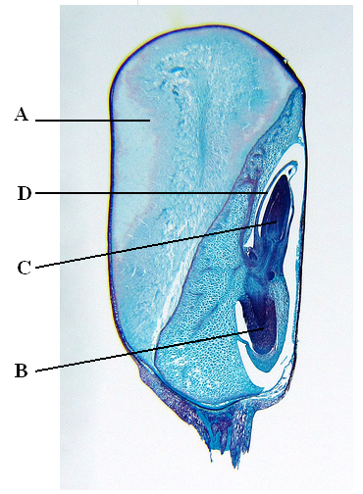
- Study the photomicrograph of the longitudinal section of a maize fruit below and answer the questions that follow.

- (i) Name the parts labelled A, B, C and D. (4marks)
A
…………………………………………………………….
B
…………………………………………………………….
C
…………………………………………………………….
D
…………………………………………………………….
(ii) Give the role played by A and D. (2 mark)
A
………………………………………………………………………………………………………………………………………………………………………………………………………………..….
D
……………………………………………………………………………………………………………………………………………………………………………………………………………………
- (i) Name the type of germination exhibited by maize grain. ( 1 mark)
……………………………………………………………………………………………………………………………………………………………………………………………………………………
(ii) Place the organisms from where the photomicrograph was obtained into its
Kingdom
Division
Class (3marks)
(iii) State three characteristics of members of the class identified in b (ii) above (3marks)
…………………………………………………………………………………………………………………………………………………………………………………………………………………………………………………………………………………………………………………………………………………………………………………………………………………………………………
- Give one reason why the maize grain is classified as a fruit. (1mark)
………………………………………………………………………………………………………………………………………………………………………………………………………………………………………………………………………………………………………………………………
- Study the organisms drawn below and answer the questions that follow.

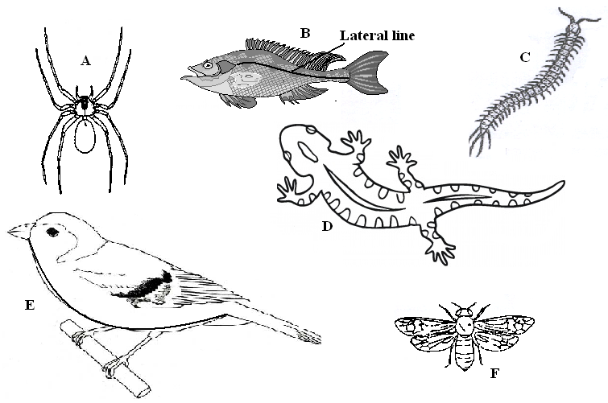

- Use the dichotomous key below to identify the class the organisms belong to. (12 marks)
- (a) Phylum Chordata ……………………………………………………… go to 2
- Phylum arthropoda ……………………………………………………. go to 3
- (a) Has scales on the body ………………………………………………… go to 4
(b) Has no scales on the body …………………………………………..… Mammalia
3. (a) Has cephalothorax ……………………………………………….……. Arachnida
(b) Has no cephalothorax …………………………………………………. go to 5
4. (a) Has fins ………………………………………………………………… Pisces
(b) Has no fins ……………………………………………………………... go to 7
5. (a) Has three pairs of legs …………………………………………………. Insecta
(b) Has more than three pairs of legs ……………………………………… go to 6
6. (a) Two pairs of legs per segment ………………………………………… Diplopoda
(b) One pairs of legs per segment …………………………………………. Chilopoda
7. (a) Has feathers ……………………………………………………………. Aves
(b) Has no feathers ………………………………………………………… go to 8
8. (a) Has a tail ……………………………………………………………….. Reptilia
(b) Has no tail …………………………………………………………….. Amphibia
Specimen | Step followed | Identity
A
B
C
D
E
F

(b) If the actual length from the tip of the mouth to the tip of the tail of the specimen B is 100mm, calculate the magnification. (2marks)
…………………………………………………………………………………………………………………………………………………………………………………………………………………………………………………………………………………………………………………………………………………………………………………………………………………………………………

