NAME________________________________________ INDEX NO ___________________________

CANDIDATE’S SIGNATURE____________
DATE_________________________________

232/3
PHYSICS
PRACTICAL
PAPER 3
2 ¹/₄HOURS

KENYA HIGH SCHOOL
POST MOCK EXAMINATIONS
FORM 4
2021
Kenya Certificate of Secondary Education

INSTRUCTIONS
Answer all the questions in this paper
You are supposed to spend the first 15 minutes of the 2 ¹/₄hours allowed for this paper reading the whole paper carefully before starting your work.
Marks are given for clear record of the observations made, their suitability and accuracy and the use made of them.
Candidates are advised to record observations as soon as they are made
Mathematical table and electronic calculators may be used.

For Examiner’s use only
QUESTION | TOTAL MARKS | CANDIDATE’S SCORE
1 | 20
2 | 20
 | GRAND TOTAL | 80 MARKS

This paper consists of 7 printed pages

Question 1
You are provided with the following apparatus
• Two dry cells
• A cell holder
• A bulb
• A voltameter
• An ammeter
• A switch
• Amounted resistance wire labelled AB

a) Set up the apparatus as shown in the circuit below.
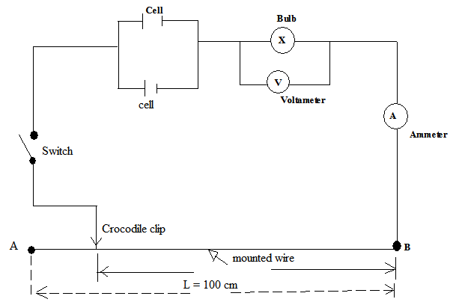

b) With the crocodile clip at A (ie L = 100cm) take the voltameter reading (V) and the ammeter reading (I). Record V and I in the table below.

Length l(cm) | 100 | 80 | 60 | 40 | 20 | 0
Voltage (V)
Current I (A)
(7 marks)
c) Repeat the procedure in (b) above for the lengths shown and complete the table above.

d) State the changes you observe on the bulb as L decrease from A. (2 marks)

………………………………………………………………………………………………………………………………………………………………………………………………………………………………………………………………………………………………………………………………………………

e) Plot a graph of voltage against length (cm) (5 marks)

f) What physical quantity does the slope of the graph represent at any given point. (2 marks)

g) From your graph determine the value of voltage at length L = 70cm. (2 marks)

h) Use your graph to describe how the physical quantity in (e) above is affected as the current increases. Explain why. (2 marks)

Question 2
You are provided with the following apparatus
• A complete stand
• Copper wire (wire length about 30cm)
• A stop watch
• A protractor
• A meter rule
• Corked optical pin
Procedure
a) Measure the length L of the copper wire.
L = .................................................. m (1 mark)

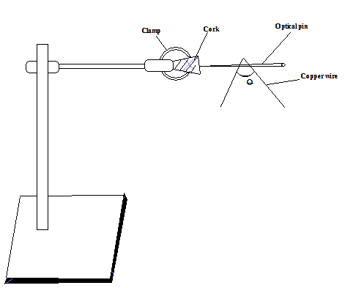
b) Bend the wire to form an angle O of 60⁰, suspend it from the corked optical pin as shown in the diagram below.

c) Give it a small displacement so that it oscillates about a point on the pin. Measure the time, t(s) for 10 oscillations of the wire.
t = ................................................. (s) (1 mark)
d) Repeat the procedure (b) above for the values of O = 70⁰, 80⁰, 90⁰, 100⁰, 110⁰.
e) Record and complete the results in the table below.
O (⁰) | 60 | 70 | 80 | 90 | 100 | 110
Cos ¹/₂O
Time for 10 oscillations, t (s)
Periodic time T (s)
T ² (s²)
¹/_{T}² (s⁻²)
(7 marks)
f) On the grid provided, plot a graph of ¹/_{T}² (s²) against Cos¹/₂O. (5 marks)

g) Determine the slope. (3 marks)

h) Given that the graph is related by the equation ¹/_{T}² = $\frac{8π2_{L}}{g}$Cos ¹/₂O, determine the value of constant g.
(3 marks)

