NAME________________________________________ INDEX NO __________________________

CANDIDATE’S SIGNATURE_____________

DATE_________________________________

232/2
PHYSICS
THEORY
PAPER 2
2HOURS

KENYA HIGH SCHOOL
POST MOCK EXAMINATIONS
FORM 4
2021
Kenya Certificate of Secondary Education

INSTRUCTIONS
Write your name and admission number in the space provided
Sign and write the date of the examination in the space provided above
This paper consists of two sections A and B.
Answer all the questions in the spaces provided.
All working must be clearly shown.
Mathematical tables and electronic calculators may be used.

For examiner’s use only
SECTION | QUESTION | TOTAL MARKS | CANDIDATE’S SCORE
A | 1-13 | 25
B | 14 | 11
 | 15 | 13
 | 16 | 11
 | 17 | 10
 | 18 | 10
 |  | GRAND TOTAL | 80 MARKS

TOTAL CANDIDATE’S SCORE

Section A + section B =

This paper consists of 9 printed pages

SECTION A (25 Marks)
Answer all the questions in this section in the spaces provided.
1. Locate the position of the image of the object placed in front of a plane mirror shown below. (2 mks)
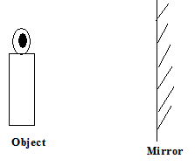

2. Show the magnetic field pattern of the current carrying conductors shown below. (2 mks)

3. State two factors that determine the strength of an electromagnet. (2 mks)

………………………………………………………………………………………………………………………………………………………………………………………………………………………………
4. State two advantages of using a convex mirror as a driving mirror. (2 mks)
………………………………………………………………………………………………………………………………………………………………………………………………………………………………
5. State two factors that affects the resistivity of an electrical conductor. (2 mks)
………………………………………………………………………………………………………………………………………………………………………………………………………………………………
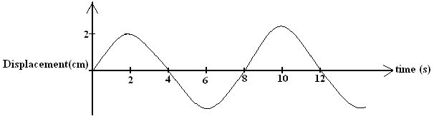
6. The figure below shows a wave in progress.

Determine the
a) Amplitude (1 mark)
………………………………………………………………………………………………………………………………………………………………………………………………………………………………
b) Frequency (2 marks)
………………………………………………………………………………………………………………………………………………………………………………………………………………………………

7. The figure below shows light travelling from less dense to more dense medium.
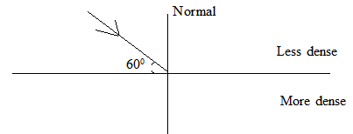

a) Show the direction of the refracted ray. (1 mark)

b) If the refractive index of the more dense medium is 1.4, calculate the angle of refraction. (3 marks)
………………………………………………………………………………………………………………………………………………………………………………………………………………………………

8. A current ,I, flowing through a wire of resistance ,R, is increased by seven times. Determine the factor by which the rate of heat production was increased. (3 marks)

………………………………………………………………………………………………………………………………………………………………………………………………………………………………………………………………………………………………………………………………………………………………………………………………………………………………………………………………
9. The wavelength of a radio wave is 1km. Determine its frequency if the speed in 3 x 10⁸ms⁻¹ (2 marks)
………………………………………………………………………………………………………………………………………………………………………………………………………………………………………………………………………………………………………………………………………………………………………………………………………………………………………………………………

10. State two uses of gold leaf electroscope. (2 marks)
………………………………………………………………………………………………………………………………………………………………………………………………………………………………
………………………………………………………………………………………………………………………………………………………………………………………………………………………………
11. Give a reason why soft iron is used as a core of the coil of an electric bell. (1 mark)
………………………………………………………………………………………………………………………………………………………………………………………………………………………………………………………………………………………………………………………………………………………………………………………………………………………………………………………………
12. State two differences between pinhole camera and the human eye. (2 marks)
…………………………………………………………………………………………………………………………………………………………………………………………………………………………………………………………………………………………………………………………………………………………………………………………………………………………………………………………
13. State two types of waves. (2 marks)
………………………………………………………………………………………………………………………………………………………………………………………………………………………………………………………………………………………………………………………………………………………………………………………………………………………………………………………………
SECTION B (55 MARKS)
Answer all the questions in this section in the spaces provided.
14. a) Define the following terms.
i) Capacitor (1 mark)

………………………………………………………………………………………………………………………………………………………………………………………………………………………………
ii) Capacitance (1 mark)

………………………………………………………………………………………………………………………………………………………………………………………………………………………………

b) Three capacitors are connected to a 10v battery.
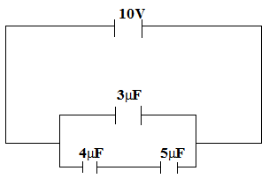

Calculate
i) the effective capacitance (3 marks)
………………………………………………………………………………………………………………………………………………………………………………………………………………………………
………………………………………………………………………………………………………………………………………………………………………………………………………………………………

ii) the total charge (3 marks)

………………………………………………………………………………………………………………………………………………………………………………………………………………………………
………………………………………………………………………………………………………………………………………………………………………………………………………………………………
c) State three factors that determine the capacitance of a capacitor. (3 marks)

i)

ii)

iii)

15. a) Define a resistor. (1 mark)

………………………………………………………………………………………………………………………………………………………………………………………………………………………………
………………………………………………………………………………………………………………………………………………………………………………………………………………………………
b) The figure below shows three resistors connected to 12v supply of internal resistance of 0.2Ω.

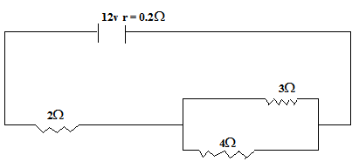

Calculate
i) the effective resistance. (3 marks)

ii) the total current in the circuit. (2 marks)

iii) the current through the 4Ω resistance. (3 marks)

c) If the current flows for 2 minutes calculate the total energy dissiparted. (2 marks)

d) State two applications of resistors in real life situation. (2 marks)

(i) ..............................................................................................................................................................

(ii)...............................................................................................................................................................

16. a) Explain briefly how a material acquires a positive charge. (3 marks)

………………………………………………………………………………………………………………………………………………………………………………………………………………………………
b) A steel pin is placed on the cap of a highly charge electroscope.

State and explain the observation that will be made on the gold leaf. (2 marks)
………………………………………………………………………………………………………………
………………………………………………………………………………………………………………………………………………………………………………………………………………………………
c) State a reason why a candle flame is blown away when a highly charged metal is brought close to it.
(2 marks)
………………………………………………………………………………………………………………
………………………………………………………………………………………………………………………………………………………………………………………………………………………………
d) Explain briefly why it is not advisable to take shelter on a tree when it is raining. (2 marks)
………………………………………………………………………………………………………………
………………………………………………………………………………………………………………………………………………………………………………………………………………………………
e) State two dangers of electrostatic charges. (2 marks)
………………………………………………………………………………………………………………
………………………………………………………………………………………………………………………………………………………………………………………………………………………………
17. a) State two methods of magnetisation. (2 marks)

………………………………………………………………………………………………………………
………………………………………………………………………………………………………………………………………………………………………………………………………………………………
b) Why is repulsion the surest way of identifying a magnet. (2 marks)

………………………………………………………………………………………………………………
………………………………………………………………………………………………………………………………………………………………………………………………………………………………
c) Complete the diagram below to show the magnetic field patterns. (2 marks)
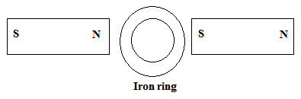

d) i) The figure below in a U-shaped iron core. Indicate the polarity at X and Y. (2 marks)

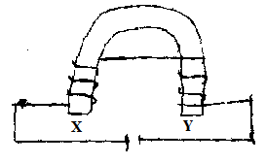

ii) State two applications of such an electromagnet. (2 marks)

18. a) A pin is placed at the bottom of a beaker containing a transparent liquid. When viewed from the top
the pin appears nearer the surface than it actually is. Explain the observation. (2 marks)

………………………………………………………………………………………………………………
………………………………………………………………………………………………………………………………………………………………………………………………………………………………

b) The table below shows the results obtained from such an experiment.
Apparent depth (cm) | 2.21 | 3.68 | 5.15 | 6.62 | 8.09
Real depth cm | 3.0 | 5.0 | 7.0 | 9.0 | 11.0
i) Plot a graph of real depth against apparent depth. (5 marks)

