KENYA HIGH EXAMINTIONS 2021
121/1
MATHEMATICS PAPER 1
MARKING SCHEME
1. | $\frac{16+20}{-12-6}$  $\frac{36}{-18}$  -2 | M1  A1 | ✔Min &deno
2. | Food = $\frac{1}{2}$  Trans = $\frac{1}{20}$  Rem = $\frac{1}{4}$  Fraction of saving  = 1 – ($\frac{1}{2}$+ $\frac{1}{20}$ + $\frac{1}{4}$) = 1 - $\frac{16}{20}$ = $\frac{4}{20}$  Salary = 3400 x $\frac{20}{4}$  = KSh. 17000 | M1  M1  A1 | ✔ Fraction
3. | $\frac{\left(y-2x\right)(2y+x)}{\left(2y-x\right)(2y+x)}$  $\frac{y-2x}{2y-x}$ | M1  M1  A1 | For den  For number
4. | $3^{2x+3}$+ 1 = 28  $3^{2x+3}$ = 27  $3^{2x}$ x $3^{3}$ = $3^{3}$  27 x $3^{2x}$ = 27  $3^{2x}$ = $1^{0}$  2x = 0  x = 0 | M1  A1
5. | S = $\frac{5.7+4.2+6.3}{2}$ = 8.1  = $\sqrt{8.1\left(8.1-5.7\right)\left(8.1-4.2\right)8.1-6.3}$  = $\sqrt{8.1 x 2.4 x 3.9 x 1.8}$ = 11.68  Shaded area = 18.05 – 11.68  = ${6.368cm}^{2}$ | B1  M1  A1  B1 | For 11.68
6. | $\frac{2.4}{100}$ x 100,000 = 2400  $\frac{3.9}{100}$ x 180,000 = 7020  = 9420 | M1  M1  A1
7. | (a) x(x + 4) = 96  $x^{2}$ + 4x – 96 = 0  (x-8) (x + 12) = 0  x = 8  Length = 12  Width = 8  (b) Perimeter = 2 (8 + 12) = 40m | M1  A1  B1 | Both
8. | 1  1  2  35⁰  60⁰  Sin-1 0.5 = (90 – a)  60⁰ = 90⁰ – a  a = 300  Cos 300  Cos a = $\frac{\sqrt{3}}{2}$ | M1 for a = 30⁰  B1 for $\frac{\sqrt{3}}{2}$ CAO
9. | (a) $\frac{CE}{BC}$ = $\frac{DE}{AB}$  $\frac{x}{x+6}$ = $\frac{7.5}{15}$  x = 6  (b) $\sqrt{6^{2}-{3.75}^{2}-}$ = 4.684  AB = 2 x 4.684 = 9.368  A = $\frac{1}{2}$ x 15 x 9.368 - $\frac{1}{2}$ x 7.5 x 4.684  = 52.698 | M1  A1  M1  A1
10. | $\frac{22}{7}$ x $5^{2}$ (10 – 6) = 314.29cm³  $\frac{4}{3}$ x $\frac{22}{7}r^{3}$ = 314.29  r = 4.217 | M1  M1  A1
11. | 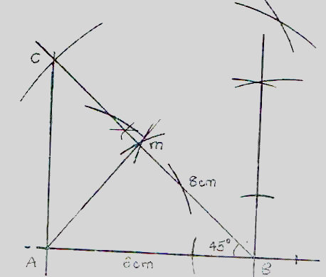  AM = 4.2cm, AC = 5.6cm (± 0.1cm) | B1  B1  B1  B1 | Construction of 450  ΔABC  ⊥ Dropped from A to BC  For AM to AC
12. | 50,48,46,……………  $T_{8}$ = 50 + 7x (-2)  = 36  $S_{2}$ = $\frac{20}{2}$ (2 x 50 + (20 – 1) (x – 2)  = 620 | M1  A1  M1  A1
13. | 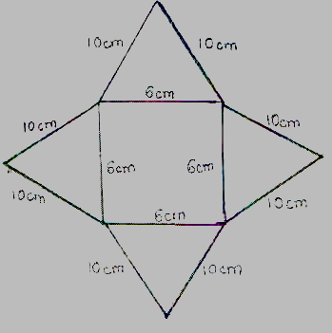  Surface area of base = 6cm x 6cm = 36cm²  Area of sides (flaps) = ( ½ x 6cm x 8cm)4 = 96cm²  Total surface area = 36cm² + 96cm² = 132cm² | B1  M1  A1 | Net
14. | 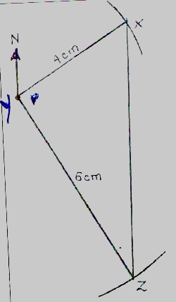  - 324⁰  - (7.2 x 5) km  = 36km | B1  B1  B1  B1 | Z accurately located wrt Y  X accurately located wrt Y  Bearing of X from Z  Distance of X from Z
15. | $2^{2x}$ - 18 x $2^{x}$ - 40 = 0  $2^{\left(x\right)2}$ - 18 x $2^{x}$-40 = 0  Let $2^{x}$ be t  t² – 18t – 40 = 0  t(t – 20) + 2(t – 20) = 0  (t + 2)(t-20) = 0  Either  t – 20 = 0 t = 20  or t + 2 = 0 t = -2  but t = 2^{x}  for 2^{x} = -2 there are no real values  but for 2^{x} = 20  $\frac{xlog2}{log}$ = $\frac{loglog 20 }{loglog 2 }$  x = 4.32 (2 dps) | M1  A1  B1 | eqn in t  both
16. | $\frac{90}{100}$x = 180,000  x = $\frac{180000}{90}$ x 100  = 200000  $\frac{120}{100}$y = 200000  BP ⇒$\frac{200000}{120}$ x 100 = 166,666.66 | M1  M1  A1
17. | = $\frac{7}{3}$ x 90 = 210km  Remaining distance = 360 – 210 = 150km  As = 90 + 110 = 200km  Time for meeting = $\frac{150km}{200km/hr}$ = 0.75 hrs  = 45 mins  Meeting time = 10.35  + .45  11.20 a.m  (ii) Distance from A 210 + (0.75 x 90)  = 210 + 67.5  = 277.5 km  (b) Time minibus arrived at B  Time = $\frac{D}{S}$ = $\frac{360}{90}$ = 4 hrs  = 8.15 + 4 hrs = 12.15 p.m  Time taken by the tourist to arrive  B = 12.15 pm – 10.30 a.m = 1 hr 45 min  = 1$\frac{45}{60}$ x 100  = 175km  ∴ Home to B = 175km  Home to A = 360 – 175  = 185km | B1  B1  M1  A1  M1  A1  M1  M1  A1  B1 | ✔ Distance covered by minibus for  2$\frac{1}{3}$ hrs  ✔Ans  ✔ CAO
18. | Cosθ = $\frac{{250}^{2}+{320}^{2}-{440}^{2}}{2 x 250 x 320}$  θ = 100.33⁰  A = $\frac{1}{2}$x 250 x 320 Sin 100.33  $\frac{39351.65}{10000}$  = 3.9352 ha  2R = $\frac{440}{Sin 100.33}$  R = 223.6  A = $\frac{22}{7}$ x 223.6² – 39351.65  = 117,781.7m2 | M1  A1  M1  M1  A1  M1  A1  M1  M1  A1 | Area of circle  Difference
19. | 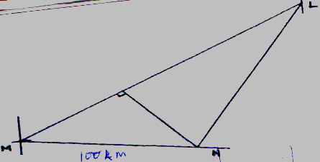  (ii) 4.4 x 50 = 220km± 5  (iii) 8.5 x 50 = 425±5  (iv) 200⁰ | B1  B1  B1  B1  B1  B1  B1  B1  B1  B1 | Pst of L  Pst of N  Pst of M  Construction of bisector  Measurement  Length  Measurement  Length  Measurement  Angle
20. | (a) $\frac{1200}{x}$  (b) $\frac{120}{x}$ + 10  $\frac{1400}{x-5}$  - $\frac{1400}{x-5}$ = $\frac{1200}{x}$ = 10  $\frac{1400x-1200(x-5)}{x(x-5)}$= 10  $\frac{1400x-1200(x-5)}{x(x-5)}$ = 10  200x + 6000 = 10x² – 50x  20x + 600 = x² – 5x  x² + 15x – 40x – 600 = 0  x(x + 15) – 40(x + 15) = 0  (x-40)(x+15) = 0  x = 40 people  40 – 5 = 35  - = $\frac{1400}{35}$  = KSh. 40 |  | B1  B1  B1  M1  M1  M1  A1  B1  M1  A1
21. | 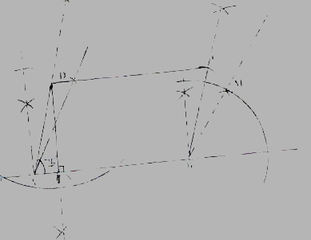  (b) (i) Length of ON = 3.9cm±0.1  (ii) Area = 6 x 3.9  = 23.4cm2 | B1  B1  B1  B1  B1  B1  B1 | Both 90⁰& 60⁰ at A  750 at A  90⁰& 60⁰ at B  75⁰ drawn at point B  Both AB = 6cm and BC = 4cm  Parrallegram completed  ⊥ Drawn
22. | 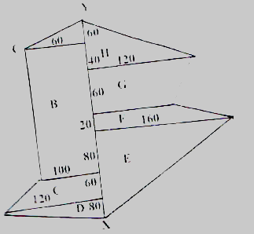  Areas.  A = $\frac{1}{2}$ x 60 x 60 = 1800m²  B = $\frac{(60+100)}{2}$x 200 = 16000m²  C = $\frac{(100+120)}{2}$ x 60 = 6600m²  D = $\frac{1}{2}$ x 120 x 80 = 4800m2  E = $\frac{1}{2}$ x 160 x 220 = 17600m²  F = $\frac{(160+100)}{2}$ x 20 = 2600m²  G = $\frac{(100+120)}{2}$ x 60 = 6600m²  H = $\frac{1}{2}$ x 120 x 100 = 6000m2  Total area = 62000m² = $\frac{62000}{10000}$ = 6.2ha  1ha = 80,000  6.2ha = 8000 x $\frac{6.2}{1}$  = KSh. 496,000.00 | B3  M1  M1  M1  M1  M1  A1 | 3 for at least 6, 2 for at least 4, 1 for at least 2
23. | (a) 6 + 14 + 24 + x + 10 + 6 + 4 = 100  x = 100 – 78  = 22  (b) Modal class 35 – 44  (c) median = 44.4 + $\frac{6}{14}$ x 10  = 48.79  (d)  Midpoint f xf  19.5 6 117  29.5 14 413  39.5 24 948  49.5 14 693  59.5 22 1309  69.5 10 695  79.5 6 477  89.5 4 358 | M1  A1  B1  M1  A1  B1  B1 | Mid points  x column
 | Σf = 100 Σxf = 5010  Mean = $\frac{xf}{f}$  = $\frac{5010}{100}$  = 50.10 | B1  M1  A1 | ✔Σf, Σxf
24. | (a)  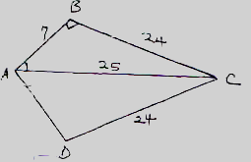  Triangle ABC  $b^{2}$+$h^{2}$=${hy}^{2}$  A$B^{2}$ + B$C^{2}$= A$C^{2}$  $7^{2}$ + ${24}^{2}$ = ${25}^{2}$  49 + 576 = 625  625 = 625  (b) BAD = 2BAC  Sin θ = $\frac{24}{25}$θ = 73.74⁰  BAD = 73.74 x 2 = 147.48⁰  (c) Area of kite = $\frac{1}{2}$ x 7 x 24 x 2  Area of sector ABD = $\frac{147}{360}$ x 3.14 x $7^{2}$  = 62.87cm²  Area shaded = 168 – 62.87  = 105.13cm² |  | M1  A1  B1  B1  M1A1  M1  A1  A1  A1

