KASSU JET EXAMINATION - 2021
Kenya Certificate of Secondary Education

232/1
PHYSICS
PAPER ONE
Jan. 2021
2 hours

Name...................................................................................Index Number......................../............
Admission Number………….Class: ……....Candidate’s Signature....................Date...............
INSTRUCTIONS TO CANDIDATES
- Write your name, admission number and index number in the spaces provided above.
- Sign and write the date of examination in the spaces provided above
- This paper consists of TWO sections A and B.
- Answer ALL the questions in section A and B in the spaces provided.
- All working MUST be clearly shown.
- Non programmable silent calculators may be used.
- ALL numerical answers must be expressed in decimal notation.
- This paper has 14 pages. It is the responsibility of the candidate to ascertain that all the pages are printed as indicated and that no questions are missing.
- Candidates should answer the questions in English.
Constant: g=10N/kg or 10m/s²
For Examiners Use Only

Section | Question | Maximum Score | Candidate’s Score
A | 1 – 13 | 25
B | 14 | 13
 | 15 | 15
 | 16 | 08
 | 17 | 09
 | 18 | 10
Total Score |  | 80

SECTION A: (25 marks)
Answer ALL the questions in this section in the spaces provided.
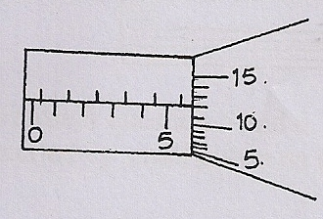
- Figure 1 shows a magnified portion of the scale of a micrometer screw gauge used to measure the diameter of spherical object.

Figure 1
State the diameter of the object (1mark)
…………………………………………………………………………………………………..
- Figure 2 shows a flask fitted with a glass tube dipped into a beaker containing water at room temperature. The cork fixing the glass tube is air tight.
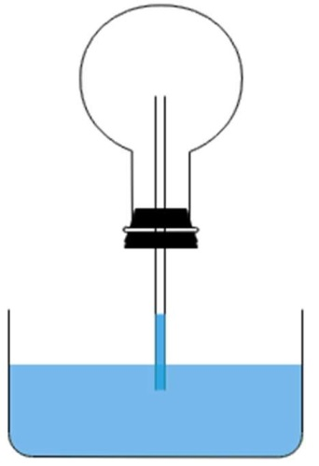
Air
Glass tube
Water
Flask
Figure 2
State with reason what is observed when the flask is held with warm hands. (2marks)

………………………………………………………………………………………………………………………………………………………………………………………………………………………………………………………………………………………………………………………………………………………………………………………………………………………………

- 1800 cm³ of fresh water of density 1g/cm³ is mixed with 2200cm³ of sea water of density 1.03g/cm³. Determine the density of the mixture. (2marks)
……………………………………………………………………………………………………………………………………………………………………………………………………………………………………………………………………………………………………………………………………………………………………………………………………………………..………
- a) State the principle of moments. (1 mark)

………………………………………………………………………………………………………………………………………………………………………………………………………………………………………………………………………………………………………………………………………………………………………………………………………………………………
b) Figure 3 shows a uniform meter rule balancing when a mass of 200g is hung at one end. Determine the tension T in the string (2marks)

Figure 3
………………………………………………………………………………………………………………………………………………………………………………………………………………………………………………………………………………………………………………………………………………………………………………………………………………………………
5. Name two forces that determine the shape of liquid drop on a solid surface. (2marks)
………………………………………………………………………………………………………………………………………………………………………………………………………………
6. It was observed that when air is blown between two pieces of paper, both cling to each other. Explain. (1mark)
………………………………………………………………………………………………………………………………………………………………………………………………………………………………………………………………………………………………………………………………………………………………………………………………………………………………

7. a) State the Hooke’s Law. (1mark)

………………………………………………………………………………………………………………………………………………………………………………………………………………………………………………………………………………………………………………………
b) Figure 4 shows identical spiral springs supporting a load of 90N. Each spring has a spring constant k = 200N/m

Figure 4

Determine the total extension of the system (take the weight of the cross bars and springs to be negligible) (2 marks)

………………………………………………………………………………………………………………………………………………………………………………………………………………………………………………………………………………………………………………………………………………………………………………………………………………………………

8. In an experiment to estimate the diameter of an oil molecule, an oil drop of diameter 0.05cm spreads over a circular patch whose diameter is 20cm. Determine the diameter of the oil molecule. (3marks)
…………………………………………………………………………………………………………………………………………………………………………………………………………………………………………………………………………………………………………………………………………………………………………………………………..…………………………

9. Figure 5 shows a rectangular loop with two thin threads loosely tied and dipped into a soap
solution.
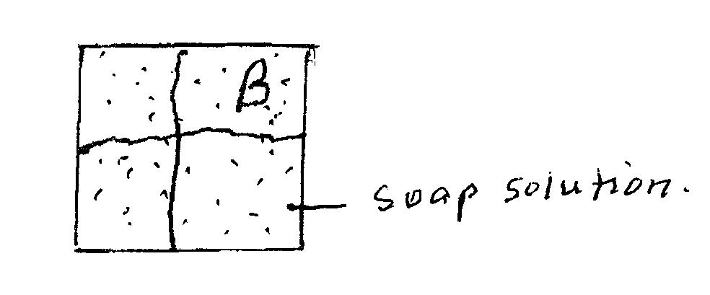
Figure 5
Draw on the side of Figure 5 what is observed when point B is punctured. (1mark)

10 a)Figure 6 shows a manometer used to measure the lung pressure of a student. Given that the atmospheric pressure is 103360Pa, determine the lung pressure of the student. (2marks)
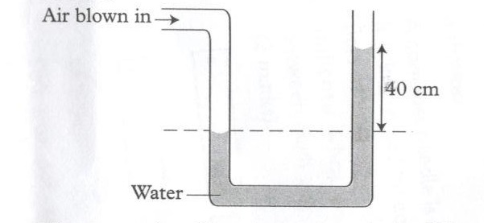
Figure 6
…………………………………………………………………………………………………………………………………………………………………………………………………………………………………………………………………………………………………………………………………………………………………………………………………………………..…………
b) State one factor affecting pressure in fluids. (1mark)

………………………………………………………………………………………………………………………………………………………………………………………………………………
11. Give a reason why mass of a body is constant everywhere. (1mark)
………………………………………………………………………………………………………………………………………………………………………………………………………………
12. A stop watch reads 08:12:84 and 09:10:72 before and after an experiment respectively. Determine the duration of the event in SI units. (2marks)
………………………………………………………………………………………………………………………………………………………………………………………………………………………………………………………………………………………………………………………………………………………………………………………………………………………………
13. Explain what thermodynamics is as a branch of physics. (1 mark)
………………………………………………………………………………………………………………………………………………………………………………………………………………………………………………………………………………………………………………………

SECTION B: ( 55 marks)

Answer ALL the questions in this section in the spaces provided.

14.a)Define the term work done as applied in physics. (1mark)
………………………………………………………………………………………………………………………………………………………………………………………………………………
b). Figure 7 shows the cross – section of a wheel and axle of radius 6.0 cm and 1.5 cm respectively used to lift a load. Use it to answer the questions that follow.

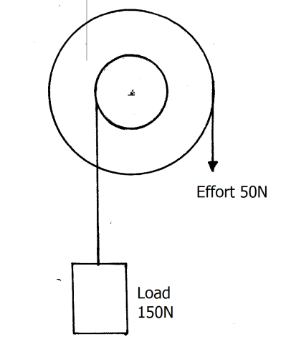 Figure 7

Determine the:
I)(i) mechanical advantage (M.A) of the system. (1mark)
…………………………………………………………………………………………………………………………………………………………………………………………………………..…
(ii) velocity ratio ( V.R) of the system. (1mark)
………………………………………………………………………………………………………………………………………………………………………………………………………………
(iii) efficiency of the machine. (1mark)
………………………………………………………………………………………………………………………………………………………………………………………………………………………………………………………………………………………………………………………
II) Give one reason why the above machine is not 100% efficient. (1mark)
………………………………………………………………………………………………………………………………………………………………………………………………………………
c) Define specific latent heat of vaporisation (1 mark)

………………………………………………………………………………………………………………………………………………………………………………………………………………………………………………………………………………………………………………………
d) 1200g of a liquid at 10⁰C is poured into a well-lagged calorimeter. An electric heater
rated 1.5 KW is used to heat the liquid. Figure 8 shows the variation of temperature of the liquid with time.

100

80

60

Temp.
(⁰C) 40

20

0 1 2 3 4 5 6 7 8
Time (min)
Figure 8

Use figure 8 to answer the following questions:

(i)State the boiling point of the liquid (1 mark)

………………………………………………………………………………………………………

( ii ) Determine the amount of heat given out by the heater to heat the liquid to the boiling point. (2 marks)
………………………………………………………………………………………………………………………………………………………………………………………………………………

(iii)Determine the specific heat capacity of the liquid. (2marks)
………………………………………………………………………………………………………………………………………………………………………………………………………………………………………………………………………………………………………………………………………………………………………………………………………………………………
iv) If 20g of the liquid vapour was collected by the end of the 8th minute, determine the specific latent heat of vaporization of the liquid. (2 marks)

………………………………………………………………………………………………………………………………………………………………………………………………………………………………………………………………………………………………………………………………………………………………………………………………………………………………

15.a) Figure 9 shows a velocity –time graph for the motion of a certain body.

Figure 9

Describe the motion of the body in the region:
(i) OA: (1mark)

………………………………………………………………………………………………………………………………………………………………………………………………………………
(ii) AB: (1mark)

………………………………………………………………………………………………………………………………………………………………………………………………………………
(iii) BC: (1mark)

………………………………………………………………………………………………………………………………………………………………………………………………………………
(b) A car moving initially at 25m/s decelerates at 4 m/s².
(i) Determine the time taken for the car to stop (2marks)

………………………………………………………………………………………………………………………………………………………………………………………………………………………………………………………………………………………………………………………………………………………………………………………………………………………………
(ii) Sketch the velocity – time graph for the motion of the car up to the time the car stopped. (1mark)

………………………………………………………………………………………………………………………………………………………………………………………………………………………………………………………………………………………………………………………………………………………………………………………………………………………………
c) A ball is projected vertically upwards with initial velocity of 80m/s. Determine the
time taken to reach maximum height. (2marks)

………………………………………………………………………………………………………………………………………………………………………………………………………………………………………………………………………………………………………………………………………………………………………………………………………………………………
d) A bullet of mass 80g moving with a velocity of 20m/s penetrates a sand bag and it’s brought to rest in 0.05 seconds. Determine average retarding force of the sand. (2marks)

………………………………………………………………………………………………………………………………………………………………………………………………………………………………………………………………………………………………………………………………………………………………………………………………………………………………

e ) (i) State the principle of conservation of linear momentum (1 mark)

………………………………………………………………………………………………………………………………………………………………………………………………………………………………………………………………………………………………………………………………………………………………………………………………………………………………
(ii) A bullet of mass 60g is fired horizontally with a velocity of 200 m/s into a suspended stationary wooden block of mass 2940g. Determine:
- Common velocity of both the bullet and the block, if the bullet embedded into the block. (2 marks)

………………………………………………………………………………………………………………………………………………………………………………………………………………………………………………………………………………………………………………………………………………………………………………………………………………………………

- Height to which the block rises. (2 marks)

………………………………………………………………………………………………………………………………………………………………………………………………………………………………………………………………………………………………………………………………………………………………………………………………………………………………
16. a) Explain why bodies in circular motion undergo acceleration even when their speed is constant. (1mark)
………………………………………………………………………………………………………………………………………………………………………………………………………………………………………………………………………………………………………………………
b) A particle moving along a circular path of radius 5cm describes an arc of length 2cm every second. Determine:
(i)Its angular velocity. (1mark)
………………………………………………………………………………………………………………………………………………………………………………………………………………………………………………………………………………………………………………………………………………………………………………………………………………………………

( ii)Its periodic time. (2marks)
………………………………………………………………………………………………………………………………………………………………………………………………………………………………………………………………………………………………………………………………………………………………………………………………………………………
c) A stone of mass 150g is tied to the end of a string 80cm long and whirled in a vertical circle at 2rev/s. Determine the maximum tension in the string. (3marks)
………………………………………………………………………………………………………………………………………………………………………………………………………………………………………………………………………………………………………………………………………………………………………………………………………………………………
(d) State one factor affecting centripetal force (1mark)
………………………………………………………………………………………………………………………………………………………………………………………………………………………………………………………………………………………………………………………………………………………………………………………………………………………………
17.a) State the Archimedes’ principle. (1 mark)

………………………………………………………………………………………………………………………………………………………………………………………………………………………………………………………………………………………………………………………………………………………………………………………………………………………………

b)The weight of a stone in air is 8.5N. When fully immersed in paraffin of density 0.8g/cm³ its weight is 7.3N. Determine the;
(i) up thrust in the paraffin. (1 mark)

………………………………………………………………………………………………………………………………………………………………………………………………………………………………………………………………………………………………………………………………………………………………………………………………………………………………

(ii) volume of the stone. (2 marks)

………………………………………………………………………………………………………………………………………………………………………………………………………………………………………………………………………………………………………………………………………………………………………………………………………………………………

c) Figure 10 shows rectangular metal block of density 12,500kgm⁻³ and dimensions 30cm x 20cm x 20cm suspended inside a liquid of density 1200kgm⁻³ by a string attached to appoint above the liquid. The three forces acting on the block are; the tension T, on the string, the weight W, of the block, and the up thrust, U, due to the liquid.

String
Liquid
Block

T

U

Figure 10

Figure 10

(i) Write an expression relating T, W and U when the block is in equilibrium inside the liquid. (1 mark)
………………………………………………………………………………………………………………………………………………………………………………………………………………

(ii) Determine the weight, W, of the block (1 mark)
………………………………………………………………………………………………………………………………………………………………………………………………………………………………………………………………………………………………………………………………………………………………………………………………………………………………

(iii) Determine the weight of the liquid displaced by the fully submerged block (2 marks)

………………………………………………………………………………………………………………………………………………………………………………………………………………………………………………………………………………………………………………………
(iv) Hence determine the tension, T, in the string (1 mark)
………………………………………………………………………………………………………………………………………………………………………………………………………………………………………………………………………………………………………………………………………………………………………………………………………………………………
18.a) Figure 11 shows a set-up that may be used to verify pressure law.
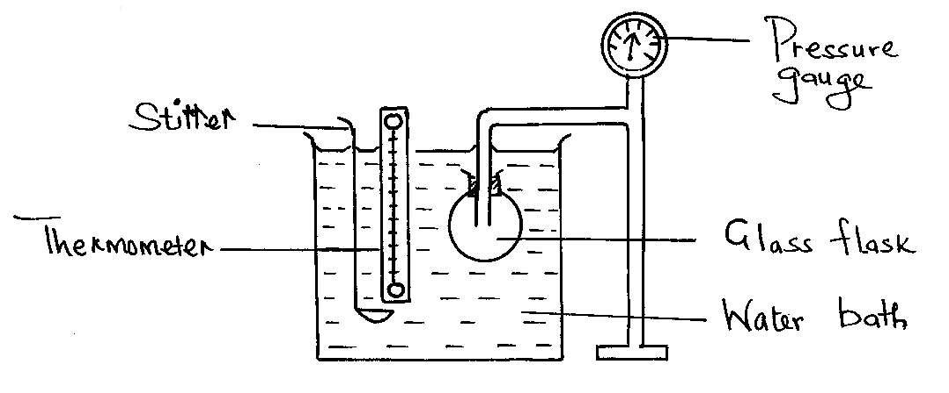

Figure 11

(i) State the measurements that should be taken in the experiment. (2 marks)

……………………………………………………………………………………………………………………………………………………………………………………………………………..
ii)Explain how the measurements in (i) above may be used to verify pressure law. (2 marks)

……………………………………………………………………………………………………………………………………………………………………………………………………………..……………………………………………………………………………………………………………………………………………………………………………………………………………..……………………………………………………………………………………………………………………………………………………………………………………………………………..
b)A column of air 26cm long is trapped by mercury thread 5.0cm long as shown in
figure11 (a) . When the tube is inverted as in figure11 (b) the air column becomes 30cm long. Determine the value of atmospheric pressure (2 marks)
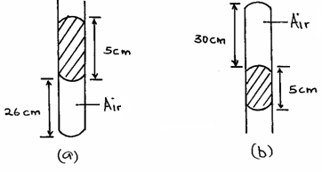

Figure11
……………………………………………………………………………………………………………………………………………………………………………………………………………..
………………………………………………………………………………………………………
c)A steel cylinder of capacity 0.45m³ contains nitrogen at a pressure of 40,000Pa when the temperature is 17°C. Determine the pressure of nitrogen if it is allowed to flow into another cylinder of capacity 8.5m³ with the temperature reduced to -23°C. (2 marks)
……………………………………………………………………………………………………………………………………………………………………………………………………………..
………………………………………………………………………………………………………

d) Using kinetic theory of gases, explain how a rise in the temperature of a gas causes a rise in its pressure if the volume is kept constant. (2 marks)
………………………………………………………………………………………………………………………………………………………………………………………………………………………………………………………………………………………………………………………………………………………………………………………………………………………………

THIS IS THE LAST PRINTED PAGE

