Name……………………………………………….Adm No……….. Class…… Index No……………………….. Signature………………

121/1
Mathematics Paper 1
Form 4
2 ½ Hours
Term 2, 2021
KASSU JET EXAMINATIONS
Kenya Certificate of Secondary Education (K.C.S.E)
INSTRUCTIONS TO CANDIDATES
- Write your name and Admission number in the spaces provided at the top of this page.
- This paper consists of two sections: Section I and Section II.
- Answer ALL questions from section I and ANY FIVE from section II
- All answers and workings must be written on the question paper in the spaces provided below each question.
- Show all the steps in your calculation, giving your answer at each stage in the spaces
below each question.
- Non – Programmable silent electronic calculators and KNEC mathematical tables may be used, except where stated otherwise.

FOR EXAMINERS USE ONLY

SECTION I
1 | 2 | 3 | 4 | 5 | 6 | 7 | 8 | 9 | 10 | 11 | 12 | 13 | 14 | 15 | 16 | TOTAL

SECTION II
17 | 18 | 19 | 20 | 21 | 22 | 23 | 24 | TOTAL

GRAND TOTAL

SECTION A (50 marks)
- Without using a calculator or tables, evaluate:
${\left(\frac{2\frac{1 }{4 } ÷ \frac{ 5}{4}+{\left(\frac{-2}{3}\right)}^{3}}{\frac{5}{7} -2\frac{2}{3}of 3+ \frac{-3}{8} }\right)}^{-2}$ (3 marks)

- Solve the equation for x. $5^{2x+1}+5^{2x}-750=0$ (3 marks)

- Simplify $\frac{8mn-6m+8n^{2}-6n}{8n-6}$ (3 marks)

- Use squares, square roots and reciprocals tables to evaluate the following giving your answer to 2 decimal places. (4 marks)
$$\frac{1}{√20.52}+\frac{2}{{\left(6.23\right)}^{2}}$$

- Susan made a loss of 20% by selling a blender at sh. 2,400. What profit would she have made had she sold it at sh. 3300? (3 marks)

- Solve for x and y using substitution method:
$\frac{1}{3}$(x + y) – 2 = 0
$\frac{1}{4}$(x - y) = 1 (3 marks)

- The number of sides of two regular polygons differs by one. If the sum of the interior angles of these polygons is in the ratio 2:3, calculate the number of sides of each polygon and name them. (3 marks)

- Solve for x in the following equation: $Sin\left(\frac{1}{2} x-{10}^{0}\right)=Cos2x$ (3 marks)

- A vehicle moves at an initial speed of 20m/s with a constant acceleration of 2m/s2 for five seconds before breaks are applied. If the car comes to rest under constant deceleration 4 seconds, determine the total distance travelled during the 9 seconds
(3 marks)

- Simplify completely the expression (4 marks)

- A point P divides the line AB shown below internally in the ratio 2:3. By construction, find the position P and measure AB.

A B (3 marks)

- In the figure below, O is the centre of the circle and reflects angle AOC =142⁰. Find angle ABC. (3 marks)
B

O
A
C

O

- A tourist arrived in Kenya with 10,000 US dollars which he converted to Ksh on arrival. He spent Kshs.428,500 and converted the remaining amount to Sterling pounds. How much did he receive in Sterling pounds? The currency exchange rate of the day was as follows; (3 marks)
Currency | Buying | Selling
1 Sterling pound | 135.50 | 135.97
1US dollar | 72.23 | 72.65

- Adam harvested 200 bags of wheat from 2 ha of his farm. How many bags of wheat would he harvest from 16 ha if he maintained the rate? (3 marks)

- Complete the solid below whose length is 7cm (3 marks)

F

A 7cm

B E

C D

- Write down three inequalities which fully describe the unshaded region R in the figure below (3 marks)
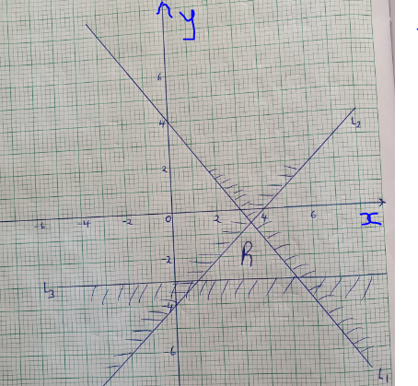

SECTION B (50 marks)
- Three points P, Q and S are pm the vertices of a triangular plain field. P is 400m from Q on a bearing of 300⁰ and R of 550m directly south of P.
(a) Using a scale of 1 cm to represent 100m on the ground, draw a diagram to show the position of the points. (3 marks)
(b) Use the scale drawing to determine;
(i) The distance and bearing of Q from R. (2 marks)
(ii) The bearing and distance of point S from P given that point S is directly 600m East of R. (3 marks)

(iii) The bearing and distance of Q from S. (2 marks)

- A bus travelling at a speed of 80km/hr left Mombasa at 8.00am for Nairobi. Two hours later, a car travelling at a speed of 100km/hr left Nairobi for Mombasa.
- Given that the distance between both cities is 500km, find the time of the day when the two vehicles met. (6 marks)

- After meeting, the speed of both vehicles dropped to 60km/hr due to traffic jam. At what time did each vehicle arrive at its destination? (4 marks)

- The figure below represents an histogram of heights against age brackets of members of a village.
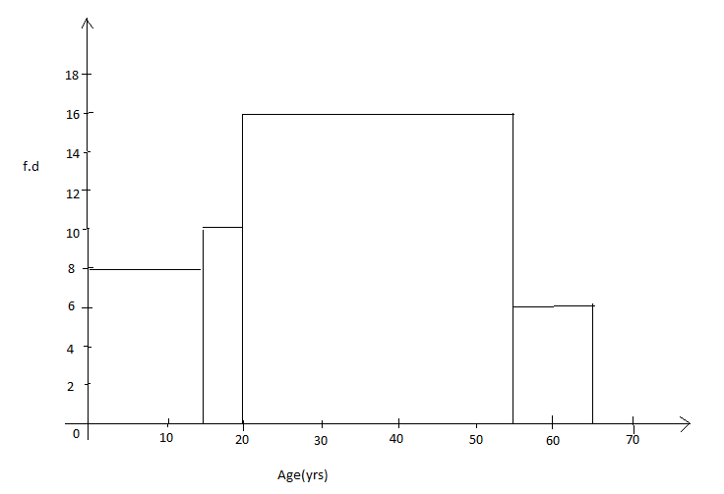
Using the figure above,
- Develop a frequency distribution table (3marks)
- Using the table in (a) above find;
- The mean. (3marks)
- The median class (1mark)
- The median (3marks)

- The diagram below shows a container base made of a frustum of a square pyramid. The top is a solid frustum of a cone.
AB = BC = 12 cm
EF = 6
Height of 10 and 6 cm respectively.
6cm
10
6
E
D
A
12
B
12
F
G
C
H

(a) Calculate the surface area of the bottom solid. (5 marks)

(b) Calculate the surface area of the top side. (4 marks)

(c) Calculate the total area. (1 mark)

- a).Complete the table below for the function
y=-$x^{2}+10x$ (2marks)
X | -1 | 0 | 1 | 2 | 3 | 4 | 5 | 6 | 8 | 10
Y |  |  | 9 |  |  | 24 |  |  |  | 0

b) On the grid provided draw the graph of y=-$x^{2}+10x$ (3marks)

c) Using the graph above solves the equations:
i) 10x-$x^{2}=0$ (2marks)

ii) $x^{2}-7x-8=0$ (3marks)

- Two lines L₁=2y-3x-6 and L₂=3y+x-20=0 intersect at point A.
    - Find the coordinates of A (3marks)

    - A third line L₃ is perpendicular to L₂ at point A. Find the equation of L₃ in form of y=mx+c, where m and c are constants. (3marks)

    - Another line L₄ is parallel to l1 and passes through (-1,3). Find the x-intercept and the y-intercept of L₄. (4marks)

- (a) PQRS is a quadrilateral with vertices P(1,4), Q(2,1), R(2,3) and S(6,4). On the grid provided, plot the quadrilateral. (1 mark)

(b) Draw P’Q’R’S’ the image of PQRS under a positive quarter turn about the origin and write down its co-ordinates. (3 marks)

(c) Draw P”Q”R”S” the image of P’Q’R’S’ under an enlargement scale factor -1 and center (0,0) and write down its co-ordinates. (3 marks)

(d) Determine the matrix of a single transformation that maps PQRS onto P”Q”R”S (3 marks)
- A curve whose equation is $3y=9-18x+\frac{27}{2}x^{2}- 3x^{3}$ turns at points P and R.
a) Find the coordinates of P and R (5 marks)

b) Determine the nature of points P and R (3 marks)

c) Sketch the curve (2 marks)

