312/2
GEOGRAPHY
Paper 2
JANUARY 2021
Time: 2¾ hours

KASSU-JET JOINT EXAMINATION
Kenya Certificate of Secondary Education
312/2
Paper 2
GEOGRAPHY

INSTRUCTIONS TO STUDENTS

- This paper has two sections A and B
- Answer ALL the questions in section A. In section B answer questions 6 and any other TWO questions.

SECTION A
Answer all the questions in this section.
1. (a) What is practical Geography? (2 marks)
(b) State three practical aspect we study in Geography. (3 marks)
2. (a) Apart from marine parks, give two other tourist attractions at the Kenyan coast. (2 marks)
(b) State three reasons why national parks have been established in Kenya. (3 marks)
3. (a) Name two towns in Kenya where motor vehicle assembly plants are found. (2 marks)
(b) State three ways in which Kenya has benefited from assembling of motor vehicles locally. (3 marks)
4. (a) Identify two indigenous beef cattle breeds raised in Kenya. (2 marks)
(b) Give three factors which favour beef farming in the Nyika plateau. (3 marks)
5. (a) Differentiate between exports and imports. (2 marks)
(b) State three factors which influence external trade in Kenya. (3 marks)
SECTION B
Answer question 6 and any other TWO questions from this section.
6. Study the photograph below and use it to answer question (a).
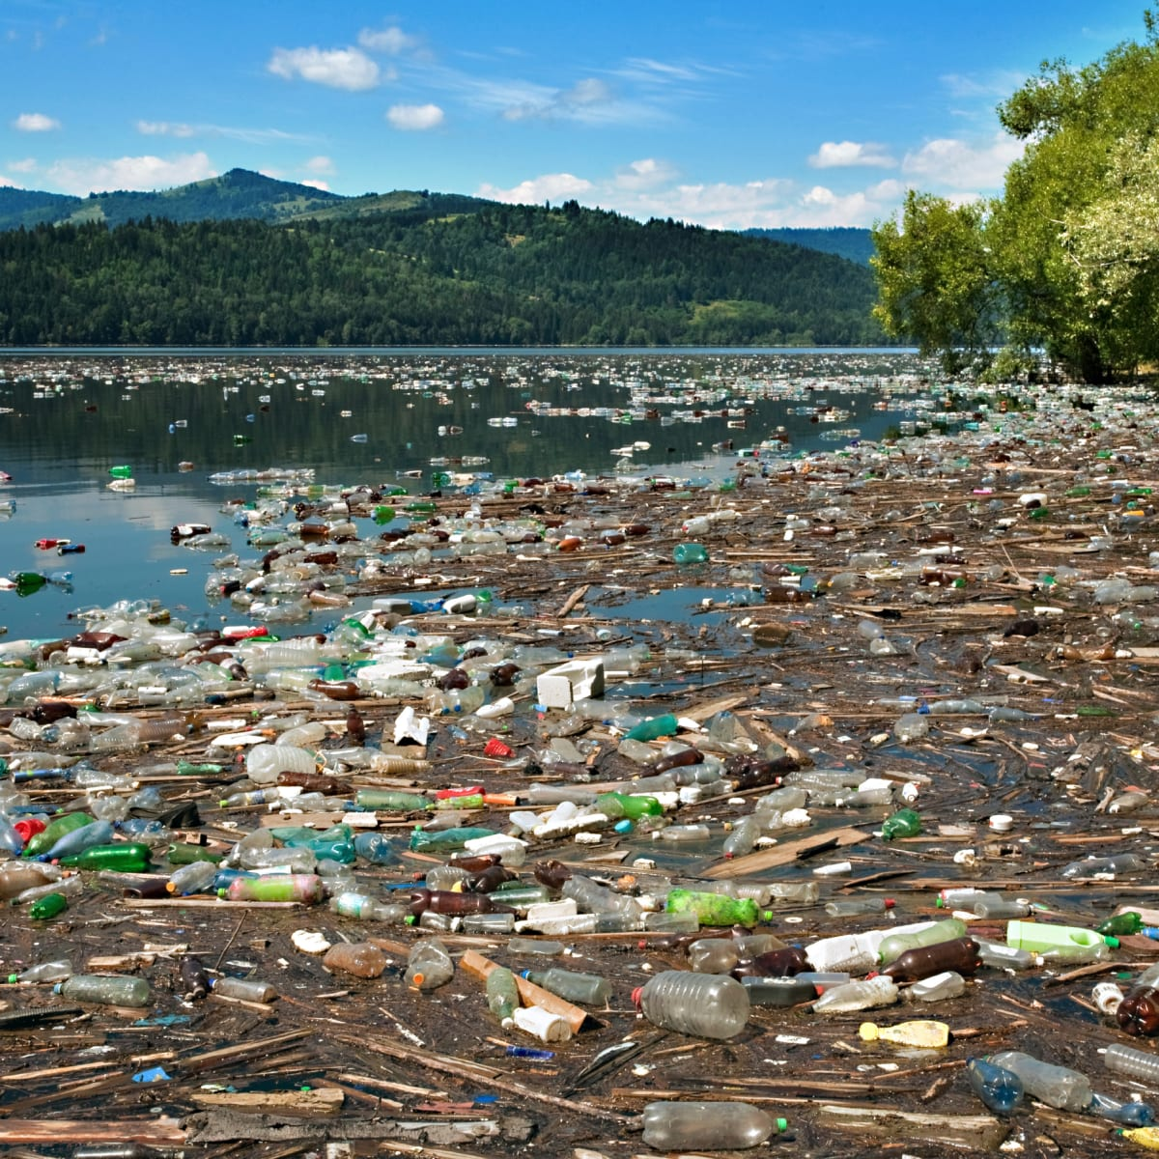
(a) (i) What evidence in the photograph shows that this is a ground general view type of photograph? (2 marks)
(ii) Name the type of pollution shown on the photograph. (1 mark)
(iii) Draw a rectangle measuring 15cm by 10cm to represent the area on the photograph. On it, sketch and label the main features shown on the photograph. (5 marks)
(iv) State three causes of this type of pollution. (3 marks)
(v) Explain three measures that may be taken to combat this type of pollution. (6 marks)
(b) (i) Name two rivers in Kenya to the west of the rift valley which cause large scale flooding. (2 marks)
(ii) Explain factors that lead to frequent flooding in the lake region of Kenya.
(6 marks)
7. (a) (i) Define the term fisheries. (2 marks)
(ii) Name two types of inland fisheries in East Africa. (2 marks)
(iii) State four measures that the government of Kenya has taken to conserve fisheries. (4 marks)
(b) Describe how basket fishing method is used to catch fish. (6 marks)
(c) The following map shows the world distribution of the major fishing grounds. Study and use it to answer the questions that follow.
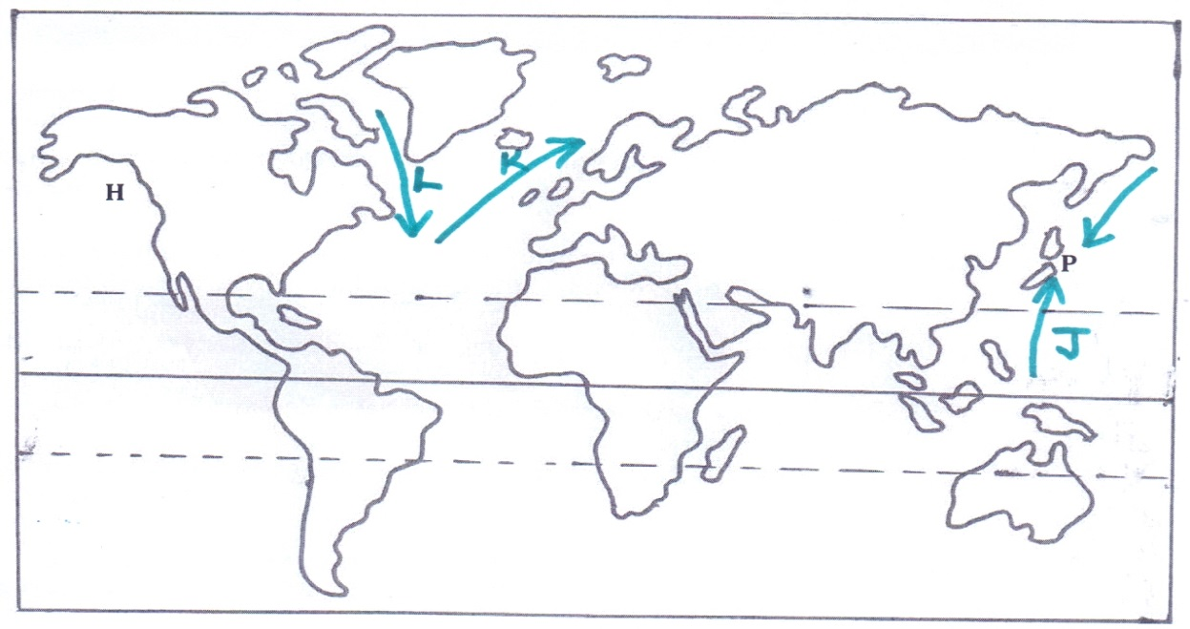
(i) Name two types of fish species found in the fishing ground marked P. (2 marks)
(ii) Identify the ocean currents labelled J, K and L. (3 marks)
(iii) Explain three physical factors that favour large scale fishing in the fishing ground marked H. (6 marks)
8. (a) (i) Identify the type of energy from the following sources of energy.
  - Tides (1 mark)
  - Uranium (1 mark)
(ii) What is Geothermal energy? (2 marks)
(iii) State three factors that hinder expansion of geothermal production in Kenya. (3 marks)
(b) Explain three problems that face the use of firewood as a source of energy in Kenya. (6 marks)
(c) (i) State four physical factors that favoured the location of the Owen Falls Hydro-electric Power project in Uganda. (4 marks)
(ii) Explain two problems the government of Kenya faces in her effort to develop H. E. P stations. (4 marks)
(d) Form Four students carried out a field study in Kamburu H.E.P plant.
(i) State two objectives for their study. (2 marks)
(ii) Give two reasons why they needed a working schedule. (2 marks)
9. (a) Differentiate between transport and communication? (2 marks)
(b) Explain how the following factors influence development of transport in Kenya.
(i) Government policy (2 marks)
(ii) Relief (2 marks)
(c) (i) Identify three conditions of roads in Kenya that cause occurrence of accidents. (3 marks)
(ii) State three measures taken by the government of Kenya to reduce road accidents. (3 marks)
(d) (i) Name two major railway lines in East Africa. (2 marks)
(ii) State three reasons why road transport is more developed than railway transport in East Africa. (3 marks)

(e) Study the map of the great lakes and the St, Lawrence Sea way provided and use it to answer the questions that follow.
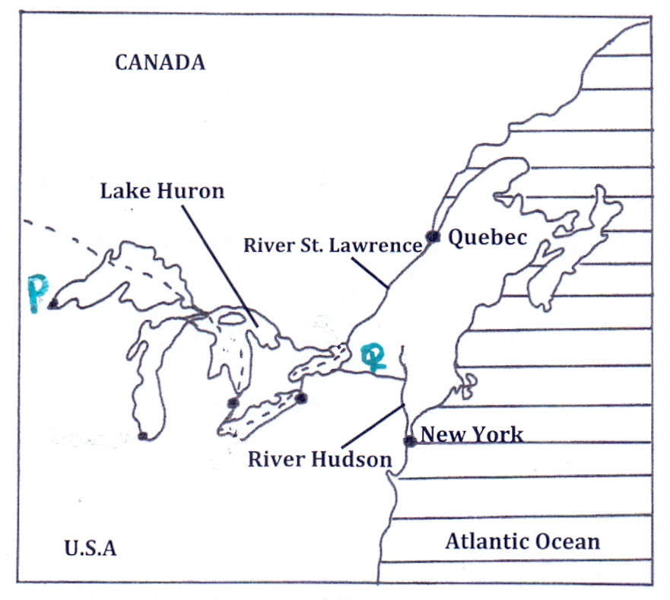
(i) Name the port mark P and the canal marked Q. (2 marks)
(ii) Explain three ways in which the sea route has contributed to industrial growth in the region. (6 marks)
10. (a) (i) What is population? (2 marks)
(ii) Give three reasons why it is important for the government to conduct a population census. (3 marks)
(b) Explain how the following physical factors has influenced population distribution in Kenya.
(i) Climate (2 marks)
(ii) Pests and diseases. (2 marks)
(c) (i) Define the term fertility. (2 marks)
(ii) Give four factors that influence fertility. (4 marks)
(iii) State four causes of intra-urban migration. (4 marks)
(d) Explain three problems that result from high population growth rate in Kenya. (6 marks)

