312/2
GEOGRAPHY
Paper 2
JANUARY 2021
Time: 2¾ hours

KASSU-JET JOINT EXAMINATION
Kenya Certificate of Secondary Education
312/2
Paper 2
GEOGRAPHY
MARKING SCHEME

SECTION A
Answer all the questions in this section.
1. (a) What is practical Geography? (2 marks)
- The study of practical skills which enhance the understanding and interpretation of geographical phenomena.
(b) State three practical aspect we study in Geography. (3 marks)
- Maps and map reading/Maps and mapwork
- Photograph work
- Time management
- Data interpretation
- Data presentation
2. (a) Apart from marine parks, give two other tourist attractions at the Kenyan coast. (2 marks)
- Sandy beaches/cliffs/caves/Indian ocean
- Coral reefs
- Mangrove swamps
- Marine life
- Warm/sunny climate of the coast
- Historical sites e.g. fort Jesus
- Traditional culture of the people/dances/shrines/Kaya forests/craft
- Water sport/beach sports
(b) State three reasons why national parks have been established in Kenya. (3 marks)
- To preserve Kenya’s natural beauty.
- To conserve wildlife/flora and fauna
- To attract tourists
- To provide opportunities for education and research
- To protect our wildlife for posterity
3. (a) Name two towns in Kenya where motor vehicle assembly plants are found. (2 marks)
- Nairobi
- Thika
- Mombasa
(b) State three ways in which Kenya has benefited from assembling of motor vehicles locally. (3 marks)
- Creation of employment
- Earns Kenya foreign exchange
- Helps Kenya save on foreign exchange.
- Has led to development of skills among Kenyans.
- Enabled Kenya to develop trade links with other neighbours.
- Stimulates development of other related industries e.g. paint
- Led to investment of capital by rich companies.
4. (a) Identify two indigenous beef cattle breeds raised in Kenya. (2 marks)
- Boran
- Zebu
- Sahiwal
(b) Give three factors which favour beef farming in the Nyika plateau. (3 marks)
- The presence of watering points/Lorian swamps/some permanent rivers to provide water for animals
- There are large tracts of land/sparsely populated areas with natural grass which provide food for animals.
- The local people keep livestock e.g their occupation provide the basis for beef farming.
- The semi-arid condition/Low Savanna grassland in the region favour beef cattle keeping.
- The area is free from animal pests especially the tsetse flies.
- Gentle slopes/ relatively flat terrain for easier movement of animals
5. (a) Differentiate between exports and imports. (2 marks)
- Exports are goods that a country sells to other countries while imports are good that a country procures from other countries.
(b) State three factors which influence external trade in Kenya. (3 marks)
- Government policy/services
- Differences/similarities in goods produced
- Availability of aids to trade
- Demand for goods locally
- Availability of transport/communication network
- The purchasing power of the people/ availability of capital.
- The level of industrialization.
- Political stability/relationship of trading partners.
- International trade agreements/restrictions.
- Varying exchange rates
SECTION B
Answer question 6 and any other TWO questions from this section.
6. Study the photograph below and use it to answer question (a).
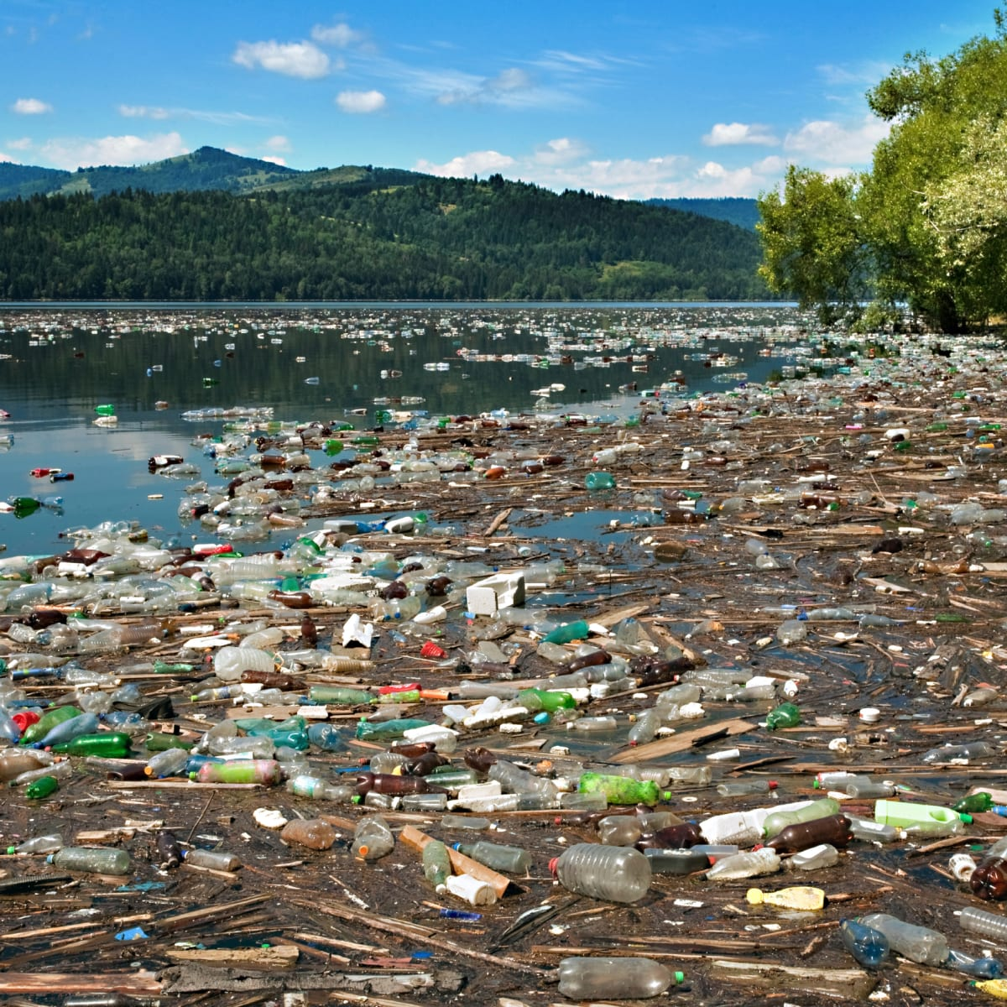
(a) (i) What evidence in the photograph shows that this is a ground general view type of photograph? (2 marks)
- The focus is on many objects
- The photograph captures the broad view of the area
- The objects become progressively smaller towards the back ground
(ii) Name the type of pollution shown on the photograph. (1 mark)
- Water pollution
(iii) Draw a rectangle measuring 15cm by 10cm to represent the area on the photograph. On it, sketch and label the main features shown on the photograph. (5 marks)
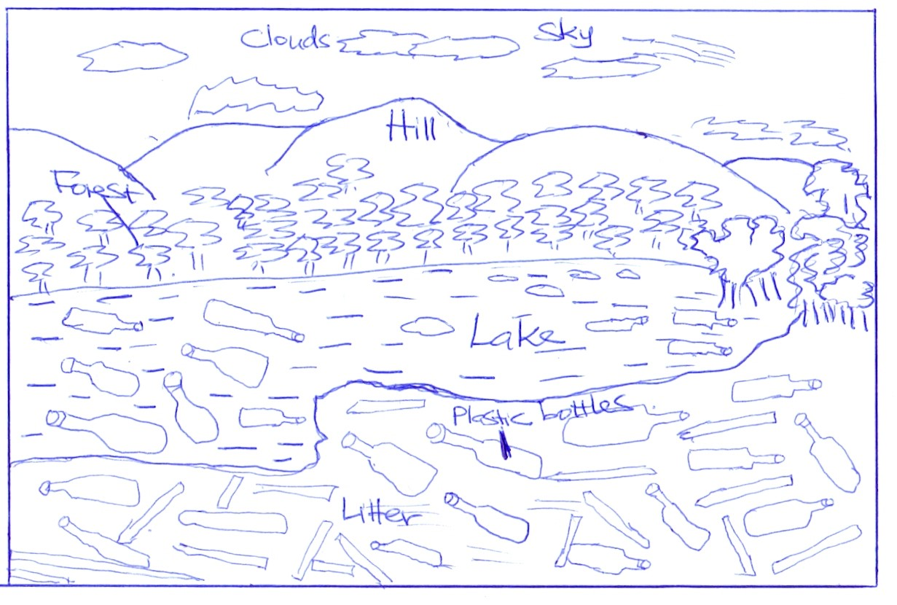
(iv) State three causes of this type of pollution. (3 marks)
- Oil leaks from ships/trucks
- Dumping of solid waste into water courses
- Surface run off/soil erosion into water depositing it.
- Disposing of raw sewages into rivers/lakes
- Washing/bathing/watering animals in rivers/lakes
- Washing away into rivers and lakes chemicals/fertilizers/ pesticides/ insecticides
- Industrial effluent when discharged into rivers/lakes
(v) Explain three measures that may be taken to combat this type of pollution. (6 marks)
- Recycling wastes in order to reduce the industrial waste turn over.
- Industrial waste such as effluents should be treated before releasing them to water to reduce their negative impact.
- Biological control of weeds should be encouraged instead of using weed killer chemical
- Enforce environmental laws on the use of improved technology for industrial efficiency.

(b) (i) Name two rivers in Kenya to the west of the rift valley which cause large scale flooding. (2 marks)
- River Nyando
- River Nzoia
- River Yala
(ii) Explain factors that lead to frequent flooding in the lake region of Kenya.
(6 marks)
- The land in the region is low lying which cause rain water to spread over a wide area.
- The adjacent highlands receive heavy rainfall which releases large volumes of water resulting to rivers overflowing their banks.
- Silt has filled the river beds making them shallow spilling their water over the banks.
- Some areas have black cotton soils which are non-porous which when it soaks up allows water to flow and spread on the surface.
- The heavy rainfall received in some of the lake regions cause the lake levels to rise thus flooding the adjacent lowlands.
- Deforestration in the catchment areas reduces water infiltration and encourage surface run-off which ends up in rives which makes them burst their banks.
- Cultivation along the river banks in most rivers have blocked the river channels and cause it to be shallow thus spilling their water over the land.
7. (a) (i) Define the term fisheries. (2 marks)
- These are water bodies where fish are found or reared and exploited for food or commercial purposes.
(ii) Name two types of inland fisheries in East Africa. (2 marks)
- Fresh water Lakes
- Rives
- Fish ponds
- Man-made reservoirs

(iii) State four measures that the government of Kenya has taken to conserve fisheries. (4 marks)
- Through restocking the overfished areas by breeding fingerings in fish farms.
- Through standardizing the mesh size of nets used to ensure only mature fish are caught.
- Through licensing commercial fishermen to control their numbers to help control overfishing.
- Through restricting fishing to specific seasons to allow breeding and maturing of fish
- Through legislation to restrict disposal of untreated and solid wastes into the ocean and lakes in order to control water pollution and ensure survival of fish.
- Through discouraging entry of foreign fishermen in Kenya’s territorial waters in the Indian oceans to avoid overfishing. (Usually 320km)
- Through enforcing international convections to protect the endangered species of fish.
- Through encouraging fish farming to ensure sufficient supply of fish from other sources other than the natural fisheries.
(b) Describe how basket fishing method is used to catch fish. (6 marks)
- It is used in shallow lake waters, ponds and rivers.
- The basket is funnel shaped to allow easy entry of fish
- The mouth of the basket has a no-return valve which prevents outward escape /movement of fish once inside the basket.
- A bait is put in the basket to attract fish.
- The basket is then lowered in shallow water with the mouth facing the direction from which water is flowing.
- The basket is held in position with ropes o/r sticks/stones to prevent it from beingswept downstream.
- It is left in that position for some time/overnight and then removed for emptying of fish.

(c) The following map shows the world distribution of the major fishing grounds. Study and use it to answer the questions that follow.
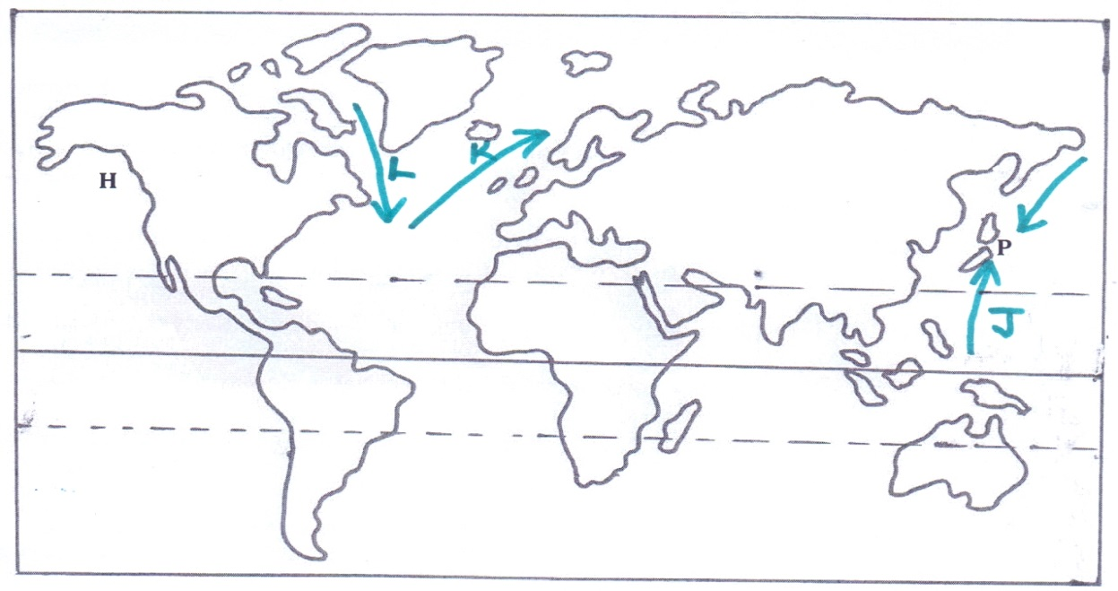
(i) Name two types of fish species found in the fishing ground marked P. (2 marks)
- Salmon
- Tuna
- Bonito
- Sardine
- Cod
- Mackerel
(ii) Identify the ocean currents labelled J, K and L. (3 marks)
J - Labrador cold ocean current
K - Warm North Atlantic drift current
L - Cold Oya-shio current

(iii) Explain three physical factors that favour large scale fishing in the fishing ground marked H. (6 marks)
- Presence of Warm North Pacific current that raises the low temperature of the water making it ideal for the growth of the planktons.
- Presence of warm north pacific current that washes the area making the water ice free thus enabling fishing to take place throughout the year.
- Presence of a highly indented coastline which forms suitable breeding sites for fish and good landing ports.
- Presence of a highly rugged mountainous landscape under dense forest cover which discourages agriculture activities thus people engage in fishing as an alternative economic activity.

8. (a) (i) Identify the type of energy from the following sources of energy.
  - Tides (1 mark)
- Tidal/wave energy
  - Uranium (1 mark)
- Nuclear energy

(ii) What is Geothermal energy? (2 marks)
- This is energy derived from steam from the hot rocks in the interior of the earth.
(iii) State three factors that hinder expansion of geothermal production in Kenya. (3 marks)
- Inadequate technology to ensure exploitation
- Limited number of suitable sites for generation and exploration
- Inadequate capital for investment
- Scarcity of skilled labour hence reliance on expatriates who are costly.
- The danger of land subsidence
(b) Explain three problems that face the use of firewood as a source of energy in Kenya. (6 marks)
- Use of firewood produces a lot of smoke which pollutes the environment
- Carbon dioxide from the wood fuel contributes to global warming.
- Leads to destruction and degradation of environment due to deforestation.
- Bulky and costly to transport
- A lot of wood is required because of low energy output
- Require a big storage area compared to other sources of energy
- Wood fuel is dirty due to soot and smoke
(c) (i) State four physical factors that favoured the location of the Owen Falls Hydro-electric Power project in Uganda. (4 marks)
- The Owen falls provided a natural waterfall/head waters which made it easy to construct a power generating plant.
- Narrow channel /gorge on the Nile River provided a suitable site for the power station reducing the cost of construction.
- Presence of L. Victoria provided a large reservoir for water.
- Abundant and reliable/constant supply of water for the generation of power throughout the year.
- Strong basement rock system which provided a firm foundation for the dam.

(ii) Explain two problems the government of Kenya faces in her effort to develop H. E. P stations. (4 marks)
- Fluctuating water levels in the rivers during drought lead to lower production hence power rationing.
- Displacement of people due to creation of the reservoir has led to high cost of compensation.
- Limited sites for both HEP and Geothermal production.
- The quantity of water downstream can greatly reduce due to the dam, especially during drought.

(d) Form Four students carried out a field study in Kamburu H.E.P plant.
(i) State two objectives for their study. (2 marks)
- To find out the factors that influenced the location of the plant/station.
- To find out the amount of energy generated daily from the station.
- To identify/find out/establish the problems facing the station.
- To investigate/determine the uses of the energy produced.
(ii) Give two reasons why they needed a working schedule. (2 marks)
- To ensure proper time management and reduce time wastage.
- To ensure important areas are covered adequately.
- Ensures that one remains within the scope of the study.
- Help to estimate the time required for the study.
- Provides a basis for evaluating the fieldwork while it is in progress.

9. (a) Differentiate between transport and communication? (2 marks)
- Transport is the movement of goods and people from one place to another while communication is the transmission of information from one person to another.
(b) Explain how the following factors influence development of transport in Kenya.
(i) Government policy (2 marks)
- The government and political leaders make decisions of developing transport and communication network in an area.
- The government plans and gives finance to construct such networks and maintain the existing transport infrastructure.
- Government may cooperate with development partners to finance construction of transport and communication networks in a country.
- Government can agree on joint ventures to build transport lines across boundaries to join different countries.

(ii) Relief (2 marks)
- Rugged terrain acts as a barrier to construction of roads and railways.
- It is easy and cheaper to construct roads, railway lines and airports on gently sloping areas.
- Railways and roads are constructed around high mountains which makes them to take longer distance hence expensive.
- Some roads are constructed parallel to the steep escarpments.

(c) (i) Identify three conditions of roads in Kenya that cause occurrence of accidents. (3 marks)
- Some roads have pot-holes which drivers may hit causing tire bursts hence loss of control of the vehicle leading to an accident.
- Some roads have steep gradient and sharp bends were drivers may lose vehicle control and veer off the road.
- Some rods have muddy and slippery surfaces during rainy season which may cause vehicles to collide.
- Some roads are unmarked and have unclear road signs which make drivers to lose vehicle control.
- Some roads have dusty conditions which cause reduced visibility leading to accidents.
- Some roads have narrow bridges which make vehicles crash head on.
- Some roads have substandard smooth surfaces where vehicles may skid and overturn.
- Absence of sidewalks for pedestrians make pedestrians walk on the road causing accidents.
(ii) State three measures taken by the government of Kenya to reduce road accidents. (3 marks)
- Introduction of speed governors on public service vehicles to control speed at 80km/hr.
- Legislation to prohibit overloading of public service vehicles with passengers.
- Construction of bumps to control speed in case of many passengers crossing busy road sections.
- Carrying out road safety education through mass media to create awareness on road safety precautions.
- Intensified police checks to track down on road un-worthy vehicles and traffic offenders.
- Repair and maintainace of roads to get rid of pot-holes.
- Strict regulations on issuing driving licenses to ensure drivers are competent.
- Use of road safety reflectors to warn other road users in case of a vehicle breakdown on the road.
- Installation of road signs to warn on bumps, sharp comers, steep road sections and traffic lights to control traffic flow in busy urban roads.
- Construction of flyovers and zebra-crossing across busy roads to reduce number of pedestrians crossing busy roads.
- Construction of sidewalks to reduce number of pedestrians on roads.
- Pedestrians and cyclists using roads at night advised to wear bright clothes to avoid being hit by vehicles.

(d) (i) Name two major railway lines in East Africa. (2 marks)
- Kenya-Uganda railway line.
- Tanzam/TAZARA railway line

(ii) State three reasons why road transport is more developed than railway transport in East Africa. (3 marks)
- Roads are more flexible and easily constructed to serve from door to door unlike railways that serve specific areas.
- Roads are constructed on different grades unlike railways which are constructed on specific gauges.
- Roads can be used by a wide range of transport agents unlike railways which are used by a single type of train.
- Roads are cheaper to construct and requires less capital unlike railways which are expensive as they require iron and steel.
- Roads carry all quantities of goods which promote small scale business while railways only carry bulky goods thus more roads are constructed as they are in great demand.
- Roads are faster means of transport as opposed to the she slow moving railway transport in most of Africa.
- Roads require less skills in construction unlike railway which require advanced skills to construct specific gauges.
- Roads are wide spread as they can be constructed on varied terrain unlike railways which can only be constructed on relatively flat land.

(e) Study the map of the great lakes and the St, Lawrence Sea way provided and use it to answer the questions that follow.
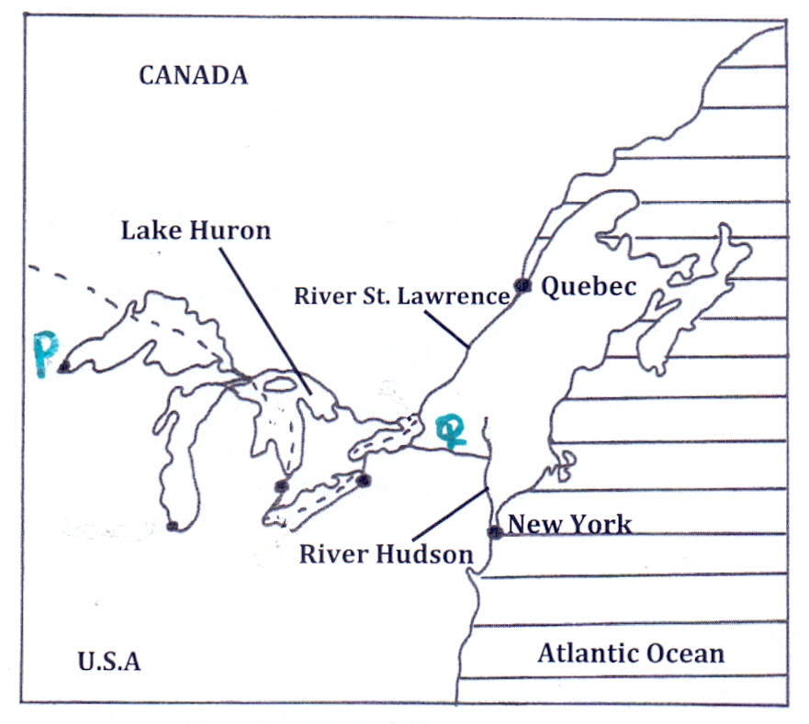
(i) Name the port marked P and the canal marked Q. (2 marks)
P - Duluth
Q - New-York State Barge Canal.
(ii) Explain three ways in which the sea route has contributed to industrial growth in the region. (6 marks)
- It has enabled easy transportation of raw materials to the industries and finished products the markets.
- It has provided cheap water transport which reduced the transportation cost of transporting bulky products.
- Dams constructed provide hydro-electric power for industrial use.
- It has led to development of ports and towns which provide cheap labour and a ready market for the industrial goods produced.
- Water reservoirs provide water for industrial use.
- It has increased the volume of trade on industrial products.

10. (a) (i) What is population? (2 marks)
- Is the total number of people living/inhabiting a geographically defined area.

(ii) Give three reasons why it is important for the government to conduct a population census. (3 marks)
- To determine the total number of people in the country
- To help in distribution of resources
- To make estimates of population growth
- For economic planning and policy making
- To identify death and birth rate or fertility and mortality rate hence determine growth rate.
- To help create new administration units or boundaries
- To help the government to generate employment
- To establish the age sex composition and dependency ratio
- To help create new administration units or boundaries

(b) Explain how the following physical factors has influenced population distribution in Kenya.
(i) Climate (2 marks)
- Areas experiencing high rainfall throughout the year are densely populated because they are suitable for arable farming/support variety of crops.
- Hot and dry areas discourage arable farming hence have fewer people/ low population densities.
- Very cold and extremely hot areas have low population densities because the low temperatures limit growth of crops, and may be harsh for human habitation.

(ii) Pests and diseases. (2 marks)
- Areas infested with pests like tsetse flies and prevalent diseases are sparsely populated due to unhealthy conditions.
- Areas that are free from pests and diseases attract many people leading to dense population.

(c) (i) Define the term fertility. (2 marks)
- Fertility is the ability of a woman to conceive and give birth to a live child.

(ii) Give four factors that influence fertility. (4 marks)
- Level of education
- Family planning or use of birth control or contraceptives.
- Medical care or hygiene or health facilities
- Nutrition or diet for healthy bodies
- Cultural beliefs e.g early marriages, naming relatives, sex preference
- Religious practices which limit use of contraceptives

(iii) State four causes of intra-urban migration. (4 marks)
- Search of better housing
- Search cheaper housing
- Nearness to places of work/ reduce cost transport
- Availability of social facilities/amenities e.g schools, hospitals/ recreational facilities, electricity, water etc.
- Insecurity in some parts of town force people to move to other estates/ parts.
- Cultural/religious affinity attracts some people to move to some parts of towns.

(d) Explain three problems that result from high population growth rate in Kenya. (6 marks)
- High dependency ratio results into little savings by the working group leading to low investments and low living standards.
- High unemployment rate leading to low living standards as the rate of population growth is higher than the job opportunities.
- Increased poverty and large number of unemployed may lead to high crime rate and social evils.
- High demand for social amenities or inadequate social amenities leads to strain and congestion in schools, hospitals, and housing and transport facilities.
- High demand for agricultural land leads to land fragmentation, landlessness and destruction of forests
- Increased demand for food has led to food shortage
- Slow economic growth rate as a lot of revenue is used to meet the demands of large population instead of investing in income generating projects.
- Rural-urban migrations resulting to congestion and social evils in urban centers.

