312/1
GEOGRAPHY
Paper 1
JANUARY 2021
Time: 2¾ hours

KASSU-JET JOINT EXAMINATION
Kenya Certificate of Secondary Education
312/1
Paper 1
GEOGRAPHY

INSTRUCTIONS TO STUDENTS

- This paper has two sections A and B
- Answer ALL the questions in section A. In section B answer questions 6 and any other TWO questions.

SECTION A
Answer all the questions in this section.

1. (a) Differentiate between a Star and a Natural satellite. (2 marks)
(b) State three weaknesses of the Passing Star Theory. (3 marks)
2. (a) Give three ways in which igneous rocks can be classified. (3 marks)
(b) Describe how Dynamic metamorphism leads to formation of metamorphic rocks. (2 marks)

3. (a) Give three agents of Weathering. (3 marks)
(b) Describe how topography influences Weathering of rocks. (3 marks)
4. (a) State three factors that influence river deposition. (3 marks)
(b) Describe radial drainage pattern. (2 marks)
5. (a) What is Glaciation? (2 marks)
(b) State three factors that influence glacial erosion. (3 marks)

SECTION B
Answer question 6 and any other TWO questions from this section.

6. Study the map of Yimbo 1:50000 (Sheet 115/1) provided and use it to answer the following questions.

(a) (i) What is the latitudinal extent of the area covered by the map.(1 mark)
(ii) Give the six-figure grid reference of Ramogi hill. (1 mark)
(b) (i) Convert the ratio scale of the map into statement scale. (2 marks)
(ii) Calculate the area covered by Lake Victoria to the east of Easting 30. Give your answer in square kilometers. (2 marks)

(c) (i) Using a vertical scale of 1 cm represent 50 metres, draw a cross- section along Northing 90 from Easting 30 to Easting 36. (4 marks)

On the cross-section, mark and name:
- Thicket vegetation ` (1 mark)
- Kapiyo school (1 mark)
- River (1 mark)
(ii) Calculate the vertical exaggeration of the the cross-section.(2 marks)
(d) (i) Citing evidence from the map, give two economic activities carried out in the area covered by the map. (2 marks)

(ii) Explain how relief has influenced the distribution of settlement in the area covered by the map. (4 marks)

(iii) Describe the characteristics of the long profile of river Yala. (4 marks)
7. (a) Distinguish between orogenic and epeirogenic earth movements. (2 marks)
(b) Give three features formed in extensional boundary of tectonic plates. (3 marks)

(c) Describe how the following causes earth’s movements
(i) Convectional currents in the mantle (4 marks)
(ii) Gravitative pressure (4 marks)
(d) State four characteristics of the Gregory Rift Valley. (4 marks)
(e) Explain four effects of faulting on the physical environment. (8 marks)

8. (a) Differentiate between derived vegetation and cultivated vegetation. (2 marks)
(b) Explain how the following factors influence vegetation distribution in Kenya:
(i) Living organisms (2 marks)
(ii) Precipitation (2 marks)
(c) The map below shows the global distribution of vegetation. Study and use it to answer the questions that follow. 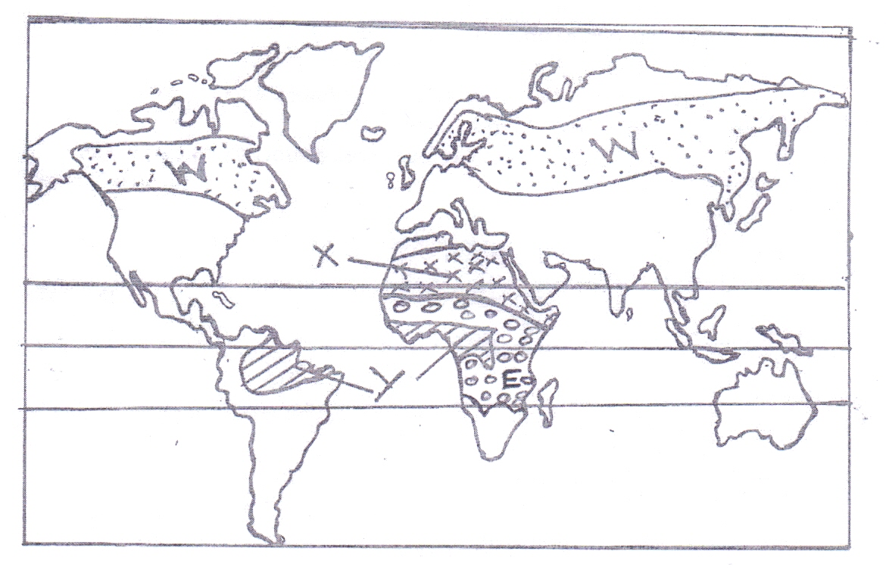
(i) Identify the vegetation labelled W,X, and Y. (3 marks)
(ii) Describe how the vegetation labeled E adapts to the environmental conditions. (6 marks)

(d) Your class is to planning to undertake a field study on vegetation in Mau forest;

(i) State three preparations you would carry out. (3 marks)
(ii) Give three sampling techniques you would use. (3 marks)
(iii) Identify four challenges you are likely to face during the actual field study. (4 marks)

9. (a) (i) Differentiate between Aridity and Desertification. (2 marks)
(ii) Explain the following processes of wind erosion.
- Abrasion (2 marks)
- Deflation. (2 marks)
(b) With the aid of a well labelled diagram, describe the formation of a Mushroom block. (5 marks)

(c) (i) State three factors which influence wind transport. (3 marks)
(ii) Give three characteristics of a Barchan. (3 marks)
(d) Form Four students carried a field study near their school on action of water in arid areas.

(i) Give three reasons why they required a route map. (3 marks)
(ii) State three problems they are likely to encounter while in the field. (3 marks)

(iii) Name two features they are likely to observe. (2 marks)

10. (a) State three factors necessary for the development of Karst scenery. (3 marks)

(b) The diagram below shows an Artesian Basin. Use it to answer the question (i) and (ii). 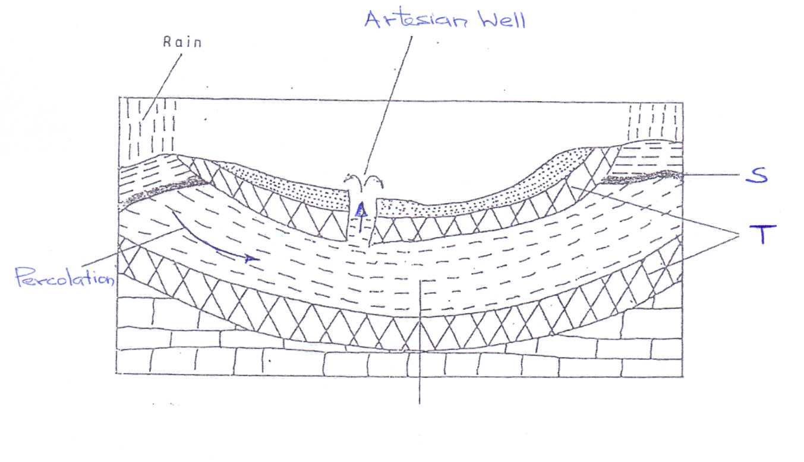

(i) Name the parts marked S and T. (2 marks)
(ii) State three necessary conditions for the formation of an artesian well. (3 marks)
(iii) Explain how a Doline is formed. (5 marks)
(c) (i) Give reasons why some Rift Valley lakes are fresh. (3 marks)
(ii) Describe how a tarn is formed. (5 marks)
(d) Explain two negative effects of lakes. (4 marks)

