Name: …………………………………….. Index No: ……………………dm No………..

Candidate Signature: …………………… Date: ……………………Class…………...

3/2/1
GEOGRAPHY
Paper 1
JANUARY 2021
Time 2 hours 45 min.

KASSU JOINT EVALUATION EXAMINATION
Kenya Certificate of Secondary Education

Instructions to Candidates

- Answer all questions in section A.
- In section B, Answer question 6 and any other two questions from the remaining questions.
- Answer all questions using the answer booklet provided.
- Candidate should check that all pages are printed and no questions are missing.

For Examination use only.

 | Maximum Score | Candidate Score
Section A. | 25
Question 6 | 25
Question 7 | 25
Question 8 | 25
Question 9 | 25
Question 10 | 25
TOTAL | 100%

SECTION A
Answer all the questions in this section.
- a) Differentiate a Star from a Natural satellite. (2mks)
b) State three weaknesses of the Passing Star Theory. (3mks)

- a) Give three ways in which igneous rocks can be classified. (3mks)
b) Describe how Dynamic metamorphism leads to formation of metamorphic rocks. (2mks)
3. a) Outline three agents of Weathering. (3mks)
b) State how topography influences Weathering of rocks. (3mks)
4. a) State the factors that influence river deposition. (3mks)
b) Describe radial drainage pattern. (2mks)
5. a) What is Glaciation? (2mks)
b) State three factors that influence glacial erosion. (3mks)

SECTION B
Answer Question 6 and Any Other two Questions in this Section.
6. Study the map of Yimbo (Sheet 115/1 provided and use it to answer the questions the following questions.
(a) (i) identify the latitudinal extent of the area covered by the map. (1 mark)
(ii) Give the six-figure grid reference of Ramogi hill. (1 mark)
(b) (i) Convert the ratio scale of the map into statement scale. (2 marks)
(ii) Calculate the area covered by Lake Victoria to the east of Easting 30 in square. kilometres (2 marks)
(c) (i) Draw a cross-section along the Northing 90 and between the Eastings 30 and 36, using a vertical scale of 1 cm represent 50 m. (4 marks)
On the cross-section, mark and name:
- Thicket vegetation (1 mark)
- Kapiyo school (1 mark)
- River (1 mark)
(ii) Calculate the vertical exaggeration of the drawn cross-section. (2 marks)
(d) (i) Citing evidence, identify two economic activities carried out in the Yimbo area. (2 marks)
(ii) Describe how relief has influenced the distribution of settlements in the area covered by the map. (4 mark)
(iii) Describe the drainage of river Yala (4marks)

7. a) Distinguish between orogenic and epierogenic earth movements. (2marks)
b) Give any three features associated with the extension boundary. (3marks)

c) Describe how the following theories causes earth’s movements
i) Convectional currents (4marks)
ii) Gravitative pressure (4marks)

d) State four characteristics of the Great Gregory Rift Valley. (4marks)
e) Explain four effects of faulting on physical environment. (8marks)

8. (a) Differentiate between derived and cultivated vegetation. (2 marks)
(b) Explain how the following factors influence vegetation distribution in Kenya:
(i) Living organisms (2 marks)
(ii) Precipitation (2 marks)
(c) The map below shows the global distribution of vegetation. Study and use it to answer the questions that follow.
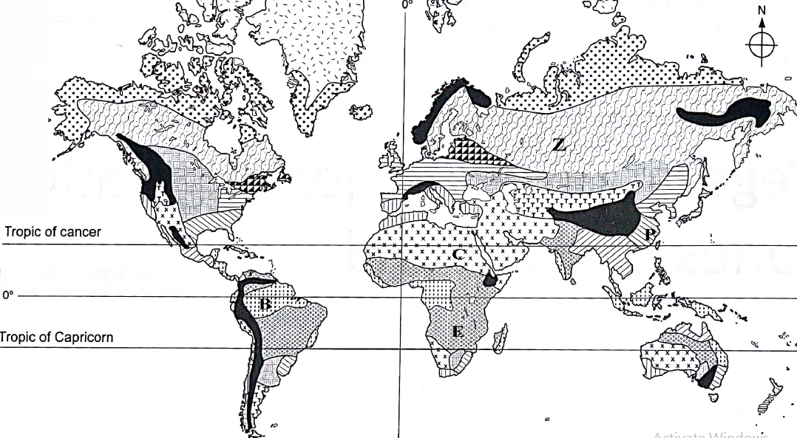
- Identify the vegetation labelled B, C and Z. (3 marks)
- Describe the adaptive characteristics of the vegetation labeled E on the map. (6 marks)
(d) Your class is to planning to undertake a field study on vegetation in Mau forest;
(i) State three preparations you would carry out. (3 marks)
(ii) Give three sampling techniques you would use. (3 marks)
(iii) Identify four challenges you are likely to face during the actual field study. (4 marks)
9. a) i) Differentiate between Aridity and Desertification. (2marks)
ii) Explain the following processes of wind erosion.
- Abrasion (2mks)
- Deflation. (2mks)
b) With a well labelled diagram, describe the formation of a Mushroom block. (5mks)
c) i) State three factors which influence wind transport. (3mks)
ii) Give three characteristics of a Barchan. (3mks)

d) Marsabit Boys high school went for a field study near their school on action of water in arid areas.

i) Give three reasons why they required a route map. (3mks)
ii) State three problems they are likely to encounter while in the field. (3mks)
iii) Name two features they are likely to observe. (2mks)

10. a) State three factors necessary for the development of Karst scenery. (3mks)
b. The diagram below shows an Artesian Basin. Use it to answer the question (i) and (ii).

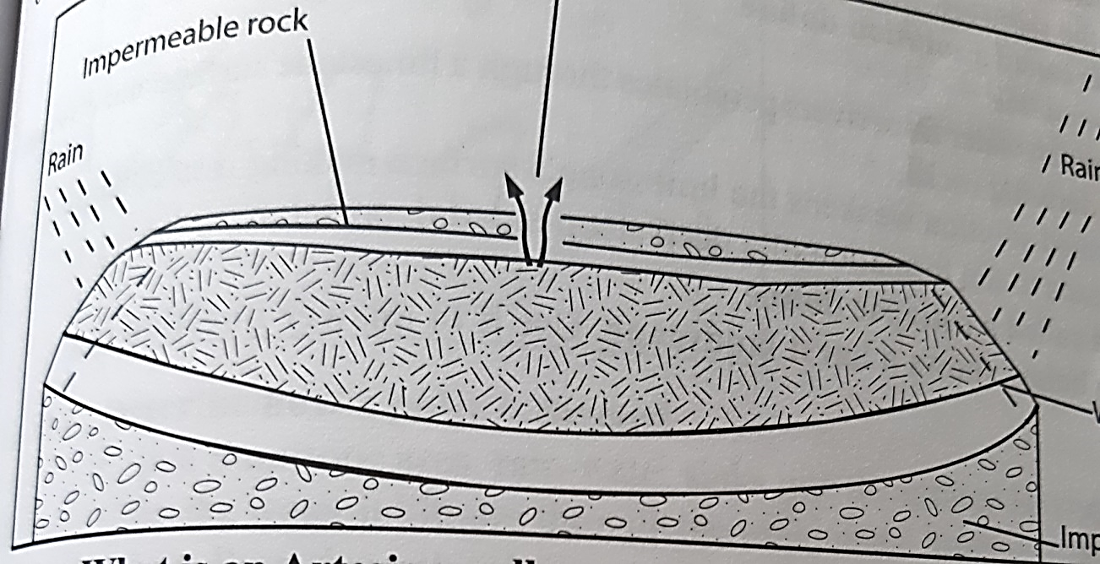

i) Name the parts marked S and T. (2mks)
ii) State three ideal conditions for the formation of an artesian well. (3mks)
iii) Explain how a Doline is formed. (4mks)

c) i) Give reasons why some lakes are fresh. (3mks)
ii) Describe how a tarn is formed. (5mks)
d) Explain two negative effects of lakes. (4mks)

