NAME………………………………………………………. STRM………ADM………….. DATE……. ……………………. SIGN…….…………………….
231/3
BIOLOGY PRACTICAL
PAPER 3
JAN 2021
Time: 1 ¾ Hours

KASSU JET EXAMINATION 2021
(Kenya Certificate of Secondary Education)

INSTRUCTIONS TO CANDIDATES
- Answer all the questions in the spaces provided.
- You are required to spend the first 15 minutes of 1 ¾ hours allowed for this paper reading the whole paper carefully before commencing your work.
- Candidates may be penalized for recording irrelevant information and for incorrect spelling especially of technical terms.

FOR EXAMINER’S USE ONLY
Question | Max Score | Candidate’s Score
1 | 13
2 | 13
3 | 14
TOTAL | 40

This paper consists of 7 printed pages. Candidates should check the question paper to ensure that all pages are printed as indicated and no questions are missing.

- You are provided with an unknown mixture labelled J
You are also provided with Benedict’s solution, dilute hydrochloric acid solution, iodine solution, Dichlorophenol-Indophenol (DCPIP) solution. Sodium hydrogen-carbonate solution, means of heating, test tubes, test tube holder and a test tube rack.
- Using the reagent provided only, test for the food substances in mixture J. Record in the table below the chemical test, the procedure of the test, your observations and conclusions. 8mks
Chemical test | Procedure | Observations | Conclusions

- Which of the components of mixture J does not undergo digestion in the mammalian digestive system? 1mk
…………………………………………………………………………………………………
- i)Name a deficiency disease that may result from a deficiency of the component identified in (b) above. 1mk
…………………………………………………………………………………………………
- Name a common carbohydrate that could be present in mixture J. 1mk
………………………………………………………………………………………………
- State the role of hydrochloric acid and sodium hydrogen carbonate in the experiment. 2mks
Hydrochloric Acid
………………………………………………………………………………………………………………………………………………………………………………………………………………………………………………………………………………………………………..
Sodium Hydrogen Carbonate
………………………………………………………………………………………………………………………………………………………………………………………………………………………………………………………………………………………………………

- The photographs below show a flower specimen. Study it carefully and use to answer the questions that follow.
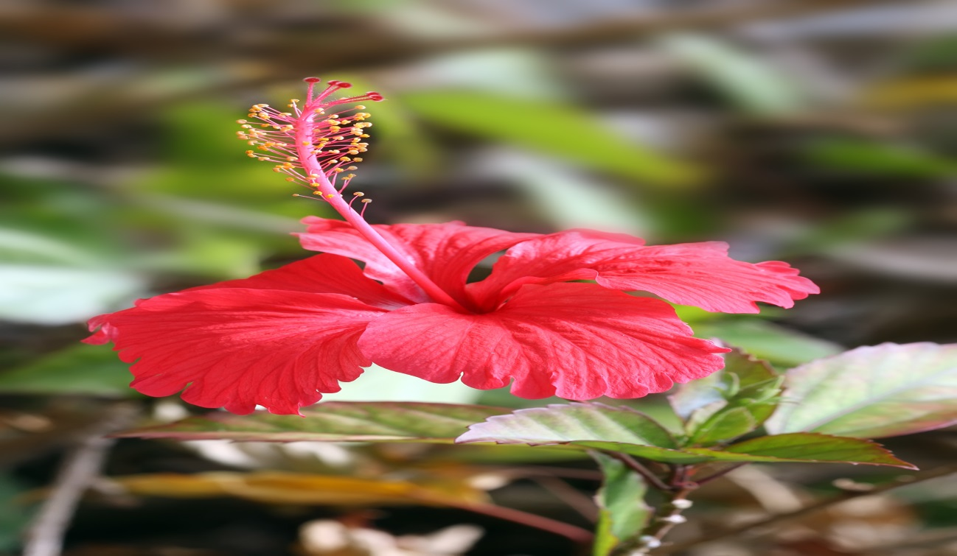
- On the photograph, label the following parts 3mks
- Stigma
- Style
- Staminal tube
- i) Classify the plant from which the flower was picked into the taxonomic groups listed below. 4mks
Kingdom
………………………………………………………………………………………………
Division
…………………………………………………………………………………………………
Sub division
…………………………………………………………………………………………………
Class
…………………………………………………………………………………………………
ii) Name three observable features from the photograph of the class you named in (a) (i) above. 3mks
……………………………………………………………………………………………………………………………………………………………………………………………………………………………………………………………………………………………………….
…………………………………………………………………………………………………..
- Suggest the pollination agent of this flower. Give reasons for your answer.
Pollinating agent 1mk
………………………………………………………………………………………………….
Reasons 2mks
……………………………………………………………………………………………………………………………………………………………………………………………………
- Below are photographs of two specimens, J and K. Both of them belong to the same Phylum and Class. Observe them carefully before you answer the questions that follow.
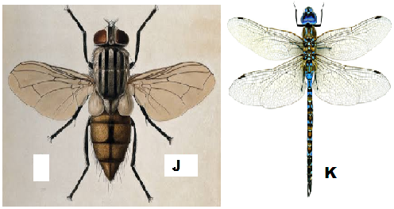

- Name the class to which J and K belong and support your answer with two reasons.
Class 1mk
………………………………………………………………………………………………….
Reasons 2mks
……………………………………………………………………………………………………………………………………………………………………………………………………………………………………………………………………………………………………….
………………………………………………………………………………………………….
- Suggest why the transport fluid in J and K has no haemoglobin. 2mks
……………………………………………………………………………………………………………………………………………………………………………………………………………………………………………………………………………………………………..
- The actual length of specimen K is 8cm, given that both J and K are under the same magnification, determine the actual length of J 3mks
…………………………………………………………………………………………………………………………………………………………………………………………………………………………………………………………………………………………………………………………………………………………………………………………………………..
- Below is a diagram showing the life cycle of specimen J.
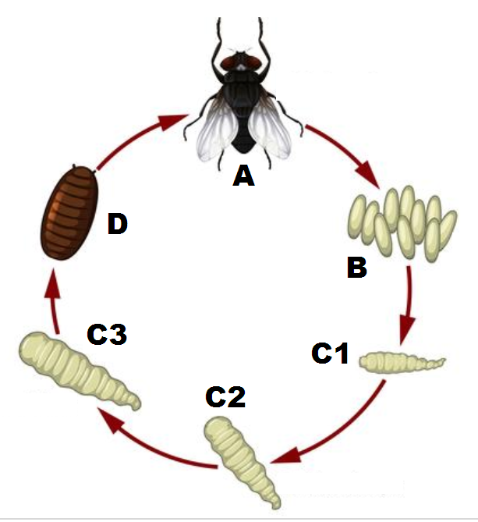
- Identify the stage labeled D. 1mk
………………………….……………………………………………………………………….
- Name the hormone responsible for the change from D to A. 1mk
………………………………………………...………………………………………………...
- Explain the differences in the change from C2 to C3 and from C3 to D. 2mks
C2 to C3
…………………………………………………………………………………………………………………………………………………………………………………………………..
C3 to D
……………………………………………………………………………………………………………………………………………………………………………………………………
- State the importance of the process illustrated above in the life cycle of the organism 2mks
........................................................................................................................................................................................................................................................................................................................................................................................................................................................................................................................................................................................................................

