KASSU JET 1 2020
BIOLOGY PAPER 231/3
- a) Mixture J: Solution containing a mixture of sucrose and vitamin C
b) Benedict’s solution, dilute hydrochloric acid solution. Iodine solution Dichlorophenol – Indophenol (DCPIP) solution, sodium hydrogen – carbonate, means of heating, 5 test tubes, test tube holder and a test tube rack
2. a) Photograph Q: complete hibiscus flower
b) Photograph Q: Half flower of hibiscus
c) Scarpel
- You are provided with an unknown mixture labled J

You are also provided with Benedict’s solution, dilute hydrochloric acid solution, iodine solution, dichlorophenol-indophenol (DCPIP) solution. Sodium hydrogen-carbonate solution means of heating, test tubes, test tube holder and a test tube rack.
- Using the reagent provided only, test for the food substances in mixture J. Record the able below the food substance tested, the procedure of the test, your observations and conclusions. (12 mks)
Food | Procedure | Observations | Conclusions
Starch | To about 2 ml of solution J add 3 drops of iodine and mix | Yellow / brown colour. Colour of iodine solution | Starch
Reducing sugar | To about 2 ml of solution J add an equal volume of Benedict’s solution, s hake to mix and heat to boil | Blue colour of Benedict’s solution remains | Reducing sugar absent
Non reducing sugar | To about 2 ml of solution J add 6 drops dilute Hcl and heat. Cool and the add NaHCO3 solution drop wise until fizzing stops. Add about 2 ml Benedict’s solution and heat to boil | Colour changes to yellow / orange / brown | Non – reducing sugar present
Vitamin C | To about 2 ml of DCPIP add solution J dropwise. | DCPIP is decourized | Vitamin C present

- Which of the components of mixture J does not undergo digestion in the mammalian digestive system. (1mk)
Vitamin C
- Name a common carbohydrate that could be present in mixture J (1mk)
Sucrose
- State the role of hydrochloric acid and sodium hydrogen carbonate in the experiment (2mks)
Hydrochloric acid hydrolyzes non-reducing sugar (s) into simple sugars / monosaccharides reducing sugars
- i)Name a deficiency disease that may result from a deficiency of one of the substances present in mixture J. (1mk)
scurvy
- ii) Give one common symptoms of the disease you have stated in € (i) above.1mk)
bleeding gums
- The photographs below show a flower specimen labelled M and a section of the same flower labelled M1.

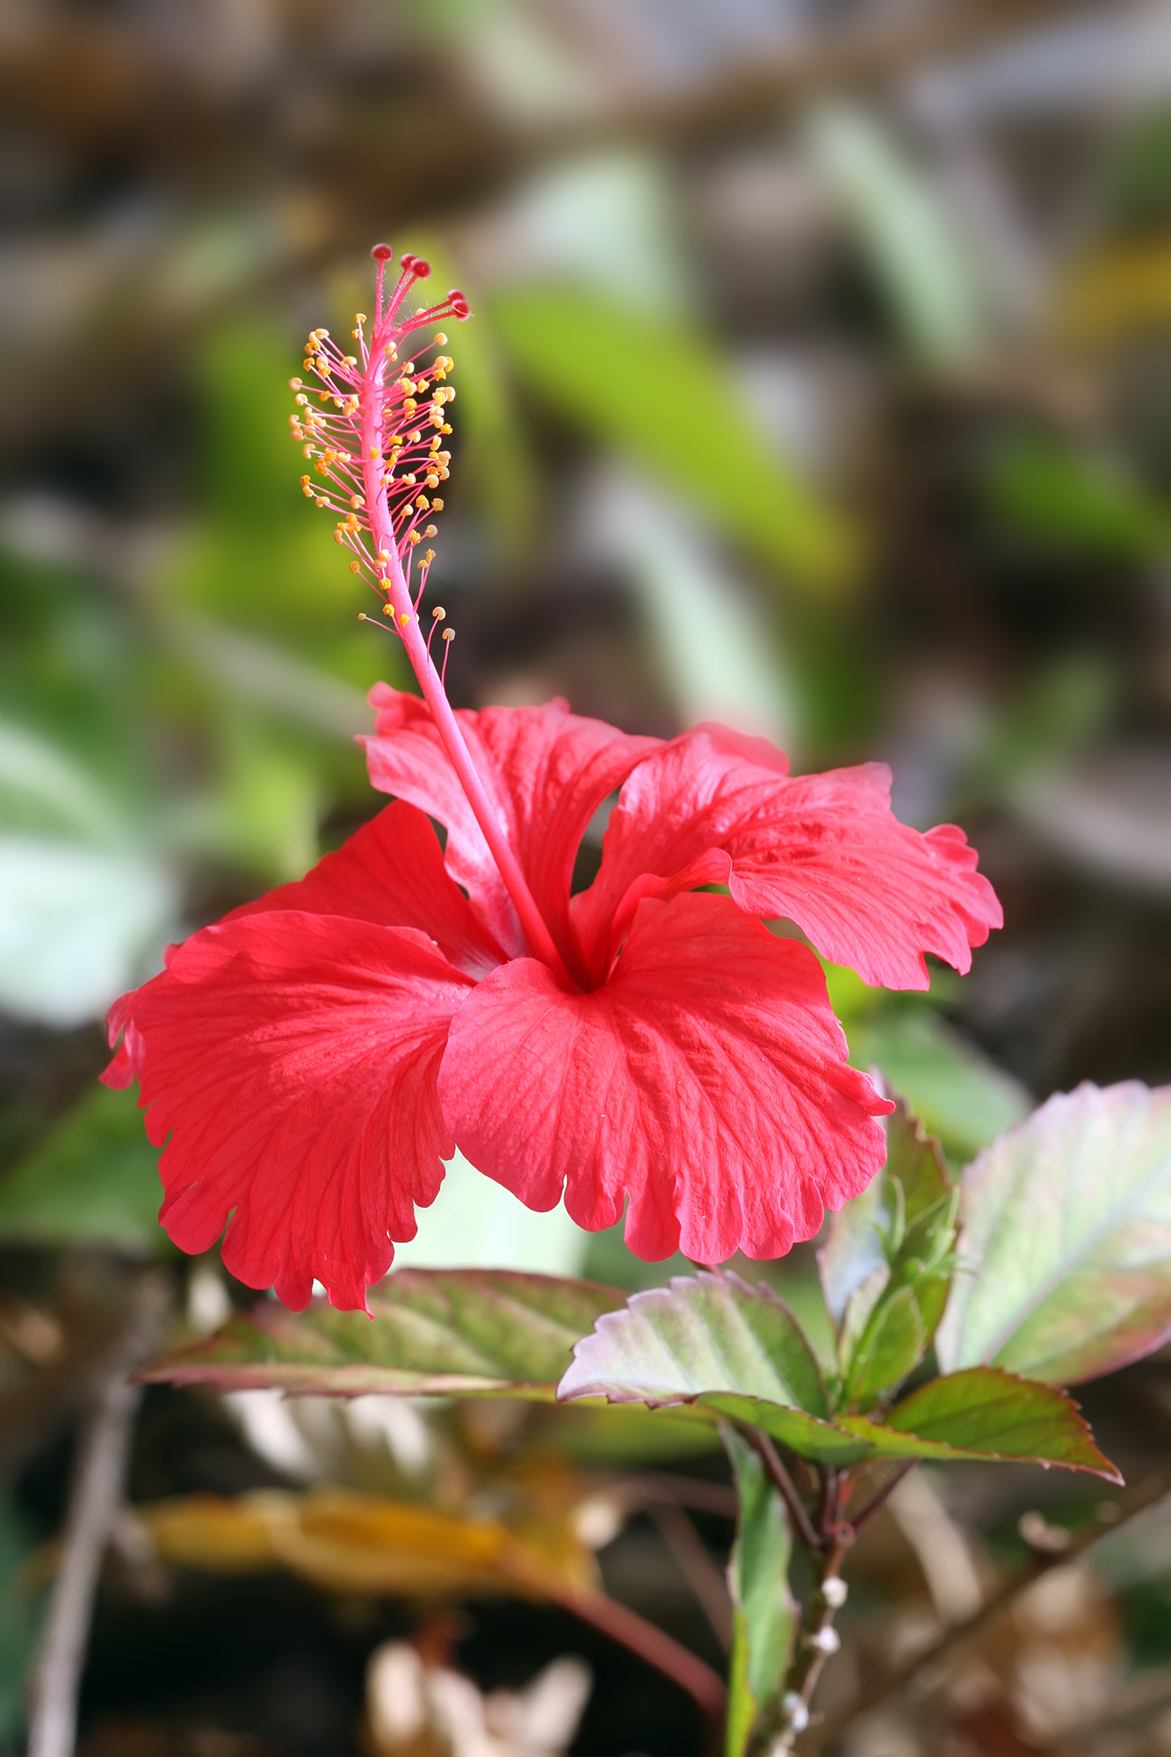
- i) Classify the plant from which the flower was picked into the taxonomic groups listed below. (4mks)
kingdom plantae
division spermatophyte
sub division angiospermae / angiospermatophyta
class dicotyledonae

ii) Name three observable features from the photographs of the class you named in (a) (i) above. (3mks)

Five petals: five stigmas; petals have network veins

- State the plane through which the flower has been cut to obtain M1. (1mk)
Longitudinal section

- Suggest the pollination agent of this flower. Give reasons for your answer (3mks)

Pollinating agent insect
Reasons brightly colouored petals
Large / conspicuous petals
For parts (d) and € below, an actual specimen is required
- Examine one flower and describe the following parts. (8mks)

Calyc: five green sepals, fused in the lower half but free at the upper half pointed tips
Corolla: five large, brightly coloured petals which are separate and overlapping/ polypetalours corolla, petals have rounded ends and prominent nectary guides
Androecium many anthers each of which is attached to a short filament. The filaments fuse to form a stamen tube that encloses the style. Anthers lie below the stigma
Gynoecium a green superior / hypognours and syncapous ovary with several ovules. A long, white style that branches near the tip. Each style branch to supports a red, round stgma
- Below are photographs of two specimens, J and K. Both of them belong to the same phylum and class. Observe them carefully before you answer the questions that follow.
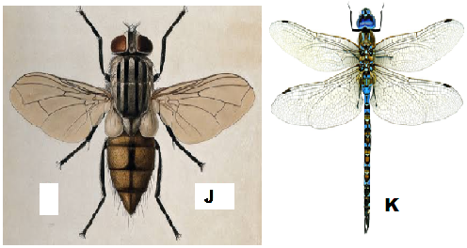
- Name the class to which J and K belong and support your answer with two reasons.
Class Insecta; 1mk Rej. insect
Reasons 2mks
- Six legs; three body parts; two antennae; two compound eyes;
- Suggest why the circulatory fluid in J and K has no haemoglobin. 2mks
Haemoglobin used to transport oxygen/ carbon (IV) oxide in the body; oxygen is taken directly to tissues/ carbon (IV) oxide taken directly from tissues by tracheoles;
- divergent evolution; 1mk
Reason one pair of wings in J reduced to halters/ are vestigial; but both are functional in K 2mks

- pupa stage; 1mk
- Ecdysone; accept Moulting hormone
- 4mks
C2 to C3 – moulting hormone / Ecdysone induce moulting; but presence of juvenile hormone prevent formation of pupa;

C3 to D – moulting hormone / Ecdysone induce moulting; but abscence of juvenile hormone lead to formation of pupa;

