**Name……………………………………………………………………………….Index Number……………..Class………………….…Candidate’sSignature…………………………Date………………………………………**

**BIOLOGY**

**PAPER 1**

**231/1**

**TIME; 2 HOURS.**

**KASSU JOINT EVALUATION TEST – January, 2021**

*(Kenya Certificate of Secondary Education)*

**BIOLOGY THEORY**

For examiner’s use only

|  |  |  |
| --- | --- | --- |
| **QUESTION** | **MAXIMUM SCORE** | **CANDIDATE’S SCORE** |
| 1 - 29 | 80 |  |

*This paper consist of 11 printed pages. Candidates should check the questions to ascertain that all the pages are printed as indicated and no questions are missing.*

1. The table below shows concentration of some minerals inside the cells of a water plant and in the surrounding water.

|  |  |  |  |
| --- | --- | --- | --- |
| Mineral | Sodium | Magnesium | Calcium |
| Cell sap | 631 | 202 | 318 |
| Surrounding water | 28 | 293 | 47 |

1. Name the process by which magnesium is taken up by the plant. (1mrk)

………………………………………………………………………………………………………………………………………………………………………………………………

1. Explain why maize plant take up calcium minerals quicker in well aerated soils than in water logged soil. (3mrks)

………………………………………………………………………………………………………………………………………………………………………………………………………………………………………………………………………………………………………………………………………………………………………………………………………………………………………………………………………………………………

1. Give a reason why a mature plant cell does not lose its shape even after losing water.

(1mrk)

…………………………………………………………………………………………….

1. i) State the function for co-factors in cell metabolism. (1mrk)

………………………………………………………………………………………………

ii) Give one example of a metallic co – factor. (1mrk)

………………………………………………………………………………………………

1. Name the features that increase the surface area of the small intestines. (2mrks)

………………………………………………………………………………………………………………………………………………………………………………………………

1. a) Name three characteristics that are used to divide the members of phylum Arthropoda into classes. (3mrks)

………………………………………………………………………………………………………………………………………………………………………………………………

………………………………………………………………………………………………

1. The diagram below represents a certain plant species.

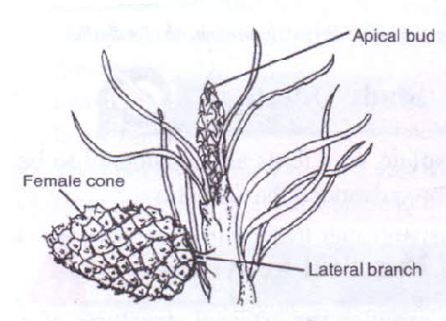

i) State the class to which the plant belongs. (1mrk)

………………………………………………………………………………………………

ii) State one observable xerophytic characteristic seen in the diagram above?. (1mrk)

………………………………………………………………………………………………………………………………………………………………………………………………

1. The chart below represents a simplified nitrogen cycle.

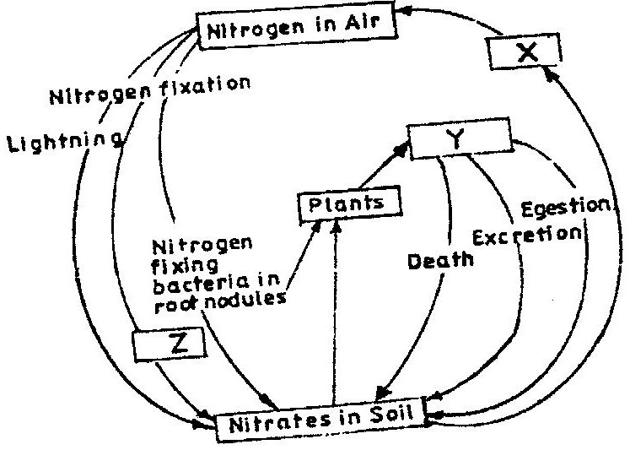

What is represented by X, Y and Z. (3mrks)

X……………………………………………………………………………………………

Y……………………………………………………………………………………………

Z…………………………………………………………………………………………….

1. People can die when they inhale gases from a burning charcoal stove in a poorly ventilated room. What compound is formed in the human body that lead to such deaths?.

(1mrk)

………………………………………………………………………………………………………………………………………………………………………………………………

1. Explain why blood from a donor whose blood group is A cannot be transfused into a recipient whose blood group is B. (2mrks)

………………………………………………………………………………………………………………………………………………………………………………………………………………………………………………………………………………………………………………………………………………………………………………………………

1. In an experiment, a student covered one of the leaves of a potted plant on both upper and lower surfaces with blue cobalt chloride paper. The plant was exposed outside for 45 minutes.

**Observation**: The cobalt chloride on the undersurface of the leave changed into pink in the first 20 minutes only as the upper surface remained blue. However at the end of the experiment, after 45 minutes, the upper surface also turned pink.

1. State the aim of the experiment. (1mrk)

……………………………………………………………………………………………………………………………………………………………………………………………………………………………………………………………………....

1. Give one significance of the results obtained. (1mrk)

………………………………………………………………………………………………………………………………………………………………………………

1. When transplanting seedlings, it is advisable to remove some leaves. Explain ( 1mrk)

………………………………………………………………………………………………………………………………………………………………………………………………

1. a) Describe the path taken by carbon (IV) oxide released from the tissue of an insect to the atmosphere. (3mrks)

………………………………………………………………………………………………………………………………………………………………………………………………………………………………………………………………………………………………………………………………………………………………………………………………

1. Name two structures for gaseous exchange in plants. (2mrks)

………………………………………………………………………………………………………………………………………………………………………………………………………………………………………………………………………………………………

1. What is the effect of contraction of the diaphragm muscles during breathing in mammals?. (2mrks)

………………………………………………………………………………………………………………………………………………………………………………………………………………………………………………………………………………………………………………………………………………………………………………………………

1. The chart below shows the number of chromosomes before and after cell division and fertilization in a mammal.

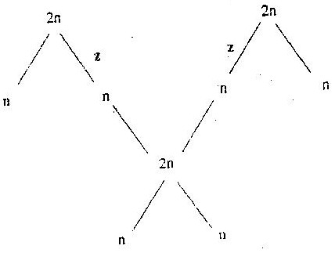

a). What type of cell division takes place at Z. (1mrk)

………………………………………………………………………………………………………………………………………………………………………………………………………………

b) Where in the female body of humans does process Z occur?. (1mrk)

………………………………………………………………………………………………………………………………………………………………………………………………………………

c) Name the process that leads to addition or loss of one or more chromosomes. (1mrk)

………………………………………………………………………………………………………………………………………………………………………………………………………………

13. State three benefits of polyploidy in plants to a farmer. (3mrks)

………………………………………………………………………………………………………………………………………………………………………………………………………………………………………………………………………………………………………………………………………………………………………………………………………………………………

14. The diagram below represents human foetus.

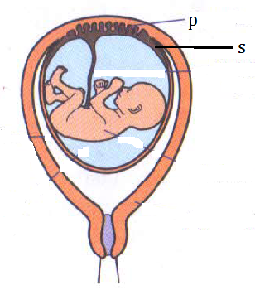

a) Name the part labelled S (1mrk)

………………………………………………………………………………………………………………………………………………………………………………………………………………

b) Give the roles of structure P in; (2mrks)

i) Nutrition.

………………………………………………………………………………………………………………………………………………………………………………………………………………………………………………………………………………………………………………………

ii) Protection.

………………………………………………………………………………………………………………………………………………………………………………………………………………………………………………………………………………………………………………………

d) What is the function of the following in the human male reproductive system?. (2mrks)

i) Epididymis.

………………………………………………………………………………………………………………………………………………………………………………………………………………

ii) Scrotal sac.

………………………………………………………………………………………………………………………………………………………………………………………………………………

15. The diagram represents an experimental set up used by students to investigate a certain process.

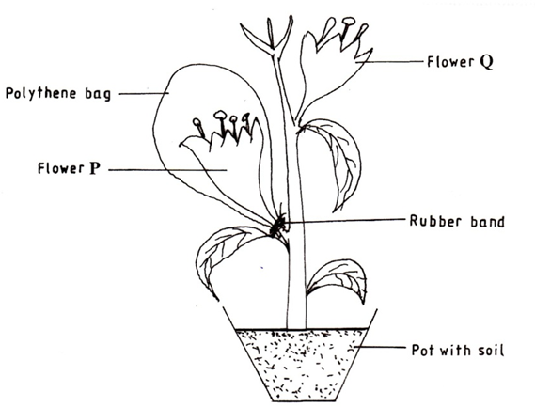

Flower Q produced seeds, while P did not. Account for the results (3mrks)

………………………………………………………………………………………………………………………………………………………………………………………………………………………………………………………………………………………………………………………………………………………………………………………………………………………………………………………………………………………………………………………………………

16. Name any two branches of microbiology. (2mrks)

……………………………………………………………………………………………………………………………………………………………………………………………….......

17. Which biological tool would a scientist require to collect rats to be used for study? (1mrk)

……………………………………………………………………………………………………………………………………………………………………………………………………………....

18. Distinguish between magnification and resolution as used in microscopy. (1mrk)

……………………………………………………………………………………………………………………………………………………………………………………………………………………………………………………………………………………………………………………...

19. A group of students set up an experiment to investigate a certain physiological process. The set up was as shown below.



1. Name the physiological process being investigated. (1mrk)

................................................................................................................................................................................................................................................................................................

1. Account for the formation and rise in the level of sugar solution at the end of the experiment. ( 3mrks)

………………………………………………………………………………………………………………………………………………………………………………………………………………………………………………………………………………………………………………………………………………………………………………………………………………………………………………………………………………………………………………………………………………………………………………………………

20. The scientific name of a blackjack is bidens pilosa. Identify two mistakes in the written name. (2mrks)

………………………………………………………………………………………………………………………………………………………………………………………………………………………………………………………………………………………………………………………

21. State two advantages of natural selection to organisms. (2mrks)

………………………………………………………………………………………………………………………………………………………………………………………………………………………………………………………………………………………………………………………

22. a) Give two ways in which sexual reproduction is important in the evolution of plants and animals. (2mrks)

………………………………………………………………………………………………………………………………………………………………………………………………………………………………………………………………………………………………………………………………………………………………………………………………………………………………

b) Explain why it is only mutations in genes of gametes that influence evolution (1mrk)

………………………………………………………………………………………………………………………………………………………………………………………………………………

23. The diagram below shows two fused bones of a mammal.

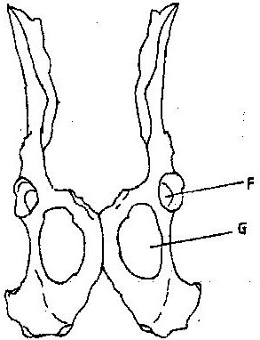

1. Identify the fused bone. (1 mark)

………………………………………………………………………………………………………………………………………………………………………………

1. Name the

(i) Bone that articulates at the point labelled F. (1 mark)

……………………………………………………………………………………………………………………………………………………………………………………………....

(ii) The hole labelled G. (1 mark)

………………………………………………………………………………………………………………………………………………………………………………………………

24. The chart below represents the result of successive crosses, staring with red- flowered

plants and white flowed plants and in which both plants are pure breeding.

Parental genotypes: Red flowers x white flowers

First filial generation

Selfed

Second filial generation

3 red flowers: 1 white flower

Phenotypic ratio 3: 1

1. What were the parental genotypes? Use letter R to represent the gene for red colour and r for white colour. (1mrk)

………………………………………………………………………………………………

1. (i) What was the colour of the flowers in the first filial generation?. (1mrk)

………………………………………………………………………………………………

ii) Give a reason for your answer in b (i) above. (1mrk)

………………………………………………………………................................................

1. What is a test- cross?. (1 mark)

…………………………………………………………………………………………………………………………………………………………………………………………………………

25. a) Name two tissues in plants which are thickened with lignin. (2 marks)

……………………………………………………………………………………………………………………………………………………………………………………………..

b) How is support attained in herbaceous plants? (1 mark)

………………………………………………………………………………………………………………………………………………………………………………………………

26. Name the type of response exhibited by; (2mrks)

(a) Euglena when it swims towards the source of light.

……………………………………………………………………………………….……

(b) Sperms when they swim towards the ovum.

…………………………………………………………………………………….………

27. A person was able to read a book clearly at arm’s length but not at normal reading distance.

(3mrks)

* + 1. State the defect the person suffered from?.

………………………………………………………………………………………

* + 1. Why was he unable to read book clearly at normal distance.

………………………………………………………………………………………………………………………………………………………………………………………..……

* + 1. How can the defect be corrected?.

……………………………………………………………………………………………………………………………………………………………………………

28. The photograph below shows the effects of certain pollutant in Nairobi dam. Study it carefully and use to answer the questions that follow.



1. Suggest the main pollutant in the dam (1mark)

…………………………………………………………………………………………………………………………………………………………………………………...

ii) What are the possible effects of pollution illustrated in the photograph (2mrks)

………………………………………………………………………………………………………………………………………………………………………………………………………………………………………………………………………………………………

1. Suggest one possible pollution control measure that can be put in place to save aquatic organisms in the dam. (1mark)

................................................................................................................................................................................................................................................................................................

29. State one structural and one functional difference between motor and sensory neurones. (2mrks)

………………………………………………………………………………………………………………………………………………………………………………………………………………………………………………………………………………………………………………………………………………………………………………………………