Name…………………………………………………………….Index no………………………
Admission No………………………………………………… Candidate’s signature…………
School ………………………………………………….............Date…........................................
231/2
BIOLOGY
PAPER 2
TIME: 2 HOURS
KASSU JET EXAMINATION
Kenya Certificate of Secondary Education (K.C.S.E)
2021
INSTRUCTIONS TO CANDIDATE:
- Write your name and index number in space provided.
- Answer all questions in section A in the spaces provided
- In section B answer questions 6 ( compulsory) and either question 7 or 8 in the spaces provided
For examiners use only:
SECTION | QUESTIONS | MAXIMUM SCORE | CANDIDATES SCORE
A | 1 | 8
 | 2 | 8
 | 3 | 8
 | 4 | 8
 | 5 | 8
B | 6 | 20
 | 7 | 20
 | 8 | 20
 | TOTAL | 80

1. a) Study the diagram of a cell organelle shown below and answer the questions that follow
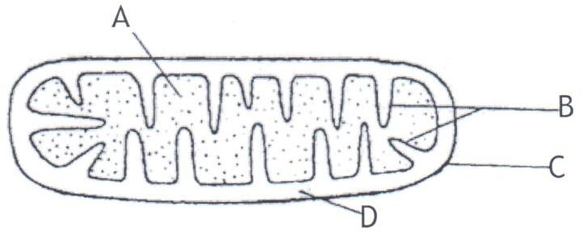
- Identify the organelle (1mark)
……………………………………………………………………………………………………………………………………………………………………………………………..
- State the function (1mark)
……………………………………………………………………………………………………………………………………………………………………………………………
- Name the parts labelled A and B (2marks)
………………………………………………………………………………………………………………………………………………………………………………………………………………………………………………………………………………………………
b) When preparing plant sections to be observed under the microscope:
Water is used to mount the tissue
Very thin sections of plant should be cut
Give a reason why each of the steps are carried out (2marks)
…………………………………………………………………………………………………………………………………………………………………………………………………………………………………………………………………………………………………………………………………………………………………………………………………………
c) Naomi observed an object using a microscope with eye piece lens of magnification X5 and an objective lens of magnification X20.What was the magnification of the object? (2marks)
……………………………………………………………………………………………………………………………………………………………………………………………………………………………………………………………………………………………………..
2. During an experiment a group of students took equal volumes of blood from the same person containing 50 red blood cells and were suspended salt solutions A, B and C.
After an hour the cells in each solution were counted and their sizes determined and results tabulated as shown below. Study the table and answer the questions that follow
Solution | A | B | C
SIZE | Large | Normal | Small
NUMBER | 20 | 50 | 50

- State the nature of solutions
B (1mark)
………………………………………………………………………………………………
C (1mark)
…………………………………………………………………………………………….
- Account for the number of red blood cells in solution A after one hour (3marks)
………………………………………………………………………………………………………………………………………………………………………………………………………………………………………………………………………………………………………………………………………………………………………………………………
- Explain how the above physiological process facilitates the following actions in living organisms
- Gaseous exchange (1mark)
………………………………………………………………………………………………………………………………………………………………………………
………………………………………………………………………………………
- Osmoregulation (2marks)
……………………………………………………………………………………………………………………………………………………………………………………………………………………………………………………………………………………………………………………………………………………………………………………………………………………………………………………...
3. A cross between a red flowered and a white flowered Mirabilis plant produced pink flowered F1 plants
- Suggest a reason to explain why there were no red or white flowered F1 plants (1mark)
……………………………………………………………………………………………………………………………………………………………………………………………………………………………………………………………………………………………..
- The F1 offsprings were selved to get F2 generation. Using appropriate letter symbols work out the following for the generation: (4marks)
- The genotypic ratio
………………………………………………………………………………………………………………………………………………………………………………………………………………………………………………………………………………………………………………………………………………………………………………………………………………………………………………………………………………………………………………………………………………………………………………………………………………………………………
- The phenotypic ratio
…………………………………………………………………………………………………………………………………………………………………………………………………………………………………………………………………………………………………………………………………………………………
c) What would be the result of crossing one of the F1 offspring producing pink flowers with a true breeding plant producing white flowers? (3marks)
……………………………………………………………………………………………………………………………………………………………………………………………………………………………………………………………………………………………………………………………………………………………………………………………………………………………………………………………………………………………………………………………………………………………………………………………………………………………………………

4. Examine the diagram of a synapse below and answer the questions that follow
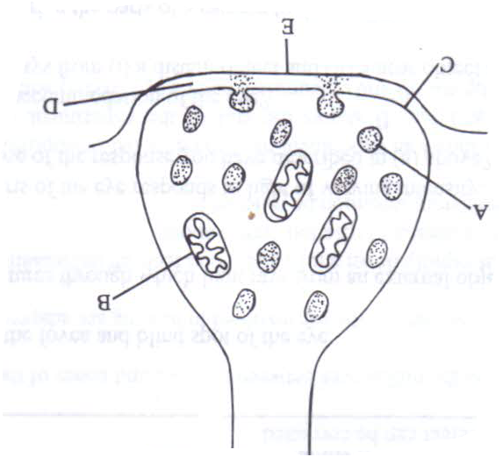
- Name the parts labelled A and C (2marks)
………………………………………………………………………………………………………………………………………………………………………………………………………………………………………………………………………………………
- Name the enzyme that exerts its effects on the structure above (1mark)
…………………………………………………………………………………………………………………………………………………………………………………………
- Name the neurotransmitter substance in impulse transmission (1mark)
………………………………………………………………………………………………………………………………………………………………………………………...
- State the function of B (1mark)
…………………………………………………………………………………………………………………………………………………………………………………………
- Identify the two synaptic inhibitors that may poison to interfere with a transmission of an impulse across the synapse (2marks)
………………………………………………………………………………………………………………………………………………………………………………………………………………………………………………………………………………………
- State the possible causes of hypermetropia (1mark)
…………………………………………………………………………………………………………………………………………………………………………………………
…………………………………………………………………………………

5. a) Define natural selection (2marks)
……………………………………………………………………………………………………………………………………………………………………………………………………………………………………………………………………………………………………………………..
b) Explain the following
Survival for the fittest (3marks)
………………………………………………………………………………………………………………………………………………………………………………………………………………………………………………………………………………………………………………………………………………………………………………………………………………………………………………………………………………………………………………………………………
………………………………………………………………………………………………………
Struggle for existence (3marks)
………………………………………………………………………………………………………………………………………………………………………………………………………………………………………………………………………………………………………………………………………………………………………………………………………………………………………………………………………………………………………………………………………………………………………………………………………………………………………………
………………………………………………………………………………………………………

SECTION B
Answer question 6 and either question 7or 8
6. Two sets of a pea seeds were germinated, set A was placed in normal daylight conditions in the laboratory while set B was placed in a dark cupboard. Starting a few days later the shoots lengths were measured twice daily and their means lengths recorded as shown in the table below.
Time in hours | 0 | 12 | 24 | 36 | 48 | 60 | 72 | 84
Set A length(mm) | 12 | 14 | 20 | 23 | 28 | 31 | 47 | 54
Set B length (mm) | 17 | 23 | 28 | 35 | 48 | 62 | 80 | 94

- Using suitable scale draw the graphs of the mean lengths in set A and B against time on the grid provided (8marks)

- From the graph state the mean shoot length of each of seedling at the 66th hour (2marks)
……………………………………………………………………………………………………………………………………………………………………………………………………………………………………………………………………………………………………………………………………………………………………………………………..

- Account for the difference of curve B and A (3marks)
…………………………………………………………………………………………………………………………………………………………………………………………………………………………………………………………………………………………………………………………………………………………………………………………………………………………………………………………………………………………………………………………………………………………………………………………………………………………………………………………………………………………………………………………………………………………………………………………….
- Explain what would happen to set up B if it were allowed to continue to grow under conditions of darkness (4marks)
…………………………………………………………………………………………………………………………………………………………………………………………………………………………………………………………………………………………………………………………………………………………………………………………………………………………………………………………………………………………………………………………………………………………………………………………………………………………………………………………………………………………………………………………………………………………………………………………...
- State three external conditions which should be constant for both set ups (3marks)
……………………………………………………………………………………………………………………………………………………………………………………………………………………………………………………………………………………………………………………………………………………………………………………………………………………………………………………………………………………………………………………………………………………………………………………………………………………………………………………………………………………………

7. Describe the role of the following parts in human reproduction
- Testes (4marks)
- Ovary (6marks)
- Sperm and ovum (6marks)
- Uterus wall/endometrium (4marks)
8.State the adaptations of the following tissues for support in plants
- Parenchyma tissues (4marks)
- Collenchyma tissues (4marks)
- Sclerenchyma tissues (2marks)
- Tracheids (6marks)
- Xylem vessels (4marks)
....................................................................................................................................................................................................................................................................................................................................................................................................................................................................................................................................................................................................................................................................................................................................................................................................................................................................................................................................................................................................................................................................................................................................................................................................................................................................................................................................................................................................................................................................................................................................................................................................................................................................................................................................................................................................................................................................................................................................................................................................................................................................................................................................................................................................................................................................................................................................................................................................................................................................................................................................................................................................................................................................................................................................................................................................................................................................................................................................................................................................................................................................................................................................................................................................................................................................................................................................................................................................................................................................................................................................................................................................................................................................................................................................................................................................................................................................................................................................................................................................................................................................................................................................................................................................................................................................................................................................................................................................................................................................................................................................................................................................................................................................................................................................................................................................................................................................................................................................................................................................................................................................................................................................................................................................................................................................................................................................................................................................................................................................................................................................................................................................................................................................................................................................................................................................................................................................................................................................................................................................................................................................................................................................................................................................................................................................................................................................................................................................................................................................................................................................................................................................................................................................................................................................................................................................................................................................................................................................................................................................................................................................................................................................................................................................................................................................................................................................................................................................................................................................................................................................................................................................................................................................................................................................................................................................................................................................................................................................................................................................................................................................................................................................................................................................................................................................................................................................................................................................................................................................................................................................................................................................................................................................................................................................................................................................................................................................................................................................................................................................................................................................................................................................................................................................................................................................................................................................................................................................................................................................................................................................................................................

