Name: ……………………………………………... Index no ……..….....................................

School: …………………………………………….. Candidate’s sign …………………….......

Class………………………………………….…..… Adm No…………………...……………...

AGRICULTURE
PAPER 2 (443/2)
JANUARY 2021
TIME: 2 HOURS
FORM FOUR KASSU MOCK
Kenya Certificate of Secondary Education (K.C.S.E.)
Agriculture
Paper 2

INSTRUCTIONS TO CANDIDATES:
- Write your name, index number, school, class and admission number in the spaces provided.
- Sign and write the date in the spaces provided above.
- Answer all the questions in section A and B
- Answer any two questions in section C.
- Answers should be written in the spaces provided in this booklet.
For Examiner’s Use Only:
SECTION | QUESTIONS | MAXIMUM SCORE | CANDIDATES SCORE
A | 1-20 | 30
B | 21-24 | 20
C |  | 20
 |  | 20
 | TOTAL | 90

This paper consists of 11 printed pages. Candidates should check to ascertain that all pages are printed as indicated and that no questions are missing.
SECTION A (30MARKS)
- Give four livestock rearing practices that can be carried out in a crush. (2mks)
………………………………………………………………………………………………..…………………………………………………………………………………………………..…………………………………………………………………………………………………..……………………………………………………………………………………………………..
- Name the part of the digestive system of poultry where insoluble grit is found. $(\frac{1}{2}mk)$
…………………………………………………………………………………………………..
- Give two distinguishing external characteristics of Californian breed of rabbit. (1mk)
………………………………………………………………………………………………..……………………………………………………………………………………………………..
- State four pre-disposing factors of livestock diseases. (2mks)
………………………………………………………………………………………………..…………………………………………………………………………………………………..…………………………………………………………………………………………………..……………………………………………………………………………………………………..
- Outline four functions of proteins in the body of an animal. (2mks)
………………………………………………………………………………………………..…………………………………………………………………………………………………..…………………………………………………………………………………………………..……………………………………………………………………………………………………..
- State four observable features of indigenous cattle (Bos indicus) (2mks)
………………………………………………………………………………………………..…………………………………………………………………………………………………..…………………………………………………………………………………………………..……………………………………………………………………………………………………..
- State four importance of creep feeding. (2mks)
………………………………………………………………………………………………..…………………………………………………………………………………………………..…………………………………………………………………………………………………..…………………………………………………………………………………………………..…………..........................................................................................................................................
- Name four materials that are collected by bees. (2mks)
………………………………………………………………………………………………..…………………………………………………………………………………………………..…………………………………………………………………………………………………..…………………………………………………………………………………………………............................................................................................................................................................

- Give the function of each of the following parts of a fish pond.
- Spillway $(\frac{1}{2}mk)$
……………………………………………………………………………………………....
- Outlet $(\frac{1}{2}mk)$
………………………………………………………………………………………………
- State four advantages of cross-breeding. (2mks)
………………………………………………………………………………………………..…………………………………………………………………………………………………..…………………………………………………………………………………………………..…………………………………………………………………………………………………..……………………………………………………………………………………………………..
- Name the part of the digestive system of a non-ruminant animal where cellulose is broken down $(\frac{1}{2}mk)$
…………………………………………………………………………………………………..
- State three field conditions under which a disc plough should be used instead of a mouldboard plough. $(1\frac{1}{2}mks)$
………………………………………………………………………………………………..…………………………………………………………………………………………………..…………………………………………………………………………………………………..…………………………………………………………………………………………………..……………………………………………………………………………………………………..
- State four advantages of artificial incubation in comparison to natural incubation as a method of hatching chicks. $(1\frac{1}{2}mks)$
………………………………………………………………………………………………..…………………………………………………………………………………………………..…………………………………………………………………………………………………..…………………………………………………………………………………………………..……………………………………………………………………………………………………..
- Give four maintenance practices carried out on the water cooling system of a tractor. (2mks)
………………………………………………………………………………………………..…………………………………………………………………………………………………..…………………………………………………………………………………………………..…………………………………………………………………………………………………..……………………………………………………………………………………………………..
- State four advantages of a four-stroke cycle engine. (2mks)
………………………………………………………………………………………………..…………………………………………………………………………………………………..…………………………………………………………………………………………………..…………………………………………………………………………………………………..……………………………………………………………………………………………………..
- Give three reasons why drenching alone is not an effective method of controlling intestinal parasites in livestock. $(1\frac{1}{2}mks)$
………………………………………………………………………………………………..…………………………………………………………………………………………………..…………………………………………………………………………………………………..……………………………………………………………………………………………………..
- Name three poultry diseases that are controlled by vaccination. $(1\frac{1}{2}mks)$
………………………………………………………………………………………………..…………………………………………………………………………………………………..…………………………………………………………………………………………………..……………………………………………………………………………………………………..
- Give the mineral whose deficiency causes the following disorders in livestock.
- Anaemia $\left(\frac{1}{2}mk\right)$
………………………………………………………………………………………………
- Parakeratosis $\left(\frac{1}{2}mk\right)$
………………………………………………………………………………………………
- Give three reasons why liming is done in fish ponds. $(1\frac{1}{2}mks)$
………………………………………………………………………………………………..…………………………………………………………………………………………………..…………………………………………………………………………………………………..……………………………………………………………………………………………………..
- If records show that a rabbit was served on 27th September 2020.Which date did it give birth.
$\left(\frac{1}{2}mk\right)$
…………………………………………………………………………………………………

SECTION B (20 MARKS)
- Below is an illustration of part of a wooden post wire fence. Study it and answer the questions that follow.
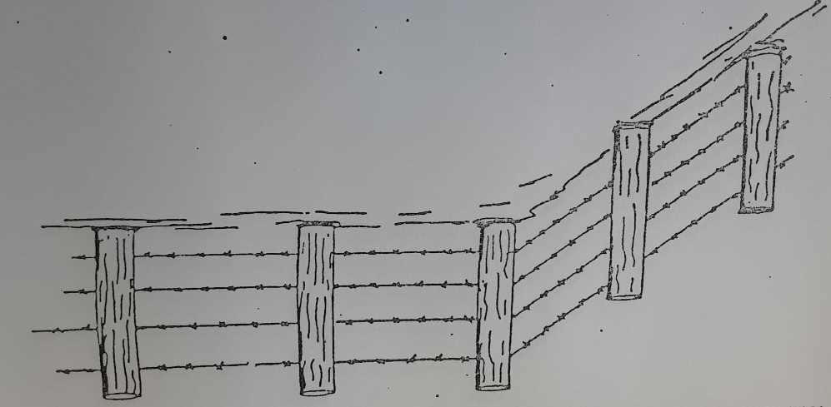
- Identify the type of wire in the illustration. (1mk)
……………………………………………………………………………………………..
- On the illustration show by drawing how the corner post should be supported. (1mk)
- On the illustration draw, label and give the function of a dropper. (2mks)
…………………………………………………………………………………………..………………………………………………………………………………………………..
- Name the correct tool for tightening the wire during construction of the fence. (1mk)
……………………………………………………………………………………………
- Observe the tools A, B and C illustrated below then answer the questions that follow.

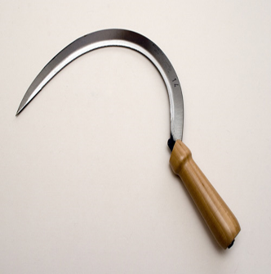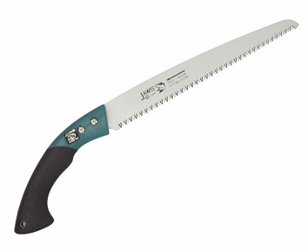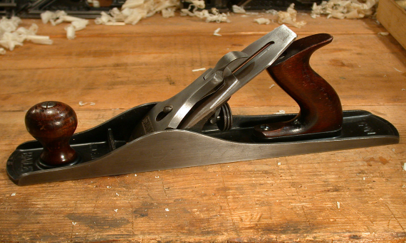
- Name tools A, B and C and state the correct use of each tool. (3mks)
Tool | Identity | Function
A
B
C

- State two maintenance practices that should be carried out to ensure that tool C is in a good working condition. (2mks)
…………………………………………………………………………………………..……………………………………………………………………………………………..……………………………………………………………………………………………......
- Below is an illustration of an activity carried out by a poultry farmer keeping layers
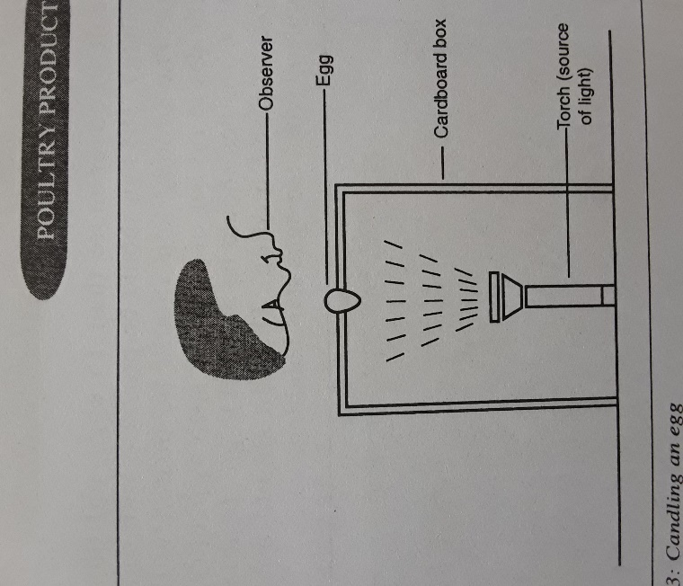
- Identify the activity carried out using the set-up. (1mk)
………………………………………………………………………………………………
- State four abnormalities in eggs that can be detected using the set-up above. (2mks)
……………………………………………………………………………………………....
- How can a farmer improve the following?
- Hardness of egg shells. (1mk)
…………………………………………………………………………………………
- Yellowness of the egg yolk. (1mk)
…………………………………………………………………………………………
- The diagrams K, L, M and N below show four possible ways of drawing milk from the teat of a cow during milking.
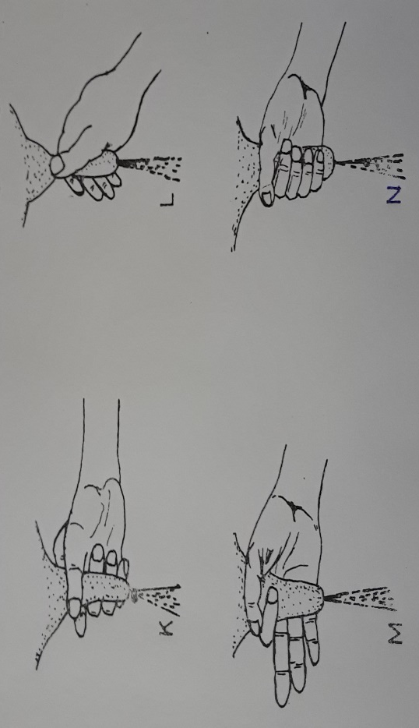

- Which diagram shows the proper way of drawing milk. (1mk)
………………………………………………………………………………………………
- How long should it take to milk a cow from the start to the end of milking. (1mk)
………………………………………………………………………………………………
- How would a milkman ensure that no milk remains in the udder at the end of milking?
(1mk)
………………………………………………………………………………………………
- Give two practices carried out on milk immediately after milking. (2mks)
………………………………………………………………………………………………………………………………………………………………………………………………………………………………………………………………………………………………

SECTION C (40MARKS)
- a) Describe the advantages of battery cage system of rearing layers. (10mks)
b) State and explain five factors affecting milk production. (10mks)

- a) State the functions of any six parts of a plunge dip. (6mks)
b) State and explain four ways through which power transmitted from the engine is made available for use. (4mks)
c) Explain five mechanical methods of controlling ticks. (10mks)

- a) State five advantages of embryo transplant. (5mks)
b) Describe coccidiosis disease under the following sub- headings.
- Animals attacked (2mks)
- Causal organism (1mk)
- Symptoms (4mks)
- Control measures (3mks)
c) A ration containing 20% DCP for growing chicks is to be obtained by mixing ground maize containing 10% DCP and fishmeal containing 50% DCP. Calculate the amount of each feedstuff in kilograms required to prepare 200kg of the feed. (5mks)
………………………………………………………………………………………………..……………………………………………………………………………………………..……….………………………………………………………………………………………..………..…..…………………………………………………………………………………..…………..……..……………………………………………………………………………..……………..………..………………………………………………………………………..………………..…………..…………………………………………………………………..…………………..……………..……………………………………………………………..……………………..………………..………………………………………………………..………………………..…………………..…………………………………………………..…………………………..……………………..……………………………………………..……………………………..………………………..………………………………………..………………………………..…………………………..…………………………………..…………………………………..……………………………..……………………………..……………………………………..………………………………..………………………..………………………………………..…………………………………..…………………..…………………………………………..……………………………………..……………..……………………………………………..………………………………………..………..………………………………………………..…………………………………………..…..…………………………………………………..…………………………………………….......………………………………………………...……………………………………………..……..……………………………………………..
………………………………………………………………………………………………..……………………………………………………………………………………………..……….………………………………………………………………………………………..………..…..…………………………………………………………………………………..………….……..……………………………………………………………………………..…………….………..………………………………………………………………………..…………….……………..…………………………………………………………………..……………….………………..……………………………………………………………..………………….…………………..………………………………………………………..…………………….……………………..…………………………………………………..……………………….………………………..……………………………………………..………………………….…………………………..………………………………………..…………………………….……………………………..…………………………………..……………………………….………………………………..……………………………..………………………………….…………………………………..………………………..…………………………………….……………………………………..…………………..……………………………………….………………………………………..……………..………………………………………….…………………………………………..………..…………………………………………….……………………………………………..…..……………………………………………….………………………………………………....……………………………………………….………………………………………………..…..…………………………………………….….
………………………………………………………………………………………………..…...……………………………………………………………………………………………….......………………………………………………………………………………………………..…..……………………………………………………………………………………………….……..…………………………………………………………………………………………..………..………………………………………………………………………………………..…………..……………………………………………………………………………………..……………..…………………………………………………………………………………..………………..………………………………………………………………………………..…………………..……………………………………………………………………………..……………………..…………………………………………………………………………..………………………..………………………………………………………………………..…………………………..……………………………………………………………………..……………………………..…………………………………………………………………..………………………………..………………………………………………………………..…………………………………..……………………………………………………………..……………………………………..…………………………………………………………..………………………………………..………………………………………………………..…………………………………………..……………………………………………………..……………………………………………..……………………………………………………………………………………………………..……………………………………………..…..
……………………………………………………………………………………………….…..…………………………………………………………………………………………..……..…..……………………………………………………………………………………..……….……..………………………………………………………………………………..………….………..…………………………………………………………………………..…………….…………..……………………………………………………………………..……………….……………..………………………………………………………………..………………….………………..…………………………………………………………..…………………….…………………..……………………………………………………..……………………….……………………..………………………………………………..………………………….………………………..…………………………………………..…………………………….…………………………..……………………………………..……………………………….……………………………..………………………………..………………………………….………………………………..…………………………..…………………………………….…………………………………..……………………..……………………………………….……………………………………..………………..………………………………………….………………………………………..…………..…………………………………………….…………………………………………..……..……………………………………………….………………………………………………………………………………………………….………………………………………………..………………………………………………….………………………………………..………..……………………………………………….
..……………………………………………………………………………………………..….……………………………………………………………………………………………..………..……………………………………………………………………………………..……….……..………………………………………………………………………………..………….………..…………………………………………………………………………..…………….…………..……………………………………………………………………..……………….……………..………………………………………………………………..………………….………………..…………………………………………………………..…………………….…………………..……………………………………………………..……………………….……………………..………………………………………………..………………………….………………………..…………………………………………..…………………………….…………………………..……………………………………..……………………………….……………………………..………………………………..………………………………….………………………………..…………………………..…………………………………….…………………………………..……………………..……………………………………….……………………………………..………………..………………………………………….………………………………………..…………..…………………………………………….…………………………………………..……..……………………………………………….………………………………………………………………………………………………….………………………………………………..………………………………………………….………………………………………..………..……………………………………………….
……………………………………………………………………………………………….…..…………………………………………………………………………………………..……...…....…………………………………………………………………………………..................
..….…………………………………………………………………………………………..………………………………………………………………………………………………..…….…..……………………………………………………………………………………..……….….…..………………………………………………………………………………..………….….……..…………………………………………………………………………..…………….….………..……………………………………………………………………..……………….….…………..………………………………………………………………..………………….….……………..…………………………………………………………..…………………….….………………..……………………………………………………..……………………….….…………………..………………………………………………..………………………….….……………………..…………………………………………..…………………………….….………………………..……………………………………..……………………………….……………………………..………………………………..…………………………………..………………………………..…………………………..…………………………………..……………………………………………………………………………………………………..

