AGRICULTURE
KASSU P1 MARKING SCHEME
1 Characteristics of intensive farming system,
- Involves maximum utilization of all available land
- High yields per unit area
- High labour utilization/ much use of manual labour
- Some little mechanization is used
- Crops may be planted twice or thrice in one year.
- Heavy application of manure and fertilization.
- Use of modern technology i.e irrigation is normally used to make up for inadequacy of moisture.
( ½ x 2 = 1mk)
b) Advantages of mixed farming;
- makes utilization of the available land
- there is diversification of farming business
- there is mutual benefit between crops and animals
- Farmer gets continues flow of income through out the year
- There is maximum use of permanent labour through out the year.
- Farmer gets high income
- Farmer and his family gets a balance diet
- There is better conservation of soil and water
( ½ x 2 = 1mk)
2 Agents of Physical weathering;
- Wind
- Water
- Moving ice
- Temperature
( ½ x 3 = 1 ½ mks)
3 Forms in which water is available in the soil;
- Superfluous water
- Hycrosgopic water
- Capillary water
( ½ x 2 = 1mk)
4 ways in which mulch control soil erosion;
- Reduce speed of surface run – off
- Insulates the soil reducing direct conduct between the soil and the agents of erosion.
( ½ x 2 = 1mk)
5 Advantages of drip irrigation;
- Little amount of water is required as compared to other types of irrigation
- Water under low pressure can be used so long as it can flow along the pipe
- It discourages fungal diseases i.e blight , CBD and others, as it does not wet the leaves
- It does not encourage the growth of weeds between the rows
( ½ x 4 = 2mks)
6 Advantages of adding organic matter to Sandy soil;
- Improved soil structure by binding together soil particles
- Improves microbial activities in the soil
- Increase the nutrient level/ fertility of sandy soil
- Impert dark colour to the soil which hel increase soil temperature
- Improves water retention capacity
- Increase soil cation –m exchange capacity , hence PH control
- Reduce leaching
( ½ x 4 = 2mks)
7 - plants mature early
- It is possible to produce crops that would otherwise not be propagated through other means like use of seeds
- Its possible to use root stock with cetain beneficial traits such as drought and disease resistance.
- More than one type of plant variety can be produced on the same rootstock
- It makes possible to repair damaged plant parts,
- Crop variety obtained may have higher /more desirable qualities in terms of taste and size.
( ½ x 4 = 2mks)
8 Reasons for using certified seeds for planting;
- Certified seeds have high germination percentage
- They are free from diseases and pests
- They give high yields
- Able to adopt to certain ecological conditions
- Bred true to type
- Free from foreign materials
- Free from physical damage
( ½ x 4 = 2mks)
9 Methods used to control weeds in pasture;
- Use of herbicides
- Slahiing / mowing/tillage
- Uprooting
( ½ x 3 = 1 ½ mks)
10 Reasons for conserving forage;
- To avoid wastage in times of planting
- To ensure enough supply throughout the year
- To earn income from selling excess forage
- To ensure good utilization of land.
( ½ x 2 = 1mk)
11 Types of labour records;
- Master roll
- Labour utilization analysis record
( ½ x 2 = 1mk)
12 CAUSES OF LAND FRAGMENTATION;
- Inheritance of land from different people
- Purchasing of land in different locations
- Compensation by government

13 Roles of trees in soil and water conservation;
- They protect the soil below from rain drop erosion by reducing the force from which it falls onto the ground.
- Prevent direct conduct between rain drops and soil
- Provide shade and reduce loss of moisture through evaporation
- Act as wind breaks
- Roots of trees bind soil particles together
- Leaves once they drop, decay to supply humus which improve water infiltration
( ½ x 4 = 2mks)
14 Reasons for earthing up tobacco crop;
- To improve drainage around the plant
- To improve the plant anchorage
( ½ x 2 = 1mk)
15 Labour productivity can be improved through;
- Training labour force
- Efficient supervision of labour
- Mechanization of farm operations or providing more efficient tools and equipment
- Giving incentives to workers i.e good housing, medical facilities etc
- Proper remuneration of workers
- Assigning tasks to workers according to skills ability and interest.
- ( ½ x 3 = 1 ½ mks)
16 Examples of working capital;
- Seeds
- Fertilizers
- Hired equipment
- Pesticides/ Insecticides
- Fuel
- Fungicides
- Herbicides
( ½ x 3 = 1 ½ mks)
17 (a) Reasons why nitrogenous fertilizers are suitable for top-dressing;
- Easily leached to lower levels /horizons beyond the root zone of crops before it is utilized by plants
- Highly soluble in water, hence gets dissolved very fast
( ½ x 2 = 1mk)
b) Defficiency symptoms of sulphur;
- leaf chlorosis
- thin stems
- reduced nodulation in leguminous plants
- stunted growth in plants
- delayed maturity.
( ½ x 4 = 2mks)
18 Symptoms of stalk borer infestation in maize;
- Windowing on leaves/ make holes on leaves
- Bore into stems and cobs
- Cause yellowing in seedlings
- Cause tillering in seedlings
- Plants of damged stems fall off
( ½ x 4 = 2mks)
SECTION B (20 Marks)
19 a) (i) Double thorne - (1mk)
(ii) Harmful effects of the weed;
- Its thorns lower the quality and palatability of pasture / cause injury to livestock
- It irritates workers, thus reducing labour efficiency
- It competes with crops for nutrients, light and space
- It increases the cost of production.
( 2 x 1 = 2mks)
b) Reasons why tillage is some times preferred as a method of weed control
- - loosens the soil/ improves aeration and water infiltration
- it facilitates earthing up in rood crop production
- Crop residues are incorporated into the soil
- It helps control soil – borne pests through exposing them on the surface.
( 2 x 1 = 2mks)
20 (a) plant population is = Area of land x Number of seeds per hole
Spacing of the crop
= 10,0000m² x 2 =
0.75 m x 0.25m
(Award 1 mk for the formula, 1mk for the calculation and 1mk for correct answer).
(b) Reasons for having correct plant population;
- Leads to high yields
- makes it easy to control pests, diseases and weeds
- It conserves soil and water/controls soil erosion.
- It facilitates field operations to be carried with ease
- It leads to efficient use of resources.
( 2 x 1 = 2 mks)
- a) - (i) Soil profile (1mk)
(ii) A- Top soil (horizon A)
- B – Sub – soil ( Horizon B)
- C – Substratum/weathered rock (Horizon C)
- D – Parent rock/Bed rock (Horizon D)
( ½ x 4 = 2 mks)
(iii) Reasons why farmers should have knowledge of the illustration above;
- Able to determine the type of crops to grow
- Enable the farmer be able to determine the depth of ploughing
- Enable the farmer to choose the implement to use during the time of ploughing
- (1 x 2 = 2mks)
22 (i) The disease is Blight/Late blight (1mk)
(ii) Category of the disease is Fungal disease. (1mk)
(iii) Three control measures of the disease above
- Spray the crop with appropriate fungicides
- Use certified seeds
- Practice crop rotation
- Practice close season
- Observe field hygiene/ destroy infected crops
- Do rogueing.
( 1 x 3 =3 mks)
SECTION C (40 Marks)
23 (a) Seedbed preparation;
- Clear land
- Plough the land early /during the dry period or before onset of rains and remove all all perennial weeds.
- Seedbed be harrowed to the right tilth
- Plough it to the right depth
- Seedbed preparation is done manually or mechanically.
- x 3 = 3mks)

(ii) Planting;
- Select suitable maize variety for the region
- Plant at the onset of then rains
- Plant seeds at the right depth i.e 2.5 cm to 10 cm depending on the moisture content of the soil.
- Spacing is 75cm to 90cm by 23cm to 30cm. this will give correct crop stand per hectare.
- Plant one to two seeds per hole depending on the spacing.
- Plant certified seeds or health seeds.
- Apply appropriate fertilizer or well decomposed manure.
(1 x 5 = 5mks)
(b) Six marketing functions;
- Buying and Assembling; acquisition of goods from farmers on payment of cash and collecting the produce from farmers. The products are are assembled or stored at a convenient points or stores.
- Transportation and distributing; farm produce are availed to consumers through transportation. The goods are distributed through middlemen who at times store, blend and package the goods.
- Storage after harvest to minimize losses.
- Processing to provide variety, increase value and prolong shelf life of produce.
- Grading according to quality.
- Packaging and packing for easier handling, transportation and storage.
- Collecting, analyzing and interpreting market information.
- Advertising to create or increase demand.
- Bearing risks such as damage, price fluctuations and physical deterioration.
- Taking measures to protect farm produce, for example by taking insurance cover.
( 6 x 2 = 12 mks for any well explained point)
24 (a)(i) Precautions taken during harvesting of pyrethrum;
- Picked flowers should be put in open woven basket to allow proper aeration/ventilation.
- Tins or polythene bags should be avoided because of poor ventilation that would lead fermentation.
- Wet flowers should not be picked because they may heat and ferment before they are dry.
- During picking flowers should not be compacted in the baskets to avoid heating up and fermentation.
- Avoid any contamination or picking flowers with twigs or leaves be avoided.
- Dry flowers immediately after picking to a moisture content of 10% to 12% to prevent fermentation.
( 1 x 3 = 3mks)

(ii) Factors that affect rooting of cuttings;
- Temperature: warm temperature encourages fast rooting of cuttings as opposed to low temperature.
- Relative humidity: high relative humidity lowers transpiration rate, which favours fast rooting.
- Light intensity: lack of light encourage rooting in hardwood plants while high light intensity enhances rooting in softwood plants.
- Oxygen supply: well aerated rooting medium encourages faster rooting.
- Moisture supply: The root- forming process requires ample supply of moisture.
- Chemical treatment: Rooting hormones, when applied at the base of cuttings fasten rooting process.
- Leaf area: Some cuttings require some leaves for photosynthesis to speed up rooting.
( 1 x 5 = 5mks)

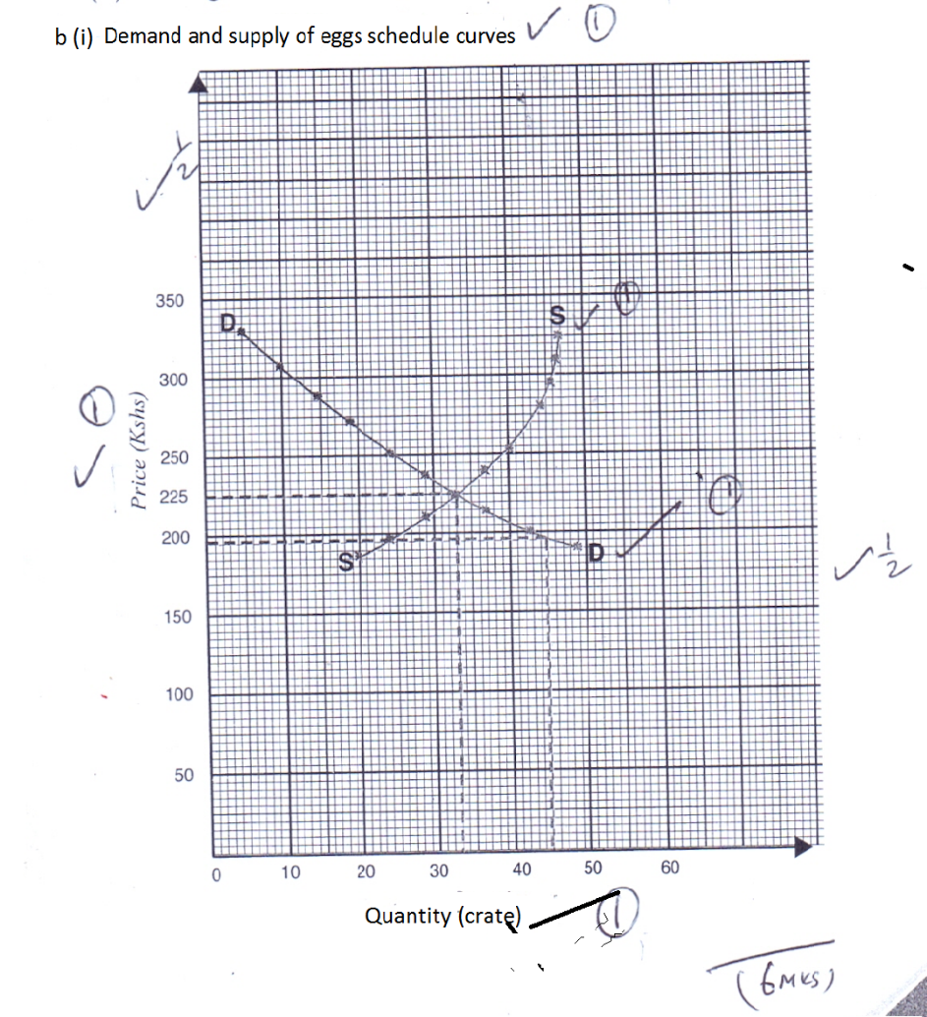
(ii) Equilibrium price is Ksh. 225.
(iii) Factor that influence demand of eggs in a market are;
- Population size
- Income of the consumers.
- Price of related goods
- Tastes and preferences
- Beliefs, customs, taboos.
- Advertisement
- Level of taxation/income
- Price expectations
- Perishability.
(1 x 4 = 4mks)
25 (a) Ways through which soil lose fertility;
- Soil erosion
- Soil capping
- Hardpans
- Leaching
- Monocropping
- Continuous cropping
- Change of soil PH
- Burning of land
- Accumulation of salts
- Infestation of weeds.
( award 2 x 6 = 12 mks for any well explained point)
(b) Factors considered in farm planning;

- Size of the farm
- Environmental factors
- The current trends in labour market
- Farmer’s objectives and preference.
- Possible production enterprize.
- Existing market conditions and price trends.
- Availability and cost of farm inputs.
- Communication and transport facilities.
- Security.
( 1 x 8 = 8 Mks for any correct 8 points).

