GOLDEN ELITE EXAMINTIONS 2020
312/2
GEOGRAPHY
PAPER 2
MARKING SCHEME

SECTION A
Question 1.
(a) An environment is the physical conditions surrounding an organism and which influence the behavior of that organism. (1x2 = 2 marks)
(b) Effects of the following environmental hazards.
(i) Earthquakes
- Leads to loss of lives
- Destroys property. (1 x 2 = 2mks)
(ii) Nuclear wastes
- Releases harmful radiations
- Causes loss of human and animal lives (1 x 2 = 2mks)
Question 2.
(a) Two species of hardwood forests grown in Kenya.
- Meru oak , Elgon teak, Red Ceda, Mvule, Muringa , Mahogany, Ebony, Cape chestnut
(2 x 1 = 2mks)
(b) Three factors that favor the development of softwood forest in Kenya.
- Cool climate enable trees to grow / flourish
- Highlands receive high amount of rainfall
- Rugged highlands discourage settlement and agriculture leaving forestry as the alternative
- High demand for softwood products encourage tree planting
- Deep soils favour forest growth
- Soft woods grow quite fast due to warm temperatures (Any 3, 3 x 1 = 3mks)
Question 3.
(a) Mining refers to all attempts to attract valuable minerals either solid, liquid or gas from the earth’s crust.
(b) Two factors that have influenced exploitation of minerals.
- Minerals that are of high demand and economic value may be mined at a very high cost because they can be sold at high prices e.g. gold, petroleum e.t.c.
- Value of the mineral: Valuable minerals like gold are oftenly mined at high costs without loss of profits while less valuable minerals are not readily mined.
- The size of any mineral reserve must be big enough to justify the purchase and the use of expensive equipments needed for exploitation. Small deposits are hardly mined.
- Quality of mineral ore: High quality ores are economical to mine while low quality ores are rarely mined.
- Transport costs:Its more economical to exploit minerals near industrial centres
- Labour
- Method of extraction (Any 4 points 4 x 1 = 4mks)
Question 4
(a) Two limitations of using photographs.
- Vertical aerial photographs are difficult to interpret without special instruments e.g. stereoscopes
- Photographs are expensive to produce
- Cameras need well focusing to avoid blurred images
- Objects that are far away from the camera may not be clear thus leading to wrong interpretation.
(Any 2 points 2 x 1 = 2mks)
(b) Two types of ground photographs.
- Ground close-up photographs
- Ground general view photographs
- Ground oblique photographs (Any two points 2 x 1 = 2mks)
Question 5.
(a) Two exotic dairy cattle breeds reared in Kenya.
- Guernsey , Friesian/Holstein, Jersey, Alderney , Aryshire, Brown Swiss (Any 2 points 2 x 1 = 2mks)
(b) Two physical factors which favour dairy farming in Denmark.
- Gentle sloping landscape ideal for grazing
- Warm climate / sunny summer/ moderate temperatures 10-17⁰C that allows outdoor grazing
- Cool climates ideal for pasture growth
- Moderate rainfall (500-1000mm) that supports growth of pasture / fodder crops
- Fertile boulder clay soils(Any 2 points 2 x 1 = 2mks)

SECTION B.
Question 6
- Grand total of vehicles moving past the gate on Monday.
- 1,740 vehicles (2marks)

- Simple pie chart showing the type of vehicles moving past the gate on Monday (radius = 3cm)
- Isuzu – 260 x 360 = 53.8⁰
1740

- Leyland – 340 x 360 =70.3⁰
1740

- Toyota – 460 x 360 =95.2⁰
1740

- Nissan – 400 x 360 =82.8⁰
1740

- Others – 280 x 360 =57.9⁰
1740
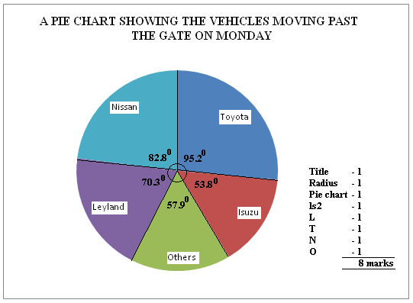
- Merits of using a simple pie chart to represent the above data.
- It gives clear visual impression of individual components
- It can be used to represent a wide range of statistical data
- Easy to read and interpret
- Clearly shows individual amounts and clear comparison of individual quantities
- Its simple / easy to construct after angles have been obtained
- It gives a good visual impression. 1 x 5 = 5mks
- Other five ways used to present statistical date.
- Graphs
- Proportional circles
- Pie charts
- Statistical tables / charts
- Age-sex pyramids
- Dot maps (1 x 5 = 5mks)
- Five methods of collecting statistical data.
- Questionnaire
- Interviews
- Observation
- Sampling
- Taking measurements
- Experimentation
- Content analysis (secondary sources)
- Counting (Any 5 = 5 x 1 = 5mks)

Question 7
(a) Types of natural forests in the world.
- Tropical hardwood forests
- Temperate hardwood forests
- Coniferous forests (3 x 1 = 3mks)
(b) Significance of forests and forest products in Kenya.
- Preservation and conservation of environment
- Acts as water catchment areas
- Regulation of climate / create a micro climate
- Provide habitat for wildlife
- It’s a source of income
- Acts as a raw material for industries e.g. paper industry
- It’s a source of employment e.g. forest guards, officers
- It promotes tourism
- It provides charcoal
- Provides fodder for animals
- Forest provide nuts, fruits and dyes, ropes nets, honey.
- It’s a hiding ground for military.
- Its an educational and research centre
- Provides wood and poles for building and construction
- It’s a source of tree leaves which are fed to silkworm (Any 5 explained 5 x 2 = 10mks)
(c) How Kenya government has done to conserve and manage forest.
- Carrying out public campaigns on the value of forests through mass media
- Carrying out research on suitability of soils and effects of pests and diseases
- It has established training institutions dealing with forestry e.g. KEFRI, Londiani forest training college.
- It has encouraged rotational felling of trees
- Infrastructural facilities like roads & mills have been provided by government.
- The government has introduced alternative sources of energy (fuel) e.g. solar energy, biogas to reduce overdependence on wood fuel
- It has enacted laws to govern the management of forests.
- It has employed forest guards and officials to curb destruction of forests
- N.G.O’s like Green Belt Movement and UNEP provide seedlings for forests.
- It has created forest reserves
- It has encouraged agro-forestry
- Extensive afforestation programme is underway(Any 5 points 5 x 1 = 5mks)
- (i) 5 factors influencing the distribution of natural forests.
- Climate
- Altitude
- Soils
- Human activities
- Aspects & Slope.(5 x 1 = 5mks)
(ii) The management of forests refers to the effective planning and control of forests and forests resources.
(1 x 2 = 2mks)
Question 8
(a) A mineral is a naturally occurring, crystalline, inorganic substance with a definite chemical composition and physical properties.(2 x 1 = 2mks)
(b) Forms in which minerals occur.
- Veins and lodes; Minerals deposited in crystalline form in crack / crevice
- Beds and seams; Coal and other minerals may occur in bed / layers as a result of deposition, accumulation and concentration in horizontal layers of earth crust.
- Weathering products; Like Bauxite is formed by deep weathering of a variety of rocks due to alternating wet and dry seasons
- Alluvial / placer deposits;some minerals like gold, tin and platinum occur as alluvial deposits within sand, clay and gravels in the river course. (4 x 2 = 8mks)
(c) Significance of minerals in Kenya.
- Rocks create beautiful sceneries which attract tourists hence earn Kenya foreign exchange.
- Rocks act as water reservoirs and store underground water
- Rocks provide parent material for formation of rich soils for agriculture
- Rocks are used in building and construction industry
- Rocks and mineral are sources of income
- Rocks provide main record of past environment
- Rocks influence landscape features
- Exploitation of rocks and minerals has led to dereliction (Any 5 points 5 x 1 = 5mks)
(d) (i) Preparations made before the study.
- Discussing / studying the topic of study
- Seek permission from authorities
- Collect required materials
- Conduct a reconnaissance
- Prepare questionnaires
- Divide into groups
- Prepare a working schedule(Any 3 pts (3 x 1 = 3mks)
- Problems encountered during the study.
- Fatigue
- Uncooperative respondents
- Financial constraints
- Language barrier
- Unfavourable weather condition like floods
- Accidents in the field
- Inaccessibility
- Thick vegetation that’s difficulty to penetrate (Any 2 points = 2mks)
- Importance of studying geography through field work.
- It gives first hand information
- It breaks classroom monotony
- Teaches skills e.g. observation skills
- Enhances learning in the real life situation
- Encourages critical thinking
- Enables one to understand his / her environment(Any 5 points 5 x 1 = 5mks)
Question 9
(a) (i) Social factors which influences agriculture .
- Technology , religion, gender roles, foreign influence (Any 3 = 3mks)
(ii) Types of maize grown in Kenya.
- Dent corn
- Sweet corn (2 x 1 = 2mks)
(b) (i) Areas in Kenya where maize is commercially grown.
- Eldoret
- Kitale
- Nakuru (any 2 x 1 = 2mks)
(ii) Stages involved in the industrial processing of maize.
- Maize grains are weighed and then put on trays
- Any undesirable grains and broken cobs are removed
- Maize is then sieved to remove any impurities like soil / rock particles
- The maize is then passed through a milling machine which grinds it into flour
- The flour is then packed into small packets and sacks according to the desired weight
- Packets are sized 1 kg, 2 kg, and 10kg while sacks weigh more than 50kg
(Any 4 pts 4 x 1 = 4mks)
(c) Problems facing maize farmers in Kenya.
- Pests e.g. stalkborers, army worms, weevils
- Diseases e.g. white leaf blight
- Adverse weather conditions like drought , floods
- Parasitic plants and weeds
- Price fluctuation
- Poor quality seeds sold by unscrupulous traders
- Inadequate storage facilities
- Expensive certified seeds
- Expensive farm inputs (Any 4 pts 4 x 1 = 4mks)
- (i) Ways through which the Kenya government assists small scale maize farmers.
- Arrange buying of maize through the cereal boards
- Conduct research to establish areas best suited for maize growing and research on diseases
- Organize demonstrations firms and field days to update farmers on current methods
- Employs extension workers who visit farmers and advise them on matters related to maize growing
- Encourage farmers to set up co-operatives to enable them pool resources together
- Improves feeder roads to ensure smooth transport of maize produce
(Any 3 x 2 = 6mks)
(ii) Uses of maize.
- Staple food
- Stalk, leaves and other remains from maize cobs are used to feed domestic animals
- Stalks and cobs are used to provide domestic fuel
- Stalks and cobs are used as organic manure
- Grains are used in the making of corn oil.(Any 4 x 1 = 4mks)
Question 10
(a) (i) Natural vegetation is the plant cover that exist naturally in an area without the interference of any external modifying influence e.g. man.(1mark)
(ii) Topographical factors influencing distribution of vegetation.
- Relief
- Aspect
- Drainage(Any 2 well state points 2 x 1 = 2mks)

(b) (i)Objectives for the study.
- To find out the type of vegetation around the school
- To determine the use of the vegetation around the school.
(Any other relevant point 2 x 1 =2mks)
(ii)How would you record the findings in your study?
- Note taking.
- Sketching.
- Tabulating.
- Phototaking. (Any other relevant point 4 x 1 = 4 marks)

(c) Well labeled diagram showing vegetation zonation on a mountain slope.
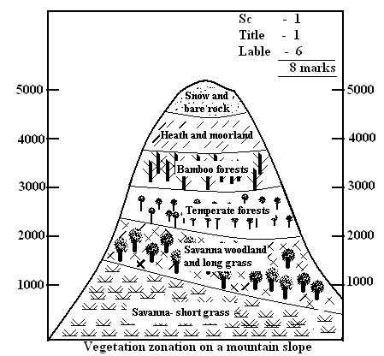

(d) (i) Adaptation features of tropical desert vegetation.
- They have succulent stems
- Leaves are reduced to thorns / spikes
- They have long tap roots
- Some plants complete their life cycle within a short period
- They shed their leaves during dry season
(Any other relevant point 5 x 1 = 5mks)
(ii) Two economic importance of desert vegetation.
- The vegetation adds beauty to the landscape
- The vegetation prevents soil erosion by binding the soil together
- The vegetation acts as a habitat for wildlife
- Some plants have medicinal value
- Some desert vegetation are used in building and construction
- Some plants are consumed as food by people
- Fibrous vegetation like sisal are used to make ropes
- The vegetation is a source of fuel either as firewood or charcoal
(Any 2 points 2 x 1 = 2mks)

