NAME …………………………..……………….. DATE …………………………

INDEX NO. ……….……….…………………...…..… SIGNATURE ……………..…………..

233/1
CHEMISTRY
(THEORY)
PAPER 1
TIME: 2 HOURS.

GOLDEN ELITE EXAMINTIONS 2020
Kenya Certificate of Secondary Education

233/1
CHEMISTRY
(THEORY)
PAPER 1
TIME: 2 HOURS.

INSTRUCTIONS TO CANDIDATES

- Write your NAME and INDEX NUMBER in the space provided above
- Sign and write the date of examination in the spaces providedabove
- Answer ALL the questions in the spaces provided
- ALL working must be clearly shown where necessary.
- Mathematical tables and silent electronic calculators may be used.

FOR EXAMINER’S USE ONLY

Question | Maximum score | Candidate’s score
1 −31 | 80
Total score | 80

This paper consists of 9 printed pages.
Candidates should check to ensure that all pages are printed as indicated and no questions are missing

- An element K has atomic number 20 while element M has atomic number 8.
- Write the electronic configuration for K and M
K
………………………………………………………………………………………….. 1mark
M
…………………………………………………………………………………….……. 1mark
- Write the symbol of the most stable ion of K and M

K
…………………………………………………………………………………………. 1mark
M
…………………………………………………………………………………………. 1mark

- Molten Lead (II) bromide is electrolyzed using carbon electrodes. Write the half equations of the reactions that occur at the anode and the cathode.
- Anode
…………………………………………………………………………………….…… 1mark
- Cathode
……………………………………………………………...……….………………… 1mark
- Explain why the conductivity of metals decreases with increase in temperature. 2marks
........................................................................................................................................................................................................................................................................................................................................................................................................................................................................................................................
- Three metal oxides XO, YO, and ZO are heated with powdered metal Y. Hot powdered Y will remove oxygen from XO but not from ZO. Arrange the metals in order of reactivity, starting with the most reactive. 1mark
................................................................................................................................................................................................................................................................................................................................................

- Some sodium chloride was found to be contaminated with copper (II) oxide. Describe how a sample of sodium chloride can be separated from the mixture. 2marks
………………………………………………………………………………………………………………………………………………………………………………………………………………………………………………………………………………………………………………………………………………
- Hot platinum wire was lowered into a flask containing concentrated ammonia solution as shown below.
Glass rod
Hot platinum wire
Concentrated Ammonia Solution

State and explain the observations made. 3marks
………………………………………………………………………………………………………………………………………………………………………………………………………………………………………………………………………………………………………………………………………………………………………………………………………………………………………………………………
- The set up below represents the apparatus that may be used to separate a mixture of two miscible liquids C and D whose boiling points are 80⁰C and 110⁰C.
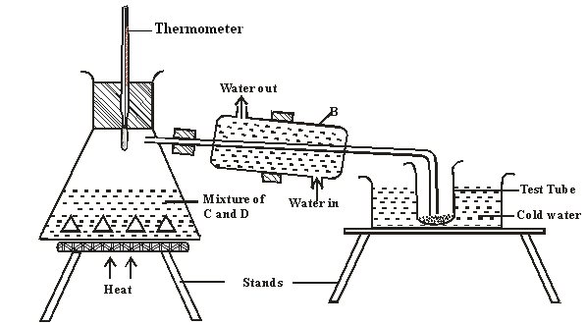

- Name B
………………………………………………………………………………….. 1mark
- What is the purpose of the thermometer 1mark
………………………………………………………………………………………………………………………………………………………………………………………………………………………………
- Which liquid was collected in the test tube? 1mark
………………………………………………………………………………………………………………………………………………………………………………………………………………………………
- Draw a dot (.) and cross (x) diagram to show bonding in carbon (II) oxide. 2marks

- Ammonium nitrate was gently heated and the products collected as shown in the diagram.
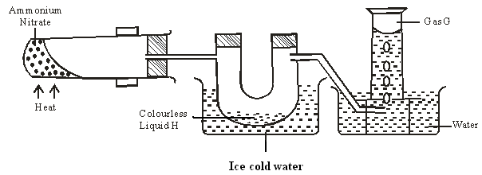

- Identify:
  - Colourless liquid H
………………………………………………………………………………………… 1mark
  - Gas G
………………………………………………………………………………………… 1mark
- Describe one physical and one chemical test that can be used to identify gas G. 2marks
………………………………………………………………………………………………………………………………………………………………………………………………………………………………………………………………………………………………………………………………………………………………………………………………………………………………………………………………
- Air was passed through several reagents as shown in the flow chart below.
Concentrated KOH solution
Excess heated copper turnings
Excess heated magnesium powder
Escaping gases
Air

- What is the purpose of concentrated potassium hydroxide solution? 1mark
……………………………………………………………………………………………………………………………………………………………………………………………………………………………………………….
- Write an equation for the reaction which takes place in the chamber with magnesium powder. 1mark
………………………………………………………………………………………………………………………………………………………………………………………………………………………………………………..
- Name one gas which escapes from the chamber containing magnesium powder.
………………………………………………………………………………………………………………………..
Give a reason for your answer 2marks
……………………………………………………………………………………………………………………………………………………………………………………………………………………………………………….

- Name the following substances.

- CH₂ CH CH₂ CH₃ 1mark
………………………………………………………………………………………………………………………………………………………………………………………………………………………………
- CH₃ CH CH CH₂ CH₃ 1mark
………………………………………………………………………………………………………………………………………………………………………………………………………………………………
- The diagram below shows the acidic and basic oxides fit into the general family of oxides.

Acidic Basic
Oxide Oxide

- State the name given to the type of oxide that would be placed in the shaded area. 1mark
………………………………………………………………………………………………………………………………………………………………………………………………………………………………
- Give the name of any oxide that would be placed in the shaded area. 1mark
………………………………………………………………………………………………………………………………………………………………………………………………………………………………
- Study the information in the table below and answer the questions that follow. The letters do not represent the actual symbols of the elements.

Substance | Solubility in water | Electrical conductivity
 |  | Solid | Molten
A | Insoluble | Good | Good
B | Soluble | Poor | Good
C | Insoluble | Poor | Poor

- Which of the substances is highly likely to be sodium chloride? Explain 2marks
………………………………………………………………………………………………………………………………………………………………………………………………………………………………………………………………………………………………………………………………………………
- What type of bond exists in substance A? 1mark
………………………………………………………………………………………………………………………………………………………………………………………………………………………………
- State a possible structure in substance C? 1mark
………………………………………………………………………………………………………………………………………………………………………………………………………………………………
- Laboratory results showed the composition of a compound to be 58.81% barium, 13.72%, sulphur and 27.47% Oxygen. Calculate the empirical formula of the compound. Ba=137, S = 32, O = 16. 2marks

- The diagram below shows a wooden splint that was placed horizontally across the middle part of a non-luminous flame.
Unburnt part
Charred black

- Explain the observation made 2marks
………………………………………………………………………………………………………………………………………………………………………………………………………………………………………………………………………………………………………………………………………………
- Explain why non-luminous flame is preferred for heating than the luminous flame. 2marks
………………………………………………………………………………………………………………………………………………………………………………………………………………………………………………………………………………………………………………………………………………
- 200cm³ of oxygen gas took 60 seconds to diffuse through a porous plug. Determine the time taken by 300cm³ of sulphur (IV) oxide to diffuse through the same plug under the same conditions.
(O=16, S = 32) 3marks

- Explain why?
- Both methane and diamond are covalently bonded. Methane is a gas but diamond is a solid with very high melting point. 2marks
………………………………………………………………………………………………………………………………………………………………………………………………………………………………………………………………………………………………………………………………………………
- Ammonia is dissolved in water using an inverted funnel. 1mark
………………………………………………………………………………………………………………………………………………………………………………………………………………………………
- Explain giving reasons why?
- Sulphuric acid is not used with marble in the preparation of carbon (IV) oxide 2marks
…………………………………………………………………………………………………………………………………………………………………………………………………………………………………………………………………………………………………………………………..…………………..
- Water cannot be used to distinguish oil fire. 1mark
………………………………………………………………………………………………………………………………………………………………………………………………………………………………
- A gas occupies 4dm³ at -23⁰C and 152 mmHg. At what pressure will its volume be halved, if the temperature then is 227⁰C.? 2marks
………………………………………………………………………………………………………………………………………………………………………………………………………………………………………………………………………………………………………………………………………………………………………………………………………………………………………………………………
- a) Sodium, Magnesium and Aluminium are elements in the periodic table. Explain why aluminium has a higher melting and boiling point than sodium and magnesium. 2marks
………………………………………………………………………………………………………………………………………………………………………………………………………………………………………………………………………………………………………………………………………………
b) The ionization energy of an atom is strongly influenced by three atomic parameters. State two of these parameters. 2marks
………………………………………………………………………………………………………………………………………………………………………………………………………………………………………………………………………………………………………………………………………………
- 15cm³ of a solution containing 2.88g/dm³ of an alkali XOH completely reacts with 20cm³ of 0.045M sulphuric acid. Calculate the molarity and relative atomic mass of X present in the alkali. 3marks

- Describe how a solid sample of calcium sulphate can be prepared using the following reagents; dilute nitric (v)acid, dilute sulphuric (vi) acid and solid calcium carbonate 4marks
………………………………………………………………………………………………………………………………………………………………………………………………………………………………………………………………………………………………………………………………………………………………………………………………………………………………………………………………………………………………………………………………………………………………………………………………………………………………………………………………………………………………
- Crude oil is the main source of organic compounds such as hydrocarbons. The hydrocarbons in the crude oil have to be separated.
- Name two important hydrocarbons obtained from crude oil. 2marks
………………………………………………………………………………………………………………………………………………………………………………………………………………………………………………………………………………………………………………………………………………
- Give the uses of the two hydrocarbons named in (a) above. 2marks
………………………………………………………………………………………………………………………………………………………………………………………………………………………………………………………………………………………………………………………………………………………………………………………………………………………………………………………………
- A hydrocarbon Q was found to decolourise potassium manganate (vii) solution. When two moles of Q were burnt completely six moles of carbon (iv) oxide and six moles of water were formed.
- Write the structural formula of Q. 1mark
………………………………………………………………………………………………………………………………………………………………………………………………………………………………........................................................................................................................................................................
- Name the homologous series to which Q belongs 1mark
………………………………………………………………………………………………………………………………………………………………………………………………………………………………
- Dilute sulphuric acid was added to a compound X, of magnesium. The solid reacted with the acid to form a colourless solution, Y and a colourless gas Z which formed a white precipitate when bubbled through lime water.
Name:-
- Compound X 1mark
………………………………………………………………………………………………………………
- Solution Y 1mark
………………………………………………………………………………………………………………
- Colourless gas Z 1mark
………………………………………………………………………………………………………………

- When dry hydrogen gas passed over heated Lead (II) oxide in combustion tube, a grey solid was formed.

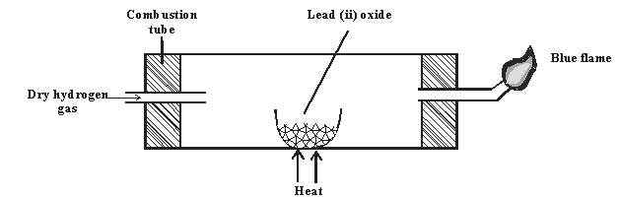

- Identify the grey solid. 1mark
…………………………………………………………………………………………………………….
- Write the equation of the reaction taking place in the combustion tube. 1mark
…………………………………………………………………………………………………………………...................................................................................................................................................................
- Write the equation involving the blue flame. 2marks
………………………………………………………………………………………………………………………………………………………………………………………………………………………………
- What do (C F C’ S) mean? 1mark
………………………………………………………………………………………………………………………………………………………………………………………………………………………………………………………………………………………………………………………………………………

- What is meant by the term allotrophy? 1mark
………………………………………………………………………………………………………………………………………………………………………………………………………………………………
- Explain in terms of structure and bonding why graphite is soft with greasy feeling. 2marks
………………………………………………………………………………………………………………………………………………………………………………………………………………………………………………………………………………………………………………………………………………………………………………………………………………………………………………………………

