STD EIGHT (8) - 2020
CODE: 0012020 SOCIAL STUDIES/ RE TIME: 2 HRS 15 MIN
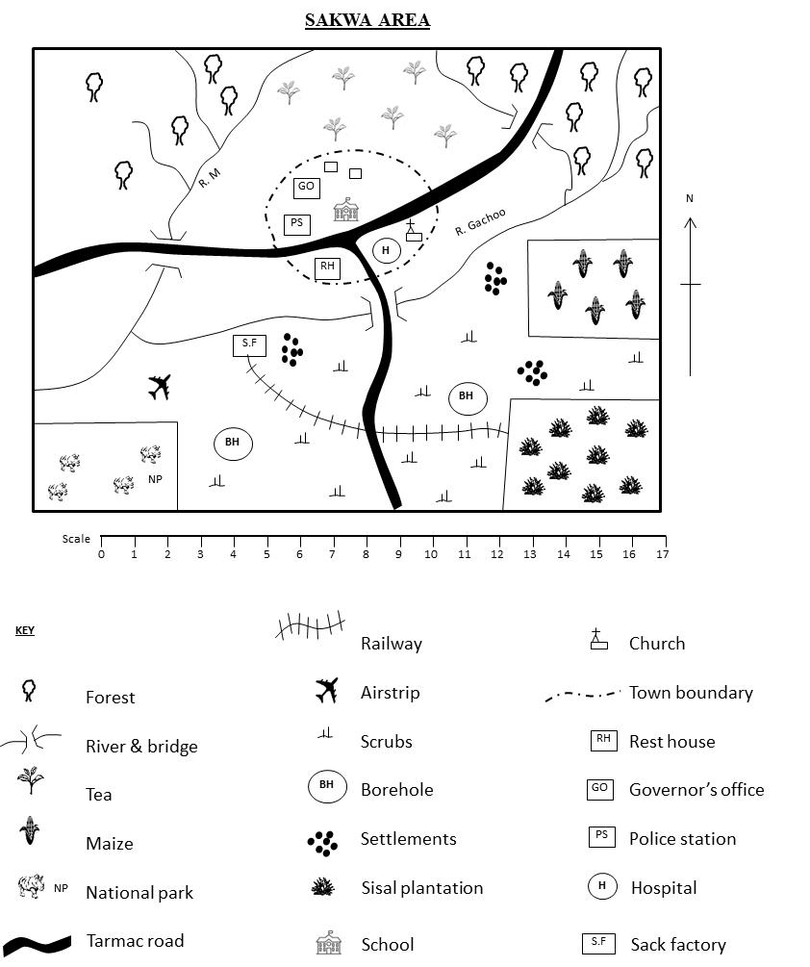

Study the map of Sakwaarea and use it to answer question 1-7
- The area represented by the map above is likely to be a:-
- location
- district
- county
- division
- The factory in the map is likely to be grouped under ____ industries.
- processing
- assembly
- manufacturing
- tertiary
- The airstrip in the map is likely to transport?
- Tourists
- Wind animals
- Sisal leaves
- Water
- The settlement pattern in the map is likely to be influenced by:-
- Presence of water
- Transport and communication
- climate
- economic activities
- River Gachoo rises from:-
- North East
- South West
- North West
- South East
- What is the approximate length of the railway line in the map?
- 9 km B. 10km
C. 15km D. 14.5 km
- People in Sakwa area belong to:-
- Islam
- Christianity
- Hindu
- African Traditional Religion
- Which one of the following groups of items consists of Kenya’s major exports?
- Coffee, electronics, animal products
- Sugar, flowers, pyrethrum
- Horticultural produce, tea, soda ash
- Petroleum, cement, textiles
- National population census in Kenya is carried out after a period of ____ years.
- 5 B. 10 C. 20 D. 18
- The most common types of industries in Kenya are:-
- Tertiary industries
- Manufacturing industries
- Assembly industries
- Processing industries
- The following are examples of mountains found in Africa. Which one was formed when young sedimentary rocks twisted due to compressional forces?
- Mt. Cameroon
- Tibesti
- The Great Karas
- Drakensberg mountain
- The diagram below shows the formation of a certain type of rainfall. It is called:-

Warm moist air
Sea
Land

- Orographic rainfall
- Convectional rainfall
- Frontal rainfall
- Cyclonic rainfall
- The following are factors and structures of population in Kenya. Which one is no true?
- High dependency ratio
- Ageing population is small
- Life expectancy is high
- Females are more than males
- Which one of the following weather measuring instruments is not correctly, matched with what it measures?
- Barometer – air pressure
- Anemometer – strength of wind
- Hygrometer – humidity
- Wind vane – direction of wind
- Which of the stages of evolution may represent the correct order from the latest to the earliest?
- Homo-sapiens – Homo Habilis – Homo erectus
- Homo habilis – homo erectus – homo sapiens
- Homo erectus – homo habilis – homo sapiens
- Homo sapiens – homo erectus – homo habilis
- Since Kenya became a multiparty state, how many general elections have been held?
- 10 B. 5 C. 3 D. 4
- Which one of the following statements is true about maize grown in Kenya and Tanzania?
- Grown by large scale farmers in Kenya
- Major foreign exchange earner in Kenya
- Grown under irrigation in both countries
- Staple food for both countries
- Which one of the following events took place latest in Kenya?
- Death of Jomo Kenyatta
- Coalition government
- Making Kenya Multiparty state
- Death of Tom Mboya
- The following are facts about road signs. Which one is true about regulatory signs?
- Usually surrounded by red circle
- Must be observed by pedestrians only
- Have a light blue background
- Normally enclosed in a red triangle
- Among the following which group represents the Bantus only
- Abaluhya, Pokomo, Nandi, Dinka
- Kikuyu, Embu, Meru, Turkana
- Hehe, Yao, Zulu, Ngoni
- Kamba, Yao, Samburu, Makua
- All of the following were reasons why European scrambled/partitioned for Africa which was the main reason?
- settle surplus population
- strategic position
- market for goods
- raw materials
- The smallest country in Africa in Areas per sq. km is
- Lesotho
- Seychelles
- Sao Tome
- Djibout
- Which agency of the UN (United Nations) is in charge if distributing food to the needy?
- WHO B. WFP
C. UNICEF D. FAO
- Below are descriptions of a certain community
- Ruled by hereditary chiefs
- Are farmers
- Participated in long distance trade
The community described above is
- Buganda B. Nyamwezi
C. Akamba D. Abawanga
- The Bantus who had settled at Shungwaya could not proceed further Northwards because:-
- They were attacked by hostile communites
- The area was dry
- There was infertile soil
- There wasn’t enough pasture
- Which one of the following industries is an example of a secondary industry?
- Sugar refinery
- Saw milling
- Cement making
- Cotton ginnery
- The following are minerals mined in Kenya. Which one is correctly matched with its method of mining?
- Gold – underground method
- Oil – dredging
- Diatomite – drilling
- Soda ash – open cast
- Which one of the following is the main factor that influences population distribution?
- Relief
- Social amenities
- Climate
- Vegetation
- The following are methods used by nationalists in Ghana in their struggle for independence. Which one was not?
- Strikes and boycotts
- Waging guerilla warfare
- Peaceful negotiations
- Demonstration
- Which one of the following countries is not former German colony?
- Togo
- Cameroon
- Libya
- Namibia
- Most rivers in Africa are polluted by:-
- Farm chemicals
- Industrial wastes
- Presence of water weeds
- Soil particles
- The Hebe people were defeated by the Germans mainly because:-
- German soldiers were better armed
- German soldiers were more in number
- The Hehe were few
- The Hehe had superior weapons
- Which one of the following towers is not part of the cocoa triangle in Ghana?
- Sekondi - Takoradi
- Port Harcourt
- Kumasi
- Accra
- Which one of the following aspects of our culture should we not preserve?
- Traditional foods
- Wife inheritance
- Traditional songs and dances
- Traditional ways of greetings
- After a general elections, the newly elected members of parliament are sworn in by:-
- Chief justice
- Attorney general
- Speaker of the National Assembly
- Judge
- The mad sign below indicates:-

- No entry
- Stop
- Danger ahead
- Round about
- Which one of the following effects of colonial rule in Africa is positive?
- Division of communities
- Erosion of African culture
- Forced labour
- Introduction of Western Education
- According to the consutution of Kenya, the amendment of the constitution is the responsibility of:-
- Senate
- Judiciary
- National assembly
- Executive
- Which one of the following is not caused by the movement of the earth around the sun?
- Different seasons
- Differences in time in different parts of the word
- Changes in position of midday sun
- Differences in the length of the day and night

Study the map of Africa below and use it to answer the questions that follow.
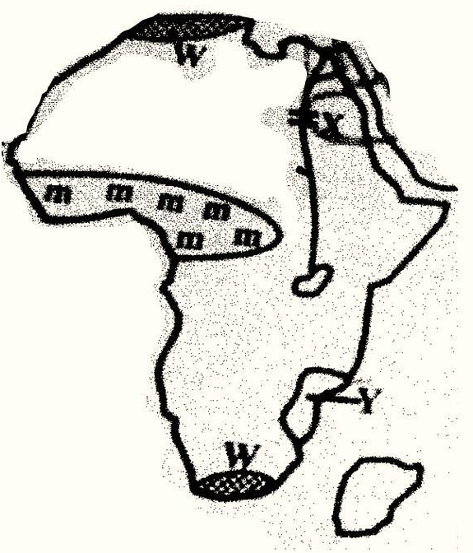

S

- The following are examples of trees found in the shaded region marked mmm. Which one is not?
- Meru Oak
- Mvule
- Rosewood
- Pine
- The country marked Y was colonized by the:-
- Portuguese
- French
- British
- Germans
- The multi-purpose river project marked x is ____.
- Kariba dam
- Volta river project
- Aswan High Dam
- Seven Guardafui
- The most westerly part marked S is:-
- Cape Agulhas
- Cape Verde
- Cape Bon
- Cape Guadafui
- The climate region marked w is known as:-
- Equatorial climate region
- Mediterranean climate region
- Tropical climate
- Temperature climate region
- Below are results of interaction between Cushites and Bantus during the pre-colonial period. Which one is not?
- Bantus learnt animal keeping from Cushites
- Bantu learnt cultivation from Cushites
- Cushites learnt farming from Bantus
- Bantus learnt circumcision from Cushites
- The dispersal point of the Bantus during their migration was:-
- Shungwaya
- Taita Hills
- Congo forest
- PubunguPakwach
- For one to be elected as a county representative, he should:-
- Be married
- Have a university degree
- Be 21 years of age and above
- Be a registered voter
- Which of the following is NOT a marriage system in Kenya?
- Religious marriage
- External marriage
- Customary marriage
- Civil marriage
- Which of the following towns would we experience hot and wet climate.
- Mandera
- Nyeri
- Lokichogio
- Kisumu
- The following are characteristics of a certain type of vegetation in Africa?
- Consists of tall elephant grass
- Has a few and scattered trees
- Leaves of the few trees are thick and hard
The vegetation described above is
- Mountain vegetation
- Scrub vegetation
- Grassland vegetation
- Mediterranean vegetation
Use the map of Africa below to answer questions 27-31
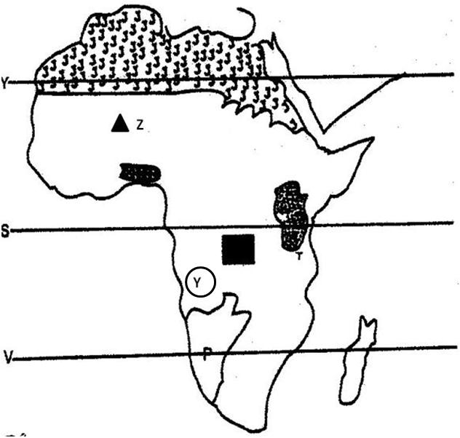

- The mountains marked Z is known to us as _____.
- Adamawa B. Ahaggar
C. Tibest D. Atlas
- The Basin marked T is ____.
- Qattara
- Lake Chad
- L. Victoria basin
- Congo
- Capital city of the country marked P is ____.
- Lusaka
- Luanda
- Gaborone
- windhoek
- the physical feature Y is
- atlas Mts.
- Ruwenzori Mts.
- Ahaggar Mts.
- Bie plateaus
- The main purpose of established a school is ____.

- to pass knowledge and skills to pupils
- give guidance and counselling
- occupy children so that they grow up
- to prepare pupils for adults
- The force indicated by letters D is called ___ force.
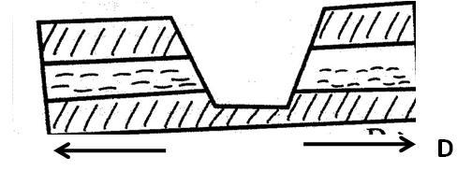

- Uplifting force
- Fault lines
- Tension force
- Compression force
- Which of these statements is true about the formation of this mountain?
- Mostly formed on semi solid sedimentary rock
- Common along the coastline extremes of the continents
- Leads to creation of rift valley lakes
- The mountains are found in Northern and Southern tips of Africa
- Which of these child rights is NOT indicated in the bill of rights?
- Right to a name
- Right to basic needs
- Right to security
- Right to vote
- Your father has been offered smuggled goods at a very cheap price. What advice would you give him?
- Cease them immediately and resell them at very high prices
- To report to the customs officials so that the smugglers can be apprehended
- Take the goods and be silent about them
- Take the goods , resell them and then report the smugglers to the authorities
- The main reason why road safety education is taught in primary school is to.
- Make learning more practical
- Create awareness on careful use of roads
- Give information about road signs
- Reduce work load for traffic officers

C.R.E
- The main teaching of the book of Genesis chapter one is that:-
- Human beings were made in the image of God
- Human beings were given authority over animals
- God is the creator of the universe
- Creation was done in 6 days
- The sign of the covenant between God and Noah was:-
- Fire
- Circumcision
- Rain
- Rainbow
- Joseph and Benjamin were favourite sons of Jacob because they were the only children of:-
- Rachel
- Rebeccah
- Leah
- Sarah
- During the Passover feast the Israelites had to eat while standing mainly because:-
- They wanted to leave before Egyptians could kill them
- They wanted to save time
- They wanted to show that they had to leave Egypt immediately
- It was a symbol of God’s presence
- Which of the following books was not written by Moses?
- Numbers
- Judges
- Exodus
- Deuteronomy
- The Lord said; “The time is coming when I will make a covenant with people of Israel and the people of Judah. The above was a prophecy of:-
- Jeremiah
- Micah
- Isaiah
- Joel
- Which prophet prophesied the refugee status of Jesus in Egypt?
- Joel
- Isaiah
- Hosea
- Jeremiah
- “Wherever you go I will go; wherever you live I will live; your God will be my God. “These words were said by ____ to _____.
- Samuel to David
- Naomi to Oprah
- Ruth to Naomi
- Boaz to Ruth
- The first king of Israel was ______.
- Solomon
- David
- Ahab
- Saul
- The parents of John the Baptist were ___ and _____.
- Zachariah and Elizabeth
- Elkanah and Hannah
- Ruth and Boaz
- Joseph and Mary

- “This is my own dear son with whom I am well pleased.” These words were spoken during Jesus _____.
- ascension
- resurrection
- baptism
- crucifixion
- Which parable of Jesus teaches about the growth of the church?
- The parable of the mustard seed
- The lost coin
- The parable of the sower
- The parable of the Good Samaritan
- The miracle that shows that Jesus had power over nature is:-
- Healing the blind man
- Commanding the wind
- Healing the paralyze man
- Raising the centurion son
- In which garden did Jesus take his disciples after the last supper?
- Mount Olives
- Golgotha
- Mt. Sinai
- Gethsemane
- Happy are those who are merciful to others _____.
- God will satisfy them fully
- God will call them his children
- The kingdom of heaven belongs to them
- God will be merciful to them
- Who was the disciple who spoke to the crowd on the day of Pentecost?
- Mathew
- Paul
- Peter
- Barthlomew
- The following were ways in which Christians suffered for their faith. Which one is not?
- Thrown in prison
- Were whipped
- They were stoned to death
- Involved in a road accident

- Which one of the following is not a letter?
- Ephesians
- Colosians
- Timothy
- Mathew
- The best way for a Christian to witness to a beggar is to:-
- Pray for them
- Tell him Jesus loves you
- Give him money
- Help him find employment
- Who said that “faith without action is dead?”
- Timothy
- Peter
- James
- Paul
- Which of the following was not given to Gikuyu by God after creation?
- Nine sons
- Animals to rear
- A lot of wealth
- Land to cultivate
- Education in the traditional African society was aimed at:-
- Character moulding
- Acquiring a degree
- Preparation for marriage
- Cattle keeping
- The stream of life in African Traditional Society includes the _____, the living. The living dead and the ancestors.
- Married
- Unborn
- Initiation
- Non-living
- Which of the following is not a stage of new life in Traditional African Society?
- birth
- confirmation
- marriage
- death
- According to the Bukusu creation story, were Khabaka’s two assistants were Mukhobe and:-
- Gikuyu
- Mumbi
- Murumwa
- Nyasaye
- Which one of the following activities in a Christian life is an example of the gift of the Holy Spirit?
- Collecting offerings
- Cleaning the church
- Preaching the word of God
- Reading the Bible
- Which one of the following is a fruit of the Holy Spirit?
- Self-control
- Faith
- Wisdom
- Knowledge
- You were playing with your friends in the field who picked sh. 20, as a Christian, what is the best advice to give to your friend?
- Tell her to take the money to her parent
- Ask her you share the money
- Tell her to go and buy sweets
- Tell her to take the money to the teacher on duty
- Halima a std 8 pupil, carries an umbrella to school and it does not rain. When she fails to carry, it rains. What type of suffering is Halima likely to undergo.
- Physical suffering
- Emotional suffering
- Mental suffering
- Spiritual suffering
- The first mission station was build at ____.
- Kaimosi
- Kisumu
- Nairobi
- Rabai

