1STEVALUATION EXAM - 2020
CODE:0012020 SCIENCE STD 8 TIME: 2 HOURS

- Which one of the following methods of food preservation renders the bacteria inactive and not dead?
- Drying
- Salting
- Smoking
- Use of low temperature
- The diagram below shows change of state in matter.
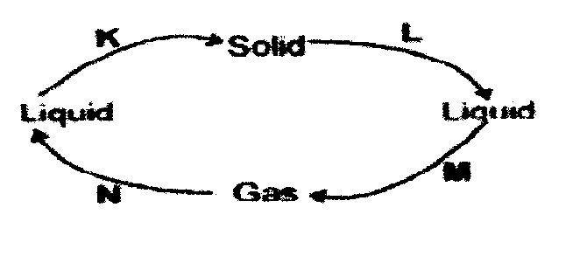

Which letter represents the process of melting?
- K B. L C. M D. N
- The movement of heat through liquids such as water takes place by
- Conduction
- Radiation only
- Convection only
- Radiation and convection
- Which one of the following materials in non magnetic?
- Iron rod
- Aluminium foil
- Cobalt strip
- Nickel coin
- External livestock parasites can be controlled through the following ways EXCEPT?
- Deworming
- Spraying
- Dipping
- Rotational grazing
- Which one of the following pairs DOES NOT constitute the living parts of the environment?
- Animals and soil
- Plants and water
- Light and air
- Sound and plants
- Gulley erosion can be BEST controlled by:-
- Making terraces
- Mulching
- Digging trenches
- Constructing porous dams
- Which one of the following is NOT an effect of water pollution on animal and plant life?
- Leading to soil infertility
- Leading to infection on animals
- Destruction of aquatic plants
- Blockage of root hairs
- Use the following diagram to answer the following
K
M
N

Which one of the following statement is TRUE about plant K?
- Is the brightest planet
- Is far away from the sun than L
- Has the largest orbit than N
- Takes the shortest time to go round the sun than N
- Which one of the following crops is NOT attacked by stalk borers?
- Maize
- Beans
- Sugarcane
- sorghum
- The following are characteristics of insect pollinated flowers. Which one is NOT?
- Large coloured petals
- Brightly coloured sepals
- Nectar at the base of the flower
- Heavy and sticky pollen grains
- The main function of the c-shaped rings in the trachea is to.
- Clean the air
- Allow Passover of saliva
- Allow exchange of gases
- Keep it wide
- Pupils carried out an activity as shown below.
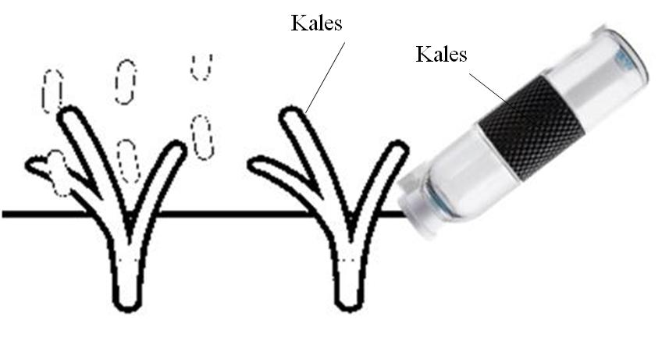

The method of water conservation practiced was
- Recycling water
- Using water sparingly
- Re-using water
- Mulching
- Which one of the following lists consists of vertebrates with similar characteristics?
- Ticks, spider, mites
- Crocodile, snake, tortoise
- Frog, toad, lizard
- Dolphin, shark, tilapia
- Which one of the following is NOT a sign of unhealthy crops?
- Reduced quality produce
- Stunted growth
- Spots and streaks
- Discoloration of plant parts
- Which of the following is HIV/AIDs likely to be transmitted by?
- Blood transfusion
- Sharing sterilized sharp cutting tools
- Sharing tooth brush
- Shaved by an infected person
- Which one of the following statements is NOT true about the blood vessels that carry blood away from the heart?
- Have valves
- Have thick walls
- Have pulse rate
- Carry blood under high pressure
- The following statements are true about energy. Which one is NOT?
- It causes motion
- It can be conserved
- It can changed from one state to another
- It is the ability to do work
- In a certain investigation, pupils shone a s torch behind different object one at a time. The aspect being investigated was ____.
- Source of light
- Uses of light
- How light travels
- Passage of light through materials
- Which of the following pair of materials can be separated by sieving?
- Wheat flour and husks
- Water and cooking oil
- Maize and chaff
- Rice and small stones
- Which one of the following diseases is usually immunized at the age of nine moths?
- Measles
- Polio
- Tetanus
- Whooping cough
- Which one of the following drugs can lead to increased appetite?
- Khat
- Tobacco
- Bhang
- Coccoine
- The type of manure made by cutting growing crops into pieces and then ploughing them into the soil in a farm is?
- Compost manure
- Green manure
- Farm yard manure
- Organic manure
- Birds are not different from mammals since both of them
- Breath by means of grills
- Are cold blooded
- Are warm blooded
- Cannot feed their young ones on milk
- The following are characteristics of all animals EXCEPT one, which one?
- Feeding
- Removing waste
- Making food
- Reacting to changed in the surrounding
- The following are signs and symptoms of a water borne disease.
- Blood in the urine and stool
- Skin rashes
- Severe itching of the bowels and bladder
The above are signs and symptoms of
- Typhoid
- Malaria
- Dysentery
- Bilharzias
- The jar used for measuring rainfall should be ____.
- Long and wide
- Short and narrow
- Short and wide
- Long and narrow
- The following are characteristics of a certain vertebrate.
- Give birth to young one
- Live in water
- Are warm blooded
The animal is LIKELY to be?
- Amphibians
- Fish
- Duck – billed platypus
- Whale
- Farmers are usually advised to carry out mulching MAINLY to?
- Prevent soil erosion
- Conserve moisture
- Eradicate weeds
- Make the soil fertile
- As the teacher asked his pupils to observe the sky, they saw clouds with the following characteristics;
- Thick and white
- Feathery
- Flat based
The type of clouds the pupils observed are also LIKELY?
- To bring rain
- To occur low in the sky
- To be seen on fine weather
- To bring thunderstorms
- The BEST way to control weeds is by ____.
- Hand picking
- Digging them out
- Uprooting
- Using chemical
- Which one of the following is NOT the use of water in industries?
- Spraying crops
- Cooling moving parts of machines
- Removing unwanted products
- Mixing with other substances to make products
- The table below shows classification of plants. Use it to answer questions 34.
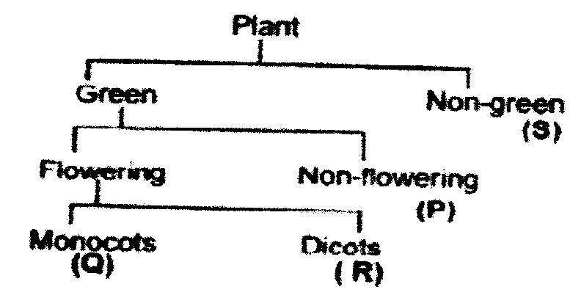

Which of the following shows CORRECT examples of each of the above groups accordingly.
Q R P S
- Beans maize fern lichen
- Maize peas algae mushroom
- Sorghum groundnuts mould toadstool
- Rice maize moss puffballs
- Empty medicine containers should be;
- Thrown away
- Re-used at home
- Buried in the soil
- Locked up in the cupboard
- One of the following types of erosion is a form of landslide which one?
- Sheet erosion
- Rill erosion
- Gulley erosion
- Splash erosion
- Std six pupils of Umoja Academy were carrying out an experiment where they set up their apparatus as shown below.
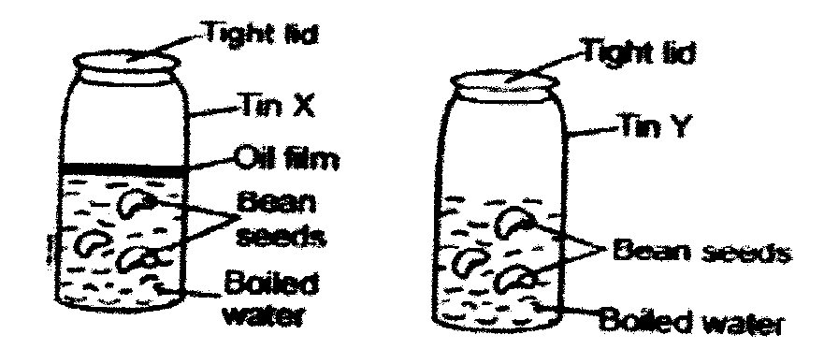

In the pupils were testing for the presence of air as requirement for germination, what mistake did they make?
- Covering both tins with tight lid
- Boiling the water
- Having fewer seeds in tin Y
- Putting an oil film on water
- Which of the following stages of HIV and AIDs infection will he victim test positive but with no visible signs?
- Window
- Symptomatic
- Full blown
- Incubation
- Materials which allow light to pass through them but one cannot see through them are said to be;
- Opaque
- Translucent
- Transparent
- Reflectors
- The process of providing the body with food necessary for maintenance of good health is called
- Feeding
- Balanced diet
- Nutrition
- Body building
- Which one of the following is both a field and a storage pest?
- Aphids
- Cutworms
- Weevils
- Stalk borer
- Which one of he following components of the environment occupies the LARGEST part of the earth’s surface?
- Water
- Air
- Soil
- plants
- Using water sparingly as a way of conserving water will involve doing all the following EXCEPT
- Using used water again
- Turning off taps after use
- Practicing drip irrigation method
- Fixing leakages in taps and pipes
- Study the experiment shown below.
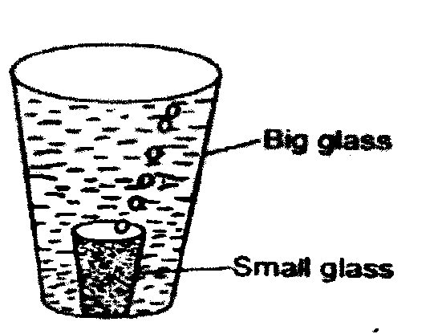

The experiment was LIKELY set to show the presence of ____.
- Water in air
- Air in the soil
- Water in the soil
- Air in the water
- Which one of the following can mix well and form one uniform solution?
- Paraffin and water
- Water and spirit
- Milk and paraffin
- Water and cooking oil
- Which one of the following is the BEST medium for sound transmission?
- Air
- Liquid
- Vacuum
- Wood
- The unit for measuring force is
- Newton
- Kilograms
- Grams
- Joules
- The experiment drawn below can be used by learners to understand that;
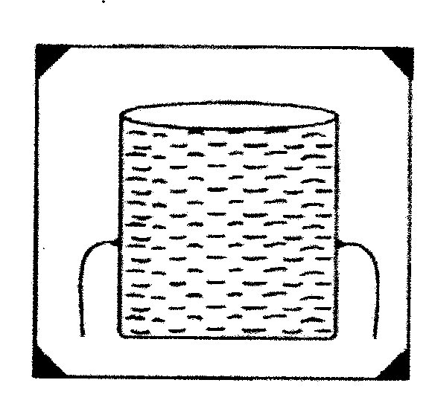

- Liquid exert pressure to all directions
- Liquids exert more pressure with depth
- Pressure in liquids is equal at its same depth
- Liquids take the shape of the container
- An animal attacked by with parasites is NOT likely to show one of the following signs. Which one?
- Rise in body temperature
- Loss of appetite
- Rough hair
- Chewing the cud
- Which one of the following statements BEST explains the term cross pollination?
- The transfer of pollen grains from the anthers to the stigma of another flower
- The fusion of pollen and ovule nucleus
- The transfer of pollen grains from the male anthers to the female stigma of another flower of the same type on the same plant
- The transfer of pollen grains from the anthers on another plant of the same kind
- Which one of the following sound enables people to rush and help other people?
- Screaming B. ambulance siren
C. car hooting D. dog barking

