**NAME: ………………………………………………….. INDEX.NO: ……..……….**

**SCHOOL: …………………………………….CANDIDATES SIGN: ………..….…**

**DATE: …………………………………**

**232/2**

**PHYSICS**

**PAPER 2**

**DECEMBER 2020**

**MERU CENTRAL SUB-COUNTY CLUSTER EXAMINATION**

***KENYA CERTIFICATE OF SECONDARY EDUCATION (KCSE)***

**TIME: 2 HOURS.**

**Instructions to candidates**

*1. Write your name, index number and school in the spaces provided above.*

*2. Sign and write the date of examination in the spaces provided above.*

*3. This paper consist of* ***TWO*** *sections;* ***A*** *and* ***B****.*

*4. Answer* ***ALL*** *the questions in section* ***A*** *and* ***B*** *in the spaces provided.*

*5.* ***ALL*** *working* ***MUST*** *be clearly shown.*

FOR EXAMINERS USE ONLY

|  |  |
| --- | --- |
| **MAXIMUM SCORE** | **80 MARKS** |
| **CANDIDATE’S SCORE** |  |

***SECTION A – 25 MARKS (ANSWER ALL THE QUESTIONS)***

1. Figure 1 below shows an object **O** placed in front of a plane mirror. A ray of light is drawn coming object **O** and striking the mirror at **P.** After striking the mirror, the ray of light is reflected.

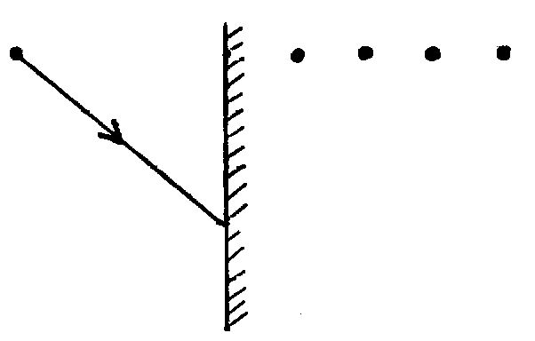

**Object**

**O**

**P**

**Fig. 1**

(i) Which of the four dots represent correct position of the image of **O**? Label this dot **Q** (1mk)

(ii) By drawing a line on the diagram above to represent the reflected ray at **P**, mark the angle of reflection and label it **r**. (1mk)

2. An echo sounder of a ship received the reflected waves from a sea bed after 0.20s. Determine the depth of the sea bed if the velocity of sound in water is 1450m/s (2mks)

3. Figure 2 below shows a simple experiment using a permanent magnet and two metal bars **A** and **B**

Put close to the iron filings.

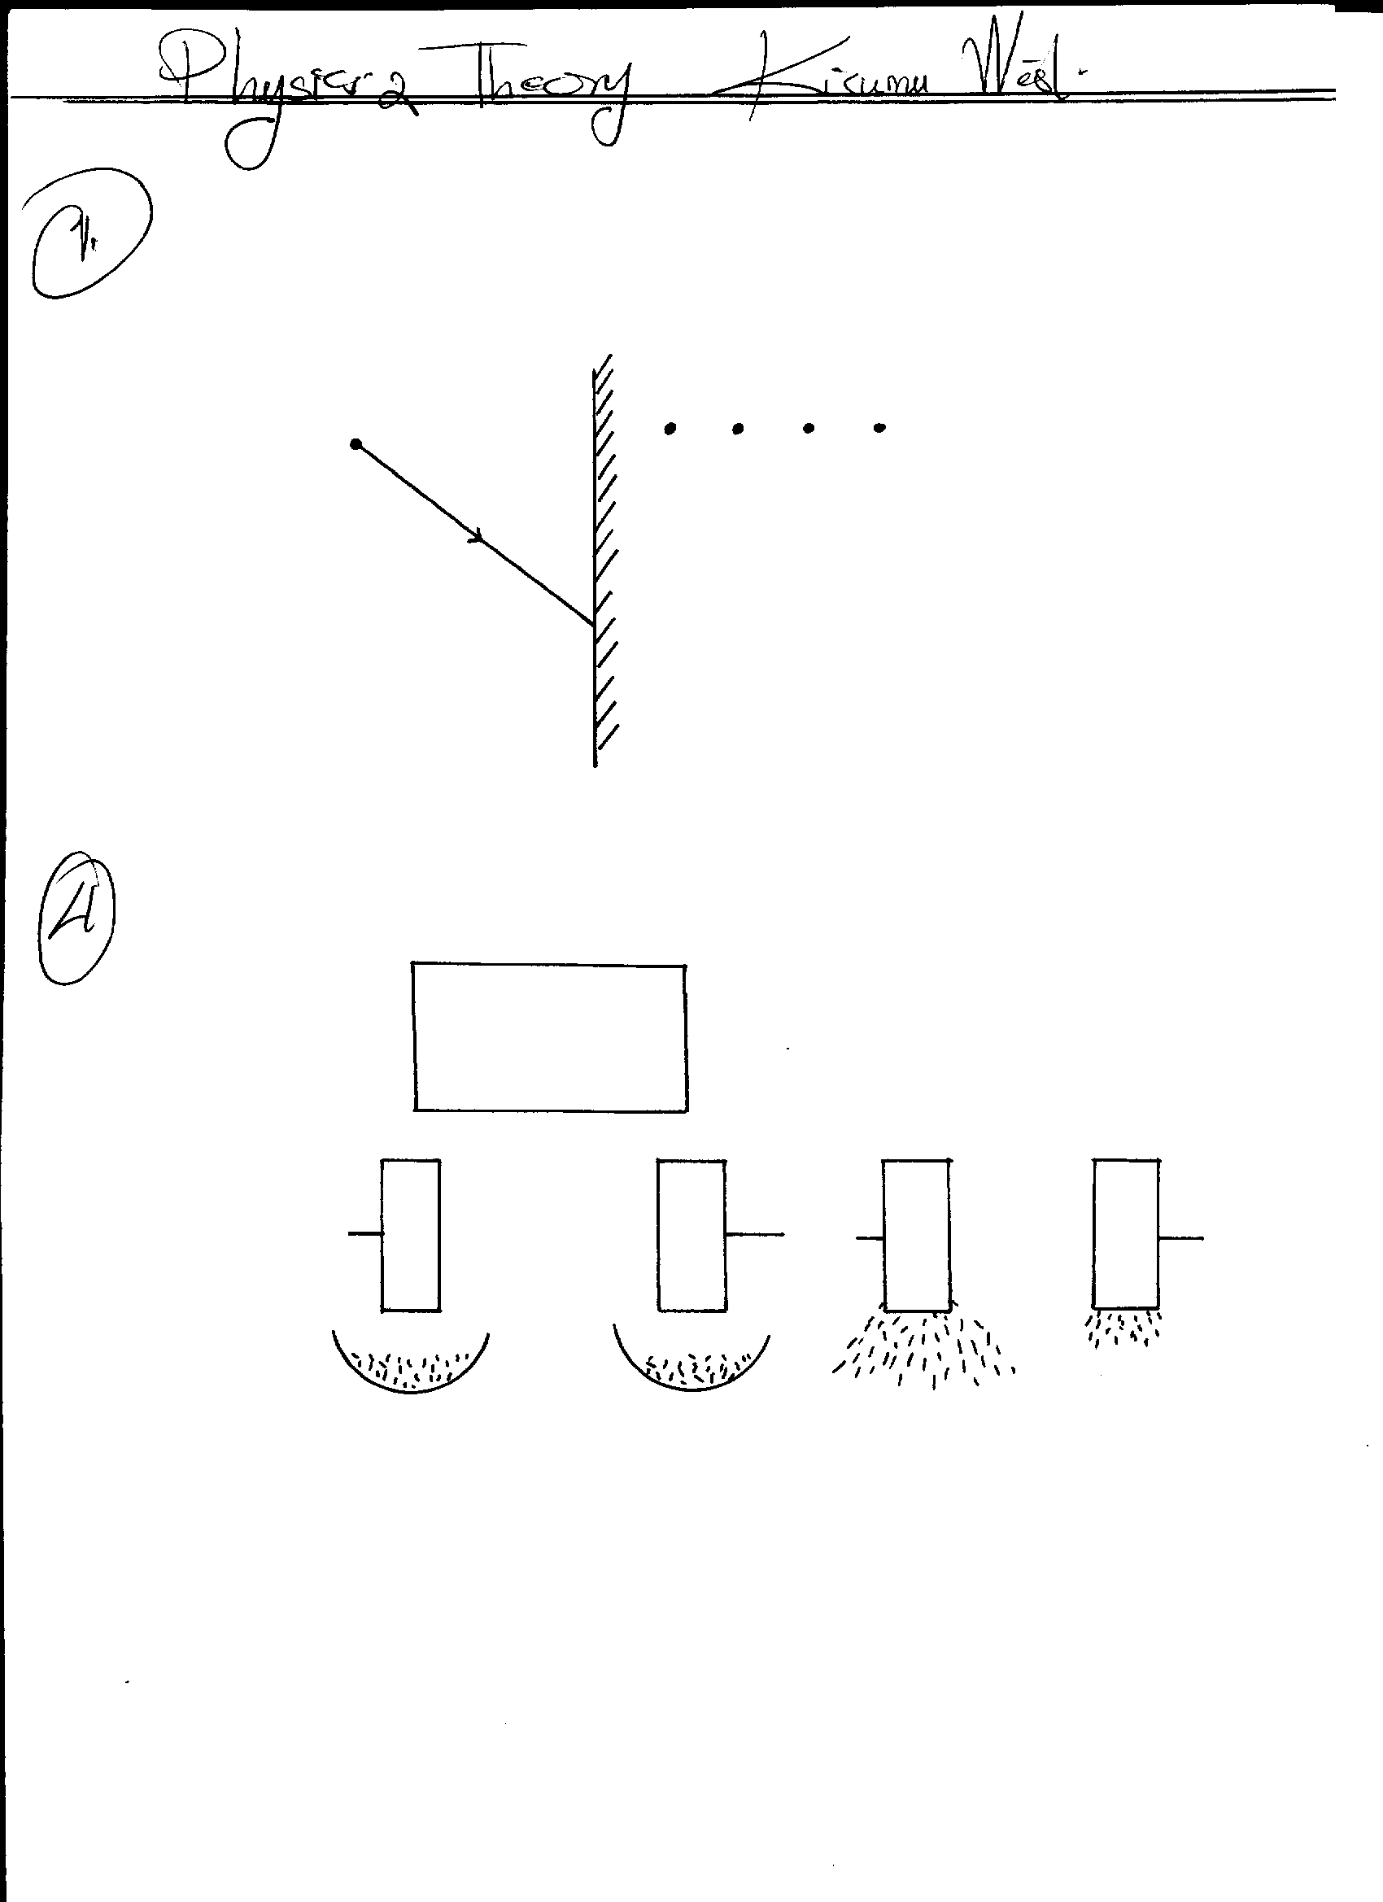

**S**

**N**

**A**

**B**

**A**

**B**

**After**

**Fig. 2**

**During attraction**

State with a reason which bar is made from a soft magnetic material. (2mks)

1. The figure below shows a highly negatively charged rod being brought slowly near the cap of a positively charged leaf electroscope. It is observed that the leaf initially falls and then rises.

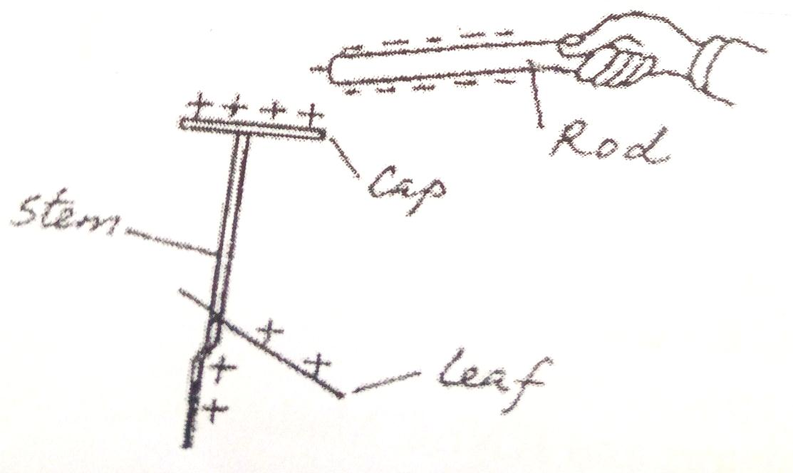

Explain this observation (2 marks)

5.(a) A generator capable of producing 100kw is connected to a factory by a cable with a total resistance of 5 ohms. If the generator produces the power at a potential difference of 5kv. What would be the maximum power available to the factory? (2 marks)

(b) State one cause of power loss in transmission of the main electricity (1 mark)

6.The figure below shows eight resistors forming a network in circuit between X and Y.

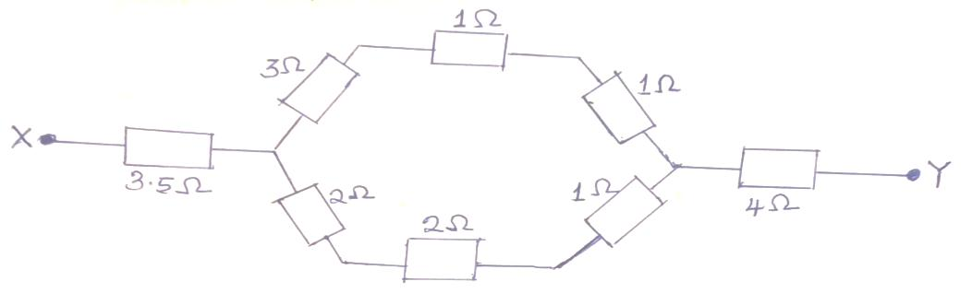

Calculate the effective resistance of the network. (3 marks)

7.State:

1. One application of ultraviolet radiation (1 mark)
2. One detector of the radiation in (a) above. (1 mark)

9. The figure below shows a rectangular coil in a magnetic fields rotating in a clockwise direction.

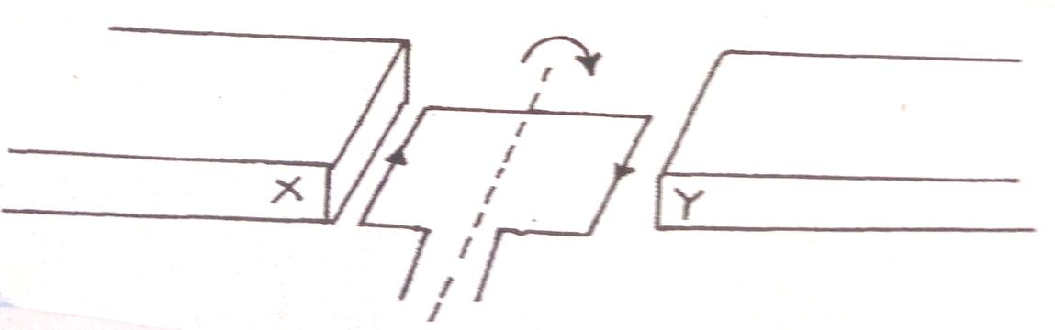

1. Indicate the poles X and Y of the magnets. (1 mark)
2. Suggest one way of increasing the magnitude of the force in such a coil. (1 mark)
3. A battery is rated at 30Ah. For how long will it work if it steadily supplies a current of 3A.

(2 marks)

1. (b) An element **R** decays by giving off an alpha particle. Complete the equation below showing the

valves of **a** and **b** (2mk)

a

b

236

72

4

2

R = V + He

a = ____________________ b = ____________________

1. ) The circuit diagram in figure13 below shows four capacitors connected between two points **A**

and **B**

**2μF**

•

**B**

**4μF**

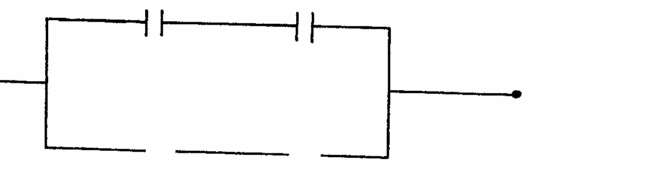

4**μF**

**2μF**

**A**

**Fig 13**

Determine the capacitance across **AB**. (3mks)

***Section B (55 marks)***

***Answer all questions***

13a)The figure below shows and image I formed by a concave mirror

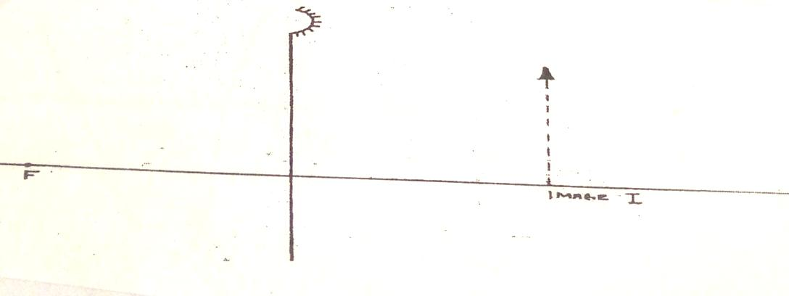

Determine its magnification M. (3 marks)

b)The figure below shows lenses of a compound microscope. The focal length of the objective is 2 cm and that of eyepiece is 4cm. The two lenses are 9cm apart. An object 1 cm high is placed 3cm from the objective lens.

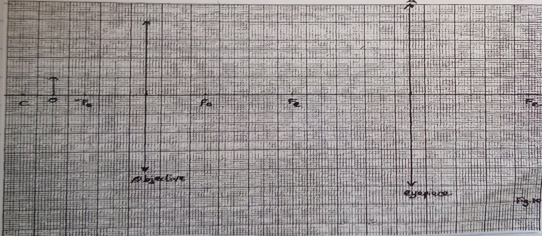

1. Construct rays to show the position of the final image seen by the eye. (4 marks)
2. Find the magnification obtained by this arrangement (2 marks)

14.The figure below shows water wave fronts

1. Approaching a boundary between a shallow and deep region. The speed of the waves in the shallow region is less than in the deep region.

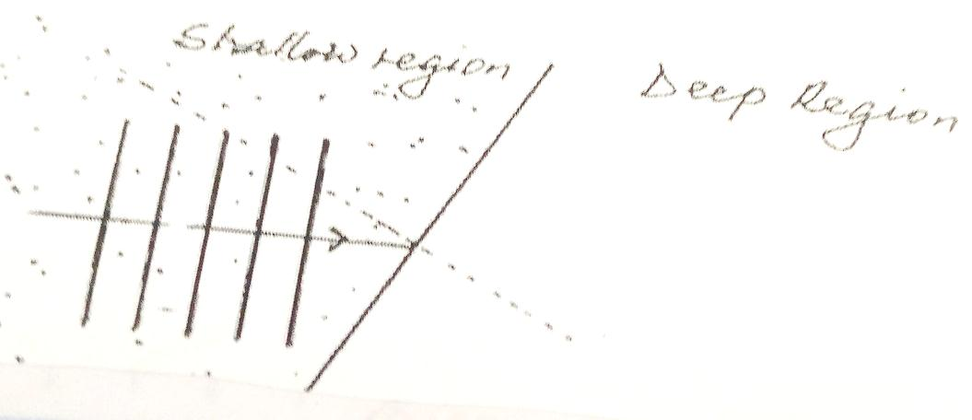

On the same diagram complete the fare to show the wave fronts after crossing the boundary.

(2 marks)

1. A vibrator is used to generate water waves in a ripple tank. It is observed that the distance between the first crest and the midpoint to the fifth trough is 237.5cm. The waves travel 224.0cm in 6.0 seconds.

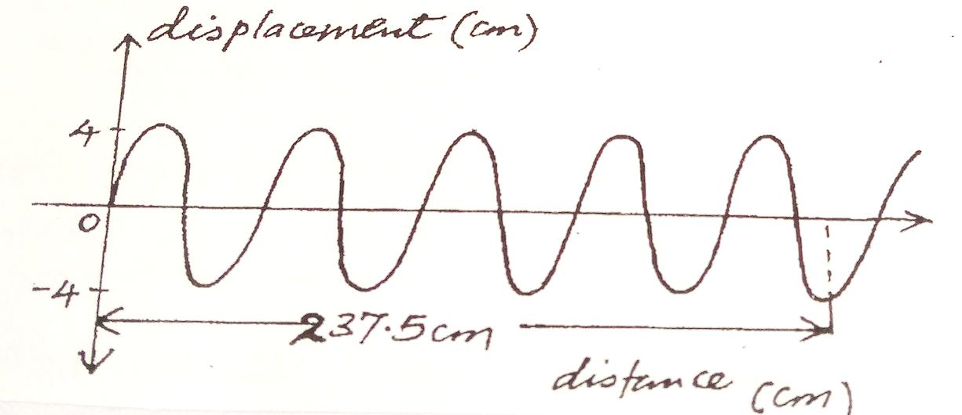

Determine:

1. The wavelength of the waves (3 marks)
2. The speed of the waves (2 marks)
3. The frequency of the vibrator (2 marks)
4. The plane water wave front are incident onto a concaved barrier as show in the figure below.

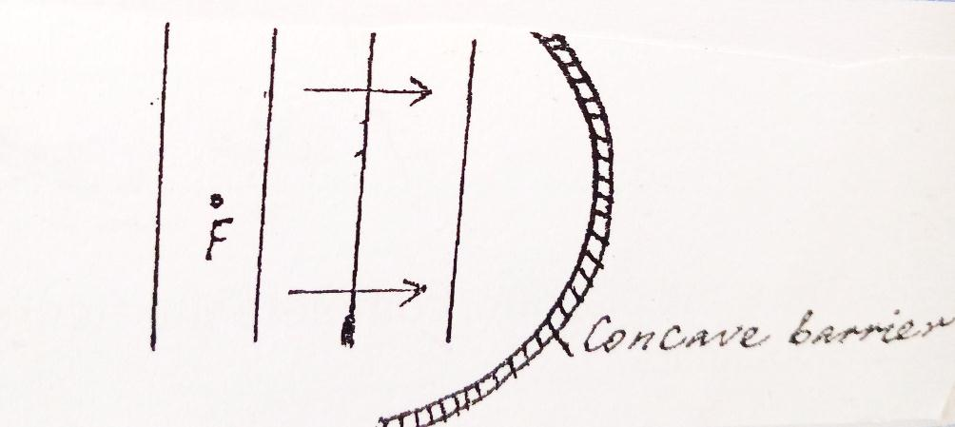

Show on the same diagram the nature of the reflected wave fronts. (2 marks)

15.The figure below shows the parts and circuit of a model X-ray tube.

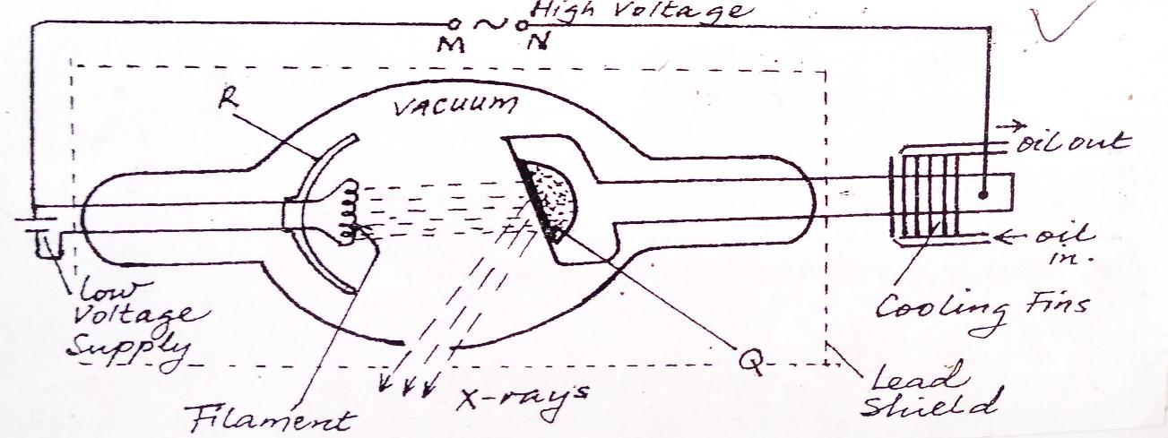

1. Name the parts labeled Q and R (2marks)

Q

R

1. State the suitable material for use in Q and give a reason for your answer (2marks)
2. State the function of part R (1 marks)
3. Describe how electrons, hence X-rays, are produced in the tube (2 marks)
4. Explain why the glass tube is evacuated (2 marks)
5. What property of lead makes its suitable material for shielding (1 mark)
6. State how the following changes affect the nature of X-rays produced
7. Increasing in potential across MN (1mark)
8. Increasing the filament current (1 mark)

16(a) What is photoelectric emission? (1 mark)

1. A radiation falls on photosensitive material state how the following changes affect the emitted photoelectrons:

(i) Increase in intensity of incident radiation. (1 mark)

(ii) Increase in the frequency of incident radiation (1 mark)

1. The figure below shows a graph of stopping potential (voltage)V, against frequency f, of a radiation falling on a photosensitive surface.

Given that eVs = hf – hfo where h= plants constant, fo = threshold frequency i.e frequency when Vs = 0 and e is the charge on an electron = 1.6 x 10-9C. Use the graph to determine;

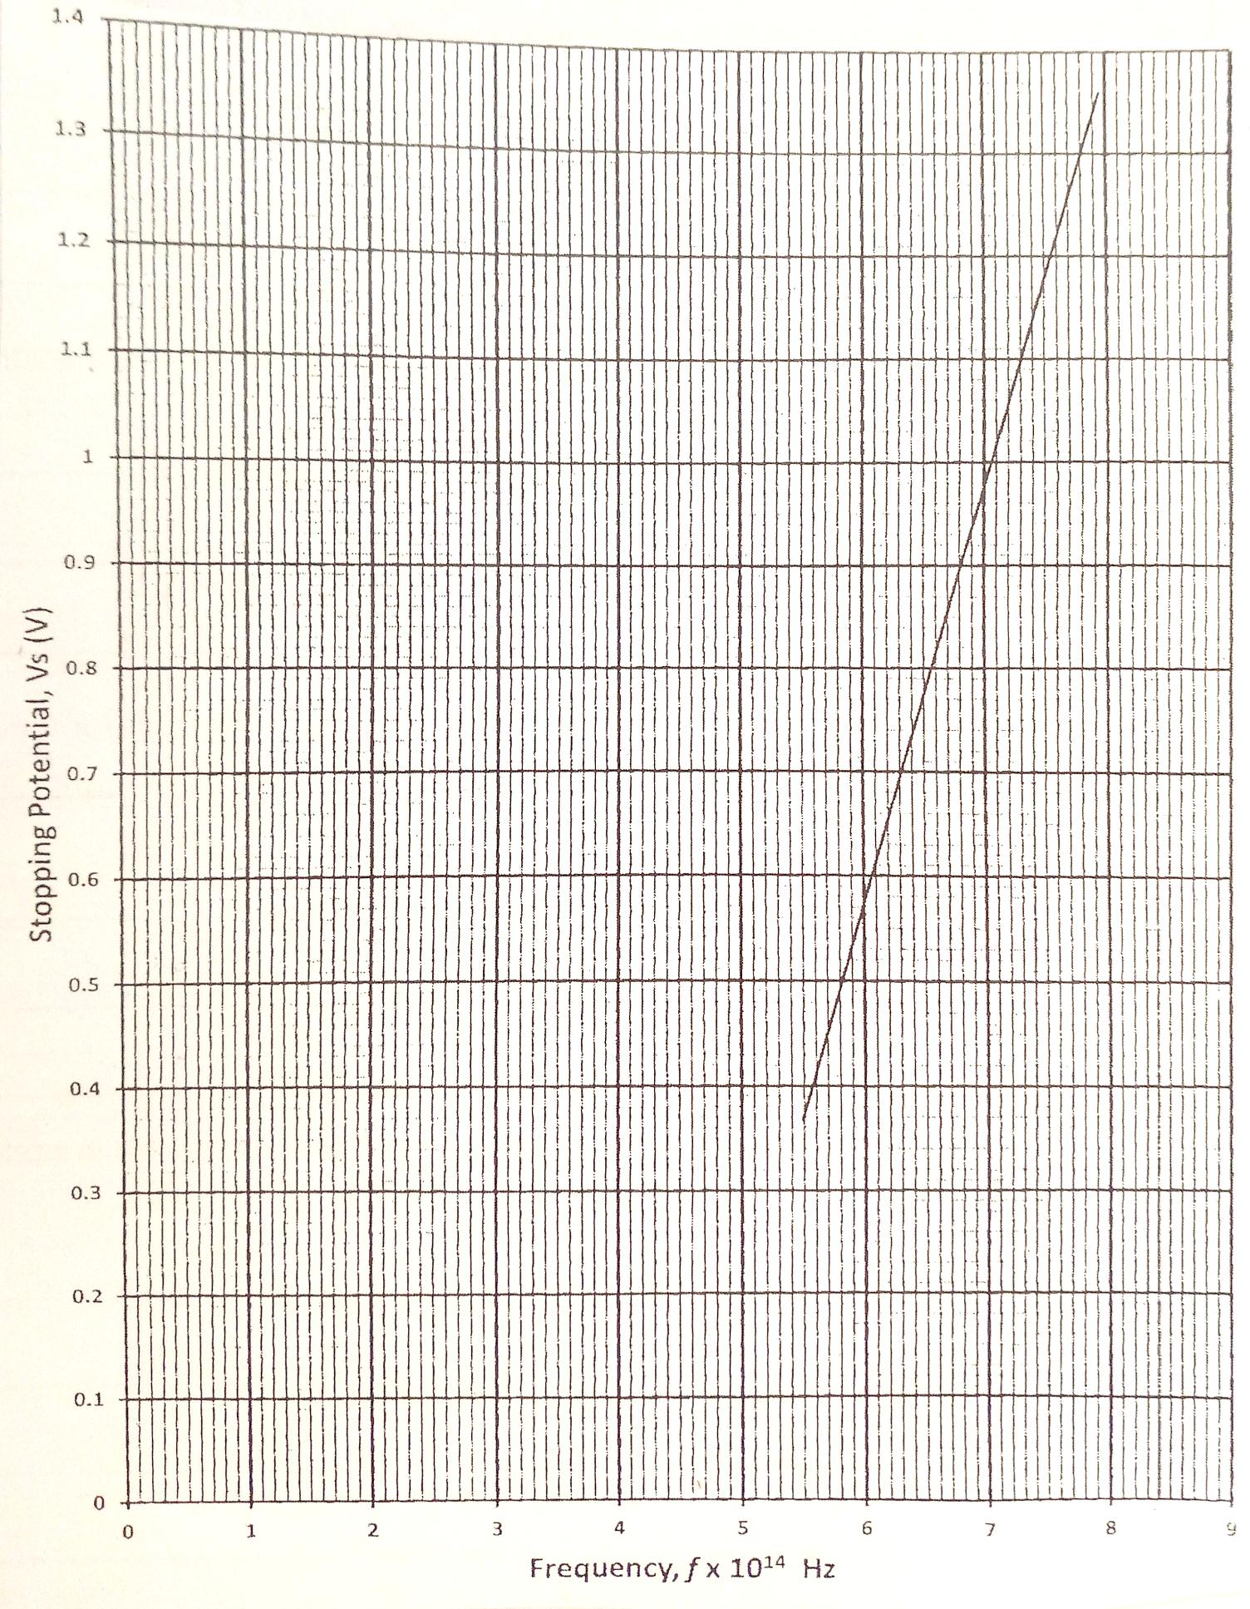

1. The threshold frequency for the surface (1 mark)
2. The gradient of the graph, hence the value of plank’s constant h. (3 marks)
3. The work function Wo of the surface given that Wo = Hfo for the surface (2mrk)

17. A student connected a circuit as shown in figure 16 below hoping to produce a rectified out put

**D1**

**A**

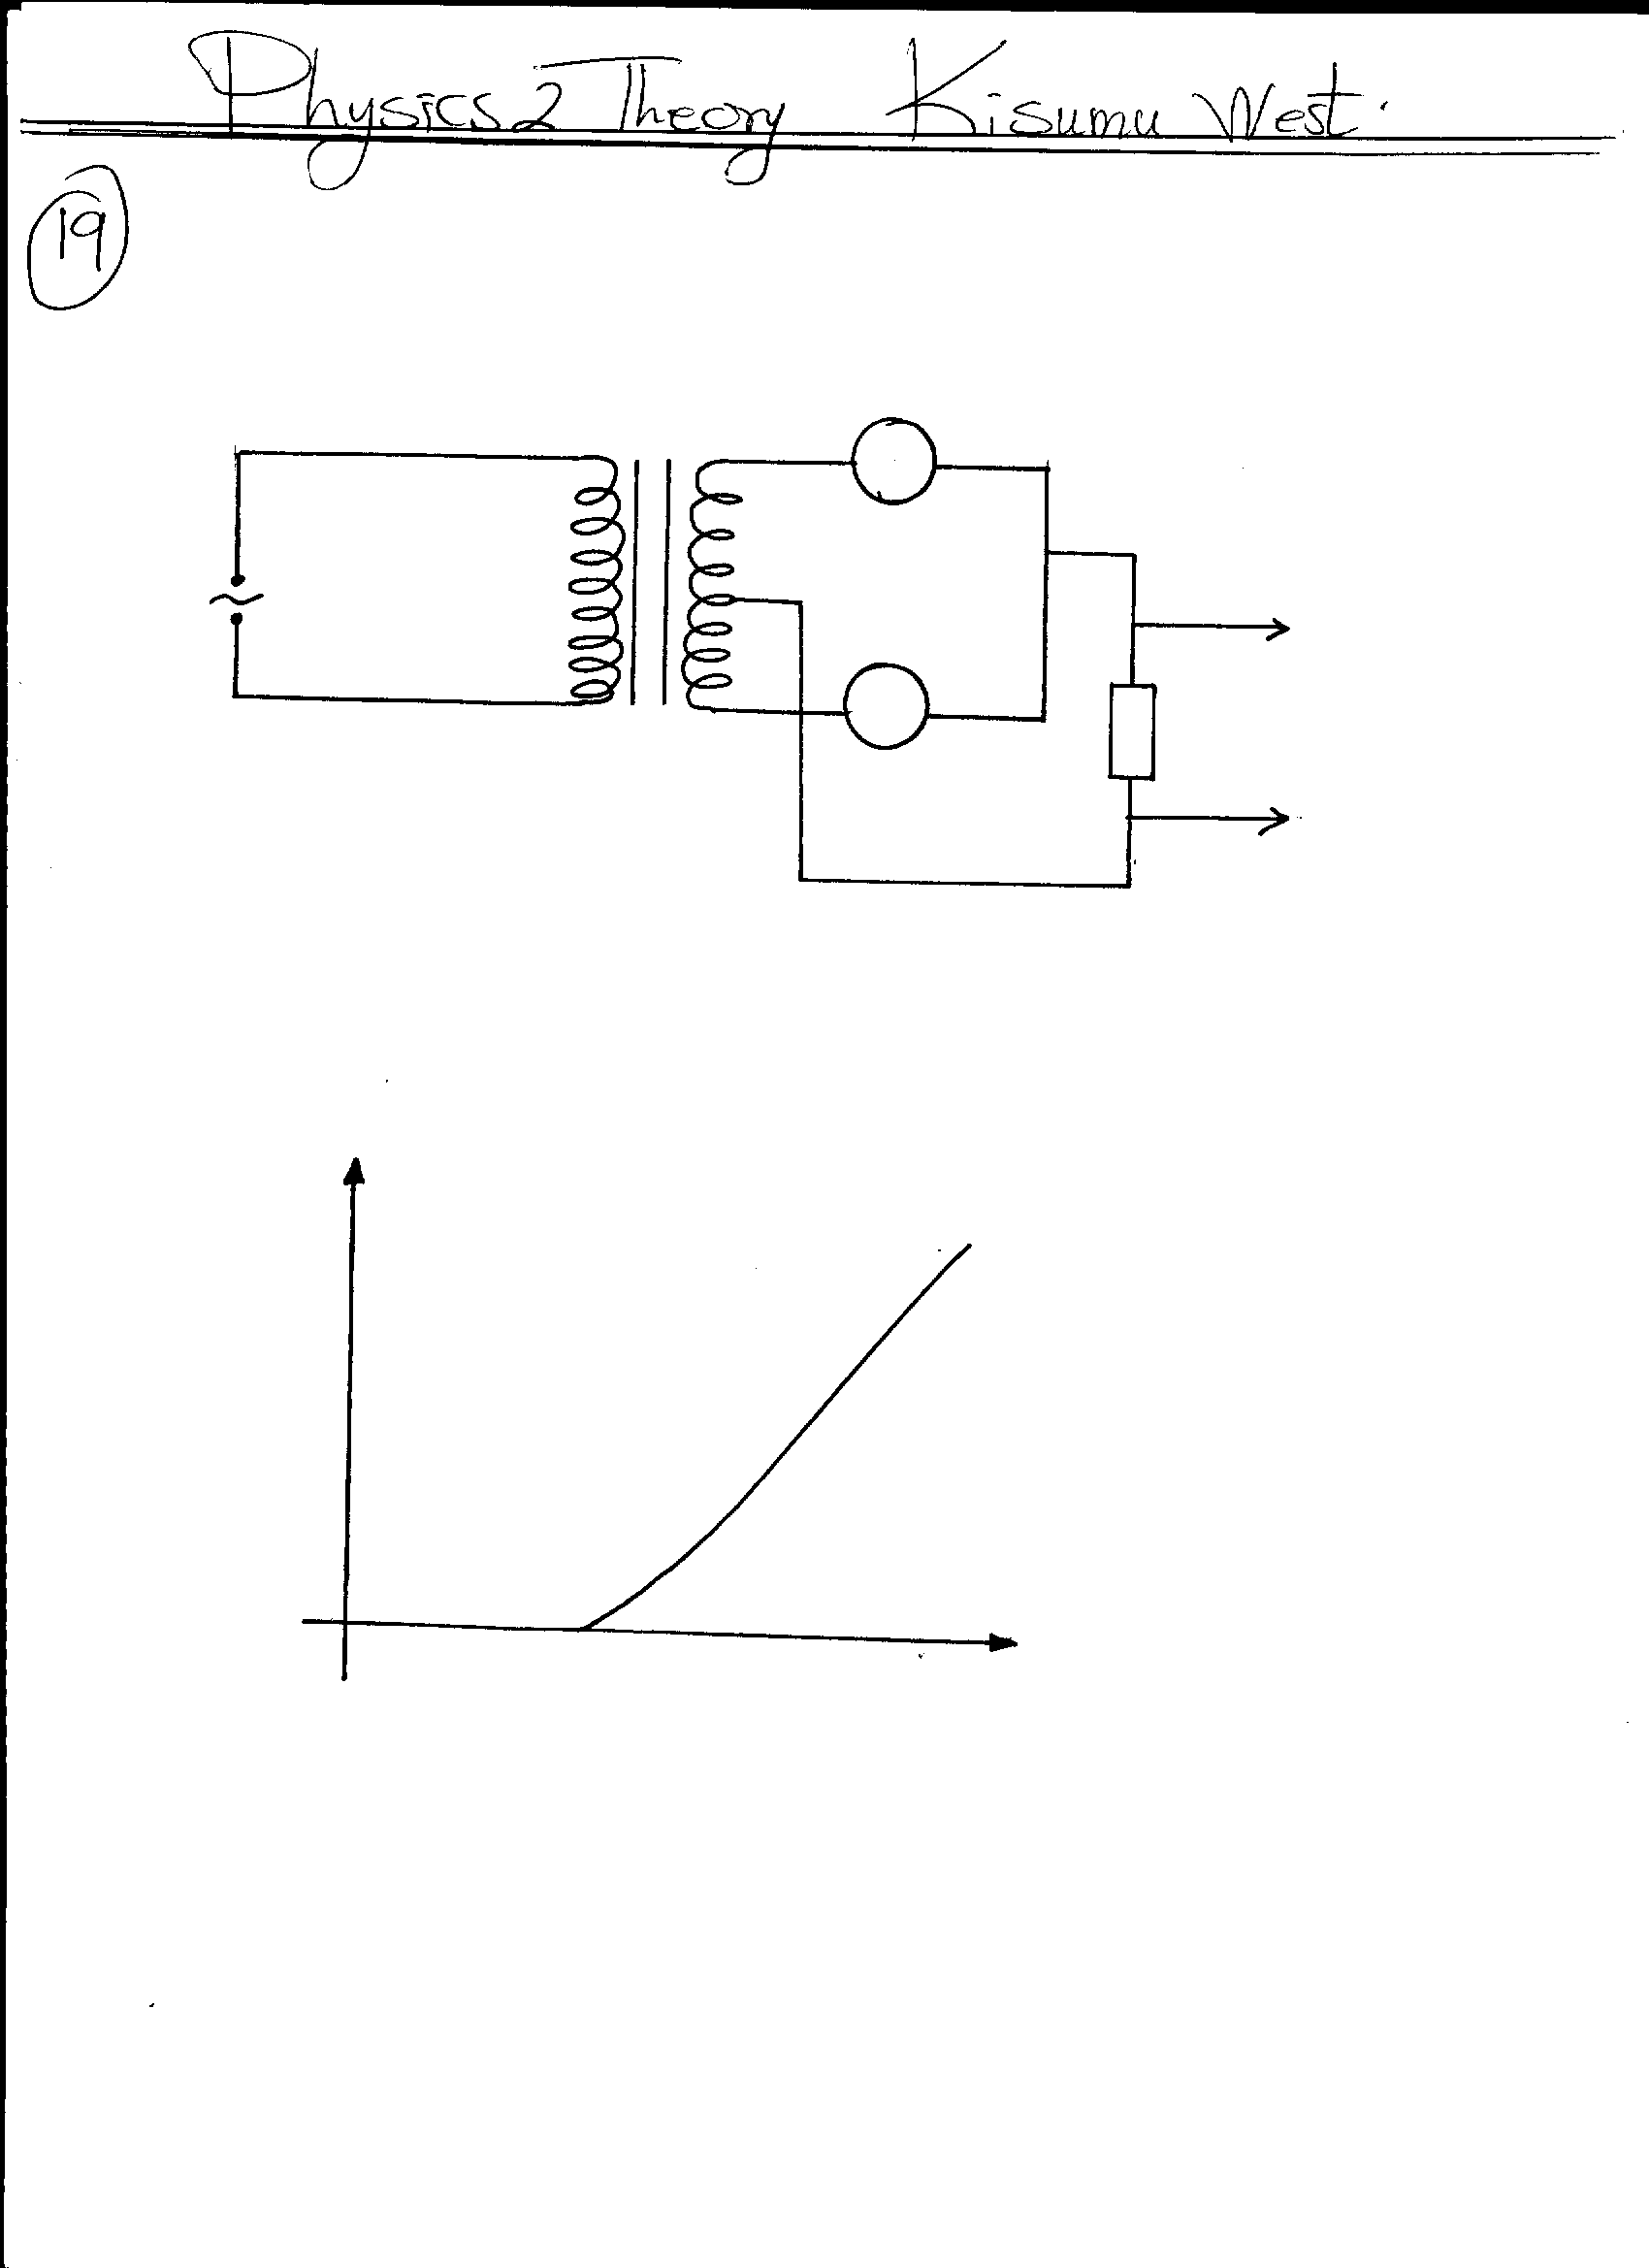

**T**

**a.c**

**TO**

**CRO**

**B**

**D2**

**R**

**Fig 16.**

(a) Sketch the graph of the output on the **CRO** screen (1mk)

(b) Explain how the output above is produced (2mks)

(c) Name other **two** uses of a junction diode (2mks)

20. Figure 7 shows two coils A and B placed close to each other. A is connected to a steady dc supply and a switch B is connected to a sensitive galvanometer.

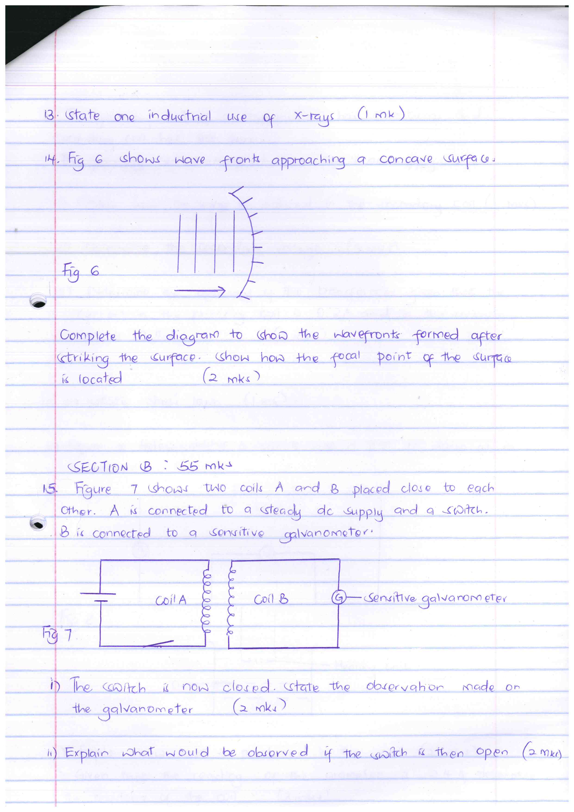

i) The switch is now closed. State the observation made on the galvanometer 2mks)

ii) Explain what would be observed if the switch is then open 2mks)

b) the primary coil of a transformer has 1000 turns and secondary coil has 200 turns the primary coil is connected to a 240v ac supply

ii) Determine the secondary voltage 3mks)

iii) Determine the efficiency of the transformer given that the current in the primary coil is 0.2A and in the secondary coil is 0.7A 3mks)