NAME…………………………..……………….. DATE ……………………………

INDEX NO. ……….……….…………………... SIGNATURE:……………..………

232/1
PHYSICS
PAPER 1
DECEMBER, 2020
TIME: 2 HOURS.

LANJET JOINT EXAMINATION 2020
Kenya Certificate of Secondary Education.
232/1
PHYSICS
PAPER 1
TIME: 2HOURS.

INSTRUCTIONS TO CANDIDATES
- Write your name and your index number in the spaces provided above.
- This paper consists of two sections A and B
- Answer all questions in section A and B in the space provided
- All working must be shown in the spaces provided in this booklet.
- Mathematical tables and silent electronic calculators may be used
- This paper consists of 10 printed pages. Candidates should check to ensure that all pages are printed as indicated and no questions are missing

FOR OFFICIAL USE
SECTION | QUESTION | MAX. SCORE | CANDIDATE’S SCORE
A | 1-12 | 25
B | 13 | 09
 | 14 | 15
 | 15 | 10
 | 16 | 11
 | 17 | 10
TOTAL SCORE |  | 80

This paper consists of 10 printed pages. Candidates should check the question paper to ascertain that all pages are printed as indicated and that no pages are missing.

SECTION A 25 MARKS
ANSWER ALL QUESTIONS IN THIS SECTION

- A micrometer screw gauge is used to measure the thickness of a stuck of 10 microscope slide cover slips. The reading with the cover slips in position is as shown in figure 1.
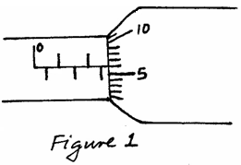
If the micrometer screw gauge has a negative zero error of 0.01mm, determine the thickness of each cover slip. (2mks)

- Explain whyammonia gas released at the back of a laboratory spreads faster on a hot day than on a cold day. (1mk)

- A piece of paper is held in front of the mouth and air blown horizontally over the paper, it is observed that the paper get lifted up. Give reason for the observation. (1mk)

- (a) Estimate the size of an oil molecule if a drop of oil of volume 6.0 × 10⁻¹⁰ m³ forms a patch of radius 32 cm on a water surface. (2mks)

(b) Other than oil patch being monolayer, state any one other assumption in the oil drop experiment. (1mk)

- In the study of free fall, it is assumed that the force F acting on a given body of mass, m, is gravitational, given by F = mg. State two other forces that act on the same body.(2mks)

- The figure below shows a displacement-time graph of the motion of a particle.
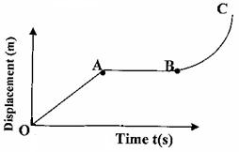

Describe the motion of the particle in the region. (3mks)
- OA

- AB

- BC

- A 60 litre giant density bottle weighs 100N when empty. What will be its mass when filled with liquid W whose density is 0.72g/cm³? (g=10N/kg) (3mks)

- Figure 3 shows a uniform wooden plank which weighs 10N. The plank is balanced at 0.8m from one end by a mass of 2.5Kg.
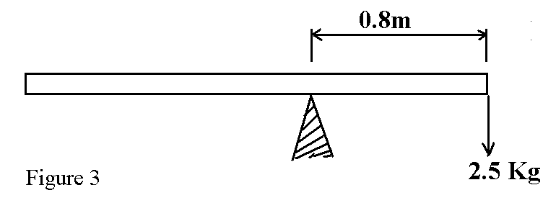
What is the length of the wooden plank in metres. (2mks)

- The figure below shows a force of 40N acting on a body of mass 4kg. The coefficient of friction between the surfaces is 0.05.

m = 4 kg
40N

Determine the acceleration of the body. (3mks)

- State onefactor that affect the spring constant of a spring. (1mk)

- A girl in a school in Nakuru plans to make a barometer using a liquid of density 1.25gcm⁻³. If the atmospheric pressure in the school is 93750Nm⁻². Determine the minimum length of the tube that she will require? (3mks)

- A form one girl observed that when mercury is put into a glass it does not wet the glass. Explain the observations made by the girl. (1mk)

SECTION B (55MARKS)
ANSWER ALL QUESTIONS IN THIS SECTION

- (i) Define Archimedes’ Principle. (1mk)

(ii) An object weighs 1.04N in air, 0.64N when fully immersed in water and 0.72N when fully immersed in a liquid. If the density of water is 1000 kg m⁻³, find:

  - The density of the liquid. (2mks)

  - Calculate the density of the metal block. (2mks)

(iii) Calculate the upthrust on the metal and the apparent weight of the metal when completely submerged in salt solution of density 1.2g/cm³. (3mks)

    - A blockof metal of volume 80cm³ weighs 3.80N in air. Determine its weight
when fully sub merged in a liquid of density 1200kgm⁻³. (3mks)

- The following readings were obtained in an experiment to verify Hooke’s law using a spring.
Mass (g) | 0 | 25 | 50 | 75 | 100 | 125
Reading (cm) | 10.5 | 11.5 | 12.5 | 13.5 | 14.4 | 16.0
Force (N)
Extension (mm)
- Complete the table (2mks)
- Plot the graph of extension against force. (5mks)
- From the graph determine the:
- Elastic limit (1mk)

- Spring constant. (2mks)

- (a) State the pressure law for an ideal gas (1mk)

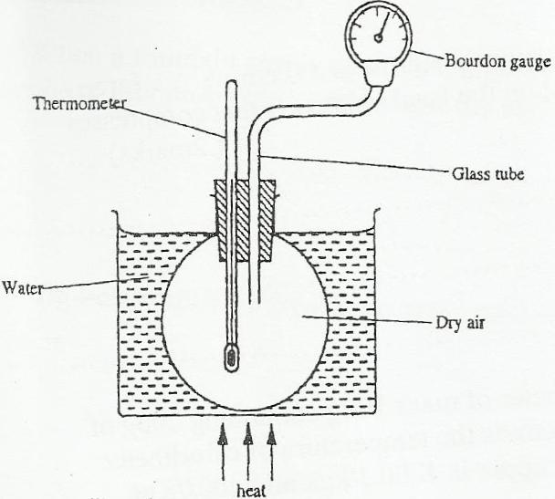
(b) The set up shows an arrangement to determine the relationship between temperature and pressure of a gas constant volume.

Explain how the result form the experiment can be used to determine the relationship between temperature and pressure. (2mks)

(c) A bicycle tyre is pumped to a pressure of 2.2 × 10⁵pa at23⁰C. After a race the
pressure is found to be 2.6 × 10⁰ pa. Assuming the volume of the tyre did not change, what is the temperature of the air in the tyre. (3mks)

(d) Air is trapped inside a glass tube by a thread of mercury 240 mm long. When the
tube is held horizontally the length of the air column is 240mm.

750 mmHg
240mm
L₁ = 240mm

Assuming that the atmospheric pressure is 750mm Hg and the temperature is constant; calculate the length of the air column when the tube is vertical with open end down. (3mks)

- a) A body of mass 20Kg hangs 4m and swings through a vertical height of 0.9m as shown inthe figure 11.
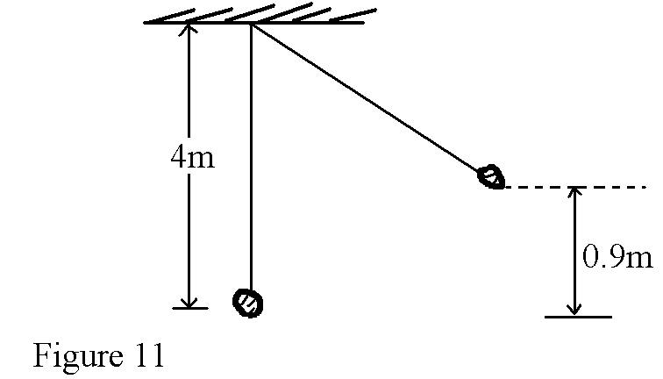
Determine;
i) The potential energy at its position. (2mks)

ii) The speed of the body when passing through the lowest point. (2mks)

b) A crane lifts a load of 2000Kg through a vertical distance of 3.0m in 6 seconds.
Determine the;
i) Work done by the crane. (2mks)

ii) Power developed by the crane. (2mks)

iii) Efficiency of the crane given that it is operated by an electric motor rated 12.5kW. (2mks)

- a) Define the term ‘heat capacity’. (1mk)

b) A block of metal of mass 150g at a 100⁰C is dropped into a well lagged calorimeter of mass 215g and specific heat capacity 400JKg⁻¹K⁻¹ containing 100g of water at 25⁰C. The temperature of the resulting mixture is 34⁰C. (Specific heat capacity of water = 4200JKg⁻¹ K⁻¹). Determine;
i) Heat gained by calorimeter. (2mks)

ii) Heat gained by water. (2mks)

iv) Specific heat capacity of the metal block. (3mks)

18. (a) State two factors affecting centripetal force (2mks)

(b) A stone of mass 0.5kg is attached to a string of length 0.5m which will break if the tension exceeds 20N. The stone is whirled in a vertical plane, the axis of rotation being above the ground, as shown in the Figure 10 below.
Stone
5.5m

0.5mm

The angular velocity is gradually increased until the string breaks. At what angular velocity, w, will the string break? (3mks)

