**NAME…………………………..……………….. DATE ……………………………**

**232/1**

**PHYSICS**

**PAPER 1**

**DECEMBER, 2020**

**LANJET JOINT EXAMINATION 2020**

**MARKING SCHEME**

**SECTION A: 25 MARKS**

**ANSWER ALL QUESTIONS IN THIS SECTION**

1. A micrometer screw gauge is used to measure the thickness of a stuck of 10 microscope slide cover slips. The reading with the cover slips in position is as shown in figure 1.

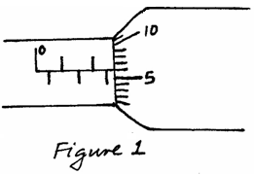

If the micrometer screw gauge has a negative zero error of 0.01mm, determine the thickness of each cover slip. (2mks)

**Thickness of 10 cover slips = 2.56 + 0.01 = 2.57mm**

**Thickness of each cover slip **

1. Explain why ammonia gas released at the back of a laboratory spreads faster on a hot day than on a cold day. (1mk)

**Rate of diffusion increases with increase in temperature**

1. A piece of paper is held in front of the mouth and air blown horizontally over the paper, it is observed that the paper get lifted up. Give reason for the observation. (1mk)

**The speed of air above increases thereby decreasing the pressure above the paper. The pressure below the paper is high as the speed is low hence lift the paper**

1. (a) Estimate the size of an oil molecule if a drop of oil of volume 6.0 × 10-10 m3 forms a patch of radius 32 cm on a water surface. (2mks)

T= **v/A**

**6 x 10-10**

* + 1. **x (0.16)2**

**= 7.459 x 10- 9 m**

**(7.45942075 x 10**- 9m)

(b) Other than oil patch being monolayer, state any **one** other assumption in the oil drop experiment. (1mk)

**The molecules in oil patch are closely packed. The oil drop be a perfect sphere/the oil patch perfect circular**

1. In the study of free fall, it is assumed that the force F acting on a given body of mass, m, is gravitational, given by F = mg. State two other forces that act on the same body.(2mks)

**Upthrust**

**Friction**

1. The figure below shows a displacement-time graph of the motion of a particle.

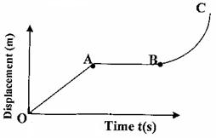

Describe the motion of the particle in the region. (3mks)

1. **OA**

**OA=Uniform velocity**

1. **AB AB = Stationary**
2. **BC BC= Accelerating**
3. A 60 litre giant density bottle weighs 100N when empty. What will be its mass when filled with liquid W whose density is 0.72g/cm3? *(g=10N/kg)*  (3mks)
4. Figure 3 shows a uniform wooden plank which weighs 10N. The plank is balanced at 0.8m from one end by a mass of 2.5Kg.

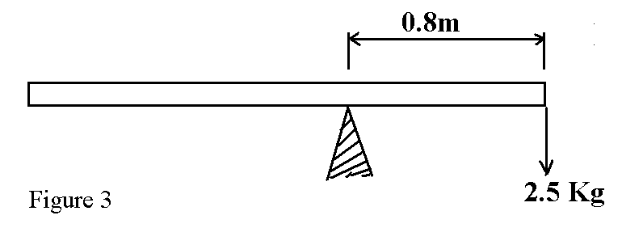

What is the length of the wooden plank in metres. (2mks)

**✓**

**✓**

**Length=(20+0.8)x2**

**=41.6m✓**

1. The figure below shows a force of 40N acting on a body of mass 4kg. The coefficient of friction between the surfaces is 0.05.

m = 4 kg

40N

Determine the acceleration of the body. (3mks)

$$p-Fr=ma$$

$40- μR=ma$

$40-\left(0.05×40\right)=4a$

$40-2 =4a$

$38=4a$

$a={9.5 m/s}^{2}$

1. State onefactor that affect the spring constant of a spring. (1mk)

* **Material of the spring**
* **Diameter of the spring**
* **Number of turns per unit length**
* **Length of the spring**
* **Thickness of the wire**

1. A girl in a school in Nakuru plans to make a barometer using a liquid of density 1.25gcm-3. If the atmospheric pressure in the school is 93750Nm-2. Determine the minimum length of the tube that she will require? (3mks)

**Atm pressure = heg**

**93750=h x 1250 x 10**

**H = 7.5 m**

1. A form one girl observed that when mercury is put into a glass it does not wet the glass. Explain the observations made by the girl. (1mk)

* **Mercury has strong cohesive force and heat adhesive forces.**
* **Water has strong adhesive forces and weak cohesive forces.**

**SECTION B (55MARKS)**

**ANSWER ALL QUESTIONS IN THIS SECTION**

1. (i) Define Archimedes’ Principle. (1mk)

**When a body is partially or wholly immersed in a fluid, it experiences an upthrust equal to the weight of the fluid displaced**

(ii) An object weighs 1.04N in air, 0.64N when fully immersed in water and 0.72N when fully immersed in a liquid. If the density of water is 1000 kg m-3, find:

* 1. The density of the liquid. (2mks)

**Upthrust in liquid**

**Upthrust in water  = 0.8 g/cm3**

* 1. Calculate the density of the metal block. (2mks)

**Weight of object in air**

**Upthrust in water √ = 2.6 g/cm3**

(iii) Calculate the upthrust on the metal and the apparent weight of the metal when completely submerged in salt solution of density 1.2g/cm3. (3mks)

**Upthrust in liquid = density x upthrust in water √ = 1.2 x 0.4 √ =0.48 N**

**Apparent weight = 0.56N**

* + 1. A block of metal of volume 80cm3 weighs 3.80N in air. Determine its weight

when fully sub merged in a liquid of density 1200kgm-3.(3mks)

**1.2 x 80 = 96g = 0.096kg √**

**Upthrust = 0.96N √**

**3.80-0.96 = 2.84N**

1. The following readings were obtained in an experiment to verify Hooke’s law using a spring.

|  |  |  |  |  |  |  |
| --- | --- | --- | --- | --- | --- | --- |
| Mass (g) | 0 | 25 | 50 | 75 | 100 | 125 |
| Reading (cm) | 10.5 | 11.5 | 12.5 | 13.5 | 14.4 | 16.0 |
| Force (N) |  |  |  |  |  |  |
| Extension (mm) |  |  |  |  |  |  |

1. Complete the table (2mks)
2. Plot the graph of extension against force. (5mks)



1. From the graph determine the:
2. Elastic limit (1mk)
3. Spring constant. (2mks)
4. (a) State the pressure law for an ideal gas (1mk)

**Pressure of fixed mass on gas is directly proportional to the absolute temperature provided volume is kept constant.**

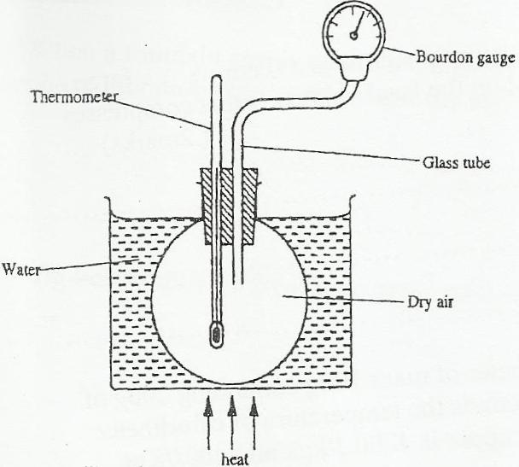 (b) The set up shows an arrangement to determine the relationship between temperature and pressure of a gas constant volume.

Explain how the result form the experiment can be used to determine the relationship between temperature and pressure. (3mks)

**Initial pressure and temperature is noted and recorded. The bath is heated, this in turn heats the air inside the flask, the values of T and P are taken at gives intervals.**

**The results obtained are used to plot a graph of pressure against temperature. A straight line graph is obtained, if temperature increases value the line passes through the origin.**

(c) A bicycle tyre is pumped to a pressure of 2.2 × 105pa at230C. After a race the

pressure is found to be 2.6 × 100 pa. Assuming the volume of the tyre did not change, what is the temperature of the air in the tyre. (3mks)

**= = =**

**T= 76.82 0C**

(d) Air is trapped inside a glass tube by a thread of mercury 240 mm long. When the

tube is held horizontally the length of the air column is 240mm.

750 mmHg

240mm

L1 = 240mm

Assuming that the atmospheric pressure is 750mm Hg and the temperature is constant; calculate the length of the air column when the tube is vertical with open end down. (3mks)

* **P1V1=P2V2**
* **(750 x 240) =Pa-240)**

**(750 x 240) = (750 – 240 )x**

**x = 352.94mm length of the air column**

1. a) A body of mass 20Kg hangs 4m and swings through a vertical height of 0.9m as shown inthe figure 11.

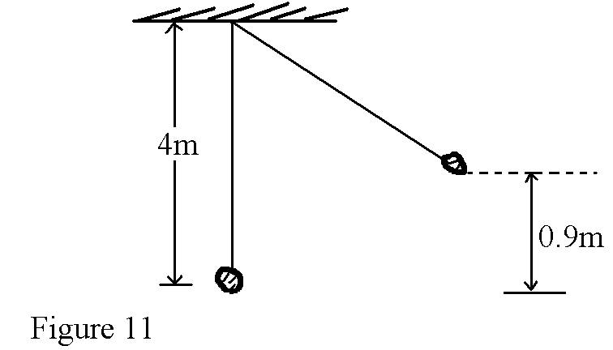

Determine;

i) The potential energy at its position. (2mks)

**P.e=mgh✓1**

**=20x10x0.9**

**=180J✓1**

ii) The speed of the body when passing through the lowest point. (2mks)

**Mgh= ½ mv2**

**v2=2gh**



✓

b) A crane lifts a load of 2000Kg through a vertical distance of 3.0m in 6 seconds.

Determine the;

i) Work done by the crane. (2mks)

**Work done=FS**

**=2000x10x3✓1**

**=6x104Nm✓**1

ii) Power developed by the crane. (2mks)

**Power=**



iii) Efficiency of the crane given that it is operated by an electric motor rated 12.5kW. (2mks)

**Efficiency=**

**=**

**=80%**

1. a) Define the term ‘heat capacity’. (1mk)

**Quantity of heat energy required to raise the given temperature of a given mass of a material by one degree Celsius**

b) A block of metal of mass 150g at a 1000C is dropped into a well lagged calorimeter of mass 215g and specific heat capacity 400JKg-1K-1 containing 100g of water at 250C. The temperature of the resulting mixture is 340C. (Specific heat capacity of water = 4200JKg-1 K-1). Determine;

i) Heat gained by calorimeter. (2mks)

**Heat gained = MC $∆∅$ (calorimeter)**

**=0.215 x 400 x (34-25)**

**= 774 J**

ii) Heat gained by water. (2mks) **Heat gained by water = MC $∆∅$**

**= 0.1 X 4200 X ( 34-25)**

**=3780 J**

iv) Specific heat capacity of the metal block. (3mks) **Heat lost by the metal block= MC $∆∅$**

**= 0.15 X c x (100-25)**

**= 11.25 C**

**Heat gained= Heat lost**

**Heat gained by water + heat gained by calorimeter= heat lost by metal block**

**774 + 3780= 11.25 C**

**4554 = 11.25 C**

**C= 404.8Jkg-1k-1**

18. (a) State two factors affecting centripetal force (2mks)

**Mass of the body**

**Radius of the path**

**Velocity of the object**

(b) A stone of mass 0.5kg is attached to a string of length 0.5m which will break if the tension exceeds 20N. The stone is whirled in a vertical plane, the axis of rotation being above the ground, as shown in the Figure 10 below.

Stone

5.5m

0.5mm

The angular velocity is gradually increased until the string breaks. At what angular velocity, ***w***, will the string break? (3mks)

$$T= {mw}^{2}r+mg$$

$20= \left(0.5 w^{2} ×0.5\right)+ \left(0.5×10\right)$

$20= {0.25 w}^{2}+5$

$15=0.25 w^{2}$

$w^{2}=60$

$w=7.746 rad/s$