GOLDEN ELITE EXAMINTIONS 2020
232/2
PHYSICS
THEORY
PAPER 2
2HOURS
MARKING SCHEME
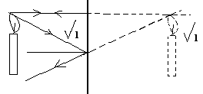
1.

2.
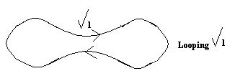

3. i) No. of turns
ii) Amount of current Max 2
slope of core

4. i) Wide view
ii) Gives upright image

5. i) Length
ii) Cross sectional area

6. a) 2/100 = 0.02m

b) F = 1/T = 1/8HZ

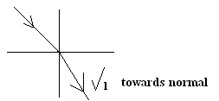
7. a)

b) Sin 300 = 1.4
Sin r0
r = 21.40

8. P = VI

= I/R

= 7 x 7 = 49 times

9. V = FΩ

300000000 = f x 1000
f = 3 x 105HZ

10. - Compare charges
- Detect charge

11. Easily magnetised& demagnetized
12. - Camera does not have iris to control amount of light as in the eye.
- Pinhole no lens while eye as a lens

13. - Progressive
- Mechanical

14. a) i) A device to store charge
ii) Ability of a capacitor to store charge.

b) i)Series 1/c = 1/4 + 1/5 = 5 + 4 = 9/20
20

Parallel c = 20/9 + 3 = 20 + 9 = 29/9μf
9
= 3.2 x 10-6F

ii) Q = cv
= 29/9 x 10-6 x 10
= 32.2 x 10-5C.

c) - Type of dielectric material
- Overlapping cross sectional area
- Distance between the plates

15. a) That which opposes the flow of electrical current.

b) i) Parallel ⇔1/R = 1/3 + 1/4
= 4 +3 = 7/12
12
R = 12/7

Series 12/7 + 2 = 12 + 14
7
= 3.86Ω

ii) V = 1R
⇔ 12 = I x 3.86
I = 12/3.86A

iii) Through 4Ω resistor
= 3/7 of total

= 3/7 x V/R

= 3/7 x 12 x 7 A

= 1.38A

E = Pt = VIt

= 12 x 1.38 x 2 x 60J

= 1987.2J
d) Radio circuit
Heater coils
Bulb filament

16. a) After rubbing two different material, one losses electrons leaving it with majority protons which are positively charged thus acquires positive charge.

b) Leaf collapses
- Sharp regions are good charge dischargers leaving the electroscope with no charge.

c) Burning candles makes the air near it charged thus repelled by the charge on the metal.

d) When lightening strikes the tree acts like an arrestor and body near it is affected.

e) - Can cause fire
- A can kill if not arrested

17. a) - Electrical
- Induction
- Storing

b) Because magnetic material are attracted by magnets and even unlike poles of a magnet.
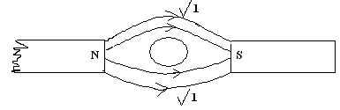
c)

d) i) X - North
Y - South

ii) - Electric bell
- Microphones / speaker

18. a) Light from dense liquid to less dense air is refracted away thus lifting the object.
b) i) From the graph paper

ii) ∆ Y = Real depth
∆ X Apparatus depth
= 11 - 2
8 - 1.5
= 9/6..5 = 1.385 (The gradient of the graph)
