Name: …………………………………………………………… Index No. …………………………
School: …………………………………………………………. Candidate’s Sign. …………………
232/3
PHYSICS
PAPER 3
DECEMBER 2020
TIME: 2 ½ HOURS
LANJET JOINT EXAMINATION 2020
Kenya Certificate of Secondary Education.
232/3
PHYSICS
PAPER 3
TIME: 2½ HOURS.

INSTRUCTIONS TO CANDIDATES:
- Write your name and index number in the spaces provided above.
- Sign and write the date of the examination in the spaces provided above.
- You are supposed to spend the first 15 minutes of the 2 ½ hours allowed for this paper reading the whole paper carefully before commencing your work.
- Marks are given for a clear record of the observation actually made, their suitability, accuracy and the use made of them.
- Candidates are advised to record their observations as soon as they are made
- Non-programmable silent electronic calculators may be used.
- Candidates should check the question paper to ascertain that all the pages are printed andthat no questions are missing.
FOR EXAMINER’S USE ONLY.

Question | Maximum score | Candidate’s score
1 | 20
2 | 20
TOTAL | 40

This paper consists of 8 printed pages candidates should check the questions to ascertain that all pages are printed as indicated and that no questions are missing

QUESTION 1 (PART A)

You are provided with the following:
- A watch glass.
- A small piece of plasticine.
- A marble.
- A stopwatch.
- Vernier calipers.
- An electronic balance (to be shared).
- Measure the mass M of the marble.

M = …………………g (½mk)

- Place the watch glass flat on the table with a small piece of plasticine to fix it firmly to the table at the place it touches.
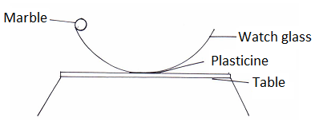
- Release the marble from one end of the watch glass and time 10 complete oscillations with a stop watch. Repeat this three times.

- Record your values in table 1 below
Table 1
 | Time for 10 oscillations | Periodic time T(s)
1
2
3 |  |  | (2mks)

Find the average periodic time T.

T = …………………. S. (½mk)

- Measure the diameter of the marble with the verniercallipers and hence find its radius.

Diameter d = …………………….. m (½mk)

Radius r = ……………………… m (½mk)

- Determine the volume (V) of the marble given that:
(1mk)

- Calculate the radius of curvature of the watch glass R from the formula.
(2mks)
Where g = 9.8m/s² and π = 3.142.

PART B
You are provided with the following
- A triangular prism of 60⁰.
- Four optical pins
- A soft board
- A plain piece of paper

Proceed as follows
(a) Place the plain sheet of paper on the soft board
(b) Place the prism with one face on the plain paper and trace its outline.
(c) Remove the prism from the plain sheet of paper.
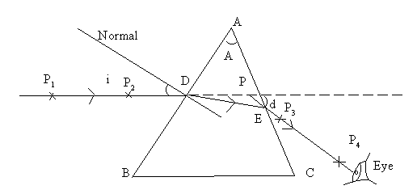

(d) Mark angle A and record its value.
A = ..........................(1mk)
(e) Draw a normal as shown and draw a ray of incident on the normal at an angle of incidence of 300.
(f) Replace the prism on the outline on the sheet.
(g) Stick two pins P1 and P2 along the path of the incident ray as shown in the diagram.
(h) View the images of P1 and P2 through the glass prism through face AC as shown on the diagram.
(i) Stick two pins P3 and P4 so that they appear to be in line with P1 and P2 as seen through the glass prism.
(j) Remove the pins and prism from the sheet. Trace the path of the ray until it emerges from the
glasses shown in the diagram.
(k) Extend the incident ray and the emergent ray until they meet at P. Measure and record the angle
of deviation d.
(l) Repeat the experiment for other angles of incidence shown in the table.

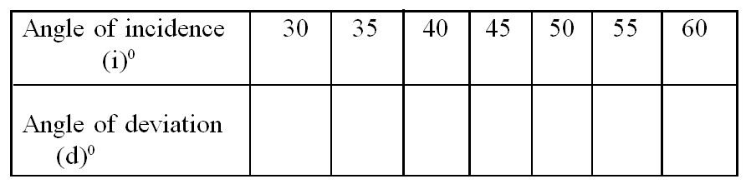

(3 marks)

(m) Plot a graph of angle of deviation (d)0 against angle of incidence (i)0. (5 marks)

(l) Present your working.

(n) From the graph determine the minimum angle of deviation D. (1 marks)

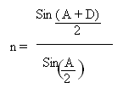
(p) Find the refractive index of the prism material using (3 marks)

QUESTION 2
PART A
- You are provided with the following apparatus.
- Two dry cells.
- Nichrome wire 100cm on a mm scale.
- An ammeter.
- Cell holder.
- Voltmeter.
- Connecting wires with crocodile clips.
- Switch.
Proceed as follows;
- Connect the circuit as shown in the diagram.

- Connect the ends A and C where AC is the length L of the Nichrome wire across the terminals as shown. Close the switch and measure both current I and potential difference (P.d) across the wire AC when L = 100cm.
Current I = ………………………………… (1 mark)
P.d, V = …………………………………… (1 mark)
- Measure the E.m.f of the cells, E.
E = ………………………………………… (1 mark)
- Reduce the length L (AC) to the lengths shown in the table below. In each case record the current, I, and the corresponding P.d.
Length L (cm) | 100 | 70 | 60 | 50 | 40 | 20
I (A)
P.d (V)
E – V (v)

(6 marks)
- Plot a graph of E – V against I(A) on x-axis in the grid provided. (5 marks)

- Given that E = V + Ir, determine the internal resistance, r, of each cell. (3 marks)

