**LANJET CLUSTER JOINT MOCK EXAM**

**PHYSICS PAPER 3**

**DECEMBER 2020**

**MARKING SCHEME**

**QUESTION ONE (PART A)**

(a) Mass of marble (mark students value) 🗸½

(d) Table 1

Award 2 marks for complete table values.

Correct to 2d.p. for time of oscillation and at least 2d.p. for periodic time.

Award 1 mark for complete table without adherence to accuracy.

Award 0 for incomplete table.

T = 0.70s (Use students averaged with a range of ± 0.02s 🗸½

(e) d = 1.70cm ± 0.05cm 🗸½

r = 0.85cm🗸½

(f) 

= 2.573cm³🗸¹

(g) 🗸¹



= 0.9369cm 🗸¹

* Check substitution and answer of the student.

**QUESTION 1 PART B**

1. 600

(L) Values of d decrease, then increase. Mark the trend. (8 marks)

m).

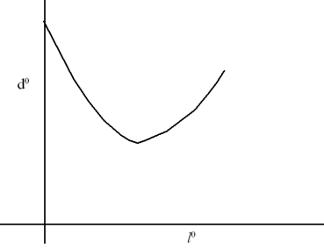

Scale

Axis labelled

Plotting

Curve

(n) Read from the graph the minimum value for d (300)

(p) Numerator and evaluated

Denominator and evaluated

Substitution

Accuracy, n = 1.5

**QUESTION 2.**

1. b) I = 0.12 0.01A✓1



V = 2.6 0.1V ✓1



c) E = 3.3 0.2V ✓1 maximum range, E = 3.5



d)

|  |  |  |  |  |  |  |
| --- | --- | --- | --- | --- | --- | --- |
| Length L (cm) | 100 | 70 | 60 | 50 | 40 | 20 |
| I (A) | 0.12 | 0.19 | 0.2 | 0.24 | 0.28 | 0.42 |
| P.d (V) | 2.6 | 2.5 | 2.4 | 2.35 | 2.3 | 2.0 |
| E – V (v) | 0.9 | 1.0 | 1.1 | 1.15 | 1.2 | 1.5 |

Use the E of the student in the row containing the values of E – V(f)

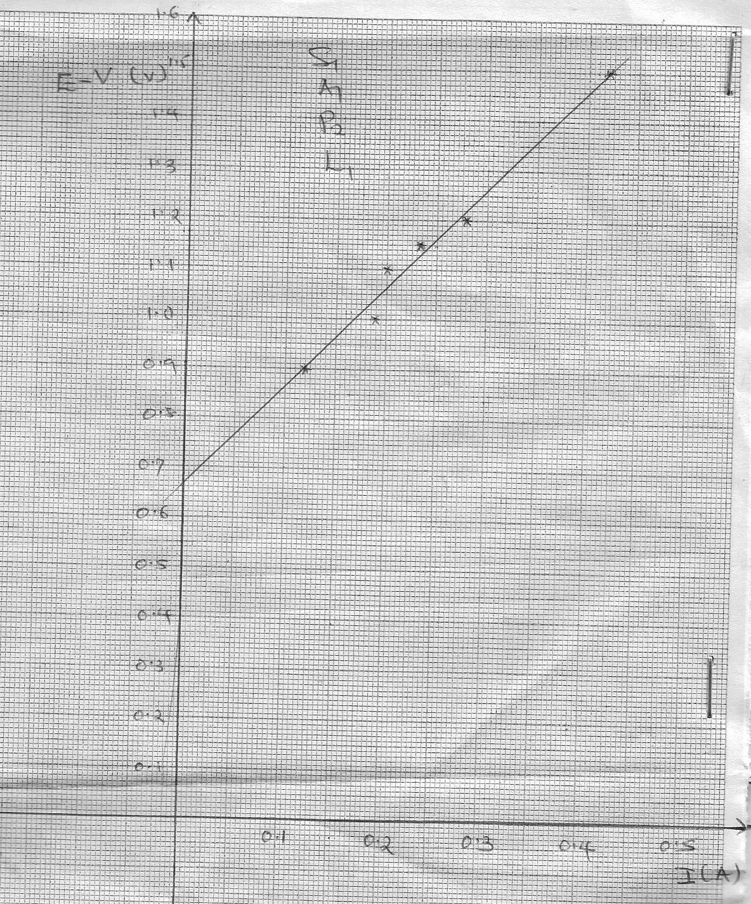

f) Slope = ✓1 =

g) E = V + Ir

E – V = rI + C✓1

r = internal resistance = slope = 2Ω ✓1