NAME: ………………………………………………CLASS:….…………… ADM NO:…………
SIGNATURE:………………………………… DATE:…………………………
232/2
PHYSICS
PAPER 2
MARCH 2020

MAGS 2 CYCLE 7 EXAMINATIONS - 2020
The Kenya Certificate of Secondary Education
Physics Paper 2

Instructions to candidates

- This paper consists of two sections A and B.
- Answer all the questions in the two sections in the spaces provided after each question
- All working must be clearly shown.
- Electronic calculators, mathematical tables may be used.
- All numerical answers should be expressed in the decimal notations.

SECTION | QUESTION | MAX MARKS | CANDIDATE’S SCORE
A | 1 – 12 | 25
B | 13 | 10
 | 14 | 10
 | 15 | 09
 | 16 | 16
TOTAL |  | 80

SECTION A (25 Marks)
Answer ALL questions in this section.

- Figure 1 shows the V-I characteristic curve of a torch bulb.

Fig.1

Explain the shape of the graph. (2 marks)
……………………………………………………………………………………………………………………………….……………..………………………..……………………………..………
- The size of the pinhole camera is increased. State and explain what happens to the image.

…………………………………………………………………………………………………(1 mark)
- Define the term sensitivity (1 mark)
……………………………………………………………………………………………………
- Why is concave mirrors used as a saloon mirror? (1 mark)
……………………………………………………………………………………………………
- Figure 2 shows a graph of magnetisation against magnetising current for two materials A and B.

Fig. 2

a) State with a reason, the material which is more suitable for use in a transformer to concentrate the magnetic fields. (2 marks)

……………………………………………………………………………………………………………………………….……………..………………………..……………………………..………

b) Determine the current required to obtain saturation for the material which is suitable for making a permanent magnet. (1 mark)

…………………………………………………………………………………………………………………………….……………..………………………..……………………………..……
- A beaker of height 10 cm is filled with water. An optical pin which is at the bottom of the beaker is then viewed from the top of the beaker. How far does the pin appear from the surface, if the refractive index of water is ) (2 marks)
……………………………………………………………………………………………………………………………….……………..………………………..……………………………..………
- An electric heater takes 4 minutes to heat some water to boiling point. How long would it take if the current flowing through it is doubled? (2 marks)
……………………………………………………………………………………………………………………………….……………..………………………..……………………………..………
- (a) State Ohm’s law (1mark)
……………………………………………………………………………………………………………
(b) The figure 3 below shows part of the scale of a voltmeter, which is being used in an experiment to measure potential difference across a resistor.
0.6V
3.0V

1

2

0

3

0.2

0

0.4

0.6

V

Fig.3

- State the accuracy of the upper and the lower scales of the voltmeter. (2 marks)
……………………………………………………………………………………………………………
- Record the reading shown by the lower scale of the voltmeter. (1 mark)
……………………………………………………………………………………………………
- The figure 4 shows region of electromagnetic spectrum.
Fig.4
Name the region that representsand give one use of each. (4marks)
  - Ultraviolet
  - Infrared
  - X- ray
  - Radio wave
- State one advantage of optical fibre cable over conventional copper cables as used in telecommunication. (1 mark)
…………………………………………………………………………………………………………
- Fig 5. below shows the paths of two rays which enter the eye from a small object immersed in water.
Eye
Fig. 5
Water
Water surface
Draw rayson the diagram to show a possible position of the object and itsactual position. (2marks)
- State two conditions necessary for total internal reflection to occur. (2marks)
………………………………………………………………………………………………………………………………………………………………………………………………………………………

SECTION B(55 Marks)
Answer ALL questions in this section.

- (a) (i) Define capacitance. (1 mark)

……………………………………………………………………………………………………………………………………………………………………………………………………………………………
(ii) A capacitor is made of two metal plates, insulated from one another, as shown in the Fig 6.

Fig. 6
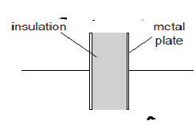

Explain why the capacitor is said to store energy but not charge. (2 marks)

……………………………………………………………………………………………………………………………………………………………………………………………………………………………
……………………………………………………………………………………………………………………………………………………………………………………………………………………………
(b) Three uncharged capacitor X, Y and Z, each of the capacitance 12 microfarads, are connected as shown in Fig 7s below

Fig. 7
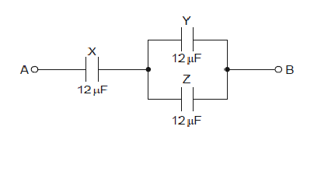

A potential difference of 9.0V is applied between points A and B. Calculate the combined capacitance of the capacitors X,Y and Z. (3 marks)

……………………………………………………………………………………………………………………………………………………………………………………………………………………………
……………………………………………………………………………………………………………………………………………………………………………………………………………………………

(c)Explain why, when the potential difference of 9.0V is applied, the charge on one plate of capacitor X is 72 microcoulombs. (2 marks)

……………………………………………………………………………………………………………………………………………………………………………………………………………………………
……………………………………………………………………………………………………………………………………………………………………………………………………………………………
(d) Determine ;
I . the potential difference across capacitor X, (2 marks)

……………………………………………………………………………………………………………………………………………………………………………………………………………………………
……………………………………………………………………………………………………………………………………………………………………………………………………………………………
II. the charge on one plate of capacitor Y. (2 marks)

……………………………………………………………………………………………………………………………………………………………………………………………………………………………
……………………………………………………………………………………………………………………………………………………………………………………………………………………………
- A wire was connected to a battery and it was found that the energy converted to heat was 30J when 20 coulombs of charge flowed through the wire in 5 seconds.
Calculate;
(i) the p.d between the ends of the wire. (2marks)
……………………………………………………………………………………………………………………………………………………………………………………………………………………………
(ii) the current flowing through the wire. (2marks)
………………………………………………………………………………………………………………………………………………………………………………………………………………
(iii) the resistance of the wire. (2marks)
……………………………………………………………………………………………………………………………………………………………………………………………………
(iv) the average power development in the wire. (2marks)
…………………………………………………………………………………………………………………………………………………………………………………………………………………………
The graph below shows results obtained in an experiment to determine the e.m.f.(E) and the internal resistance, r, of a cell.
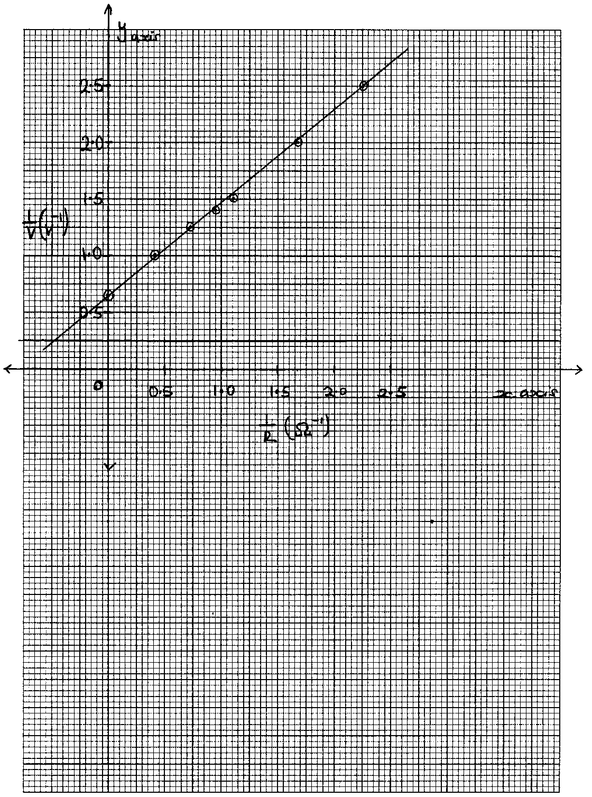
Given that the equation of the graph is = + 1
Use the graph to determine the values of:-

(i) E (2marks)
…………………………………………………………………………………………………………………………………………………………………………………………………………
ii) r (3marks)
……………………………………………………………………………………………………………………………………………………………………………………………………………………
- Thefigure8 belowshowstwographswhichrefertothesamewave.
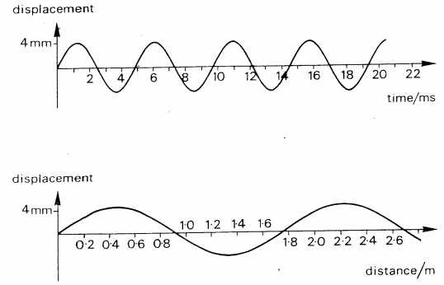
Fig. 8

    - Calculatethespeedofthewave. (4marks)

……………………………………………………………………………………………………………………………………………………………………………………………………………………
……………………………………………………………………………………………………………………………………………………………………………………………………………………

    - Distinguishbetweenprogressiveandstationarywaves. (2marks)
……………………………………………………………………………………………………………………………………………………………………………………………………………………………………
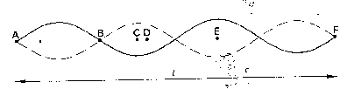
ii) Figure9 belowshowsastationarywaveon astringstretchedbetweentwopointsAandFwhich areadistanceL apart.

Fig. 9

DescribetheoscillationsofthepointsB,C,Dand E.Comparetheseoscillationsintermsof theirrelativephasesand amplitudes. (3marks)
…………………………………………………………………………………………………………………………………………………………………………………………………………………………………………………….………………………………………………………………………
iii) WhatisthewavelengthintermsofL. (1mark)
………………………………………………………………………………………………………………
- i)Statethecharacteristicsofimagesformedbya pinholecamera. (2marks)

………………………………………………………………………………………………………………………………………………………………………………………………………………
ii)Whatistheeffectsontheimage whenthecameraiselongated? (2mark)

………………………………………………………………………………………………………………………………………………………………………………………………………………………………

The figure 10 below shows how a white light behaves when it is incident on a equilateral glass prism.

Fig. 10
iii)Explain why it split into different colours between A and B. (3 marks)
……………………………………………………………………………………………………………………………………………………………………………………………………………
iv)Suppose the white light is incident on the face SR normally, State and explain the observation. (3 marks)
………………………………………………………………………………………………………………………………………………………………………………………………………………………
- (a) Define the term principal focus in relation to a thin convex lens (2marks)
………………………………………………………………………………
(b) Distinguish between a real and a virtual image. (2marks)
………………………………………………………………………………………………………………
(c) The Fig.11 below shows an arrangement of lenses, L_{o} and L_{e} used in a compound
microscope F_{o} and F_{e} are principal foci of L_{o} and L_{e} respectively.
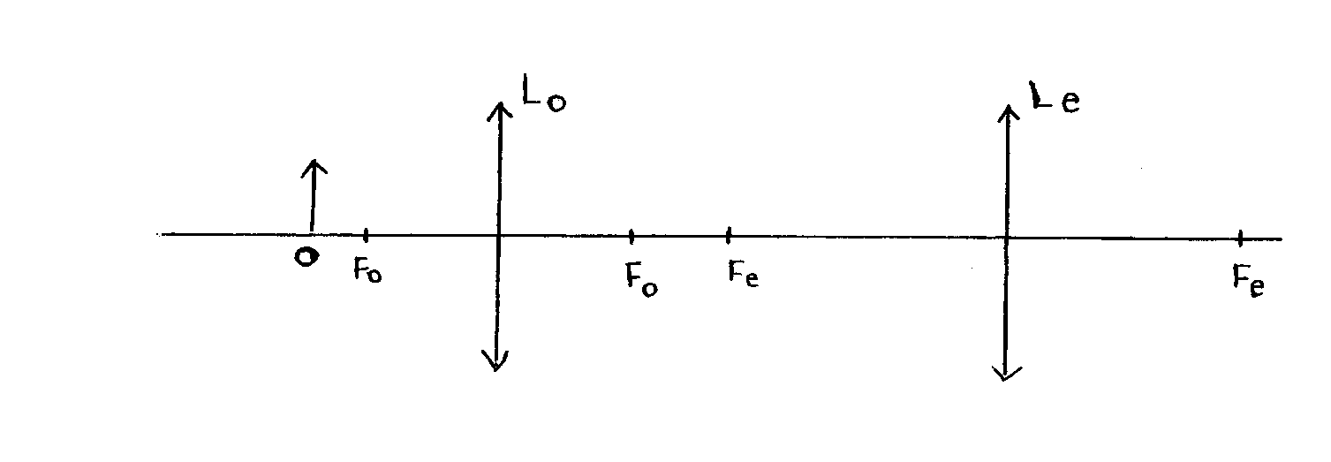

Figure 11
Draw the rays to show how the final image is formed in the microscope (3marks)
(d) The table below shows the object distance, U and the corresponding image distance, V for an
object placed
U (cm) | 20 | 25 | 30 | 35 | 40 | 45
V (cm) | 60.0 | 37.5 | 30.0 | 26.3 | 24.0 | 22.5
(cm⁻¹)
(cm⁻¹)

(i) Complete the table and plot a graph of against (7marks)
(ii) Determine the focallength of the lens. (2marks)

