Name _________________________________________ Index No____________________
School _____________________ Candidate’s Signature ___________
Date __________________________
232/3
Physics Practical
Paper 3
March/April, 2020
Time: 2 $hours$
ARISE AND SHINE TRIAL 1 EXAM
MARCH/APRIL – 2020

INSTRUCTIONS TO CANDIDATES
- Write your name and index number in the spaces provided above
- Sign and write the date of examination in the spaces provided above
- Answer ALL the questions in the spaces provided in the question paper
- You are supposed to spend the first 15 minutes of the 2 ½ hours allowed for this paper reading the whole paper carefully before commencing your work.
- Marks are given for a clear record of the observations actually made, their suitability, accuracy and the use made of them.
- Candidates are advised to record their observations as soon as they are made.
- Non-programmable silent electronic calculators and KNEC Mathematical tables may be used.
- Candidates should check the question paper to ascertain that all the pages are printed as indicated and that no questions are missing.

For Examiners’ Use Only
Question 1
QUESTION | i | ii | iii | vi | vii | viii | ix | TOTAL
MAXIMUM SCORE | 1 | 1 | 1 | 7 | 5 | 2 | 3 | 20
CANDIDATE’S SCORE

Question 2
QUESTION | Q2A |  |  | Q2B |  |  |  | TOTAL
MAXIMUM SCORE | c | d | e | b | c | d | e
CANDIDATE’S SCORE |  |  |  |  |  |  |  | 20
This paper consists of 8 printed pages
QUESTION 1
PART A
You are provided with the following apparatus:
- A metre rule
- A spring balance
- A weight of 2N with a hook
- Stand
- Knife edge support
- Two light strings about 30cm long

Proceed as follows;
- Using the strings provided make two loops to be used as hooks L₁ aNd L₂ in the diagram.
- Suspend the spring balance from a clamp and using one of the loops support the rule from the spring so that the loop L₂ is on the 95cm mark.
- Support the other end of the rule with a knife edge at the 10cm mark so that the rule is horizontal.
- Using loop L₁ suspend the 2N weight at a distance d=10cm from the knife edge as shown and take the readings of the spring balance, F. Record the results in the table.
- Adjust the distance d to 20cm, 30cm etc. and each time recording the reading of the balance to complete the table. (4 marks)
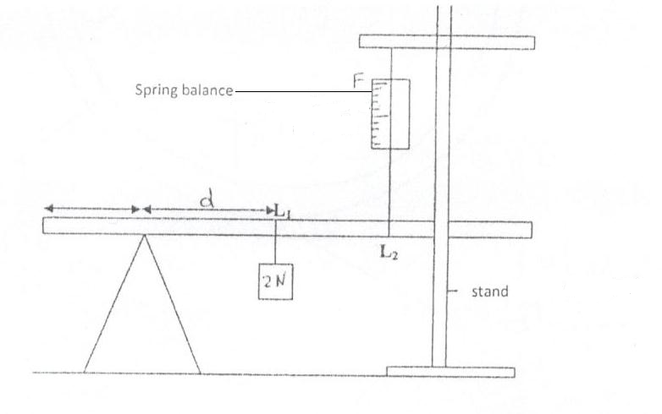
Distance (d) (cm) | 10 | 20 | 30 | 40 | 50 | 60 | 70 | 80
Force (N)

(f). (i). Plot a graph of force (F) against distance (d). (4 marks)
(ii). From the graph determine
(a). The slope (3 marks)
………………………………………………………………………………………………………………………………………………………………………………………………………………………………………………………………………………………………………………………
(b). The value of f when equation of the graph is 85f = 2md + 40k.
Determine the value of k and m. (2 marks)
………………………………………………………………………………………………………………………………………………………………………………………………………………………………………………………………………………………………………………………
Part B
You are provided with the following
- Watch glass
- A class marble
- Plasticine
- Stop watch
- Micrometer screw gauge
(a). Place the watch glass on flat table and hold it firmly using plasticine.
(b). Roll the marble and count five oscillations.
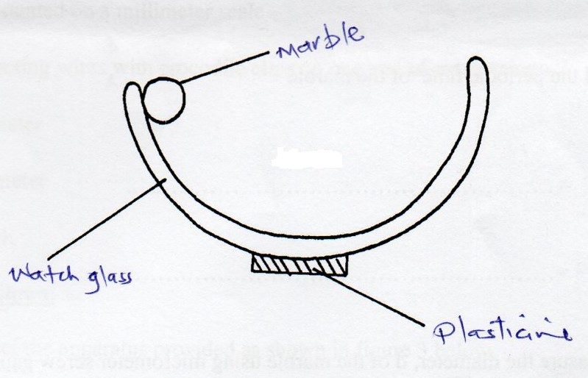
(i). Time for five Oscillations
t = ………………………………………… (1 mark)
(ii). Repeat three times and find the average (1 mark)
t₁ = …………………………………………………
t₂ = …………………………………………………
t₃ = …………………………………………………..
(iii). Find the periodic time of the marble. (1 mark)
T = ____________________________________

T² = ___________________________________
(c). Measure the diameter, d of the marble using micrometer screw gauge
d = ……………………………………… (1 mark)
d). You are given the following equation
T = 2π $\frac{\sqrt{7 \left(b – r\right)}}{5g}$

Where r is the radius of the marble, g is acceleration due to gravity, b is a constant of the system.
Determine the value of b. (2 marks)
………………………………………………………………………………………………………………………………………………………………………………………………………………………………………………………………………………………………………………………………………………………………………………………………………………………………
QUESTION 2

You are provided with the following apparatus
- Two new dry cells
- A resistor labeled Q
- Wire mounted on a millimeter scale
- 6 connecting wires 3 with crocodile clips on one end
- A voltmeter
- An ammeter
- A switch

Proceed as follows:
(a). Connect the apparatus provided as shown in figure 3 below.
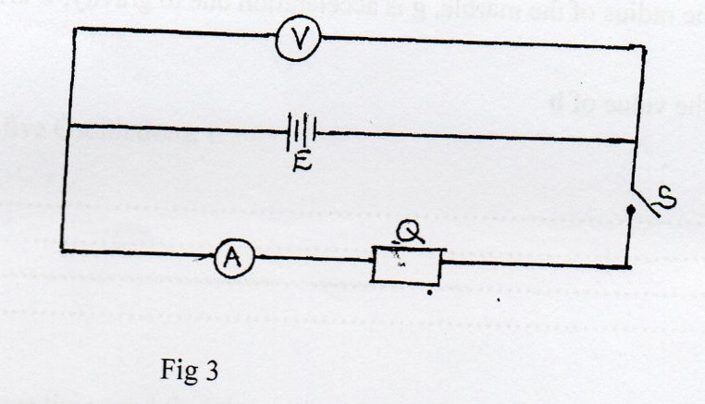
(i). Take the voltmeter reading when the switch S is open.
V₁ = ………………………………….volts (1 mark)
(ii). Close the switch S, and take the voltmeter reading V₂ and the ammeter reading I
V₂ = ………………………………volt (1 mark)
I = ……………………………….. Amperes (1 mark)
(iii). Calculate the quantity P = V₁ – V₂ (2 marks)
I
………………………………………………………………………………………………………………………………………………………………………………………………………………………………………………………………………………………………………………………………………………………………………………………………………………………………………………………………………………………………………………………………………
(b). Set up the circuit as shown in figure 4.
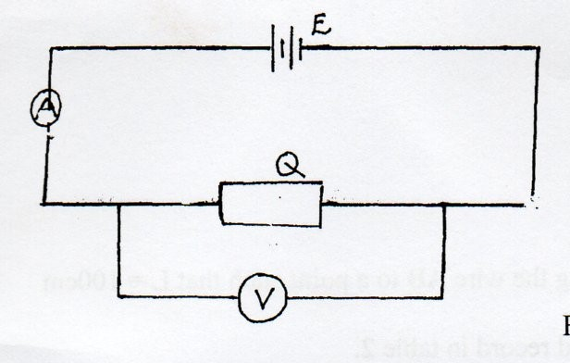
Figure 4
(i). Take the voltmeter reading V and the ammeter reading I. (2 marks)
V = ………………………………………….
I = ……………………………………………
(ii). Determine the resistance R of Q given that (1 mark)

R =V
I
………………………………………………………………………………………………………

………………………………………………………………………………………………………
(c). Set up the circuit shown in figure 5.
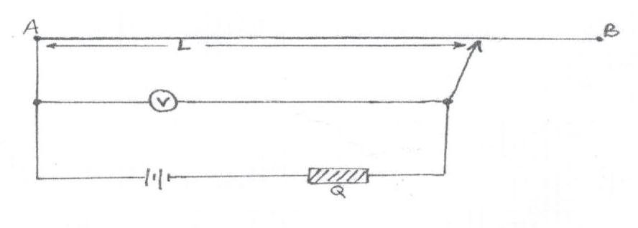
(d). Move the crocodile clip along the wire AB to a point such that L = 100cm
Note the voltmeter reading and record in table 2.

(e). Repeat (d). above for values of L =80cm,60cm,40cm,20cm and 0cm, tabulate your results.
(5 marks)
Table 2
Length L (cm) | 100 | 80 | 60 | 40 | 20 | 0
1 1
L cm
Voltmeter Reading
(V)
¹/_{V} ¹/_{V}

(f). Plot the graph of ¹/_{V} against ¹/_{L.} (5 marks)

(g). Find the slope of the graph. (2 marks)
………………………………………………………………………………………………………………………………………………………………………………………………………………………………………………………………………………………………………………………………………………………………………………………………………………………………

