NAME:…………………………………………INDEX NO. …………………ADM NO….................

232/2 Signature: ……………………..… Date: ………………………

PHYSICS
PAPER 2

MARCH/APRIL 2020
TIME: 2 HRS.
ARISE AND SHINE TRIAL 1 EXAM
MARCH/APRIL 2020

INSTRUCTIONS TO CANDIDATES:
- Write your Name and Index Number in the spaces provided above.
- Sign and write the date of examination in the spaces provided above.
- This paper consists of two sections; A and B.
- Answer ALL the questions in Section A and B in the spaces provided.
- All workings must be clearly shown.
- Non-programmable silent electronic calculators and KNEC Mathematical tables
may be used.

FOR EXAMINER’S USE ONLY:

SECTION | QUESTION | MAXIMUM SCORE | STUDENT’S SCORE
A | 1 - 13 | 25
B | 14 | 12
 | 15 | 14
 | 16 | 08
 | 17 | 10
 | 18 | 11
TOTAL SCORE |  | 80

SECTION A (25 MARKS)

Answer all questions in this section in the spaces provided.

1. The figure below shows two point sources of light with an opague object placed between them and the screen.

.

Light Source Screen
. Opaque object

Complete the diagram to show the nature of the shadows formed. Label the shadows. (2 marks)
………………………………………………………………………………………………………………………………………………………………………………………………………………………………………………………………………………………………………………………………………………
2. A boy watching fireworks display sees the light from an explosion and hears the sound 2.5 seconds later. Determine how far the explosion is. (Speed of sound in air 330m/s). (2 marks)
………………………………………………………………………………………………………………………………………………………………………………………………………………………………………………………………………………………………………………………………………………

3. The table in figure 9 below shows part of the electromagnetic spectrum in order of decreasing wavelength.

A | B | INFRA RED RADIATION | VISIBLE LIGHT | C | D
(a). How are waves C produced? (1 mark)
………………………………………………………………………………………………………………………………………………………………………………………………………………………………
(b). State one use of the wave D. (1 mark)
………………………………………………………………………………………………………………………………………………………………………………………………………………………………
4. A polythen rod held in the hand can be charged by rubbing it with cloth but a metal rod cannot be charged in a similar way. Explain why. (2 marks)
………………………………………………………………………………………………………………………………………………………………………………………………………………………………………………………………………………………………………………………………………………
5. An object X is brought close to, but not touching, a bar magnet which placed on an electronic balance as shown in figure 3. The reading on the balance decreases. Explain this observation. (1 mark)
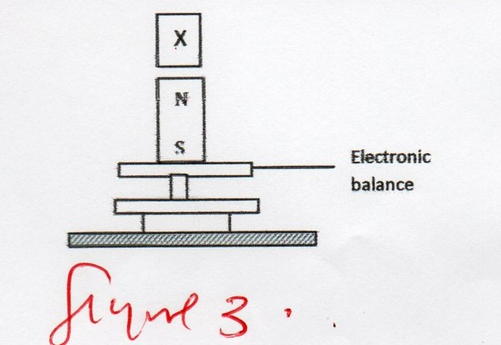

Figure 3

………………………………………………………………………………………………………………………………………………………………………………………………………………………………………………………………………………………………………………………………………………
6. A pendulum bob takes 0.5 second to move from its mean position to a maximum displacement position. Calculate its frequency. (2 marks)
………………………………………………………………………………………………………………………………………………………………………………………………………………………………………………………………………………………………………………………………………………………………………………………………………………………………………………………………
7. The figure below shows a ray of light incident on a glass prism.

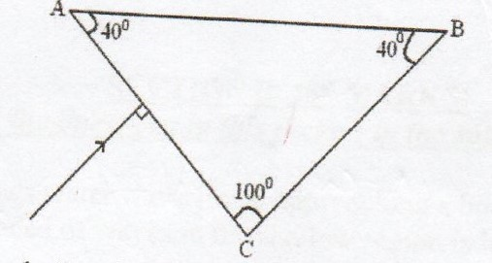

Given that the critical angle for the glass is 39º, sketch on the diagram the path of the ray through the prism. (2 marks)

- Figure 2 below shows a Leclanche’ cell
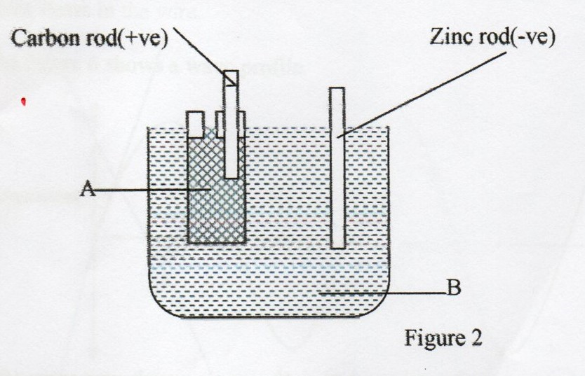
Name the chemical substances in the parts labeled.
A……………………………. (2 marks)

B ……………………………

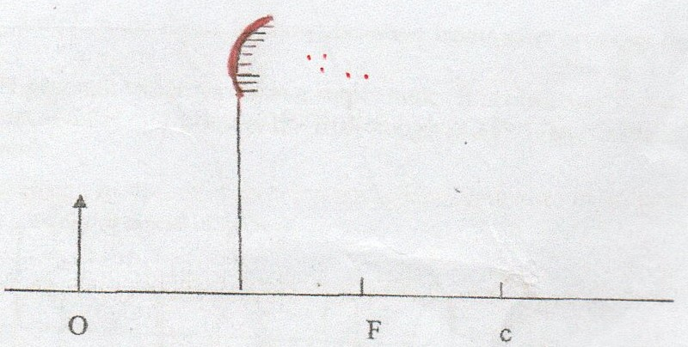
Draw rays to locate the position of the image. (2 marks)

- A plotting compass is placed above an insulated wire shown in figure 5

N S figure 5

When current is switched on the North Pole deflects as shown. Indicate the direction in which the current flow in the wire. (1 mark)
………………………………………………………………………………………………………………
……………………………………………………………………………………………………………..
11.The three resistors K, L and M in figure 7 have equal resistance. If the reading on ammeter X is 6A, determine the reading on ammeter Y? (3 marks)
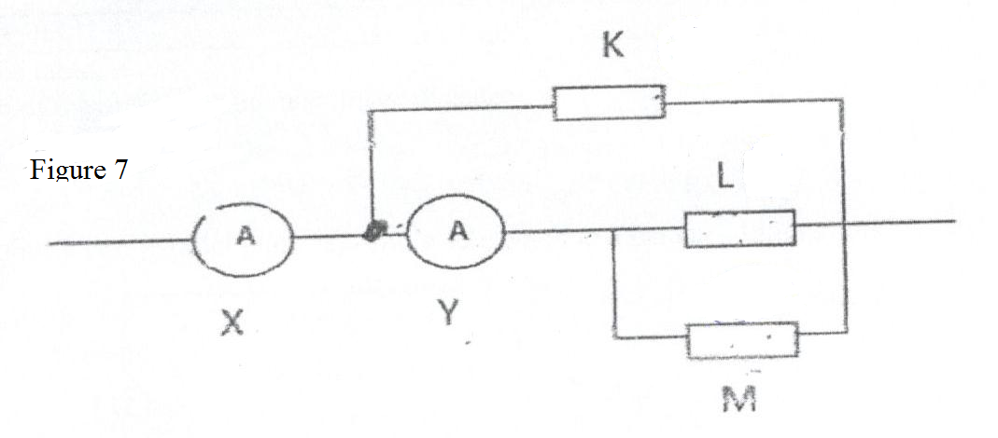
………………………………………………………………………………………………………………………………………………………………………………………………………………………………………………………………………………………………………………………………………………………………………………………………………………………………………………………………
- State two factors that determine the magnitude of an induced e.m.f in a conductor. (2 marks)
………………………………………………………………………………………………………………………………………………………………………………………………………………………………

13. (a). Explain why filament bulbs use more energy as compared to fluorescent tubes. (2 marks)
………………………………………………………………………………………………………………………………………………………………………………………………………………………………………………………………………………………………………………………………………………
………………………………………………………………………………………………………………

SECTION B (55 MARKS)
Answer all questions in this section

14. The following data was collected to find the focal length of a convex lens
Object distance,u,cm | 44.3 | 30.0 | 23.9 | 20.0 | 15.0
Magnification | 03 | 0.5 | 0.7 | 1.0 | 2.0
Image distance,v,cm
(a). Complete the table. (2 marks)
(b). Plot a graph of magnification against image distance (5 marks)
(c). From the graph, determine f, the focal length of the lens (3 marks)
(d). Determine the power p of the lens. (2 marks)

15. (a). Figure below shows two parallel plate capacitors connected to a battery. Initially the switch S is open.
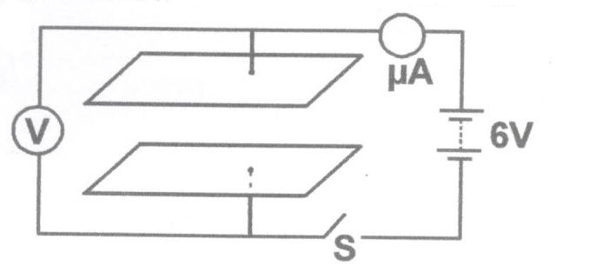
The switch is now closed and left for a few seconds.
- In the space below sketch a graph of current reading with time from time the switch is closed.
(2 marks)
………………………………………………………………………………………………………………………………………………………………………………………………………………………………………………………………………………………………………………………………………

- Determine the reading of V after a long time. ( 1mark)
…………………………………………………………………………………………………………………………………………………………………………………………………………………………

- How does the capacitance of the plates change when the plates are moved further apart?
(1 mark}
…………………………………………………………………………………………………………………………………………………………………………………………………………………………
(b). Figure below shows an electrical circuit with three capacitors A,B and C and a resistor of value 12KΩ and a p.d of 12V across the capacitors. (2 marks)

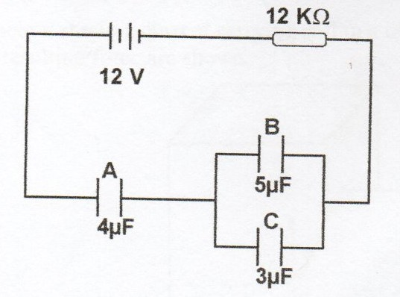

Determine:
- the current flowing in the system. (2 marks)
…………………………………………………………………………………………………………………………………………………………………………………………………………………………

- the total capacitance of the capacitors (3 marks)
…………………………………………………………………………………………………………………………………………………………………………………………………………………………
……………………………………………………………………………………………………………..

- the total charge stored in the capacitors (3 marks)
……………………………………………………………………………………………………………
……………………………………………………………………………………………………………..
……………………………………………………………………………………………………………………………………………………………………………………………………………………………………………………………………………………………………………………………………………………………………………………………………………………………………………………
16. (a).Use the figure below to answer the questions that follows
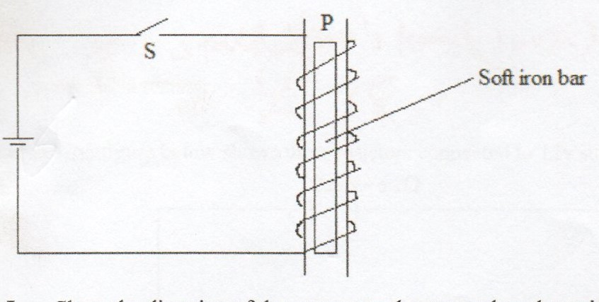
- Show the direction of the current on the turns when the switch S is closed. (1 mark)
…………………………………………………………………………………………………………………………………………………………………………………………………………………………
- State the polarity at P. (1 mark)
…………………………………………………………………………………………………………………………………………………………………………………………………………………………
- Explain using domain theory what happens on the soft iron bar. (1 mark)
……………………………………………………………………………………………………………
……………………………………………………………………………………………………………
- If steel bar was used instead, what could be the difference? ( 1mark)
…………………………………………………………………………………………………………………………………………………………………………………………………………………………
(b). Figure below shows a current carrying coil in a magnetic field. The direction of the current and the resulting force are shown.
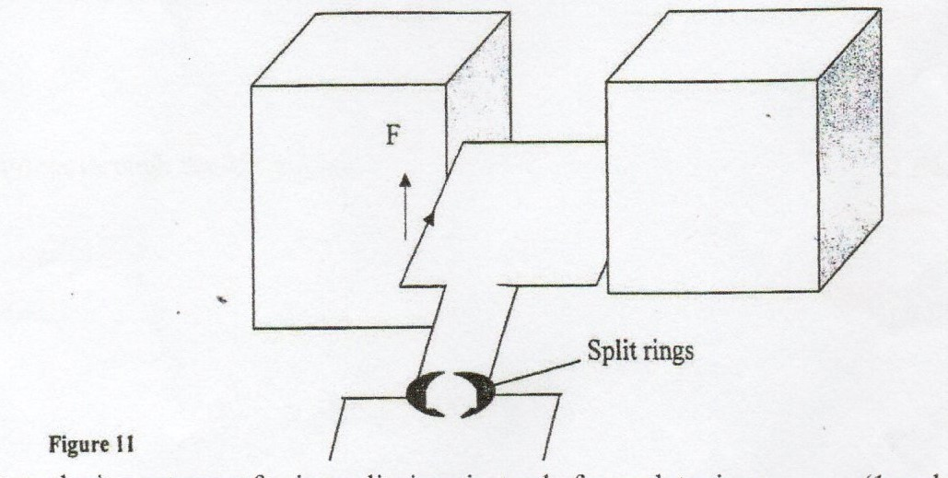
(I). State the importance of using split rings instead of complete rings. (1 mark)
…………………………………………………………………………………………………………………………………………………………………………………………………………………………

(II). Indicate the polarity of the magnets if the force developed acts as shown in the diagram. (1 mark)
…………………………………………………………………………………………………………………………………………………………………………………………………………………………

(III). State one factor that would be altered to change the speed of the coil. (1mark)
…………………………………………………………………………………………………………………………………………………………………………………………………………………………

(c). Give a reason why attraction in magnetism is not regarded as a reliable method of testing polarity of a magnet. (1 mark)
……………………………………………………………………………………………………………
……………………………………………………………………………………………………………
……………………………………………………………………………………………………………
17. (a).(i). Copy and complete the diagram to show how crest 6 and 7 are reflected. (1 mark)
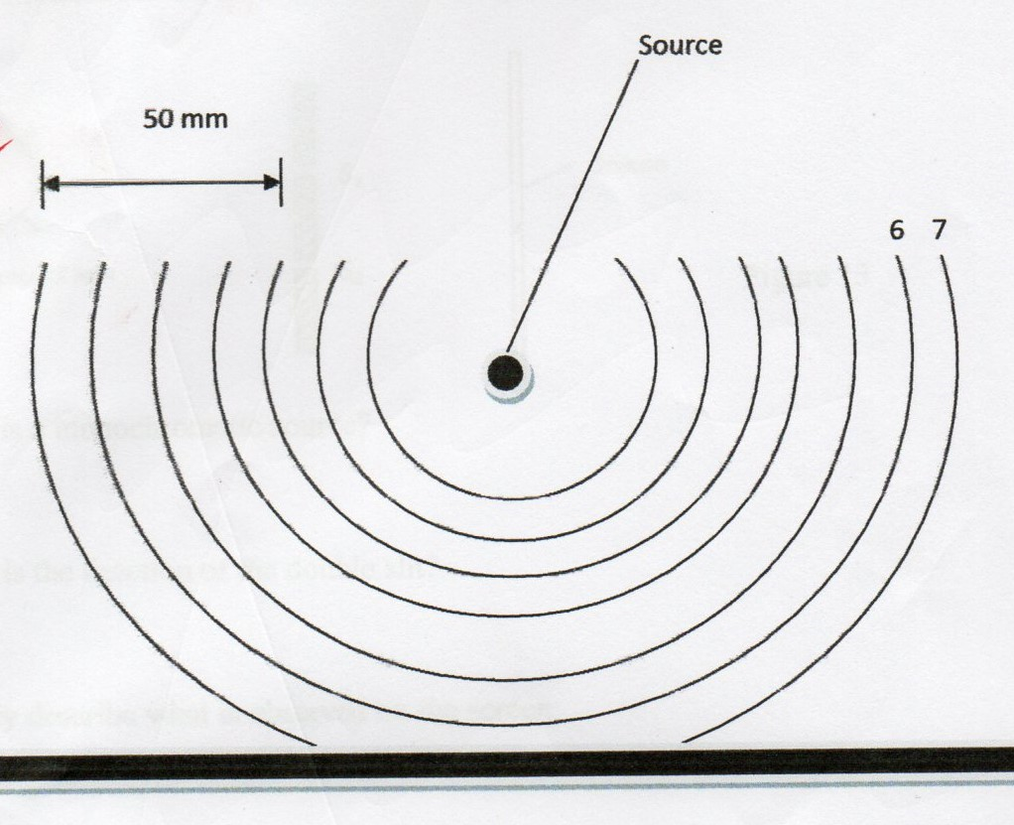
(ii). From the figure determine the wavelength of the water waves. (1 mark)
…………………………………………………………………………………………………………………………………………………………………………………………………………………………
(iii). Find the frequency of the waves if their speed is 60mm/s (2 marks)
…………………………………………………………………………………………………………………………………………………………………………………………………………………………
…………………………………………………………………………………………………………………………………………………………………………………………………………………………

(b). Figure 12 below shows wave - fronts approaching an obstacle. Complete the diagram to show the wave fronts as they pass the obstacle and beyond. (2 marks)
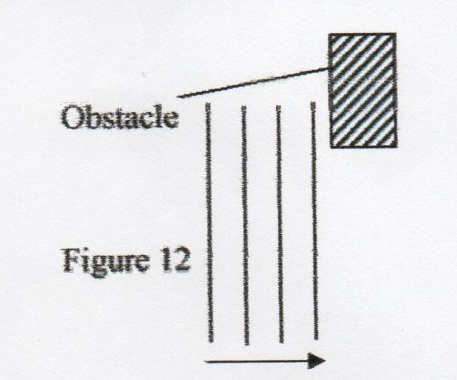

(c)(i). In an experiment to observe interference in light a double slit was placed close to a source of light as shown below.
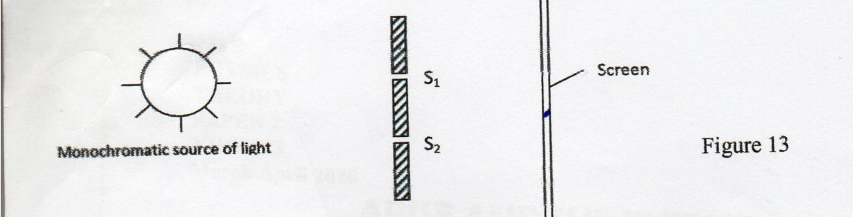

I. What is a monochromatic source? (1 mark)
…………………………………………………………………………………………………………………………………………………………………………………………………………………………
II. What is the function of the double slit? (1 mark)
…………………………………………………………………………………………………………………………………………………………………………………………………………………………
III. Briefly describe what is observed on the screen. (1 mark)
…………………………………………………………………………………………………………………………………………………………………………………………………………………………
(ii). Briefly explain what is observed on the screen when:-
I. The distance between the slits is reduced. (1 mark)
…………………………………………………………………………………………………………………………………………………………………………………………………………………………
II. White light is used. (1 mark)
…………………………………………………………………………………………………………………………………………………………………………………………………………………………
18. (a). State ohm’s law (1 mark)
………………………………………………………………………………………………………………
(b). The figure below shows three resistors connected to 12v supply of internal resistance of 0.2Ω
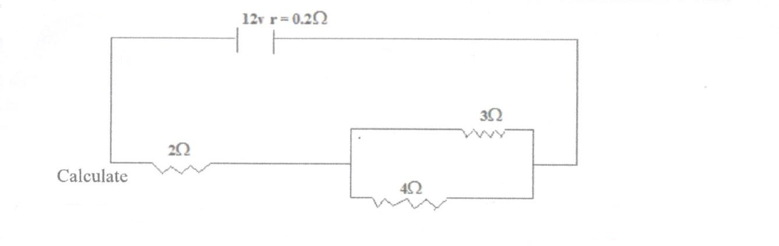
Determine:
I. the effective resistance. (3 marks)
………………………………………………………………………………………………………………………………………………………………………………………………………………………………………………………………………………………………………………………………………………
II. the total current in the circuit. (2 marks)
………………………………………………………………………………………………………………………………………………………………………………………………………………………………………………………………………………………………………………………………………………
III. The current through the 4Ω resistor. (2 marks)
………………………………………………………………………………………………………………………………………………………………………………………………………………………………………………………………………………………………………………………………………
(c). Figure 9 shows a battery connected in series with a switch and a lamp. A high resistance voltmeter is connected across the terminals of the battery.
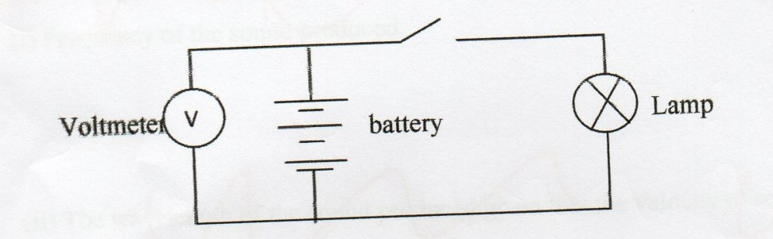
- The voltmeter reads 4.5V when the switch is closed and 3.6V when the battery drives a current of 0.3A through the lamp.
Determine
(a). The e.m.f of the battery. (1 mark)
………………………………………………………………………………………………………………………………………………………………………………………………………………………………

(b). The terminal p.d of the battery when supplying a current of 0.3A (1 mark)
………………………………………………………………………………………………………………………………………………………………………………………………………………………………
(c). The p.d across the lamp (1 mark)
………………………………………………………………………………………………………………………………………………………………………………………………………………………………

