**232/2**

**PHYSICS PAPER2**

**MARKING SCHEME**

1. Regulates the amount of current needed for an electric component. 🗸1
2. Ferromagnetic materials contain domains with dipoles facing in different directions for a particular domain🗸1. During magnetization, all dipoles are made to face in one direction🗸1. At this stage the material is said to be magnetically saturated.

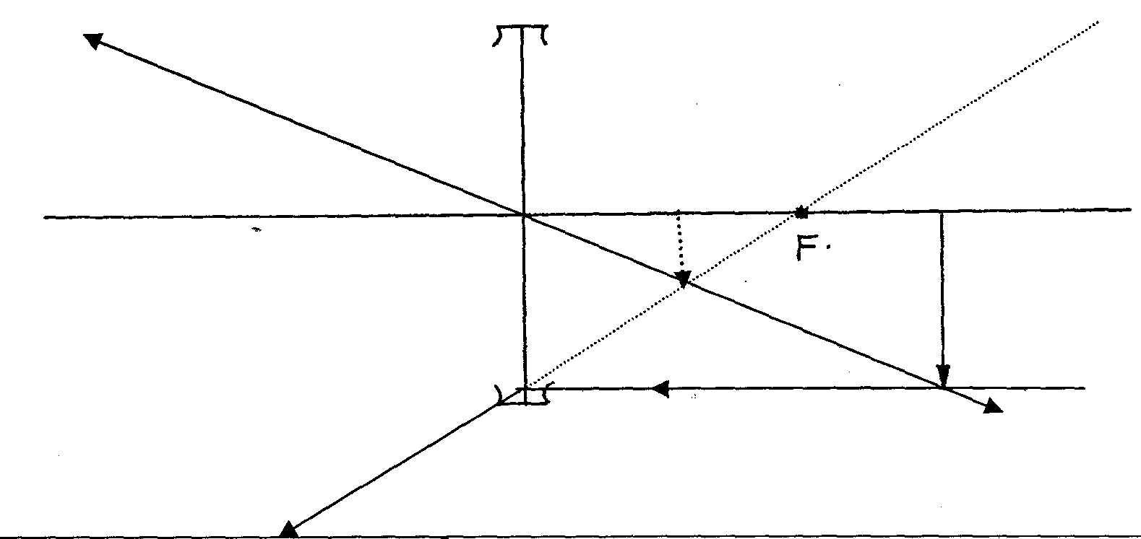

1. The amount of accelerating potential. 🗸1
2. Thermionic emission requires heat for an electron to be emitted from the surface of the metal 🗸1while Photo electric-requires light energy of sufficient frequency for an electron to be emitted from the metal surface. 🗸1
3. 20×5=40F

F=2.5N🗸1

Force R=(4-2.5)N

=1.5N🗸1

R is a repulsive force. 🗸1

1. 1/Re =1/2+1/2

Re =1Ω🗸1

R=V/I

I=V/R🗸1

=3A🗸1

1. Ultra violet radiation🗸1
2. time between two successive claps=50/20

=2.5seconds🗸1

Distance travelled by sound to the wall and back=400×2

=800m🗸1

Speed,s=distance/time

=800/2.5

=320m/s🗸1

1. a)

b) –erect/upright

-real

-Same size as the object

Any two🗸2

1. X – A beta particle🗸1

a – 206🗸1

b – 82🗸1

1. The gold leaf becomes more positive as a result of attraction of the negative charge towards the metal cap and as a result, the divergence of the leaf increases.🗸2

**SECTION B**

1. a) In transverse wave, the vibration of particles is perpendicular to the direction of travel of the wave 🗸1 but in longitudinal the vibration is parallel to the direction of the wave travel🗸1

b) i.

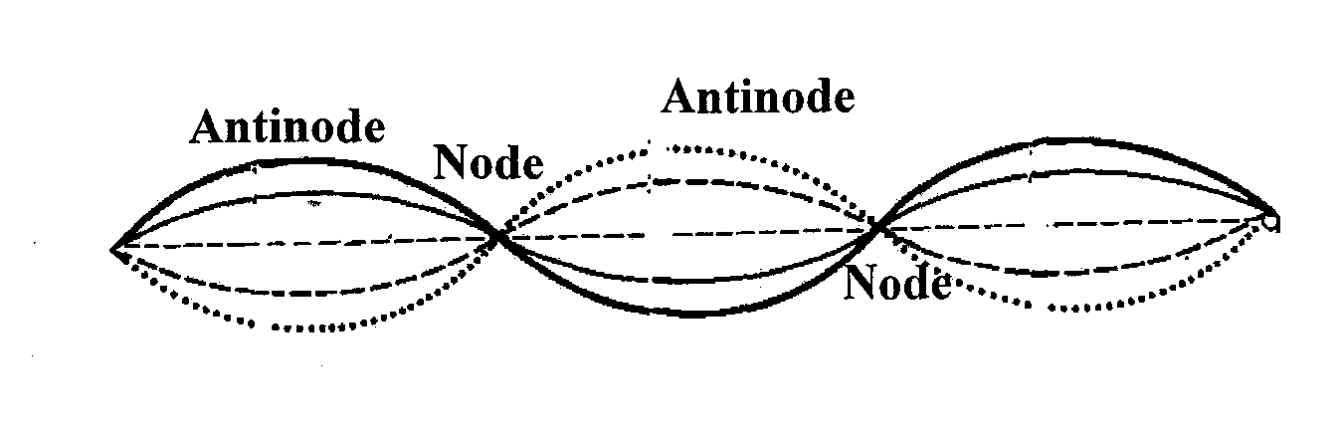

ii. The distance between a node and anti node = ¼ 🗸1

 = 1.0 x 10-3 x 4

= 4.0 x 10-3 m🗸1

c)5 waves = 6.4 cm

= 6.4/5

= 1.28 cm🗸1

V = f 🗸1

= 1.28 x 8

= 10.24cm/s🗸1

d) 2.5 complete oscillation

period T = 0.02/2.5

.

=0.008sec🗸1

f=1/T🗸1

=1/0.008

=125Hz🗸1

1. a) e.m.f is the potential difference across the terminal of a cell in an open circuit. 🗸1

b) i

|  |  |  |  |  |  |  |
| --- | --- | --- | --- | --- | --- | --- |
| R(ohms) | 1.6 | 2.1 | 2.5 | 3.6 | 5 | 8 |
| i(A) | 1 | 0.8 | 0.7 | 0.5 | 0.37 | 0.34 |
| 1/I (A-1) | 1.000 | 1.250 | 1.429 | 2.000 | 2.703 | 2.941 |

½ Mark for each correct entry to 3 d.p 🗸3

ii.

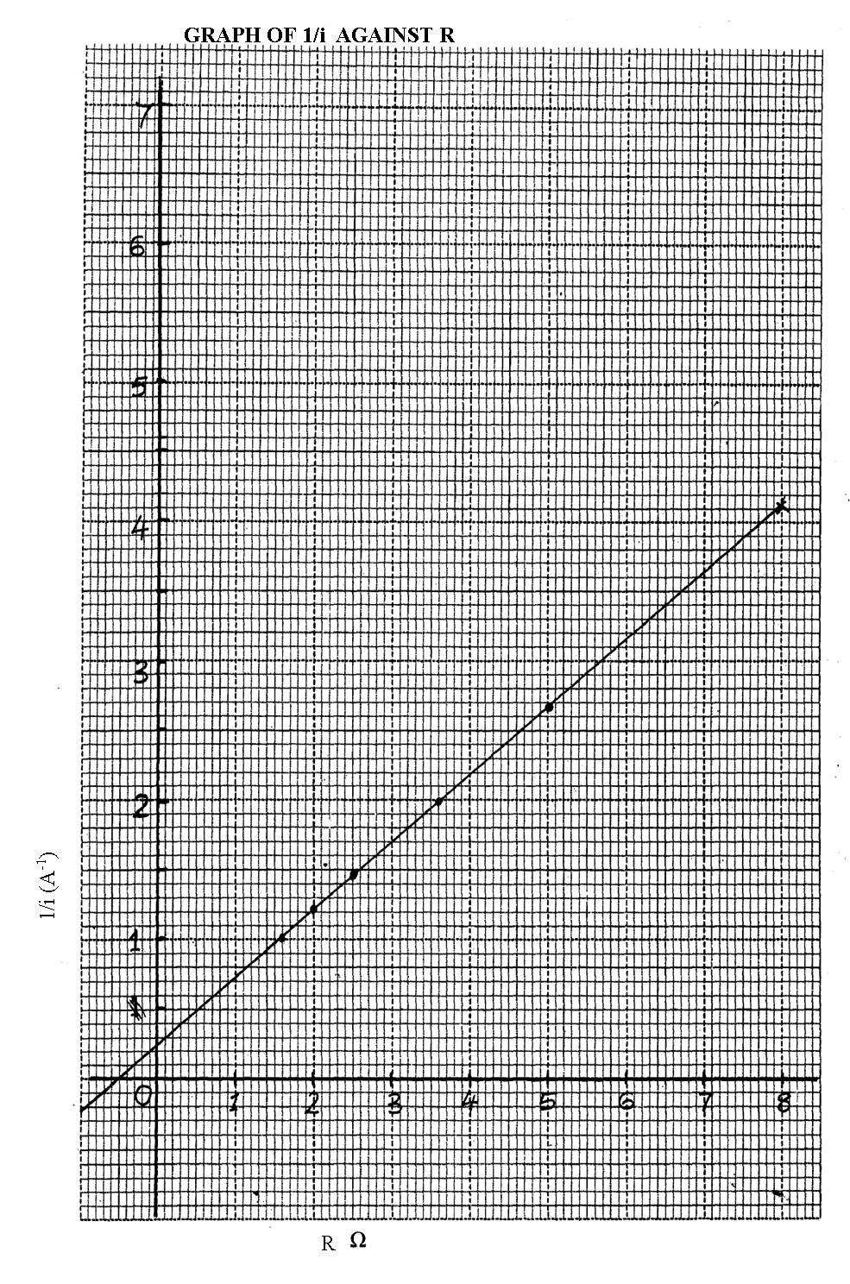

Axes🗸1

 Scale🗸1

Plotting🗸 2

 Line🗸1

iii. Gradient = 1/E🗸1

= $\frac{2.7-1}{5-1.6}$

=0.5🗸1

1/E=0.5

**E =** 2.0 V🗸1

Y – Intercept = r/E

= 0.25🗸1

**R =** 0.25 x 2.0

= 0.5Ω🗸1 (**Allow for error transfer)**

15. a)- Area of overlap🗸1

-Distance of separation 🗸1

-Nature of the dielectric🗸1

b) 🗸2

200µF 300µF 600µF

c) i) Q=CV🗸1

=6 × 2 × 10-6

=1.8×10-5 C 🗸1

ii) Ce=(2+4) µF

=6 µF🗸1

P.d across 2 µF=6/2

=3V🗸1

P.d across 4 µF=6/4

=1.5V🗸1

d) Moving clouds get charge by friction force. The clouds induce positive charges on the spikes of the arrester at the top of the conductor🗸1. This makes the earthed plate to become negatively charged🗸1. The negative charges on the earthed plate are immediately conducted to the ground through the copper strip🗸1.

1. a) Is the minimum amount of energy needed to eject/dislodge an electron from a metal surface. 🗸1

b) -intensity of the radiation. 🗸1

-energy of the radiation. 🗸1

-Type of metal. 🗸1

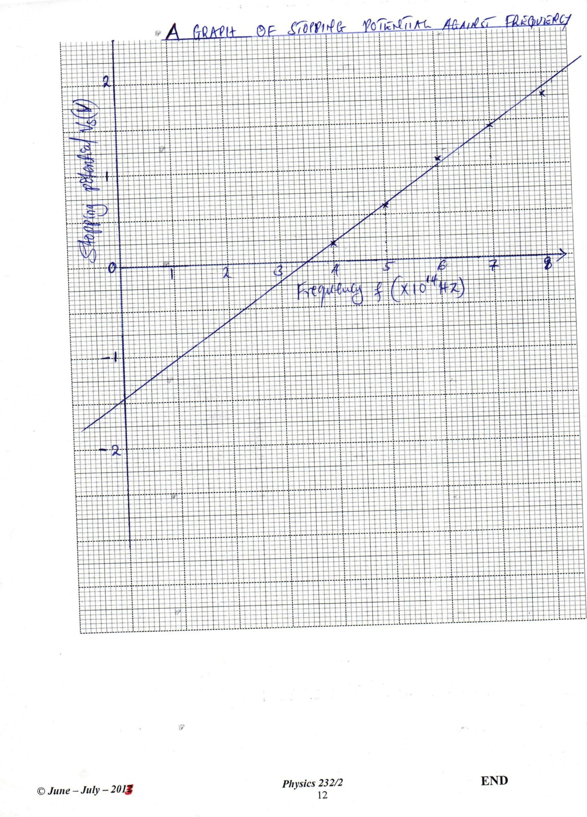

cthreshold frequency=x-intercept🗸1

=3.5×1014 HZ🗸1

1. eVs=hf-hfo

Vs=hf/e- hfo/e

Slope=h/e

=4.07×1014🗸1

h= 4.07×1014×e

= 4.07×1014×1.6×10-19

=6.5×10-34Js🗸1

1. Wo=hfo🗸1

=3.5×1014×6.5×10-34

=2.26×10-19J🗸1