Name: …………………………………………………………… Index No. …………………………
School: …………………………………………………………. Candidate’s Sign. …………............
Date: ………………………………............................................

232/1
PHYSICS THEORY
PAPER 1

MARCH/APRIL 2020
TIME: 2 HOURS

ARISE AND SHINE TRIAL 1 EXAM
MARCH/APRIL - 2020

INSTRUCTIONS TO THE CANDIDATES:
- Write your name and index number in the spaces provided above.
- This paper consists of TWO sections; A and B.
- Answer ALL the questions both in section A and B in the spaces provided below each question.
- ALL workings MUST be clearly shown; marks may be awarded for correct steps even if the answers are wrong.
- Mathematical tables and silent electronic calculators may be used.
- Candidate Must check the question paper to ensure that all the pages are printed as indicated and that no questions are missing.
- Take: Acceleration due to gravity=10m/s² Density of water = 1g/cm³ and Pull of gravity =10kg/N.
- This paper consists of 10 printed pages.
For Examiners’ Use Only
SECTION | QUESTION | MAXIMUM SCORE | CANDIDATE’S SCORE
Section A | 1-10 | 25
Section B | 11 | 11
 | 12 | 12
 | 13 | 13
 | 14 | 8
 | 15 | 14
 | TOTAL | 80
SECTION A (25 MARKS)
Answer all questions in this section in the spaces provided

- The Vernier calipers in the figure below has a zero error of -0.05cm. It was used to measure the diameter of an object and the reading was as shown.
2 3

0 10
(a). Determine the actual diameter of the object. (2 marks)
______________________________________________________________________________________
(b). In an experiment to determine the density of Liquid G, a student obtained the following data:
- Mass of an empty density bottle = 35.0g
- Mass of the density bottle + water = 60.0g
- Mass of the density bottle + Liquid G = 53.5g
Determine the density of Liquid G. (density of water is 1g cm⁻³) (3 marks)
____________________________________________________________________________________________________________________________________________________________________________________________________________________________________________________________________________________________________________________________________________________________
- The figure below shows the shapes formed when drops of water and mercury are placed on the surface of a clean glass plate.
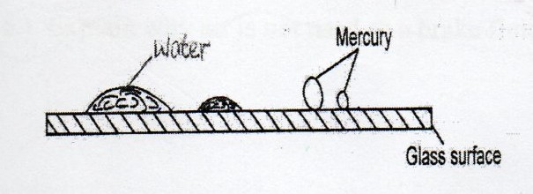

Explain the difference in the shapes (2 marks)
______________________________________________________________________________________________________________________________________________________________________________3. State the possible reason why if water is used as a barometric liquid, the glass tube to hold the column of the liquid is longer (1 mark)
______________________________________________________________________________________________________________________________________________________________________________
4. A beaker is filled completely with water. A spoon full of common salt is added slowly. The salt dissolves and the water does not overflow. State the reason why water does not overflow. (1 mark)
______________________________________________________________________________________________________________________________________________________________________________
5. Explain one advantage of mercury over alcohol as a thermometric liquid. (2 marks)
______________________________________________________________________________________________________________________________________________________________________________
6. A form one student set up the apparatus as shown below.
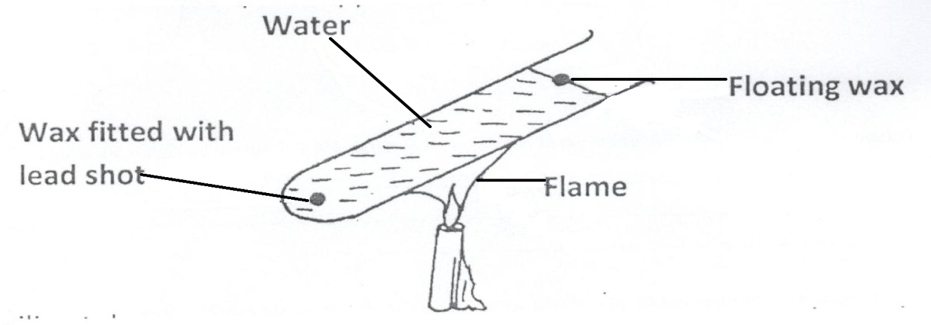
The boiling tube was heated in the middle as shown.

(i). Which wax melted first? (1 mark)
_______________________________________________________________________________________
(ii). Explain your answer in (i) above. (2 marks)
______________________________________________________________________________________________________________________________________________________________________________
7. The figure below shows a uniform bar of length 1.4m pivoted near one end. The bar is kept in equilibrium by a string as shown.
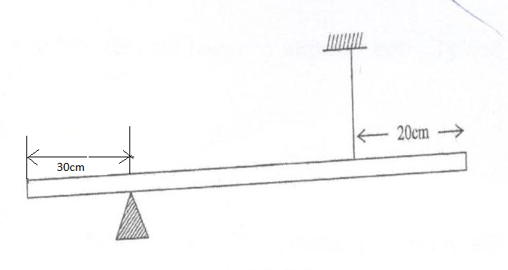

Given that the weight of the bar is 1.5N, determine the tension in the string. (3 marks)
_____________________________________________________________________________________________________________________________________________________________________________________________________________________________________________________________________
8. You are provided with two identical springs each of spring constant k. Sketch a diagram showing the arrangement of springs that produces an effective spring constant of 2k. (1 mark)

9. (a). State two factors that must be kept constant for a gas to obey Boyle’s law. (2 marks)
______________________________________________________________________________________________________________________________________________________________________________
(b).The volume of air 26cm long is trapped by a mercury thread 5cm long as shown below. When the tube
is inverted, the air column becomes 30cm long. What is the value of atmospheric pressure in cmHg.
(3 marks)
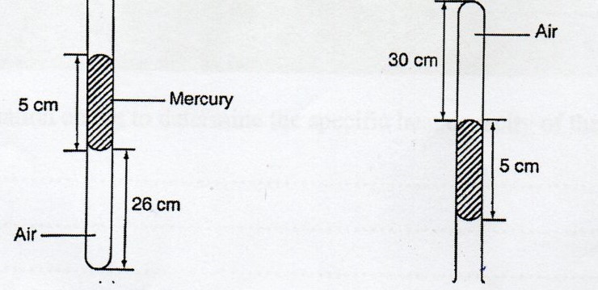
_____________________________________________________________________________________________________________________________________________________________________________________________________________________________________________________________________
10. Water is known to boil at 100ºC. A student heated some water and noticed that it boiled at 101ºC. State two possible reasons for this observation. (2 marks)
______________________________________________________________________________________________________________________________________________________________________________

SECTION B: 55 MARKS

Answer all the questions in this section.

11. (a). State the law of floatation. (1 mark)
_______________________________________________________________________________________

(b). Figure 8 shows a piece of cork held with a light thread attached to the cotton of a beaker. The beaker if filled with water.
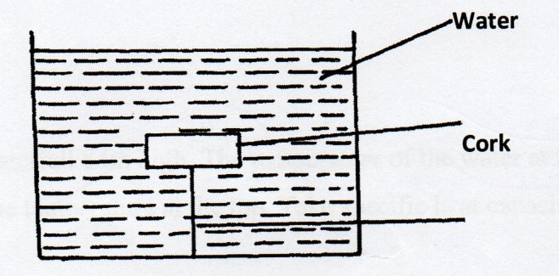
(i). Indicate and label on the diagram the forces acting on the cork. (3 marks)

_____________________________________________________________________________________________________________________________________________________________________________________________________________________________________________________________________
(ii). Write an expression showing the relationship between the forces. (1 mark)
_______________________________________________________________________________________
(c). A solid displaces 8.5cm³ of liquid when floating on a Liquid X. The density of the solid if 0.8g/cm³.

Determine
(i). Up thrust on the solid when floating. (3 marks)
_____________________________________________________________________________________________________________________________________________________________________________________________________________________________________________________________________
(ii). Density of the liquid X. (2 marks)
_____________________________________________________________________________________________________________________________________________________________________________________________________________________________________________________________________
(d). State one feature of a hydrometer that makes it sensitive in its function. (1 mark)
_______________________________________________________________________________________
12 (a). Define latent heat of fusion of a substance. (1 mark)
_____________________________________________________________________________________________________________________________________________________________________________
(b). An electric heater rated 6000W is used to heat 1kg of ice initially at -10ºc until all the mass turns to steam. Given that
Latent heat of fusion of ice =334,000J kg⁻¹
Specific heat capacity of ice = 2,100Jkg⁻¹K⁻¹
Specific heat capacity of water = 4,200Jkg⁻¹K⁻¹
Latent heat of vaporization = 2,260 000 Jkg⁻¹

Calculate

(i). the amount of energy required to raise the temperature of ice from -10ºC to 0ºC (2 marks)
_____________________________________________________________________________________________________________________________________________________________________________________________________________________________________________________________________
_______________________________________________________________________________________
(ii). the amount of energy required to completely melt the ice at 0ºC. (2 marks)
_____________________________________________________________________________________________________________________________________________________________________________________________________________________________________________________________________
(iii). the amount of energy required to raise the temperature of the melted ice from 0ºC to 100ºC (2 marks)
_____________________________________________________________________________________________________________________________________________________________________________________________________________________________________________________________________
(iv). the amount of energy required to vaporize the water. (2 marks)
_____________________________________________________________________________________________________________________________________________________________________________________________________________________________________________________________________
(v). the minimum time required for the ice to be heated until all its mass turns to steam. (3 marks)
_____________________________________________________________________________________________________________________________________________________________________________________________________________________________________________________________________
13. (a). State Newton’s first law of motion (1 mark)
_______________________________________________________________________________________
_______________________________________________________________________________________
(b). A wooden block resting on a horizontal bench is given an initial velocity u, so that it slides on the bench surface for a distanced before coming to a stop. The values of d were measure and recorded for various values of initial velocity u. Figure 10 shows the graph of u² against d.
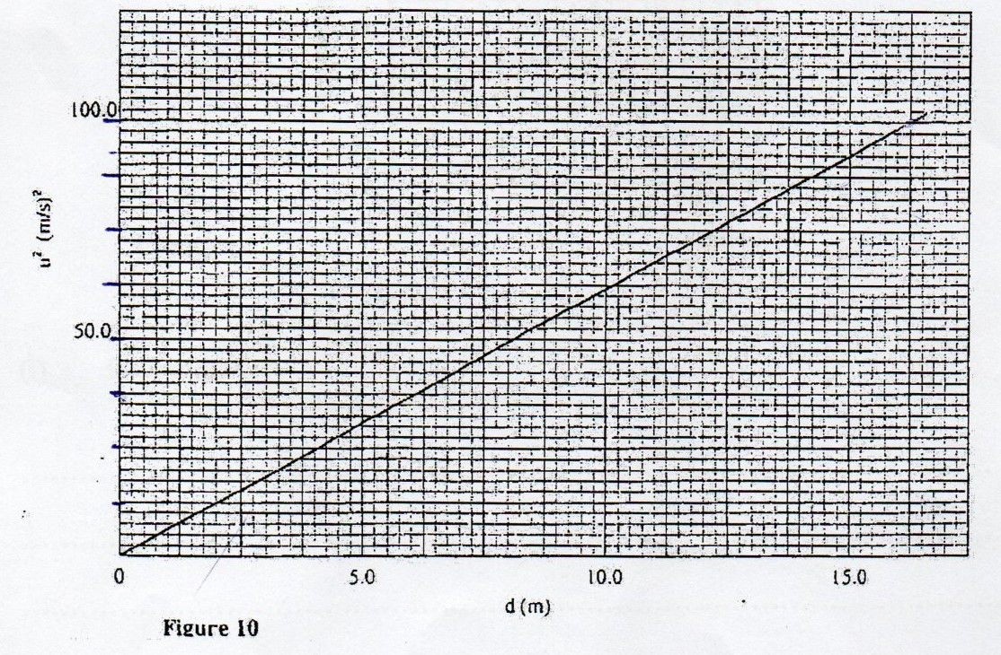

(i). Determine the slope, S of the graph. (3 marks)
_____________________________________________________________________________________________________________________________________________________________________________________________________________________________________________________________________
(ii). Given that u² = 20kd, where k is a constant for the bench surface, determine the value of k from the graph. (2 marks)
____________________________________________________________________________________________________________________________________________________________________________________________________________________________________________________________________________________________________________________________________________________________
(iii) State how the value of k would be affected by a change in the roughness of the bench surface.
(1mark)
______________________________________________________________________________________________________________________________________________________________________________

(c). A ball of mass 200g is projected vertically upwards with an initial velocity u. Figure 11 shows the velocity-time graph for part of its motion.
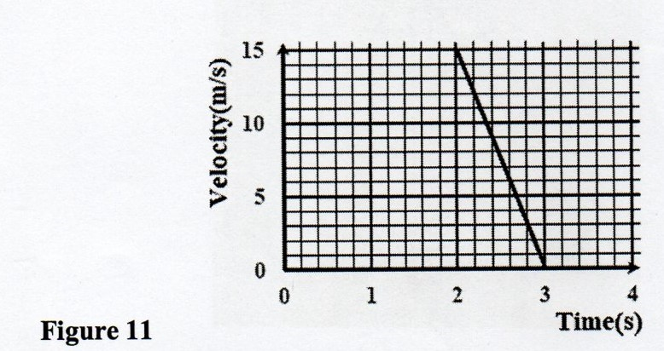

Determine:
(II). Deceleration of the ball. (2 marks)
________________________________________________________________________________________________________________________________________________________________________
____________________________________________________________________________________
(II). Maximum height of the ball (3 marks)
________________________________________________________________________________________________________________________________________________________________________
________________________________________________________________________________________________________________________________________________________________________
(ii). Explain why the value of deceleration obtained in (i)(I) is less than the expected value of acceleration due to gravity,g. (1 mark)
________________________________________________________________________________________________________________________________________________________________________
____________________________________________________________________________________
14. (a). Define angular velocity (1 mark)
_______________________________________________________________________________________
(b). State the reason why a body in uniform circular motion is said to be accelerating. (1 mark)
______________________________________________________________________________________________________________________________________________________________________________
(c). The graph of centripetal force against the square of angular velocity ($ω$²) is plotted as shown
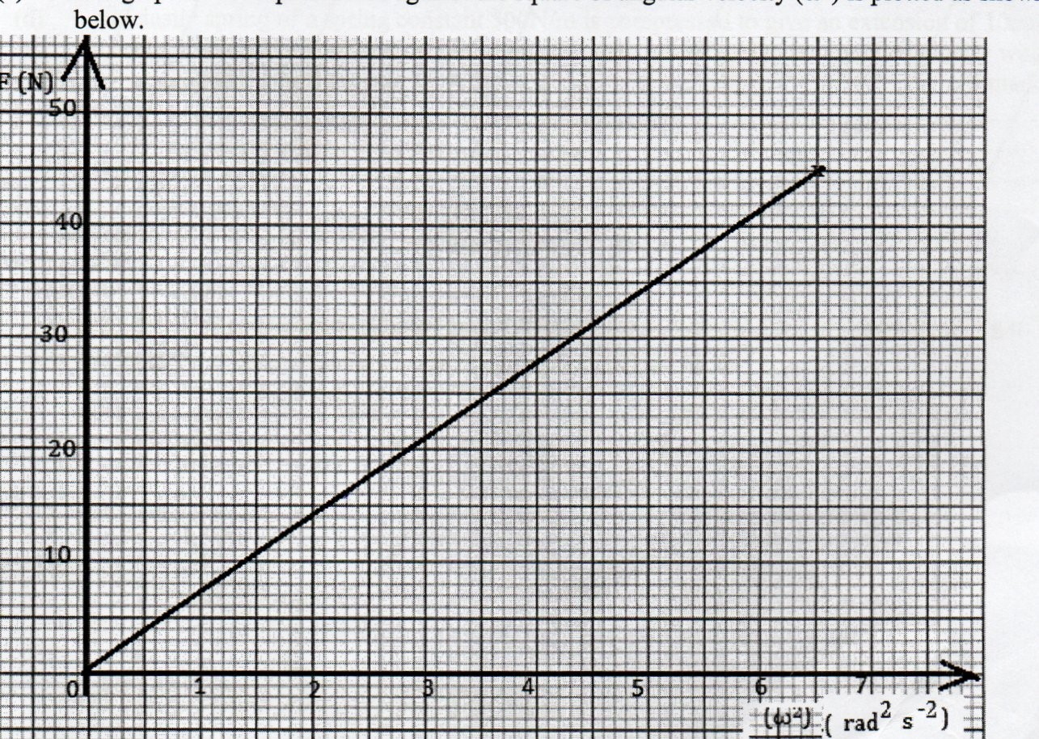
(i). From the graph determine the slope. (2 marks)
_____________________________________________________________________________________________________________________________________________________________________________________________________________________________________________________________________
(ii). Given that F = mrw²; determine m when r = 1.23m (2 marks)
_______________________________________________________________________________________
_____________________________________________________________________________________________________________________________________________________________________________________________________________________________________________________________________
(iii). Determine the angular velocity attained when a force of 16N is applied. (2 marks)
_______________________________________________________________________________________
_____________________________________________________________________________________________________________________________________________________________________________________________________________________________________________________________________
15. (a). The figure below show a simple pendulum of length 80cm, the pendulum bob whose mass is 50g oscillates between points A and B through its rest position C. A and B are both 10cm higher than C. (2 marks)
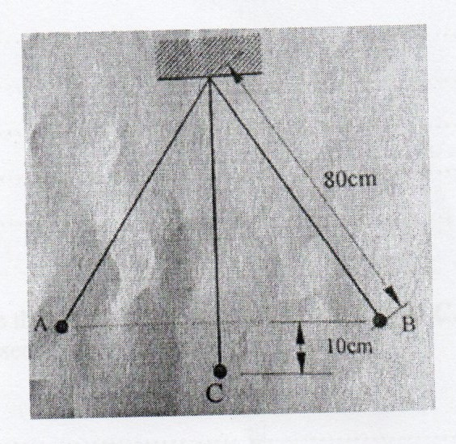

(i). Indicate with an arrow on the path ACB, the direction of the greatest velocity of the bob as it moves from A to B. (1 mark)
_______________________________________________________________________________________
(ii). State the form of energy possessed by the bob at point A. (1 mark)
_______________________________________________________________________________________
_______________________________________________________________________________________
(iii). Determine he tension in the string as the bob passes point C. (3 mark)
(take acceleration due to gravity g=10ms⁻²
_______________________________________________________________________________________
_______________________________________________________________________________________
______________________________________________________________________________________________________________________________________________________________________________
(b). A matatu whose mass is 2500kg is lifted using a screw jack of 10mm pitch. If the handle is 30cm from the screw. Find the force applied (neglect friction and take π=3.142) (1 marks)
______________________________________________________________________________________________________________________________________________________________________________
(c). A person of mass 75kg runs up a flight of stairs and develops a power of 300W. Calculate the velocity of the man. (3 marks)
_______________________________________________________________________________________
______________________________________________________________________________________________________________________________________________________________________________
(d). The figure below shows an inclined plane and a load of mass 15kg pulled by an effort of 100N
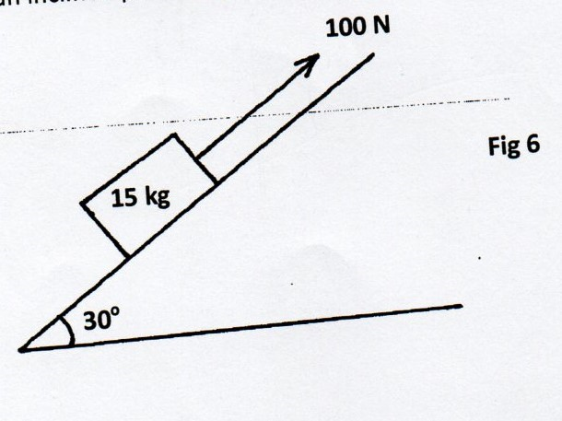
Find the efficiency of the machine. (3 marks)
_______________________________________________________________________________________
______________________________________________________________________________________________________________________________________________________________________________

