PHYSICS 232/1 MARKING SCHEME
1. 3.54 = 0.01 = 3.55 mm√
2. Cohesive force between mercury molecules is greater than adhesive force between mercury and glass√ Adhesive force between water and glass is greater than cohesive force between water molecules√
3.The frozen surface is a bad conductor of heat hence it insulates the water below against heat losses to the cold air above.
4. A extends by 6/4.5 =1.33m
B & C, 3/4.5=0.67m
Total extension=1.33+0.67
=2.00m
5.At equilibrium, sum of anti-clockwise moments = sum of clockwise moments √
W x 0.85 = 20 x 0.3 + 30 x 0.65
W = 6 + 19.5
0.85
W = 30N
6. t² = 2s/g
t = ± 2s = 40
g 10
t = 2sec √
range = 10 x 2 = 20m √

7. h₁ρ₁g = h₂ρ₂g
h1 = 13600 x 0.64 √1
800
h1= 10.88m √1
8.-expands regularly -does not wet glass ---opaque and silvery hence visible
9. Angle of inclination
Nature of surface
Length of inclination
Height of inclination
Frictional force between the surfaces (any two 2mks)

10. 108km/h 108 x 100 = 30m/s
3600
Acceleration 0 – 30 = -6m/s² √ M1
5
F = ma = 1000 x 6 = 600N √ M1
11. Due to the rise in temperature, the gas expands and since the size of the gas container is fixed, the pressure inside exceeds the one outside and explodes
12. (i) The car is accelerating
u = ²⁰/_{0.02} = 1000m/s √
v = ⁴⁰/_{0.02} = 2000m/s
a = 2000 – 1000 = 25000m/s²
0.04

13. a) Pressure law states that the pressure of a fixed mass of gas is directly
proportional to its absolute temperature, provided the volume is kept constant√2.
b) i) Measurements: temperature with thermometer and pressure with bourdon
gauge √1
(ii) Heat the water as you stir gently /
Tabulate various values of temperature T √1 and corresponding values
of Pressure (P) √1
Plot a graph of Pressure (P) against absolute temperature (T) √1
The graph is a straight line (determine the value of P)
T √1
i(ii) P₁√1 = P₂ = 4 x 10⁵ √1 = P₂ = 4 x 10⁵ x 348 = 4.67 x 10⁵Nm⁻²√1
T₁ T₂ 25 + 273 75 + 273 298

14. (a) Quantity of heat required to change a unit mass of a substance from solid to liquid without change in temperature. √

(b) (i) Hanging weights exert pressure on the ice beneath it making it melt at a temperature below its meeting point;√
Water formed (melted ice) flows over the wire and it solidifies immediately since it is no longer under pressure; √
As it solidifies latent heat of fusion is related and conducted√ by the copper wire to melt the ice below the wire. The process continues until the wire cuts through leaving the block intact.
(ii) Cotton thread would not cut through the ice at all; √ because it is a poor conductor of heat and cannot conduct the latent heat of fusion released by the solidifying ice to melt the ice below.

C (i) Heat gained = Heat gained by + Heat gained by
Melting ice melted ice (water)
= MLf + mc ΔӨ
= (0.040 x 340,000) + (0.040 x 4200 x T) √
= 13600 + 168 T Joules√
(ii) Heat lost by water = mc Δ Ө
= 0.4 x 4200 (20 – T)
= 1680 (20-T)
= 33600 – 1680 T Joules√
(iii) Heat gained = Heat lost
13,600 + 168T = 33600 – 1680T√
1848T = 20,000
T= 10.8ºC√
d) Boiling | Evaporation
Takes place at fixed temperature | Takes place at all temperatures.
Occurs throughout the liquid | Take place on the surface of the liquid.
Decreasing atmospheric pressure lowers boiling point | Decreasing atmospheric pressure increases rate of evaporation.
Draught over the surface has no effect on boiling point. | Draught over surface increases rate of evaporation

15. (a) A floating body displaces its own weight of the fluid in which it floats. √
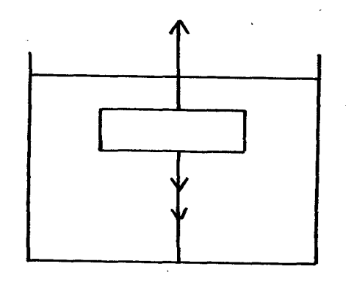
Upthrust √
Weight Mg√
Tension T√
b) (i)

(ii) U = mg + T√
C) (i) Upthrust = weight of solid√
= pvg
= 800 kg/m³ x (115 x 10 ⁻⁶) m³ x 10 N/kg√
= 0.092 N√
(ii) Weight of liquid displaced = upthrust
Pvg = 0.092√
+ = 0.92
(8.5 x 10 ⁻⁶) x 10√
= 1082.4 kg/m³√
16. (a) Microphone√
(b) Ratio of work output to work input expressed as a percentage. √
(c ) (i) Efficiency = $\frac{M.A}{V.R}×100$%√
M.A =100/40
=2.5
Efficiency = $\frac{2.5}{4}×100$%
=62.5%√
(ii) VR = Distance moved by effort
Distance moved by load.
4 = distance moved by effort √
0.6
Distance moved by effort = 4 x 0.6
= 2.4 m√

(iii) Power = work done by effort
time
= 40 x 2.4 √
15
= 6.4 w√
17. (a) (i) Instantaneous velocity – Rate of change of displacement at a particular time √ M1
(ii) Uniform acceleration - Rate of change or velocity that is constant √ M1
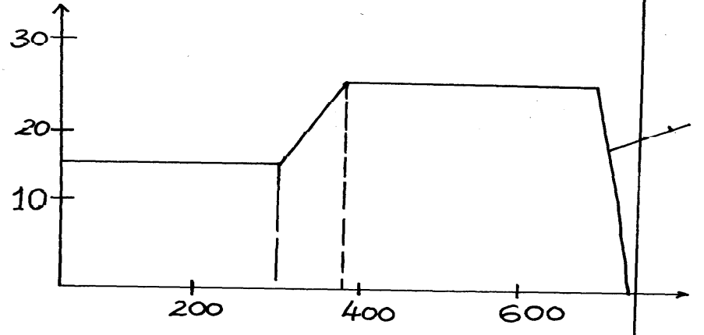
(b)
√ M1

√ M1
Velocity

Time

(ii) Acc. = Gradient = 25 – 15√ M1 = 10 = 0.5m/s √ M1
320 – 300 20
(iii) Distance traveled = area under the graph
= (300 x 15) +20/20 915 + 25) + 25/2 (300 + 300) √ M1
= 4500 + 400 + 4875 = 9775m √ M1

(c)(i) Horizontal distance = N x t
= 8 x 4= 32m

(ii) ht = ½ gt² = ½ x 10 x 16 √ M1 = 80m √ M1
(iii) v = u + at
U = 0
= 0 + 4 (10) √ M1 = 40m/s √ M1

