2020 FORM 4 TERM 1 ENTRY EXAMS
FORM 4 PHYSICS PP.3 (PRACTICAL)
TIME: 2 ½ HOURS

NAME:………………………………………ADM.NO…………………………..CLASS:……

INSTRUCTIONS TO CANDIDATES;

- Write your name and admission number in the spaces provided.
- Answer all questions in the questions in the spaces provided.
- All working must be clearly shown where necessary.
- Non- programmable silent electronic calculator may be used
- Candidates should check the question paper to ascertain that all pages are printed as indicated and that no question is missing.

Question | Maximum score | Candidate’s score
1 | 20
2 | 20
Total | 40

Question 1
You are provided with the following apparatus
- A rectangular glass block
- Four optical pins
- Four office pins
- A plain white sheet of paper
- A soft board
Proceed as follows
a) Fix the plain sheet of paper on the soft board using the four office pins
b) Place the glass block on the plain sheet of paper and trace its outline. Remove the glass block and mark the outline MNOP.
c) Mark a point R on MN such that MR is a quarter of MN. Construct a perpendicular through R one edge MN through to edge PO
d) Draw line AR such that angle i = 10ᵒ and replace the glass block.
e) Fix pins P1 and P2 along AR and while viewing through the glass block from the opposite facing PO stick two other pins P3 and P4 in line with the image of P1 and P2. Remove the glass block and draw-line through P3 and P4 to meet PO at S. Join S to R (see figure below)
f) Measure and record distance x and y on the table below
g) Repeat procedure (a) to (f) for values. Values of angle i = 20ᵒ, 30ᵒ, 40ᵒ, 50ᵒ, 60ᵒ and 70ᵒ and complete the table (8mks)

Angle i | X (cm) | Y (cm) | x/y | Sin i
10ᵒ

20ᵒ

30ᵒ

40ᵒ

50ᵒ

60ᵒ

70ᵒ

i) On the grid provided plot a graph of sin i against x/y (5mks)
ii) Determine the slope, n, of the graph (2mks)

Part B
You are provided with
- A cell and cell holder
- Switch
- A 10Ω carbon resistor labeled R
- Six connecting wires, two with a crocodile clip on one end
- An ammeter 0-1 A
- A voltmeter (0-5V) or (0-3V)
Procedure
- Set up the apparatus as shown below

Record the reading E of the voltmeter
E = …………………………….volts (1mk)
- Close the switch and record the reading V of the voltmeter and I the reading of the ammeter
V……………………….. volts (1mk)
I……………………..Amperes (1mk)
- Given that E=V+Ir, determine the value of r (2mks)

Question 2
You are provided with the following
- Water in a beaker
- Complete retort stand
- Two clamps
- 100ml measuring cylinder
- Boiling tube
- Cotton thread
- Meter rule
- Beam balance (can be shared)
- Vernier calipers (can be shared
Proceed as follows
i) a) Using the Vernier calipers, measure the internal diameter of the boiling tube D=…………………………………………. (1mk)
b) Measure the length H, of the boiling tube
H=…………………………………….cm (1mk)
ii) Measure the mass of the boiling tube using the beam balance M=…………………………………….g (1mk)
iii) Clamp the boiling tube vertically with its base resting on a flat surface as shown, Use the second clamp to clamp the meter rule beside the boiling tube.
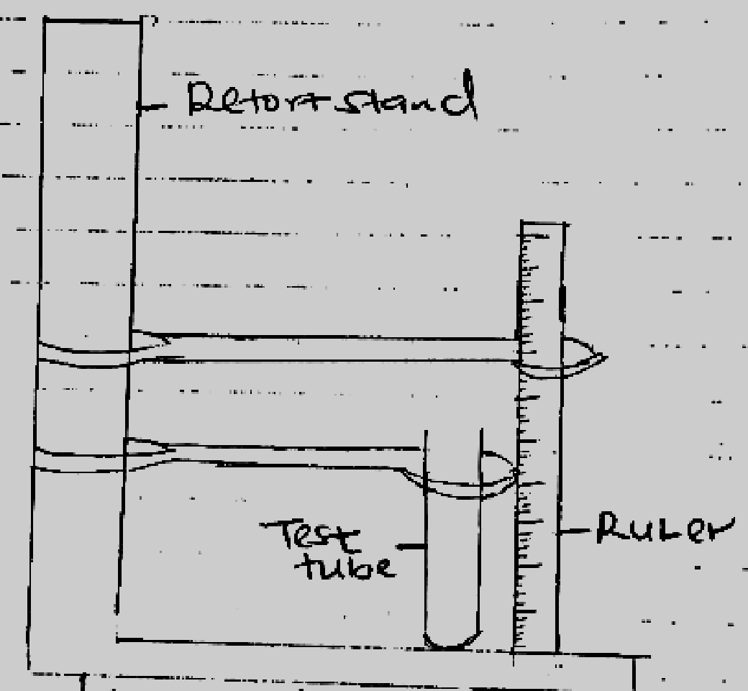
iv) Measure 10ml of water and pour into the boiling tube. Measure the height h, of the water. Keep adding water in small amounts in the boiling tube and complete the table below

VOLUME IN CM³/ML | HEIGHT H(CM)
10
20
35
45
50
65
(3mks)
v) On the grid provided, plot a graph of volume V(cm³) of water (y-axis) against height h (cm) (5mks)
vi) From the graph determine the slope, (3mks)

vii) Wind the cotton thread ten times round the boiling tube, pushing the windings very close together, the turns should not overlap on each other.
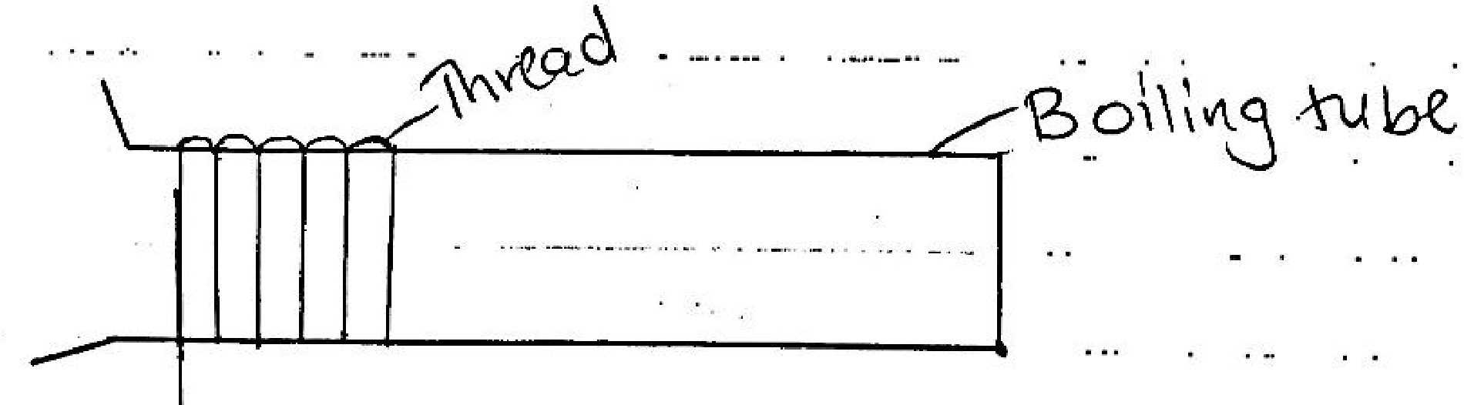
Unwind the thread and measure the length L of the thread.
L……………………… (cm) (1mk)
viii) Calculate the volume V of the glass material which the boiling tube is made of, given that
V=h [2𝐿²/2500−5]

V= ………………………………………. (2mks)
ix) Calculate the density d in kg/m³, of the glass material of the boiling tube.

d=…………………………................... (3mks)

