Question 1.
Part A
Angle i X (cm) Y (cm) x/y Sin i
10ᵒ 0.8 6.4 0.125 0.1736
20ᵒ 1.6 6.6 0.246 0.3420
30ᵒ 2.4 6.8 0.360 0.5000
40ᵒ 3.1 7.0 0.443 0.6428
50ᵒ 3.9 7.4 0.527 0.7660
60ᵒ 4.9 8.0 0.612 0.8660
70ᵒ 5.6 8.5 0.659 0.9397
Total 2mks 2mks 2mks 2mks
i) graph
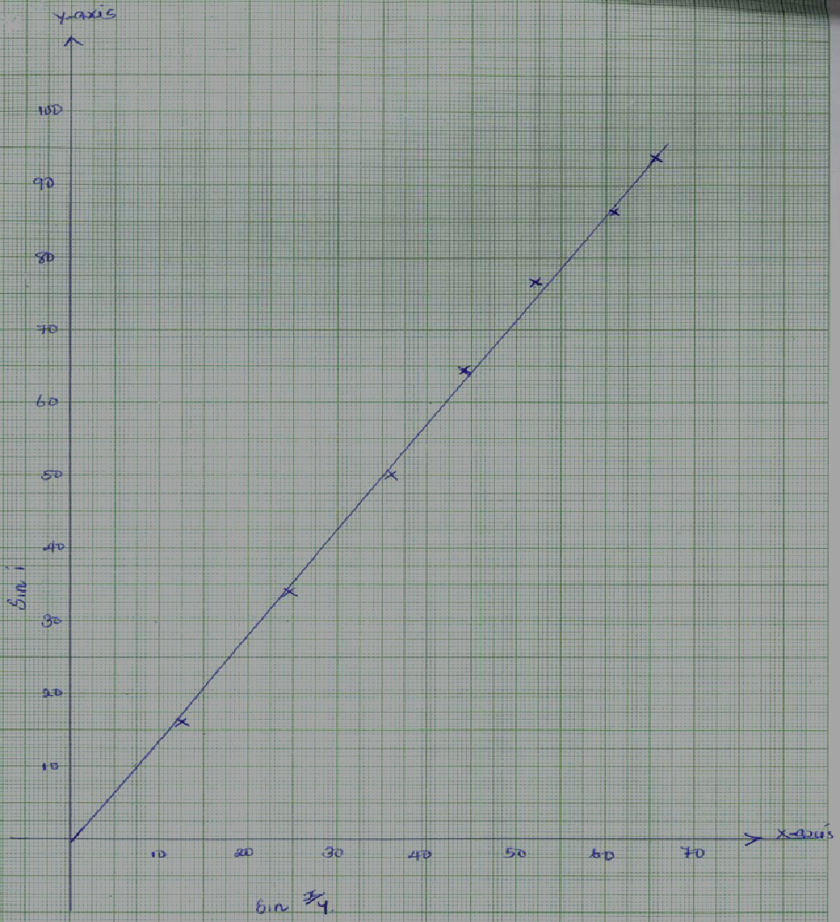
ii) slope =sin i
x/y
= 0.78 – 0.25
0.55 – 0.18
= 0.53
0.37= 1.432

Part B
a) E = 1.6V +/- 0.1
b) V= 1.4V +/- 0.1
I=0.1 +/- 0.1
C) E= V+ Ir
1.6=1.4+ 0.1r
r= 2Ω

QUESTION 2
i) a) 2.24cm ±0.1

b) H=14.9cm ± 0.1
ii) 24.7g ±1
Volume of water in cm3/ml | Height h (cm) (±𝟎.𝟖)
10  20  35  45  50  65 | 2.7  5.1  6.4  8.8  10.0  13.6
Each ½mk total 3mks (3mks)
v) Graph paper
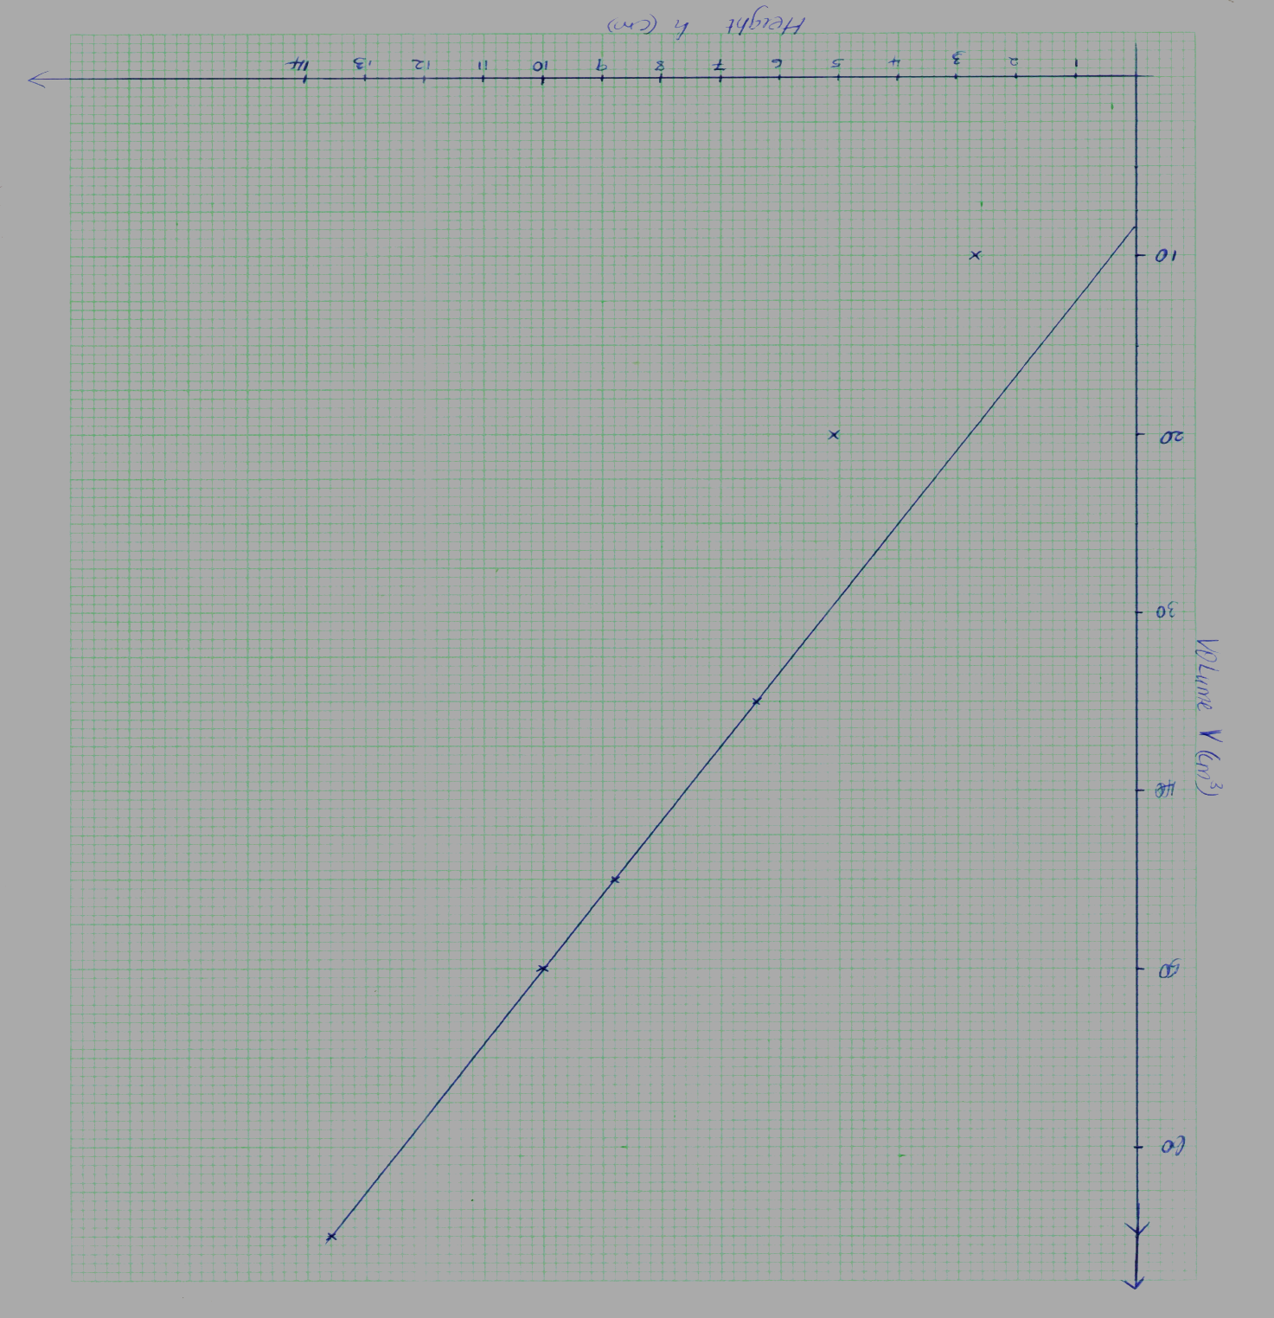

vi) Gradient = 𝑐ℎ𝑎𝑛𝑔𝑒𝑖𝑛𝑦/𝑐ℎ𝑎𝑛𝑔𝑒 𝑖𝑛 𝑥
= 62−40/13−78 √1
= 225.2√1
= 4.231cm² without unit ½mk
vii) L= 86cm ±1.0
viii) H{ 2𝐿²/2500−5} = 14.9{ 2×(86)2 /2500−4.231
= 14.9 [14792/2500−4.231 = 149{5.9168 – 4.231}
= 14.9×1.6858 = 25.11842√1𝑚𝑘
ix) Density = 𝑚𝑎𝑠s/𝑣𝑜𝑙𝑢𝑚𝑒 = 24.7/25.11842 = 0.9833g/cm3

