Name: ………………………………………………………Adm. No: ………Class ………
232/2
PHYSICS Paper 2 (THEORY)
Time: 2 Hours
2020 FORM 4 TERM 1 ENTRY EXAMS
Kenya Certificate of Secondary Education (K.C.S.E)

PHYSICS
Paper 2
Time: 2 Hours
INSTRUCTIONS TO CANDIDATES:-
- Write your name, Admission number and class in the spaces provided above.
- This paper consists of two sections; A and B
- Answer all the questions in section A and B in the spaces provided
- All working must be clearly shown.
- Mathematical tables and electronic calculators may be used
- This paper consists of 10 printed pages. Candidates should check to ascertain that all pages areprinted as indicated and that no questions are missing.
- Candidates should answer the questions in English.
- Take g=10N/kg
For Examiner’s Use Only:

Section | Question | Maximum  Score | Candidate’s  Score
A | 1 – 12 | 25
 | 13 | 10
 | 14 | 12
B | 15 | 12
 | 16 | 8
 | 17 | 4
 | 18 | 9
Total Score |  | 80

SECTION A (25MARKS)Answer all the questions
- Figure1 below shows two mirrors M1 and M2 are inclined at right angles to each other.
Fig 1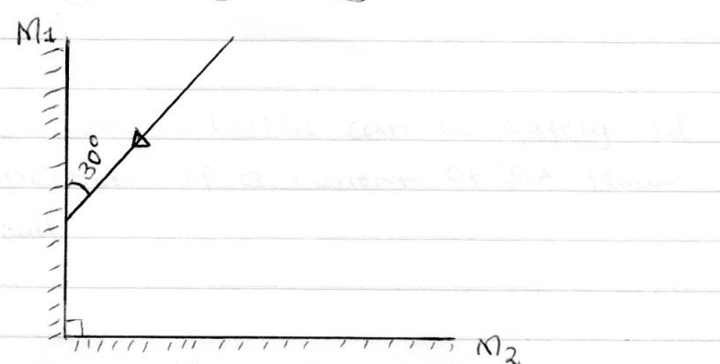
Trace the reflection of the ray through the two mirrors and find the angle between the incident ray and reflected ray of mirror M₂. (2mks)
- State the reasons why a convex mirror is preferred over a plane mirror for use as a driving mirror. (1mk)

- A current of 0.5A flows in a circuit. Determine the quantity of charge that crosses a point in 4 minutes through the circuit. (2mks)

- A radio station broadcasts on a wavelength of 150m at a frequency of 200 kHz. Calculate the velocity of the radio waves. (2mks)

- The internal resistance of the cell in the figure below is 0.5 Ω.
Fig 2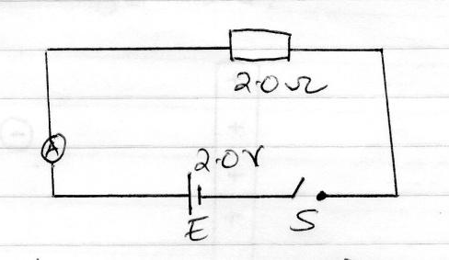
Determine the ammeter reading when the switch S is closed. (2mks)

- A man standing 400 away from a wall bangs two pieces of wood together and hears an echo 2.5 seconds later. Determine the speed of sound in air at that place. (2mks)

7. State the property of light associated with formation of shadows. (1 mark)

8. In the circuit diagram shown in figure 3 the lamps are identical and cells are also identical.

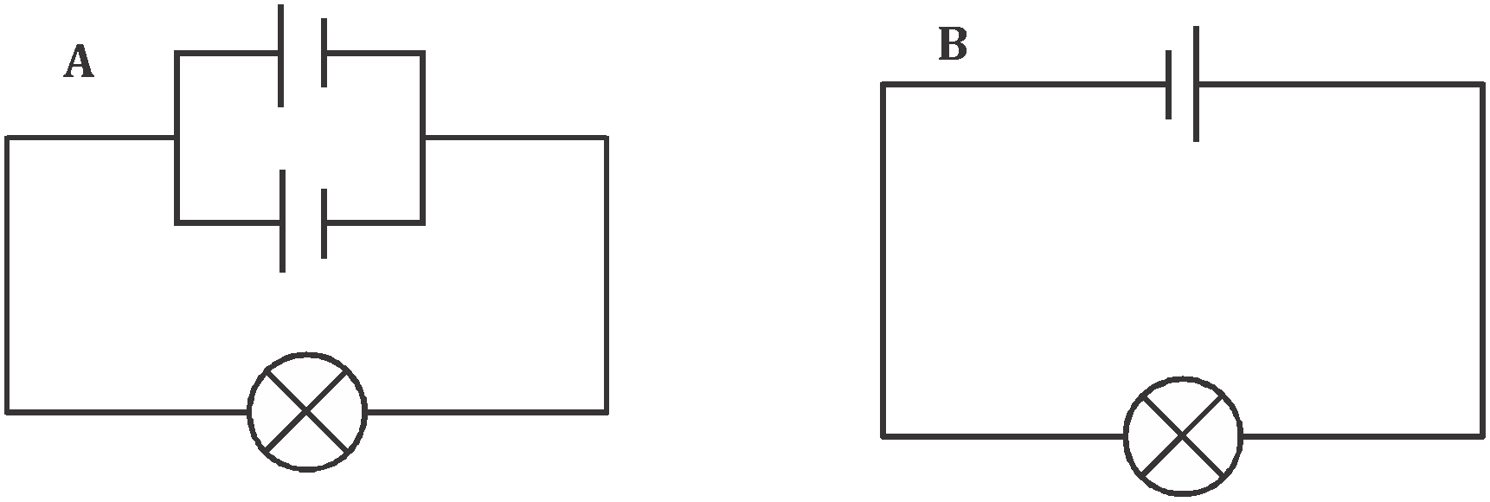

Fig 3
State with a reason, in which circuit the lamp will be lit for a longer period. (2 marks)

9. Explain in terms of domain theory, what happens when a bar magnet is placed in a solenoid in which an alternating current flows. (2 marks)

10. Use appropriate rays to complete the ray diagram in figure 4 and state the position of the object formed. (3 marks)
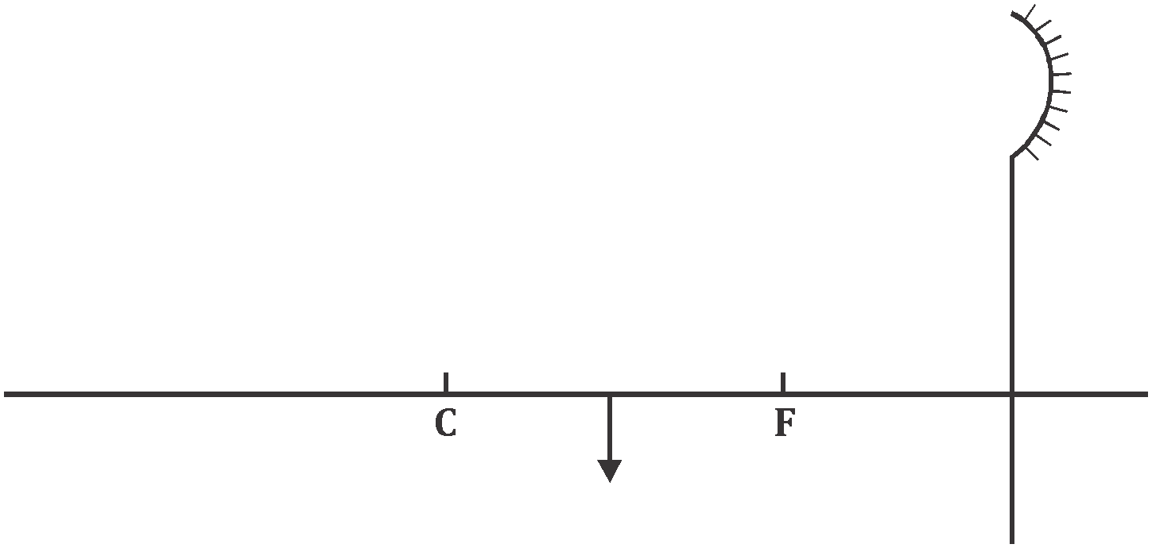

Fig 4

11. Figure 5.0 shows a transverse wave.

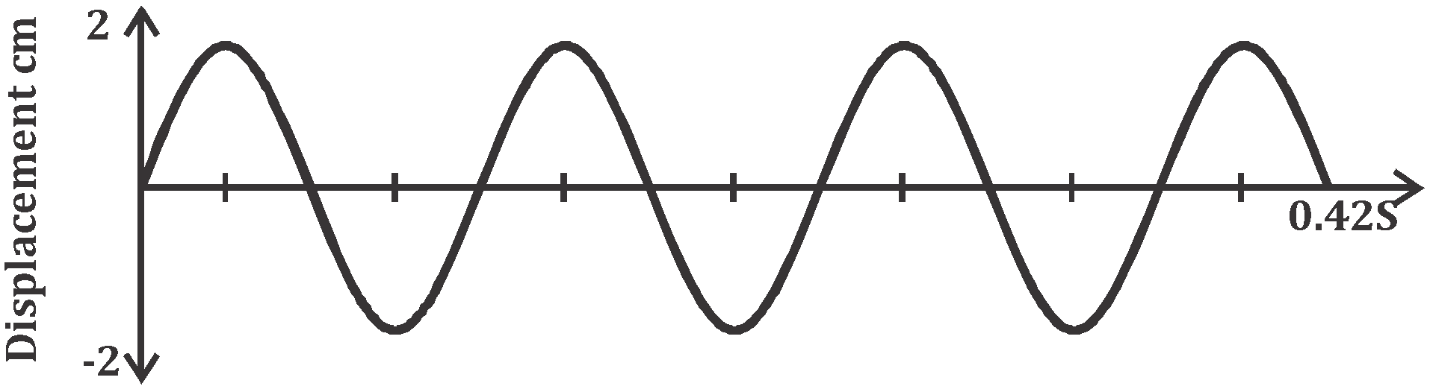

- Calculate the frequency of the wave. (2 marks)

- Sketch another wave on the same diagram that has double the frequency and half the amplitude and label it as M. (1 mark)

12. The figure 6.0 below shows a network of capacitors.

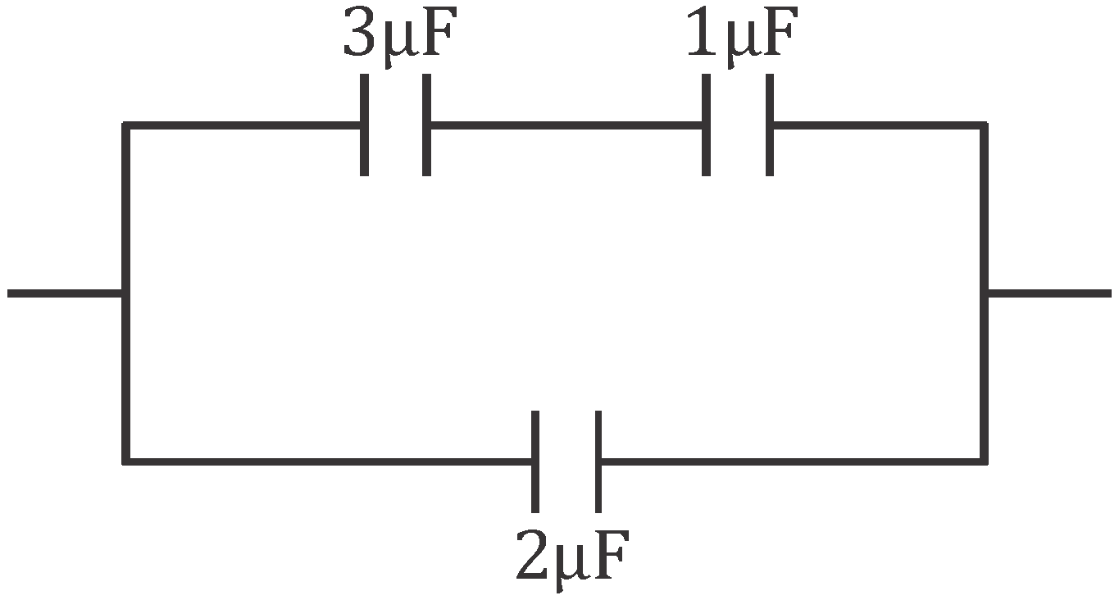

Determine the combined capacitance of the network. (2 marks)

SECTION B( 55MARKS)
- The figure below shows a ray of green light through a prism. The speed of green light in the prism is 2.0 x 10⁸m/s
^{Fig 7}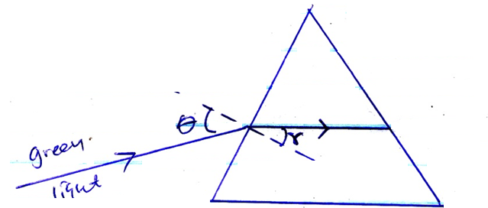
- Determine the refractive index of the prism material( speed of light in air = 3.0 x 10⁸m/s (3mks)

- Given the r ==23.2⁰, determine the angle Ѳ (3mks)

- i) The diagram below show two prisms
Fig 8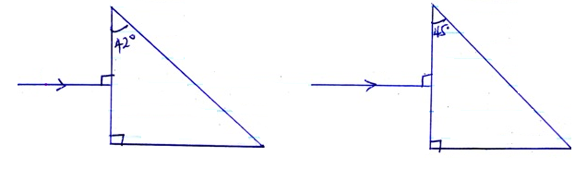
Given that the critical angle of the glass in both prisms is 42⁰ sketch the paths of the two rays in each prism indicating all the angles. (2mks)

ii) Give two application of total internal reflection (2mks)

- a) What is meant by the term capacitance? (1mk)

- The figure below shows a point placed near a positively charged rod.
Draw on the diagram the resulting electric field patterns. (1mk)
Fig 9
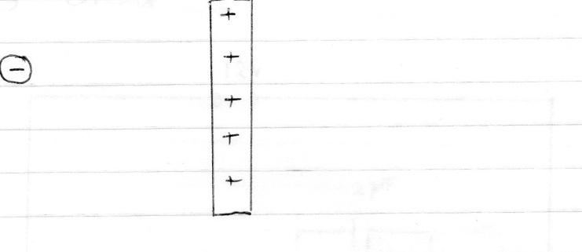

- When a positively charged conductor is brought close to a candle, the flame is diverted as shown in the figure below. Explain this observation. (2mks)
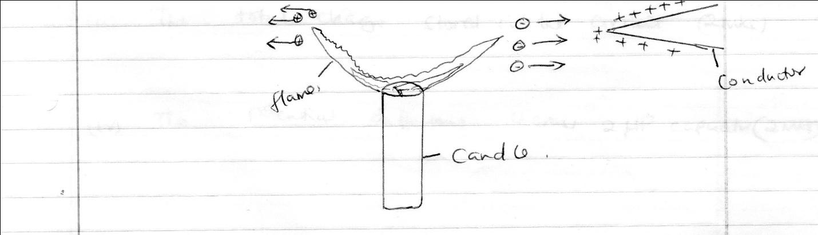
Fig 10

- The figure below shows three capacitors of capacitance 3µF, 2µF, and 6µF. Connected to a 12v supply circuit.
Fig 11 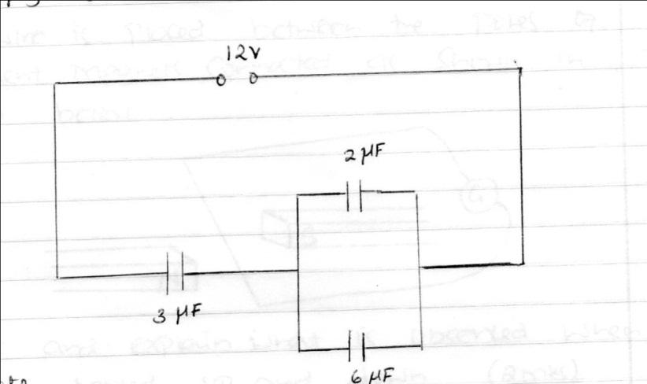
Calculate:
- The total capacitance of the circuit. (3mks)

- The total charge stored in the circuit. (3mks)

- The potential differences across 2µF capacitor. (2mks)

15. (a) Explain how sound reaches our ears. (2 marks)

(b) State two characteristics of sound waves. (2 marks)

(c) Wambua strikes a steel super bridge with a hammer. If the speed of sound in steel is 5,200 m/s, determine the time taken for the sound to reach another Samuel 2.6 km far off the bridge with his ear on the rail. (2 marks)

(d) A boy whistles once at a distance 250 m from a vertical cliff. If the temperature in the surrounding is 5⁰C .If the speed of sound = (331.5m/s at 0⁰c) the speed in air increases at about 0.6 m/s per ⁰C,
  - Determine the distance travelled by sound. (2 marks)

  - Determine the speed travelled at 5⁰C. (2 marks)

  - Calculate the time taken for the boy to hear the echo. (2 marks)

16. a) Define electric current (1mks)

- The figure below shows an electric circuit with two bulbs B₁ and B₂ which are identical.
Fig 12 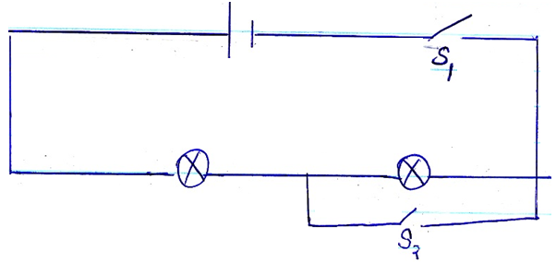
B₂
B₁
Explain what happens to the bulbs when
- S₁ only is closed (2mks)

- S₁ and S₂ are closed (2mks)

- The figure below shows an electric circuit. Use the circuit to determine the current supplied by the battery (3mks)
Fig 13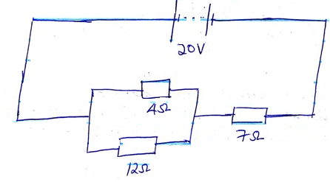

- a) Figure 14 below shows a series of wave fronts one wavelength apart approaching a gap between barriers in ripple tank.

Figure 14

On the same diagram, show what happens when the waves pass through the gap. (1 mark)

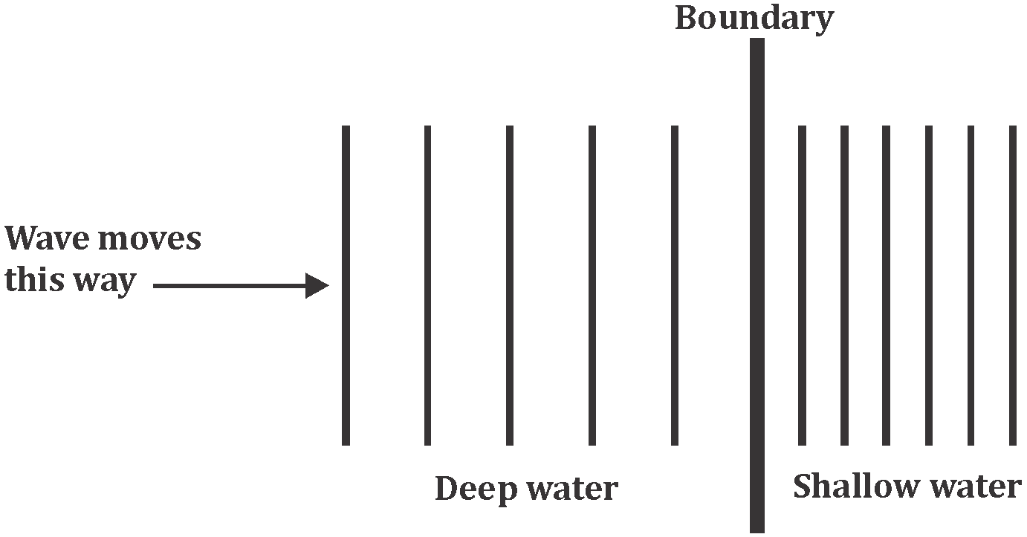
- Some plane water waves were produced in a ripple tank. They pass from a region of deep water into a region of shallow water. Figure 15.0 shows what the waves look like from above.

Fig 15

State what happens at the boundary to
- the frequency of the waves (1 mark)

- the speed of the waves (1 mark)

- the wavelength of the waves (1 mark)

- (a) State three factors that affect the strength of an electromagnet. (3marks)

- In the set up below, the suspended metre rule is in equilibrium balanced by the magnet and the weight shown. The iron core is fixed to the bench:
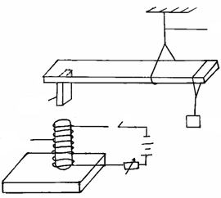

Thread
Magnet
N
S
S
Weight
Soft
iron core

Fig 16

          - State and explain the effect on the metre rule when the switch S, is closed.(2marks)

          - What would be the effect of reversing the battery terminals? (1mark)

- The figure below shows two parallel current carrying conductors A and B placed close to each other. The direction of the current is into the plane of the paper.

A
B

On the same figure;
          - Sketch the magnetic field pattern. (1mark)

          - Indicate the force F due to the current on each conductor. (1mark)

