2020 FORM 4 TERM 1 ENTRY EXAMS
232/2
PHYSICS
PAPER 2

MARKING SCHEME
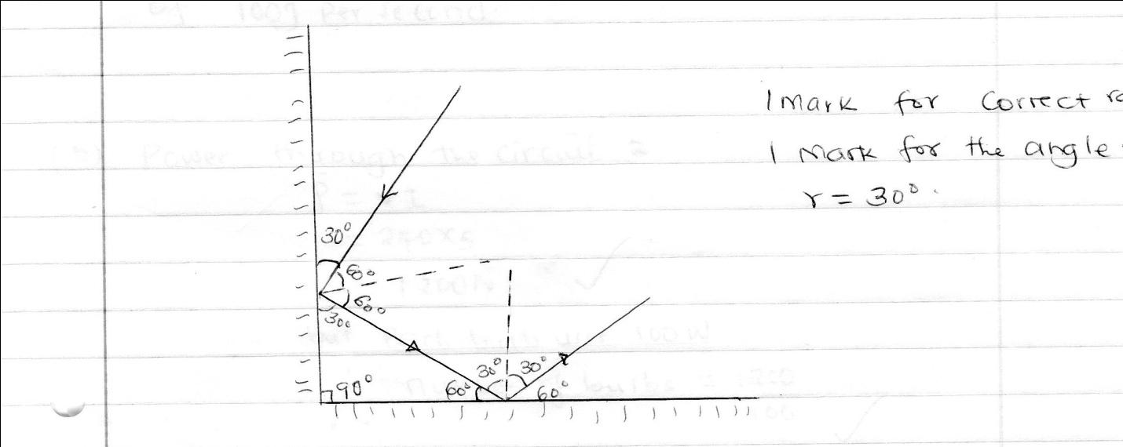
=60⁰
ray

- Gives a wide field of view.
- Q= It
= 0.5 x 4 x 60√
= 120C√
- v= λf
= 150 x 200 x 1000
= 30,000,000
=3.0 x 10⁷ m/s√
- E = IR
2= 2I +0.5 I√
2=⁵/₂ I
I = 0.8 A√

- Speed = 2d
t
= 2 x 400
2.5
= 320m/s.
- Light travels in a straight line. Rectilinear propagation of light .√
8. Circuit A
The cells in A are in parallel, current drawn from each cell in less than in B
or
Effective internal resistance in circuit A is less than in B
- Alternating current disarranges / disorients / upsets the alignment of the dipoles in the domains causing dipoles to lose the alignment

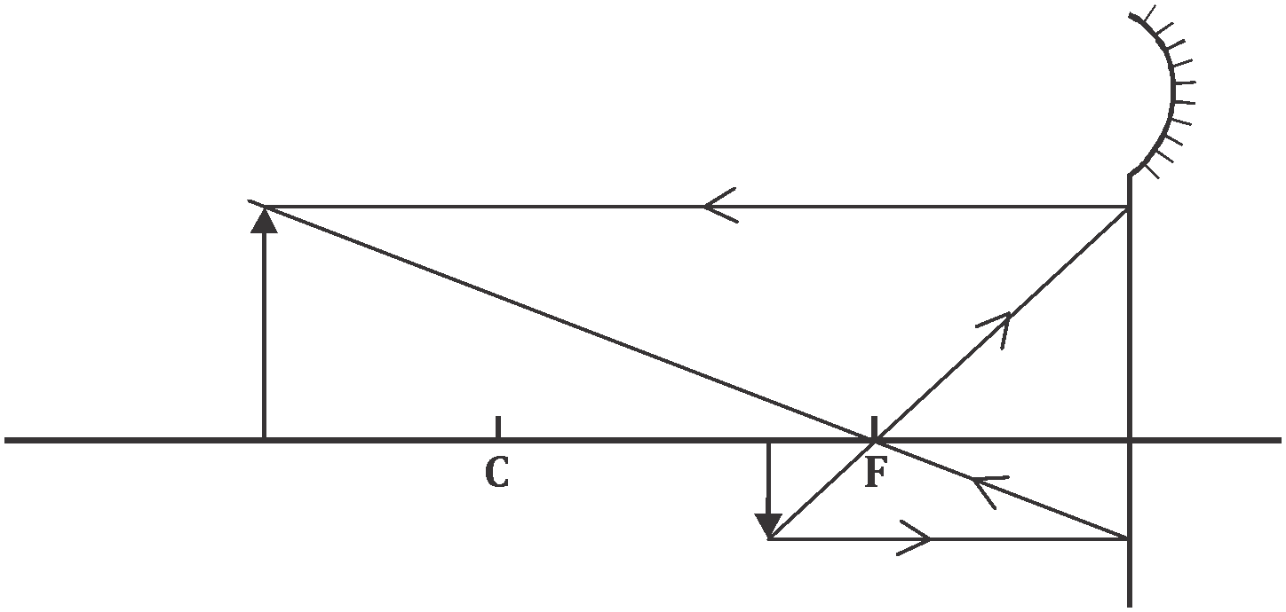
10.

correct rays (2mks)
nature of the object

Image is real
11 a) f = 1
T
= 1
0.12
= 8.333 Hz
b) New f = 16.666
A = 1
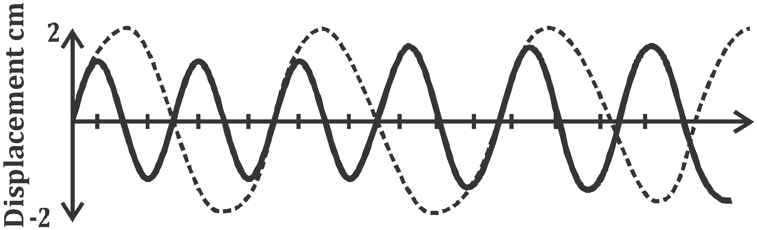

M

12. For series 1 = 1 + 1
C_{s} 3 1
= 1 + 3 =4
3 3
C_{s} = 3 = 0.75µF
4
for parallel : C_{e} = (2 + 0.75)µF
= 2.75µF

- (a)

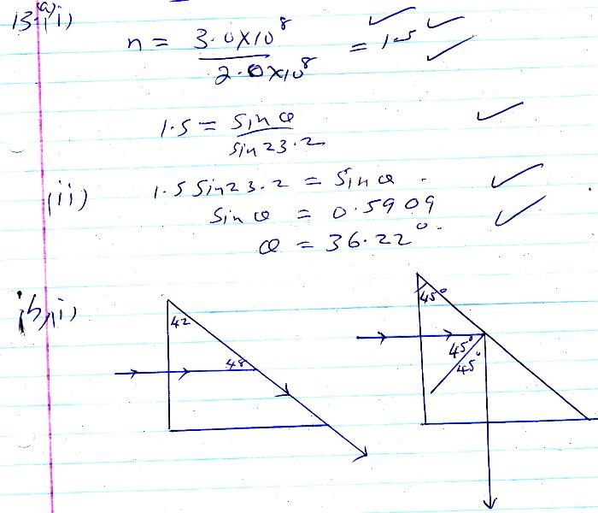
ii)

- Periscope
Prism binoculars
Optical fibre

- a) Its charge stored per unit voltage.

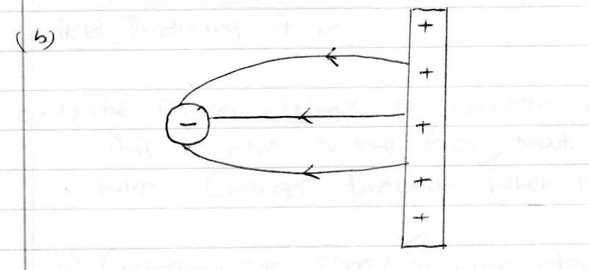
- The higher concentration of positive charges at sharp end of the conductor causes ionization of the surrounding air√ to produce electrons and positive ions. Electrons are attracted towards the conductor while heavy positive ions drift away diverting the part of the flame.√
- i) C_{P}=2+6=8µf√
C_{T}=3x8 = 24 = 2.18 µf.√
3+8 11
- Q =CV √
= 2.18 X 10⁻⁶ X 12√
= 2.616 X 10⁻⁵ C√
- p.d across 2 µf = 2.616 x 10⁻⁶√
8 x 10⁻⁶√
= 3.27V √
15 (a)Sound is a form of energy and it comes from vibrations. √These vibrations create sound waves which move through mediums√ such as air and water before reaching our ears.
(b) Loudness
- Pitch.
- Timbre or quality
- Frequency and pitch
- Fundamental tones and harmonics
(c) Time taken = distance / speed = 2600 / 5200 =0.50 seconds√√
(d) Distance travelled = 2d = 250 x2 =500m
(i)Speed at 5⁰C = 331.5+ (0.6 × 5) = 334.5m/s
(ii)Time taken = distance / speed = 500 / 334.5

= 1.5 second
- (a) rate of flow of change
- Both bulbs light with the same brightness – they receive the same amount of current
(II) Only bulb B₁ light. Bulb B₂ is short circuited

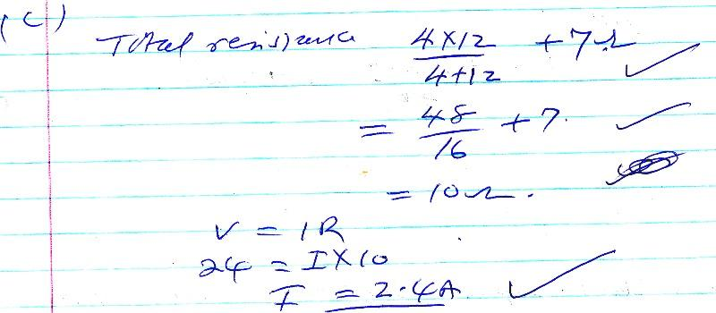

- a)
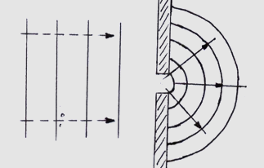
b) i) Frequency not affected
ii) Speed reduces
iii) Wavelength reduces
18 (a) - Amount of current.✓①
- Number of turns in a coil ✓①
- Shape of the core ✓①
- (i)The magnet will be attracted ✓① towards the soft iron core.
The end of the coil facing the magnet becomes South Pole when switch is closed; and the rule turns anticlockwise ✓①
ii) The polarities of the electro-magnet becomes reversed therefore the magnet is now repelled away from iron core ; and the rule turns clockwise ✓①

- (i) & (ii)
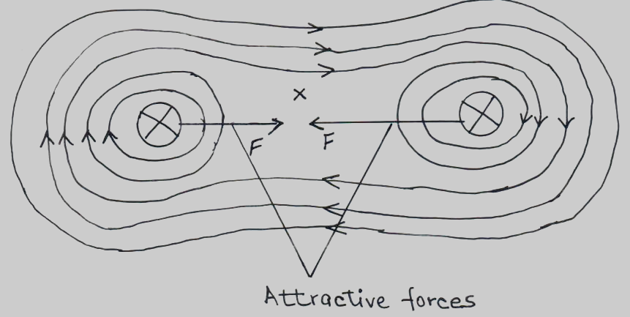

- Field ✓①
- Attractive forces ✓①

