Name………………………………………………………………..IndexNo…………………………
Candidates Signature……………. Date………………………………
511/3
MUSIC
Paper 3
November, 2020
2 ½ hours.

MOKASA JOINT EXAMINATION
Kenya Certificate of Secondary Education
MUSIC
Paper 3
2 ½ hours.

Instructions to Candidates

- Write your name and index number in the spaces provided above
- Sign and write the date of examination in the spaces provided.
- Answer all questions in this paper
- In question 4 choose any two of the questions numbered (a), (b), (c) and (d)
- DO NOT remove any pages.
- This paper consists of 11 printed pages
- Candidates should check the question paper to ensure that all the pages are printed as indicated and no questions are missing.

For Examiners Use Only
Section | Question | Maximum Score | Candidate’s Score
A | 1a | 09
 | 1b | 06
 | 2 | 15
B | 3 | 14
 | 4 | 14
 | 5 | 10
 | 6 | 10
 | 7 | 06
C | 8 | 16
Grand Total |  | 100
SECTION A: BASIC SKILLS
- (a) Continue the following to make a melody of sixteen bars for voice introducing a Duplet. Modulate to the Dominant before returning to the tonic. Add phrase marks. (9marks)
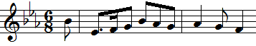

(b) Using staff notation, compose a tune to the following words. Add phrase marks. (6marks)
‘Singing, playing and dancing together
Keeps the children united and happy’

- Harmonize the following melody for Soprano, Alto, Tenor and Bass (SATB). Choose appropriate chords from I, ii, IV, V and vi. Incorporate a passing six-four in the first bar. (15marks)

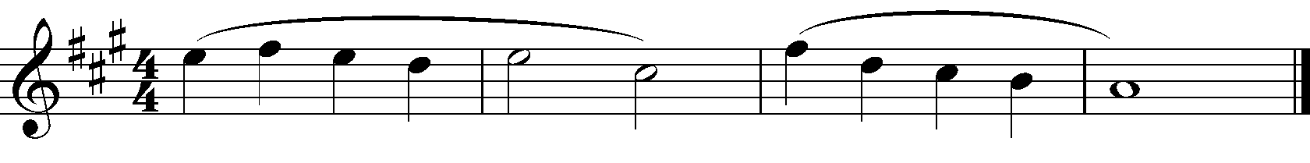

SECTION B: HISTORY AND ANALYSIS (48 marks)
3. AFRICAN MUSIC

a) Identify each of the following Kenyan dances: (3 marks)

Entabanana ………………………………………………………………………………………
Akisuk ………………………………………………………………………………………
Cheptilet ………………………………………………………………………………………
b) State any two roles of Chisasi in a Kamabeka dance. (2 marks)
……………………………………………………………………………………………………………………………………………………………………………………………..
c) State any three qualities of a good soloist.in a Kenyan folk dance. (3 marks)
………………………………………………………………………………………………………………………………………………………………………………………………………………………………………………………………………………………………………………………
d) Identify the following Kenyan traditional instruments. (4marks)
i) Nzumari……………………………………………………………………………………..
ii) Kalapapla…………………………………………………………………………………...
iii) Karing’aring’a………………………………………………………………………………
iv) Pukan………………………………………………………………………………………..

4. WESTERN MUSIC

Answer any two of the questions (a), (b), (c) and (d).

(a) Thomas Morley
i) State any three characteristics of Morley’s madrigals. (3 marks)
…………………………………………………………………………………………………………………………………………………………………………………………………………………………………………………………………………………………………………………………………………………………………………………………………………………………
ii) Name the theory book that Morley published (1mark)
………………………………………………………………………………………………………………………………………………………………………………………………………………
iii) List any three of Morley’s sacred vocal works (3 marks)
………………………………………………………………………………………………………………………………………………………………………………………………………………………………………………………………………………………………………………………
b) Domenico Scarlatti
- What was Domenico Scarlatti’s nationality? (1 mark)
………………………………………………………………………………………………
- Explain three key factors that influenced Domenico Scarlatti’s musical career. (3marks)
………………………………………………………………………………………………………………………………………………………………………………………………………………………………………………………………………………………………………………………………………………………………………………………………………………………………………………………………………………………………………………………………………………………………………………………………………………iiii) State any two appointments that were held by Domenico Scarlatti. (2 marks)
…………………………………………………………………………………………………………………………………………………………………………………………………………………………………………………………………………………………………………………………………………………………………………………………………………
iv) Identify the following works by Scarlatti. (1 mark)
Esercizi per gravicembalo………………………………………………………………….
L’Ottavia restituita al trono ………………………………………………………………..

c) Felix Mendelsohn
- Name any two of Mendelsohn’s symphonies (2 marks)
………………………………………………………………………………………………………
………………………………………………………………………………………………………
- State any two characteristics of music of the period in which Mendelsohn lived
(2 marks)
………………………………………………………………………………........................
………………………………………………………………………………………………………………………………………………………………………………………………
………………………………………………………………………………………………………………………………………………………………………………………………
- What is unique about St. Mathews passion by Mendelsohn. (1 mark)
……………………………………………………………………………………………………………………………………………………………………………………………………
- Outline any two contributions Mendelsohn made to the music of his period. (2marks).
………………………………………………………………………………………………………
………………………………………………………………………………………………………
………………………………………………………………………………………………………
d) Vaughan Williams
i) Name any two appointments of V. Williams? (2marks)
………………………………………………………………………………………………………………………………………………………………………………………………………………
ii) Give the exact names of Vaughan’s 1st 3rd and 7th symphony respectively. (3 marks)
………………………………………………………………………………………………………
………………………………………………………………………………………………………
………………………………………………………………………………………………………
iii) Identify the following works by Vaughan Williams: (2 marks)
Hugh the Drover ………………………………………………………………………………..
Benedicite……………………………………………….……………………………………………
The poisoned kiss…………….…………………………………………………………………
Linden Lea ………………………………………………………………………………………………...
5. Prescribed Traditional African Music Siriri from folk music of East Africa
- Describe the progress of the introductory section of the recording? (3 marks)
………………………………………………………………………………………………………………………………………………………………………………………………………………
………………………………………………………………………………………………………
………………………………………………………………………………………………………
………………………………………………………………………………………………………

- What is the medium of this work? (2 marks)
………………………………………………………………………………………………………………………………………………………………………………………………………………
………………………………………………………………………………………………………
- State any two characteristics of African music evident in this work? (2 marks)
………………………………………………………………………………………………………
……………………………………………………………………………………………………… d) Describe the relationship between the high pitched Siriri and the voice (2 marks)
………………………………………………………………………………………………………
………………………………………………………………………………………………………
………………………………………………………………………………………………………
………………………………………………………………………………………………………
e) State the style of the music of the low pitched siriri (1 mark)
………………………………………………………………………………………………………………………………………………………………………………………………………………
………………………………………………………………………………………………………

6. Prescribed Western:
Ludwig Van Beethoven: Septet Op. 20 Movement 4(Tema Con Variazioni)-
a) State the form of the theme. Cite bar numbers to support your answer. (2marks)
………………………………………………………………………………………………………………………………………………………………………………………………………………………………………………………………………………………………
b) Differentiate between the following: -
    - The theme from bar 0 - 4 in the violin and the coda from bar 112b -116a in the clarinet. (1mark)
………………………………………………………………………………………………………………………………………………………………………………………………………………………………………………………………………………………………
    - Orchestration in variation 1 and variation 2 (1mark)
………………………………………………………………………………………………………………………………………………………………………………………………
………………………………………………………………………………………………c) Identify any three ways in which the theme has been varied in variation 4.
(3marks)
……………………………………………………………………………………………………………………………………………………………………………………………
………………………………………………………………………………………………………………………………………………………………………………………………
………………………………………………………………………………………………

d) Citing bar numbers, identify any two ornaments used in the music. (2marks)
………………………………………………………………………………………………………………………………………………………………………………………………
e) State the tempo of this work. (1mark)
………………………………………………………………………………………………

7. Unprepared Analysis
Study the music extract below and answer the questions that follow.

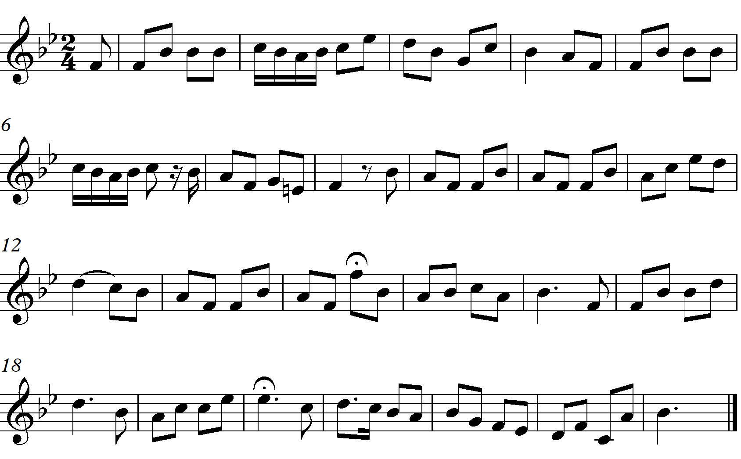

a) Identify the following in this music:- (3marks)
i) Repetition
………………………………………………………………………………………………
ii) Sequence
………………………………………………………………………………………………
iii) The climax
………………………………………………………………………………………………

b) State the form of this music. (1mark)
………………………………………………………………………………………………
c) By use of bar numbers identify the key to which the music modulates. (1mark)
………………………………………………………………………………………………d) Give the term that describes the start of this music. (1mark)
………………………………………………………………………………………………

SECTION C: GENERAL MUSIC KNOWLEDGE (16 marks)
8. a) Name any three non-transposing woodwind instruments. (3marks)
………………………………………………………………………………………………………………………………………………………………………………………………………………………………………………………………………………………………………………………
b) Define the following musical terms (5 marks)
- Music industry
…………………………………………………………………………………………………………………………………………………………………………………………………………………………………………………………………………….…………
- Ballet
………………………………………………………………………………………………………………………………………………………………………………………………………………………………………………………………………………………………
- Rondo
………………………………………………………………………………………………………………………………………………………………………………………………
iv) Calando
………………………………………………………………………………………………………………………………………………………………………………………………
v) Ensemble
………………………………………………………………………………………………………………………………………………………………………………………………

c) Enumerate three key players in the music industry. (3 marks)
………………………………………………………………………………………………………………………………………………………………………………………………………………………………………………………………………………………………

d) Rewrite the following music in open score, use the treble, alto, tenor and bass clefs. (5marks)
