MOI GIRLS HIGH SCHOOL - ELDORET
MOKASA 1 TRIAL EXAMINATION 2020
511/1 – MUSIC SIGHT READING

1. SAXOPHONE
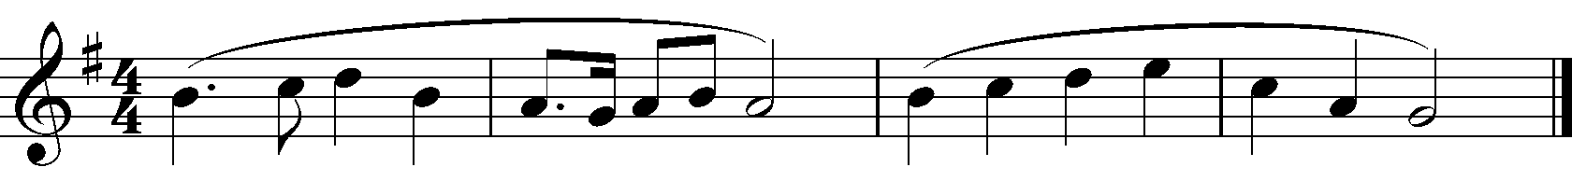

2. SAXOPHONE
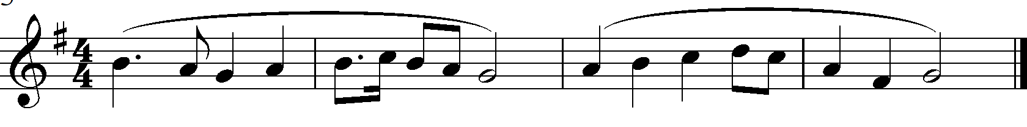

3. TRUMPET /CORNET
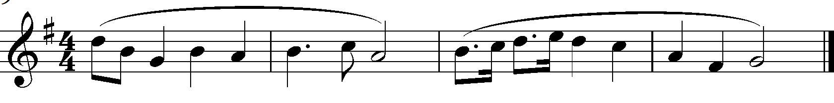
4. CLARINET
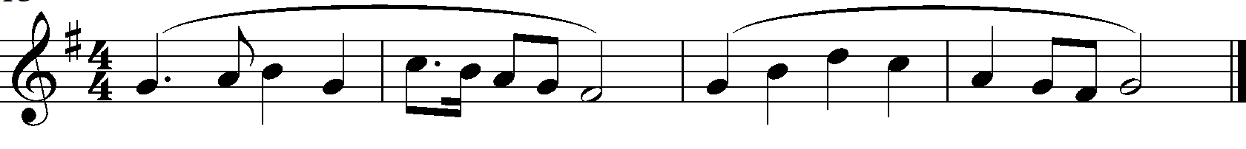
5. GUITAR
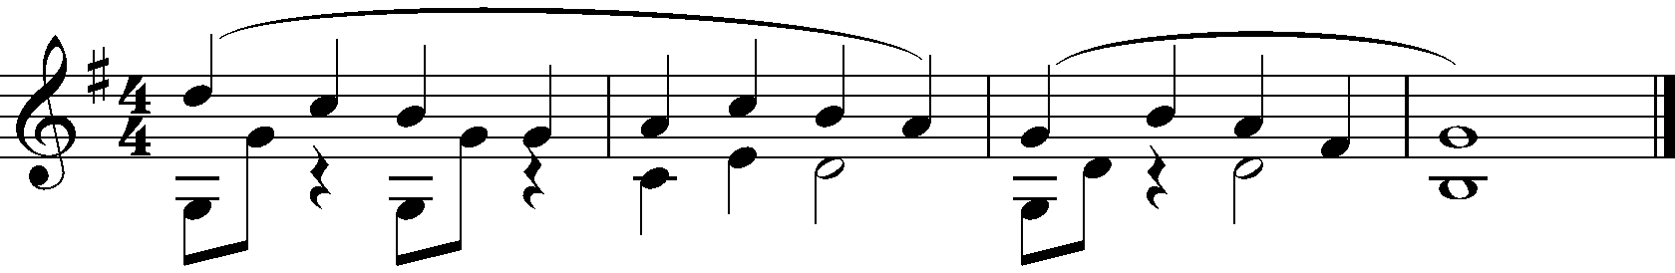

6. VIOLA
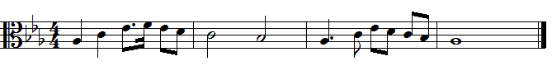

7. CELLO/ EUPHONIUM/TROMBONE
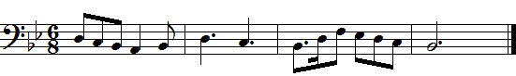

8. TUBA/ DOUBLE BASS
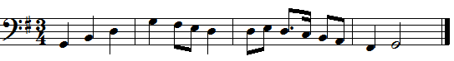
9. VOICE
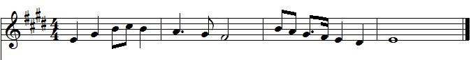
10. RECORDER
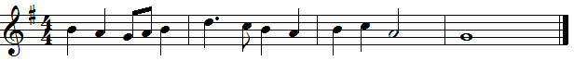
11. VIOLIN
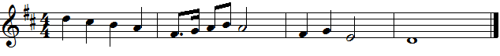
12. FLUTE
