MARKING SCHEME MATHEMATICS PAPER 121/1
ARISE AND SHINE TRIAL 1 EXAM
MARCH/APRIL-2020
1 | ½ x ⁷/₂ + ³/₂ (⁵/₂ -²/₃ )  =⁷/₄ + ³/₂ (15-4)  6  =⁷/₄ +³/₂ ¹¹/₆  =74 +¹¹/₄  =¹⁸/₄  deno ¾ x ⁵/₂ ÷¹/₂  =¹⁵/₈ x 2  =¹⁵/₄  ¹⁸/₄÷ ¹⁵/₄ = ¹⁸/₄ x ⁴/₁₅  =¹⁸/₁₅  =⁶/₅ | M1  M1  A1
2 | __5__ x 12000 = 4000  6+5+x  __5_ = 4000  11+x = 4000  12000  60 = 44+4x  4x =16  x=4 | M1  M1  A1 | Equ  Evaluating for x
 | 10x = 30.2323  1000x = 3023.2323  -990x = -2993  x=2993  990 | M1  A1
4 | Angle ACB =180º-(70º+10º) angle C/D CA= angle CAB  =180º-80º  =100º  Angle OAD = 180º- (70ºx2)  = 40  2  =20º | M1  A1  M1  A1 | Sum of angles of AD  Base angle of isosceles∆
5 | V = ⁴/₃πr³  = ⁴/3π x 3 x 3 x 3  36πcm³  = m  v  = 100  36π  = 8.727g/cm³ | M1  M1  A1
6 | __1__ = 0.2737 x10  0.3654  = 2.737  3.24x 2.737  1.8x2.737  4.9266  =4.93 | B1  M1  A1
7 | a) EFD  C  A B  b).Tetrahedron | B1  B1 | Correct diagram
8 | No std log  47.26 0.866² 4.726x10¹ 8.66x10¹ 1.6745 1.9375x2 + 1.8750  345.8 3.458x10² 1.5495 3 0.5165 - 2.5388  9.499x10⁻³ 3.9777  9.499x10⁻³ | M1  M1  M1  A1 | All logs  +ve & -ve  powers
9 | (a). 3x-2y-5=0  2y=+3x+5  ²/₃y=³/₂x-⁵/₂  y=³/₂x-2.5  G=³/₂,1 ½ or 1.5  b). G₂=²/₃  y-6=²/₃  x-4  3y-18=-2x+8  3y=-2x+8+18  y=-2x+26  3 3 | B1  M1  A1 | Equation
10 | (2x+20/x^{x}-50)  x-50+2x+20=180º  3x-30=180º  3x=210  x=70º  ex<=70-50  =20º  No.of sides =360º  20º  =18 | M1  A1
11 | x-5 – __7(x-5)__  x+5 (x-5)(x+5)  x-5 – _y_  x+5 x+5  = x-12  x+5 | M1  M1  A1 | Factorising numerator & Denominator  Simplify
12 | _5_ x1000 + 1260  100 105  50+12=62 US$  Total US$(1000+62)  US$ 1062  1US$=Ksh 63.00  US$ 1062x63  1US$  =Ksh.66906 | M1M1  M1  A1
13 | - a+2b=c  $\left({2 \atop 3}\right)$+2b=$\left({3 \atop 5}\right)$  2b=$\left({3 \atop 5}\right)$-$\left({2 \atop 3}\right)$  2b=$\left({1 \atop 2}\right)$x¹/₂  b=$\left({0.5 \atop 1}\right)$  (ii). (a+b) = $\left({2 \atop 3}\right)$+$\left({0.5 \atop 1}\right)$=$\left({2.5 \atop 4}\right)$  /a+b/=$\sqrt{{2.5}^{2}+4^{2}}$  $\sqrt{6.25+16}$  $\sqrt{22.25 }$ =4.71699 4.72 | M1  A1  M1  A1
14 | 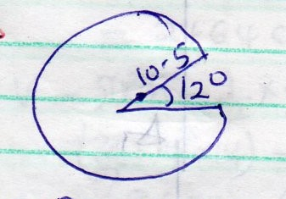  L=$__θ$ x π2r+2r  360  348 x 2$π$(0.5) + 2(10.5)=658.83  360 | M1A1
15 | x+11 > 4x-19  -3x > -30  -x >-10  x <10  4x – 19 ≥ 2 – x  5x ≥ 21  x ≥ 4 ¹/₅  integral values 5,6,8,9
16 | 2 27 30 45  3 27 15 15  3 9 5 5  3 3 5 5  5 1 5 1  1 1  LCM=2x3³x5  =270  Q=270+3=  =273 | M1  A1 | For table /factorisation
 | SECTION B
17 | (a)Let the length of train be=x  Distance covered =5+x  R.S=30-25=5k/hr  =5x5 = _25_  18 18m/s  Time = 1 ½ min = 90s  5+x =25 x 90  18  x=120m  b). Time = 4 ⁴⁸/₆₀ = 0.08hrs / 240+48=288 sec  60  Distance = 25 x 288  18  =400m  c). Distance train travelled in 45mins  d= 45 x 25 x 4  60  = 18.75km  R.S = 5km/hr  to catch up t=18.75  5  =3.75hrs | M1  M1  A1  M1  M1  A1  M1  A1  M1  A1 | Getting RS  Changing speed to m/s  time in s
18 | - 75-79  class Mid pts f fx C+  60-64 62 B1 2 124 B1 2  65-69 67 3 201 5  70-74 72 6 432 11 B1  75-79 77 11 847 22  80-84 82 8 656 30  85-89 87 7 609 37  90-4 92 2 184 39  95-99 97 1 97 40  $$\sum{f=40 }$$ $$\sum{fx3250}$$  Mean x =$\sum{fx}$  $\sum{f}$  =3250  40  = 81.25  Median class 70-75  74.5 + 40 – 11 5  _2____  11  78.59 | M1  A1  B1M1  A1 | For 74.5
19 | (a).  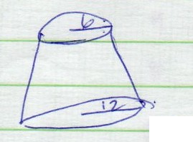  L= $\sqrt{6^{2}+{7.2}^{2}}$  = 9.372  = 9.4M  (b). 7.2+h =2  h  h=7.2m  L = $\sqrt{{12}^{2}+{14.4}^{2}}$ = 18.74m  L = $\sqrt{6^{2}+{7.2}^{2}}$ =9.37.2m  (πx12x18.74) – (πx6x9.372)  =529.82m²  c). (¹/_{3π} x12²x14.4) – (¹/_{3π} x6²x7.2)  =1900=4m³  19.00.04x1000  =1900.04m³  (d). 500x40  20.000L  1900040  20000  =95.002 days | M1  A1  M1  A1  M1  A1 | FT
20 | No. of suits be x  57600 per suit in whole sale  x  57600 – 480 = 57600  x x+4  57600 – 57600 = 480  x x+4  57600x + 230400 -5700x = 480x² + 1920x M1  480x² + 1920x = 230400  x² + 4x = 480  x² + 4x = 480  x²+4x 4 ² = 480 + 4 ²  2 2  (x+2)² = 484  x+2 = ±22  Hence x = 22 – 2 or -22 -2  x = 20 or -22 ignore  No of suits 20  (b). B.P = 57600 = 2880  20  % profit =_720_ x 100%  2880  =25% | M1  M1  M1  M1  M1  A1  B1  M1  M1  A1
21 | 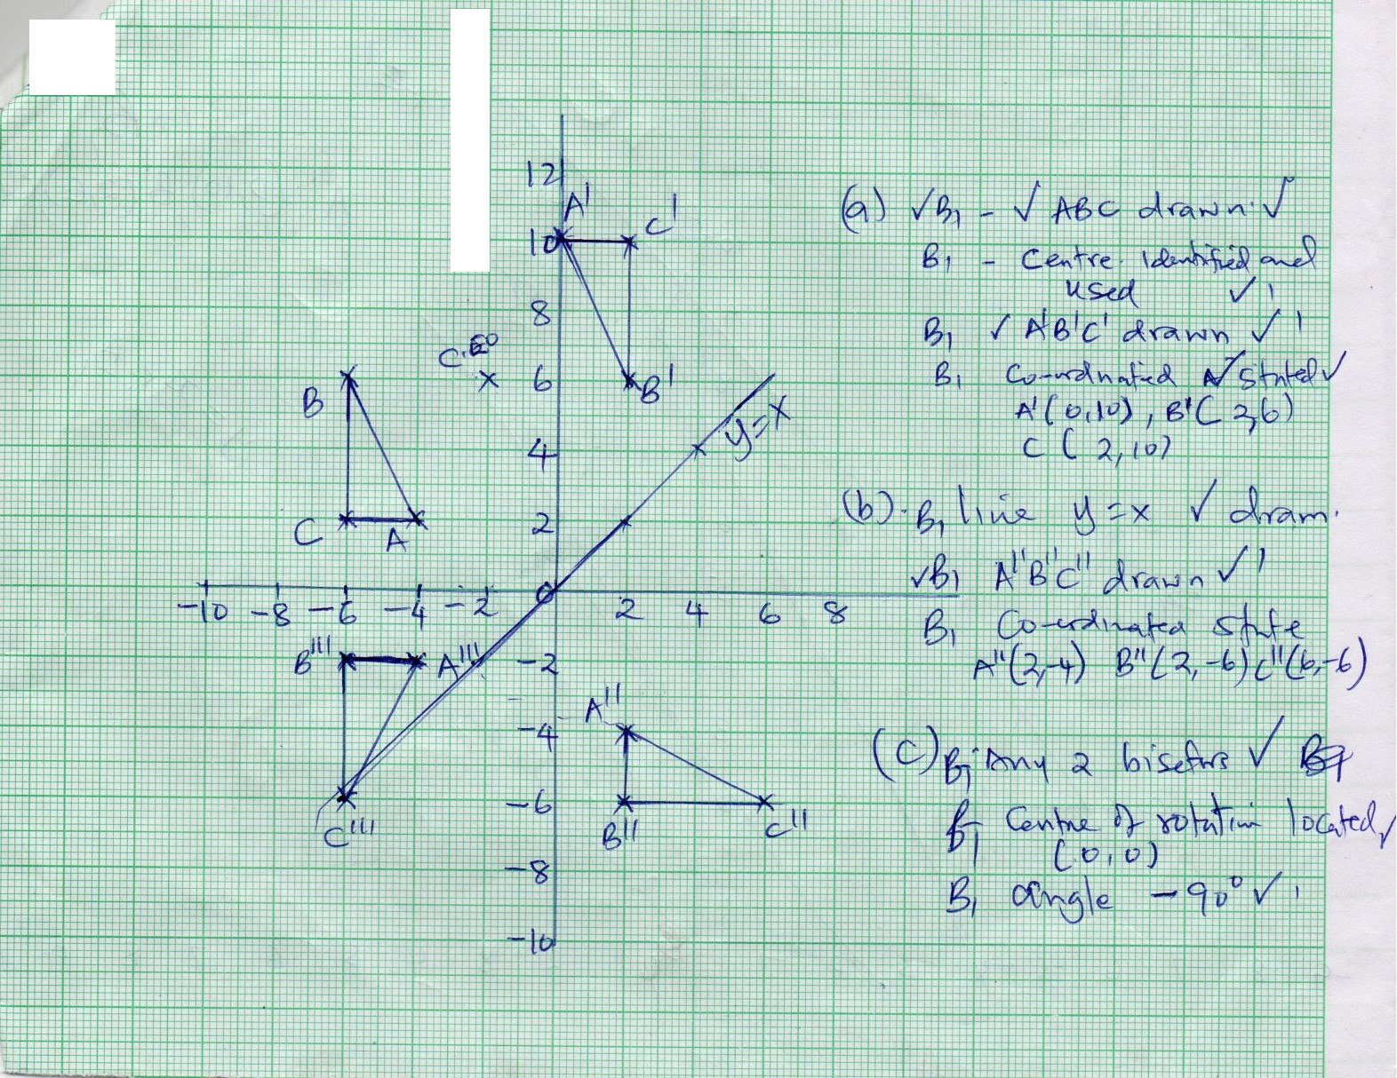
22 | (a). Sin$θ$ = sin 30º  5 4  Sin$θ$ = 5 sin 30º  4  =38.68º  Obtuse angle 180 – 38.68 = 141.32  (b). <ABD = 180º – (38.68x2)º  = 102.64o  AD² = 4²+4²-2x4x4 Cos 102.64º  AD = 6.24M  c). <DBC =180º – (30 +141.32)º  = 8.68  Sin 8.68 = Sin 30º  DC 4  DC = 1.28M  (d). Area of ∆ABC  ½ x4x5 sin (8.68+102.64)º  =10 sin 111.32  9.32m² | M1  A1  B1  M1  M1  A1  M1  A1  M1  A1 | FT  Accept alternative  method
23 | (a)  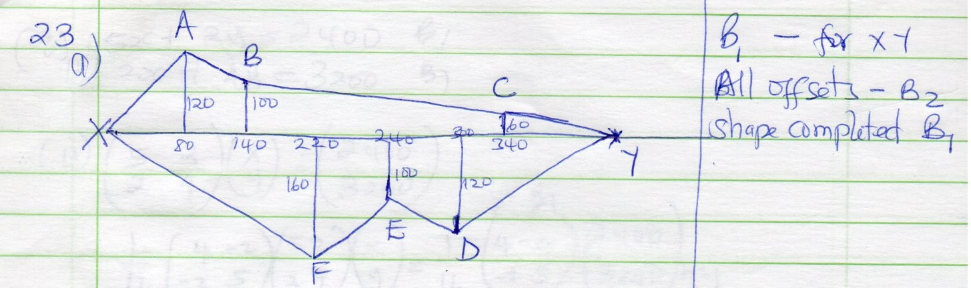  - Area ½ x 50 x 120 = 4800  ½ (120+100)60 = 6600  ½ (100+60)200 =16000  ½ x 60 x 60 =1800  ½ x220 x 160 =17,600  ½ (160 + 100)20 =2 600  ½ (100 + 120)60 = 6600  ½ x 100 x 120 =_6000_  62000M²  62000  10000  = 6.2x80,000  Cost =Ksh.496,000 | M1  M1  M1  A1  M1  A1 | B1 –for xy  All offsets –B2  Shape completed B1
24 | (a)(i) 5x + 2y =2400 B1  2x + 4y = 3200 B1  (ii). $\left({5 2 \atop 2 4}\right)\left({x \atop y}\right)$= $\left({2400 \atop 3200}\right)$ B1  ^{1/}₁₆ $\left({4-2 \atop -2 5}\right)$ $\left({5 2 \atop 2 4}\right)\left({x \atop y}\right)$= ¹/₁₆ $\left({4-2 \atop -2 5}\right)\left({2400 \atop 3200}\right)$ M1  $\left({x \atop y}\right)$=1/16$\left({3200 \atop 11200}\right)$M1  $=\left({200 \atop 700}\right)$=  x=200/=, y=700/= A1 (both)  (b). Buying price = (16x200) + (20x700) M1  =sh.17,200 M1  Selling price = (120 x 16x200) + (115 x 20 x 700)  100 100  =3840 + 16,100  =sh.19,940  % profit = 19940 – 17200 x 100 M1  17200  =15.93% A1

