2020 FORM 4 TERM 1 OPENER EXAMS
MATHEMATICS PAPER 1 MARKING SCHEME.
No. 1 -8 -5 x -8 +6
-8 + 40 +6
=38 m1

-3 – 8 $÷$2 x 4
-3 – 4x 4 = 19

=$\frac{38}{-2}√$
=-2$√$

NO. 2
$\frac{17}{7}$ -$\frac{11}{6}$ = $\frac{25}{42}$ X $\frac{6}{5}$ =$\frac{5}{7}$
$\frac{2}{3}$ X $\frac{9}{4}$ = $\frac{3}{2}$ - $\frac{8}{7}$ = $\frac{5}{14}√$
$\frac{5}{7}$ X $\frac{14}{5}$ = 2$√$

NO.3
Let mother’s years be x and son’s be y now:
X+14 = 2(y+14)………………………..i
X + 14 = 2y + 28
X – 2y = 14 ………………………………ii
(x-4)+ (y-4)=30
X + y = 38………………………………….iii$√$
Iii – ii x+y = 38
+ -x + 2 = -14
3y = 24 $√$ x=30$√$
At son’s birth:mothers age = 30-8 =22 years$√$

No. 4
105000 x 9.74
= sh 1,022,700
$$\frac{1022700 - 403879}{12.11}√$$
=51100 rands$√$

No. 5
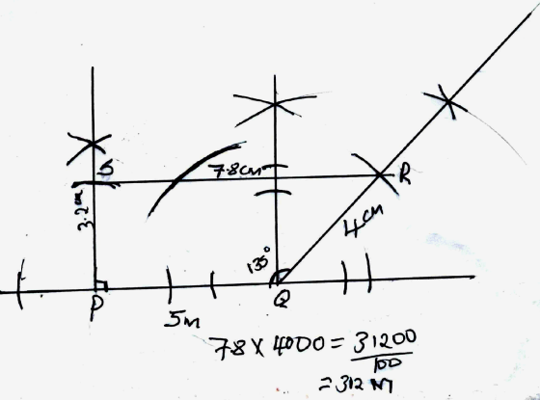
No 6
g: c: s = 8 : 20 : 15
$\frac{43}{15}$x 15$√$
= 43 Animals$√$

No. 7
100% = x
90% = 1440
$$\frac{1440 x 100}{90}$$
=1600

120% =1600
100% =x
$$\frac{1600 x100}{120}$$
=1333.3

1600 – 1333.3 = 266.70
No. 8
$\frac{1}{0.03654}$ – 4.151²
4.151² = 17.231
$\frac{1}{0.03654}$ = $\frac{1}{3.654 ×{10}^{-2}}$ = $\frac{1}{3.654}×\frac{1}{{10}^{-2}}√$
=0.2737 $×{10}^{2}$ = 27.37$√$
27.37 – 17.231 = 10.139$√$

No. 9
$$\frac{{12a}^{2}-{3b}^{2}}{{2a}^{2}-ab-b^{2}}$$
$$\frac{3\left(2a+b\right)\left(2a-b\right)}{2a\left(a-b\right)+b \left(a-b\right)}√√$$
$$\frac{3\left(2a-b\right)}{a-b}√$$

No. 10
Sin $\left(x+{60}^{0}\right)$ = cos 2$x$
$X$+60 +2$x$ = 90$√$
$3X$ = 30
$X$ = 10⁰$√$
$tantan \left(x+60\right)$ = tan 70⁰
= 2.748 (from tables)
=2.748 (from calculator)
4 s. f. 2.7475 $√$

No. 11
$\frac{12}{8}$ = $\frac{3}{2}$
a.s.f. = $\frac{9}{12}√$
Area PST = $\frac{4}{9} ×336$ = 149 $\frac{1}{3}√$
Area QRST = 336 -149$\frac{1}{3}$ = 186$\frac{2}{3}√$

No 12
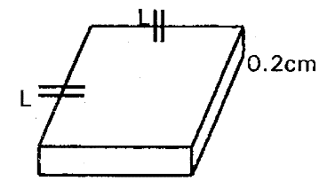
Volume = $\frac{mass }{density }$
=$\frac{1050{cm}^{3}}{8.4}$ = 125 ${cm}^{3}$
$∴$ L x L x 0.2 cm = 125 ${cm}^{3}√$
L² = $\frac{125 cm}{0.2}$ = 625$√$
L = $\sqrt{625 }$ = 25 cm$√$

No. 13
2 x 3.142 x 36 = 226.224
3.142 x 610.82 = 204.0$√√$
Total 430.224$√√$

No. 14
9-3x $>$ 2x + 2
$\frac{7}{5}>$x$√$
$x$+ 1$>$-2x-1
$$3x > -2$$
X $>$ -$\frac{2}{3}√$
$-\frac{2}{3}<$x$<$ 1$\frac{2}{5}$
$$interal values 0, 1√$$

No.15
3t+2a=9000..... (i)
4t+a =9500...... (ii)
Multiply (ii)x2
8t+2a =19000-
3t+2a =9000
5t = 10000
t = 2000$√$
substitutingin (i) above
3 x 2000 + 2a = 9000
a = $\frac{3000}{2}$
a = 1500$√$
t = 2000
2 x 2000 + 5 x 1500
= 11500$√$

No.16
a) $r^{2}$= ${7.6}^{2}$ + ${4.8}^{2}$ – 2 x 7.6 x 4.8 cos 80
= 57.76 + 23.04 – 12.67
= 68.13 $√$
R = 68.13
= 8.3$√$

b) $\frac{sin b }{4.8}$ = $\frac{sinsin 80 }{8.254}$
SinB = 0.5727
B = sin -10.5727$√$
= 34.9⁰$√$

SECTION II
No 17.
a) 2y – 3x = 6
3y + x = 20
2y - 3x = 6$√$
9y + 3x = 60
11y = 60
Y= 6$√$
X = 20 -18
= 2
Co-ordinates of A are (2,6) $√$

b) L₂: 3y = -x + 20
y = - $\frac{1}{3}x$ + 20 $√$
Gradient of perpendicular = 3
$\frac{y-6}{x-2}$ =3$√$
Y= 3$X$- 6 + 6
Y = 3$X√$

c) Gradient of L₄= gradient of L₁
=$\frac{3}{2}$
$\frac{y-3}{x-1}$ = $\frac{3}{4}√$
2y -6 = 3$X$ + 3
2y - 3$X$ = 9 $√$
When $X$ = 0 y = 4.5$√$
When y = 0 x = -3$√$

No. 18
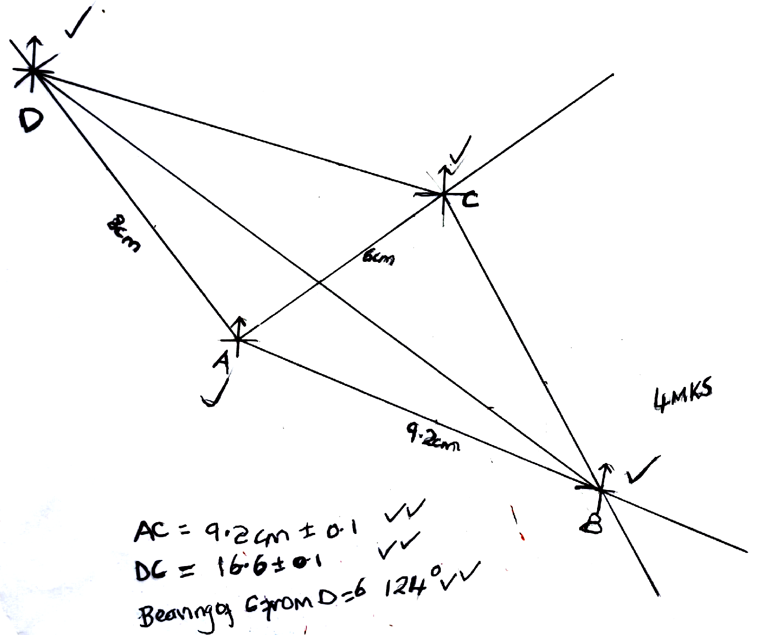

No. 19
a) x + 2 + 12 + 7 +15 + $X$= 40
$X$= 4$√$
b) Mean of $\frac{Σfx}{Σf}$ = $\frac{1287.5}{40}$ = 32.1875$√√$
c)
CB | 4.5-14.5 | 14.5-29.5 | 29.5-34.5 | 34.5-44.5 | 44.5-49.5
Fd | 0.2 | 0.8 | 1.4 | 1.5 | 0.8
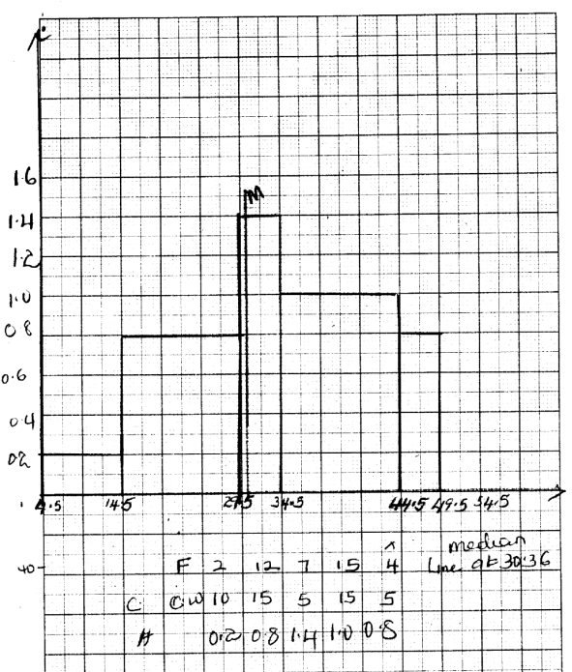  Fx | 19 | 264 | 224 | 595.5 | 188

d) total area A = 10 x 0.2 = 2 $√$
B= 15 x 0.8 = 12 2 + 12 + 7 + 15 + 4
C = 1.4 x y = 6 $√$ = $\frac{40}{2}$= 20$√$
D = 1.5 x 10 = 15
E = 0.8 x 5 = 4
Point to draw the lie is 29.5 + $\frac{6}{7}$ =30.36
No.20
a) $a^{2}$ =$b^{2}$+ $c^{2}$ – 2bc cos A
$7^{2}$ = 10² + 8² - $\left(2 x 10 8\right)$ cos A
49=164- 60 cos A
-116 =160 cos A
Cos A =$\frac{116}{160}√$
Cos A = 0.725$√$
Cos¹ 0.725 = 43.53115
$<$BAC = 43.53$√$
b) $\frac{a}{sinsin A }$ = 2R
$\frac{7}{sin 43.53}$ = 2R$√$
R =5.082cm$√$
(c) Sin 43.53 = $\frac{3.5}{r}$
r = $\frac{3.5}{sinsin 43.53 }=$5.082 cm$√$
Area of $△$OCB =$\frac{1}{2}$ ab sin $θ$
= $\frac{1}{2}$x 5.082 sin 87.06$√$
= 12.896cm²$√$
Area of sector ACB
=$\frac{θ}{360}πr^{2}$
=$\frac{87.06}{360}$ x $\frac{22}{7}$ x 5.082 = 19.630$√$
Shaded region
(19.630 — 12.896) = 6.734 cm²$√$

No. 21
- 15m/s$√$
- Maximum speed
$$\frac{1}{2}\left(15+h\right)×10+\frac{1}{2}\left(10+30\right)h=825$$
$75+5h+20h=825√$
$$25h=750√√$$
- $h=30m/s$(i) = $\frac{30-15}{10}$
= 1.5m/s²$√$

(ii) = $\frac{0-30}{20}$ = $-$1.5m/s²$√√$

- $\left[\frac{1}{5}\left(15+30\right)×10+10×30\right]÷20$

= $\left(225+300\right)÷20$
=26.25 m/s$√√√$

No.22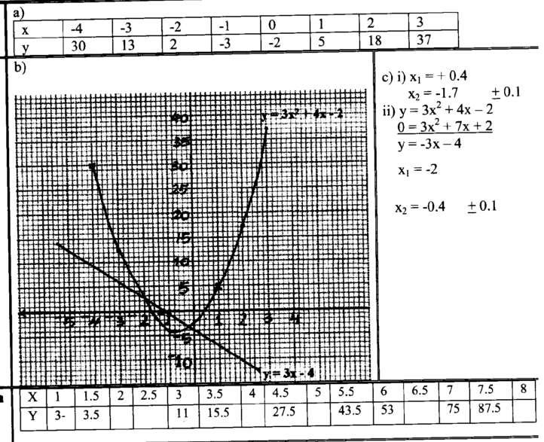
$$√√√√√√√√√√$$

No. 23
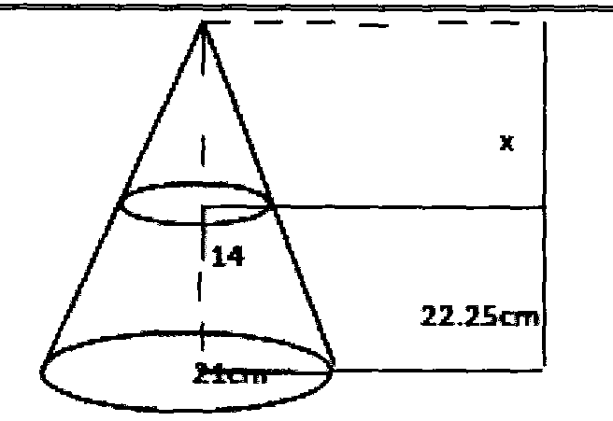
a) i) Volume
Ratio $\frac{x}{14}$ =$\frac{22.5+x}{21}$
21$X=$14(22.5 +$X)$
21= 14(22.5 + x)$√$
21x - 14x = 315
x = 45cm$√$
Volume of whole cone
=$\frac{1}{3}$ x $\frac{22}{7}$ x 21 x 21 x 67.5 =31185 cm³$√$
Volume of small cone
= =$\frac{1}{3}$ x $\frac{22}{7}$ x14 x 14 x 45 = 9240 cm³ $√$
Volume of frustum
31185- 9240 = 21 945 cm³$√$
ii) Mass of frustum
Mass=21945x$\frac{3g}{{cm}^{3}}$=65835g $√$
Mass in kg= $\frac{65.835 g}{1000g}$ = 65835kg$√$
b) 20% of 65.835kg = 13.167 kg
65.835 - 13.167 = 52.668 kg$√$
Volume of material remaining =
$\frac{56682}{3}$= 17556cm³$√$
Length of cube = $\sqrt[3]{17 556 }$= 25.99 cm$√$

No.24
(a) (i) 6400 + 1750 x 20
= Ksh4 400$√$
(ii) 41 400— 36000=Ksh 5400$√√$

(b) 36000 $(1+r/100)$ = 41 400

(1+$\frac{r}{100}$) = 1.15$√$
(1 + $\frac{r}{100}$) = ${1.15}^{\frac{3}{5}}√$
$\frac{r}{100}$= 0.087473554$√$
r= 8.7473554$√√$
(c) 36000 x 1.087²
= 42536.484$√$
42536.484 - 36000$√$
=6536.484$≈$ Ksh 6536$√$

