**MAGS 2 CYCLE 7**

**MATHEMATICS**

**PAPER 2**

**MARKING SCHEME**

|  |  |  |  |  |  |  |  |  |
| --- | --- | --- | --- | --- | --- | --- | --- | --- |
| 1. | |  |  | | --- | --- | | No. | Log | | 45.3  0.00697  8.450 x 10-1  **0.8450** | 1.6651  +  3.8432  1.5083  1.7275  1.7808  3  +   * T.9269 | | | | M1 ✓ All logs  M1 +, -  M1 division by 3  A1 | | |
| 2. | 2Sin2 x – 1 = 1 – Sin2x + Sinx  3Sin2x – Sinx – 2 = 0  (3Sinx + 2) (Sin x – 1) = 0  Either  Sinx = 0.6667 or Sin x = 1  x = 900, 221.81, 318.19 | M1 Evaluation  M1 Factorisation  A1 | | |
| 3. | (a) 1 + 5 x + 10 x +10x  + 5 x …  1 + + + + + ….  (b) (2.5)2 = (  1.5 =  x = 2  1 + + + +  1 + 7.5 + 22.5 + 33.75 + 25.3125 + ….  90.063 | M1 Factorisation  A1  M1 Substitution  A1 | | |
| 4. | E =  E2 =  E2Y – 3E-2XP = P – 3u  P + 3E2XP = E2Y+3u  P = | M1 Squaring  M1 Collecting terms in P  A1 Subject obtained | | |
| 5. | ) θ  V  D  B  E  2  2  8  V  E  O    Cos θ =  = 0.1936  θ = Cos- 0.1936  θ = 78.840 | M1 Expression for angle  A1 | | |
| 6. | A.S.F = Determinant of matrix  = x (x + 3) – 12  x2 + 3x – 12 = 6  x2 + 3x – 18 = 0  x2 – 3x + 6x – 18 = 0  x(x – 3x) + 6(x – 3) = 0  (x + 6) (x – 3) = 0  X = - 6 or x = 3 | M1 equation obtained  M1 factorisation  A1 | | |
| 7. | A 2 D 1 B  O  OD = OA + AD  +  +  +  8i + 4j + 6k  Co-ordinates of D are(8, 4, 6) | M1 Expression for OD  M1 Simplification  A1 | | |
| 8. | Cost price =  = 152.50  Profit = 180 – 152.50  = 27.50  % Profit = x 100  = 18.03% | M1 Cost price  B1 Profit  A1 | | |
| 9. | Zα ⇒ Z =  Z1 =  1.6z  % Change = x 100%  x 100  = 60% |  | | |
| 10. | = 14000  = 14724  % error x 100  = 4.917 | M1 Rounding off  M1 Expression for % error  A1 | | |
| 11. | x2 – 4x + y2 + 6y – 1 = 0  x2 – 4x + 4 + y2 + 6y + 9 = 14  (x – 2)2 + (y + 3)2 = 14  Centre (2, -3)  Radius = 3.742 | B1 Completing square on RHS  B1 Completing square LHS  B1 for radius and centre | | |
| 12. | ∠OBA = 150  ∠AOB = 180 – (15 + 15) = 1500  ∠ACB = 750  2R =  R =  r = 4.146  Area of circle  3.142 x 4.1462  54.01 | M1 or equivalent  M1 area equation  A1 | | |
| 13. | (a) - =  Required time  or 3 hrs 20 min  (b) - - =  Required time  7 hrs | M1 Expression  A1  M1 Expression  A1 | | |
| 14. | (a) Det. 20 – 9 = 11  Inverse ⇒  (b) =  =  =  x = , y = | B1 Inverse  M1 Equation formed  S1 Simplification  A1 | | |
| 15. | = 4( | M1 Conjugate  A1 | | |
| 16. | L1 y = x  y > x  L2 + = 1  x + y = 4  x + y ≤ 4  L3 + = 1  -3x + y = 3  y – 3x = 3  y – 3x ≤ 3 | B1 Inequality obtained  B1Inequality  B1 Inequality obtained | | |
| 17. | (i)  Hence P =  When Q = 27, R = 121  P =     1. Q1 = 1.21Q²   R1 = 0.866025403  P1 = K  K  New value of New change =  = 39.7187651%  Hence increase of **39.72%**  (iii)  K =  =  = 6 Eqn = Q =  P =  =  = | M1 🗸 constant  M1 substitution  A1  M1 expresions  M1 for p1  M1  A1  M1  M1  A1 | | |
| 18. | C:\Users\Nzambia\AppData\Local\Microsoft\Windows\Temporary Internet Files\Content.Word\kkkkkkkk.jpg |  | | |
| 19. | (a) a + d = 8  a + 4d= 17  3d=9  d = 3  ∴ a = 5   1. 2nd = 8   10th = 5 + 9 × 3 = 32  42nd = 5 + 41 × 3 = 128  ∴GP is 8, 32, 128, - - - -  a = 8  r = 4  nth term of G.P = arn – 1  ∴10th term = 8(4)9  = 2097152  (c)      = 2796200 | M1 Equations  A1  A1  M1  M1 For the three terms  M1 Substitute  A1  M1  M1  A1 | | |
| 20. | E1  E1  E1  E1  (a)  (b) (i) +  +  =  (ii) + +  + =  (iii) +  =  (iv) +  = | B1 Probability  B1 Probability  B1 Expression  A1  M1  A1  M1 Expression  A1  M1 Expression  A1 | | |
| 21.  (a) | |  |  |  |  |  |  |  | | --- | --- | --- | --- | --- | --- | --- | | Height  X (cm) | f | d | d 2 | fd | fd2 | cf | | 25 – 29  30 – 34  35 – 39  40 – 44  45 – 49  50 – 54  55 - 59 | 5  12  18  30  17  11  7 | -3  -2  -1  0  1  2  3 | 9  4  1  0  1  4  9 | -15  -24  -18  0  17  22  21 | 45  48  18  0  17  44  63 | 5  17  35  65  82  93  100 | |  | Σf=100 |  |  | Σfd= 3 | Σfd2 =235 |  | | | |  |
| 22. | P  EAFB765C  30  37.5  N  C    EAFB765C  30  30  C  B      N  EAFB765C  A  B  60  37.5  37.5    3  1 | |  | |
| 24.  (a) | 6CCBF3C2   |  |  |  |  | | --- | --- | --- | --- | | b)  c)  d) | It is an enlargement centre origin (0,0) scale factor 2    Note correct the 2nd matrix in (b) from  to |  |  | | |  | |
| 21. |  | |  | |
|  |  | |  | |

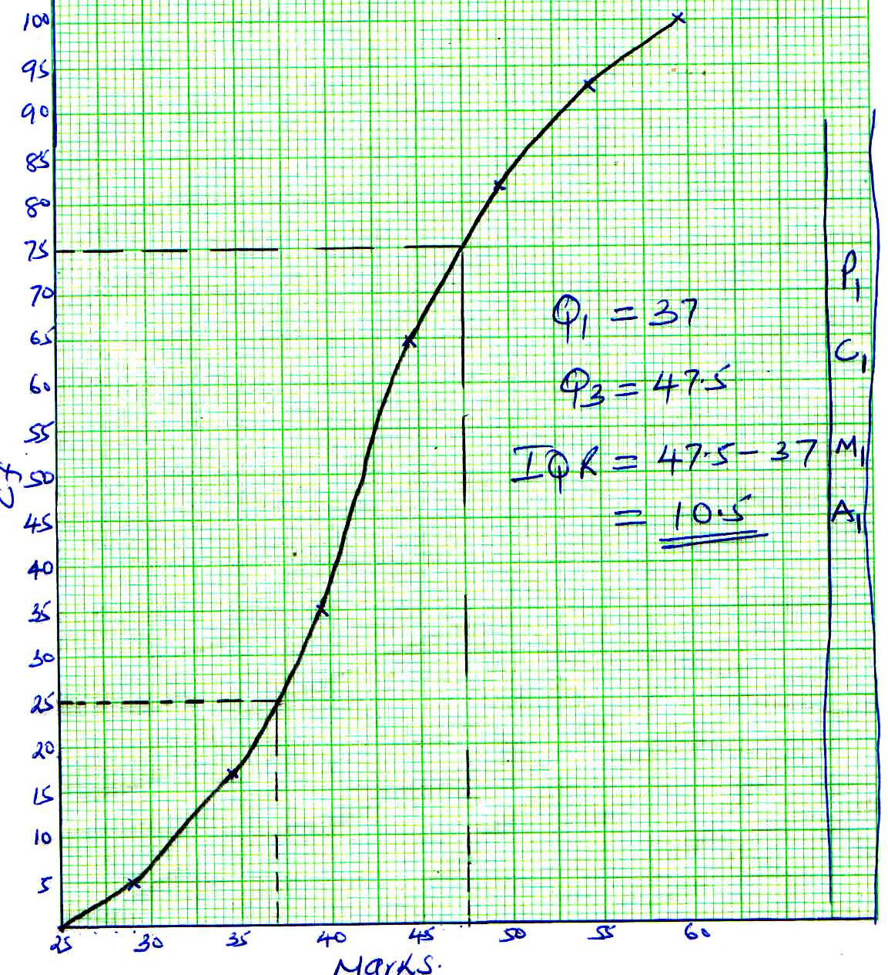21.

23. 