MAGS 2 CYCLE 7 JOINT EVALUATION
MATHEMATICS PAPER 1
MARKING SCHEME

1. |  | M1  M1  A1  03
2. | $$\sqrt{6.458 ×{10}^{-2}}+ 2 {\left(\frac{1}{0.4327}\right)}^{2}$$  2.541 + (2.311)²  = 2.541 + 2(5.307)  = 2.541 + 10.61  =13.155 | M1  M1  M1  A1  04
3. | χ + 5y = 129250  2χ - 4y = 22000  6χ + 10y= 258500 -  6χ - 12y= 66000  22y = 192500  y = 8750  χ = 28,500 | M1 both  M1eliminatio  A1  03
4. | $$\frac{a^{4}- b^{4}}{a^{3}- {ab}^{2}}$$  $$\frac{\left(a^{2}- b^{2}\right) \left(a^{2}+ b^{2}\right)}{a \left(a^{2}- b^{2}\right)}$$  $$= \frac{a^{2}+ b^{2}}{a}$$ | M1  M1  A1  03
5. | $9^{(x-1)}$ x $3^{(2x+1)}$ = 243  Change to base 3  $3^{2(x-1)}$x $3^{(2x+1)}$ = $3^{5}$  2 (x – 1) + 2x + 1 = 5  2x – 2 = 2x + 1 = 5  4x – 1 = 5  4x = 6  x = 1.5 | M1  M1  A1 03
6. | (x + 2 ) ( x – 5 ) = 60  x² – 5x + 2x – 10 = 60  x² – 3x – 70 = 0  x² – 10x + 7x – 70 = 0  x ( x – 10) + 7(x – 10) = 0  ( x – 10) ( x +7) = 0  x = 10 x = -7  Length 10 + 2 = 12m
7. | 98.54 x 1200 = 118248  45600 + 118248  = 163848$÷98.36$ $=1665.7991$ = 1666 dollars | M1  M1  M1 03
8. | HCF of 240, 320 and 380  120 320 380  2 120 160 190  2 60 80 95  5 12 16 19  HCF = 2 x 2 x 5 = 20 cm  Area = 20² = 400cm² | M1  M1  A1 03
9. | $\frac{ 1}{8}$x + x = 180  $\frac{9}{8}$ x = 180  x = 180 x 8  9  = 160  Exterior ˂ = $\frac{1}{8}$ x 160 = 20  No. of sides 360 = 18  20 | M1  A1  B1 03
10. | 2ϴ + 30 + ϴ - 60 = 90  3ϴ = 120  ϴ = 40  Tan 40 = 0.8391 | M1  M1  A1  03
11. | $\frac{12}{2}$ = 1.2 x k  k = $\frac{6}{1.2}$ = 5  Length in cm Frequency  7.5≤ x ≤ 9.5 12  9.5 ≤ x ≤ 11.5 5 x 1.6 = 16  11.5≤x ≤ 15.5 5 x 0.8 x 4 = 16  15.5≤ x ≤ 21.5 5 x 2 x 6 = 60 | B1 Constant  B1  B1  B1 04
12. | i) at P y= o :. 3(0) + 4(x) = 12  x = 3 P(3,0)  ii) y= - ⁴/₃ x + 3 m₁ = ⁻ ⁴/₃ m2 =3/4  y – 0 = ³/₄  x- 3  4y = 3x – 9 :. Y = ³/₄ x– 2¹/₄ | M1  M1  A1
13. | L. S. F$=$ 12 : 8= 3 : 2  V.S. F = 27 : 8  27 = 2litres  8 = ?${ 8}/{27} x 2= \frac{16 litres}{27}$  $$\left(\frac{16}{27} x 1000\right) cm3$$  = 592.592593${cm}^{3}=592.59$ | B1  M1  A1  03
14. | AB= $\left(\begin{matrix}K & 4 \\ 3 & 2\end{matrix}\right)$ $\left(\begin{matrix}1 & 2 \\ 3 & -4\end{matrix}\right)=\left(\begin{matrix}K+12 & 2K-16 \\ 9 & -2\end{matrix}\right)$  -2(K+12) -9 (2K-16)=10  -2K-24-18K+144=10  -20K = -110  ∵K=5.5 | M1  M1  A1
15. | Total ration ¼ + ½ + 1/5 = 5+10+4 = 19  20 20  Vol. Shared = 19 x 1000 = 950cm³  20  Soita = ½ x 950  ¹⁹/₂₀  10 x 950 = 500cm³  19 | M1  M1  A1 03
16. | $\log{\frac{b^{2}}{a }}$ = $\log{b^{2}-\log{a}}$  2(0.48) – 0.30  0.96 – 0.30  = 0.66 | M1  M1  A1 03
17. | a) V.R = 90+110 = 200km/h  10.35a.m – 8.15a.m = 2hrs 20min = 2 ¹/₃ hrs  Distance covered by matatu by 10.35cm  = ⁷/₃ x 90 = 210km  Remaining distance 760 – 210 = 550km  Time taken = 550 = 2 ¾ hrs  200  Distance minibus had moved = 11 x 90 = 247.5km  4  Distance from A = 210 + 247.5  = 457.5km  b) They met at 10.35  2.45  13.20  = 1320hrs or 1:20pm  c) By 10.30a.m minibus had covered  9 x 90 = 202.5km  4  Time taken by minibus to B  760 – 202.5 = 6⁷/₃₆hrs = 6.19hrs  90  Distance covered by the motorist in this time.  6.19 x 100 = 619km | B1  B1  B1  A1  M1 for addition  A1  B1  B1  M1 A1  10
18. | 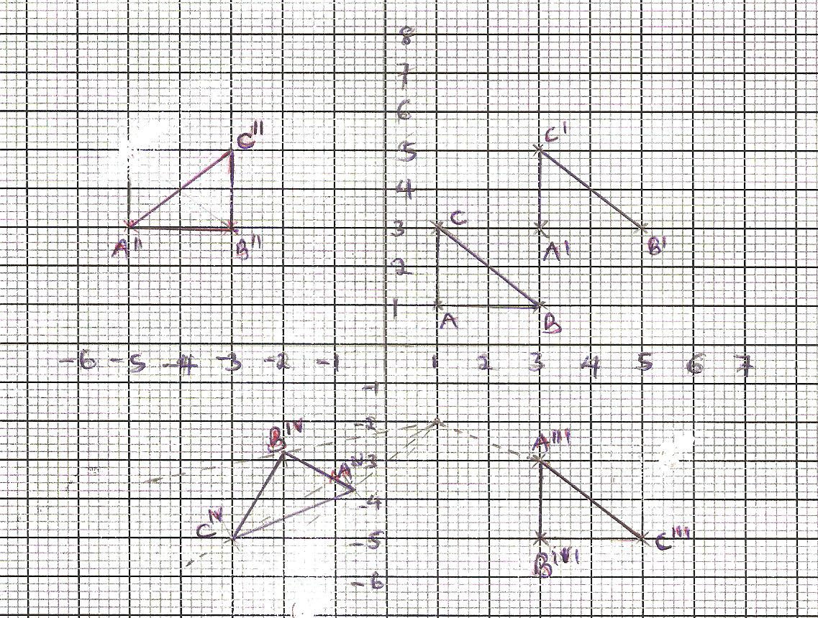  A¹ = $\left(\begin{matrix}1 \\ 1\end{matrix}\right)+\left(\begin{matrix}2 \\ 2\end{matrix}\right)$= $\left(\begin{matrix}3 \\ 3\end{matrix}\right)$  B¹ = $\left(\begin{matrix}3 \\ 1\end{matrix}\right)+\left(\begin{matrix}2 \\ 2\end{matrix}\right)$= $\left(\begin{matrix}5 \\ 3\end{matrix}\right)$  C¹ = $\left(\begin{matrix}1 \\ 3\end{matrix}\right)+\left(\begin{matrix}2 \\ 2\end{matrix}\right)$= $\left(\begin{matrix}3 \\ 5\end{matrix}\right)$  A¹¹ = $\left(-5,3\right)$B¹¹ = $\left(-3, 3\right)$C¹¹ = $(-3,5)$  A¹¹¹ = $\left(3,-3\right)$B¹¹¹ = $\left(5, -3\right)$C¹¹¹ = $(3,-5)$  A^{IV} = $\left(-0.6, -3.8\right)$ B^{IV} = $\left(-2, -2.8\right)$ C^{IV} = $\left(-3,-5\right)$  Object and image 1, image 3, image 4, | B1  B1B1  B1B1  B1B1  B1
19.a | (i) (4000 x 12) +(1100 x 12)  = Sh. 61,200  (ii) 1st slab 4200 x 2$=$ 8400  2nd slab 3800 x 3 = 11400  3rd slab 4600 x 5 = 23000 $=$ 42800  4th slab y x 6 = (61,200 – 42800)  y = K₤ 3066.67  Taxable income= (12600 + 3066.70  = K₤ 15666.67  (iii) $\left(\frac{15666.67 x 20}{12}\right)$ - 10800  = KSh. 15,311.12  (iv) 26111.12 – 4000  = Sh. 22,111.12 | M1  A1 or 5100 x 2  M1  M1  M1  A1  M1  A2  M1  A1
20. | (a) Pq = 2(8sin 35)  = 9.177 = 9.18  (b) = $\frac{8\sin{35}}{\sin{20}}$  = 13.42  = 13.42  (c) Area of minor segment circle centre A  $\frac{70}{360}$ x 3.142 x 8 x 8 -$\frac{1}{2}$ x 8 x 8sin 70 = 9.03  (d) Area of minor segment circle centre B  $\frac{40}{360}$ x 3.142 x 13.42² –$\frac{1}{2}$ x 13.42 x 13.42 x sin 40 =4.99  (e) Area of shades region = Area of Δs  APQ and PQB – Area =(30.07+57.88)-(9.03+4.99)  =73.93 | M1  A1  M1  A1  M1  A1  M1  A1  M1  A1
21. | 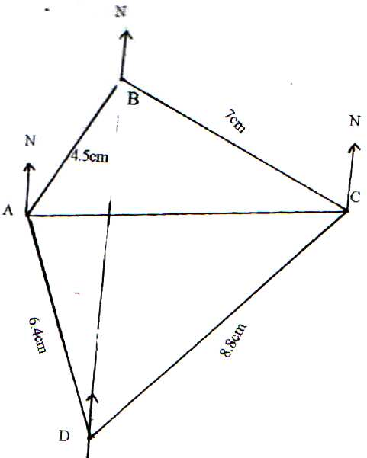  (b) (i) N200W  (ii) 5420W  (c) (i) 6.4 x 100knm = 640km  (ii) 8.8 x 100km = 880  (d) (i) 3000  (ii) 2680 | B1 A located  B1 B located  B1 C located  B1 D located  B1  B1  B1  B1  B1  B1
 |  | 10
22. | P  S  O  Q  R  T  OS = $\frac{1}{3}$OP QT = $\frac{3}{4}$OS  OR = $\frac{1}{3}$OQ  (i) SR = SO + OR  = $\frac{1}{3}$P + $\frac{1}{3}$Q  = $\frac{1}{3}$(Q – P)  (ii) QR = QO + OS  = Q + $\frac{1}{3}$P  = $\frac{1}{3}$P – Q  (iii) PT = PS + ST  = -$\frac{2}{3}$P + $\frac{1}{4}$(-QS)  = -$\frac{2}{3}$p + $\frac{1}{4}$ (Q - $\frac{1}{3}$P)  =-$\frac{2}{3}$p + $\frac{1}{4}$q - $\frac{1}{12}$p  = -$\frac{2}{3}p$ - $\frac{1}{12}$p + $\frac{1}{4}$q  =-$\frac{9}{12}$p + $\frac{1}{4}$q  = $\frac{1}{4}$q - $\frac{3}{4}$p  (iv) TR = TQ + QR  = $-\frac{3}{4}$ QR - $\frac{2}{3}$Q  = -$\frac{3}{4}$($\frac{1}{3}$p – q) - $\frac{2}{3}$Q  = -$\frac{1}{4}$p + $\frac{3}{4}$q - $\frac{2}{3}$q  $$\frac{9Q-8Q}{12}$$  = - $\frac{1}{4}$P + $\frac{1}{12}$Q  = $\frac{1}{12}$Q - $\frac{1}{4}$P  PT = $\frac{1}{4}$Q - $\frac{3}{4}$P  TR = $\frac{1}{12}$Q - $\frac{1}{4}$P  ∴ PT = 3TR or $\frac{1}{3}$PT = RT  Common point T  PT is a multiple of TR  PT = 3TR  Hence PTR are collinear | B1  B1  M1  A1  M1  A1  M1  A1  M1 (both seen)  M1 (both seen)  A1 conclusion
23. | - -the angle which the chord makes with tangent is equal to the angle subtended by the same chord in the alternate segment of the circle  - -Diameter subtends right angle at any point on the circumference of the circle  - - The base angles of isosceles triangle are equal  - -Angles subtended on the circumference by the same arc in the same segment are equal  - -The angle which an arc subtends at the centre is twice that it subtends at any point on the circumference of the circle | B1  B1  B1  B1  B1  B1  B1  B1  B1
 |  | 10
24. | (a)  x -8 -7 -6 -5 -4 -3 -2 -1 0 1 2 3 4  2x² 128 98 72 50 32 18 8 2 0 2 8 18 32  5x -4 -35 -30 -25 -20 -15 -10 -5 0 5 10 15 20  -12 -12 -12 -12 -12 -12 -12 -12 -12 -12 -12 -12 -12 -12  y 76 51 30 13 0 -9 -14 -15 -12 -5 6 21 40  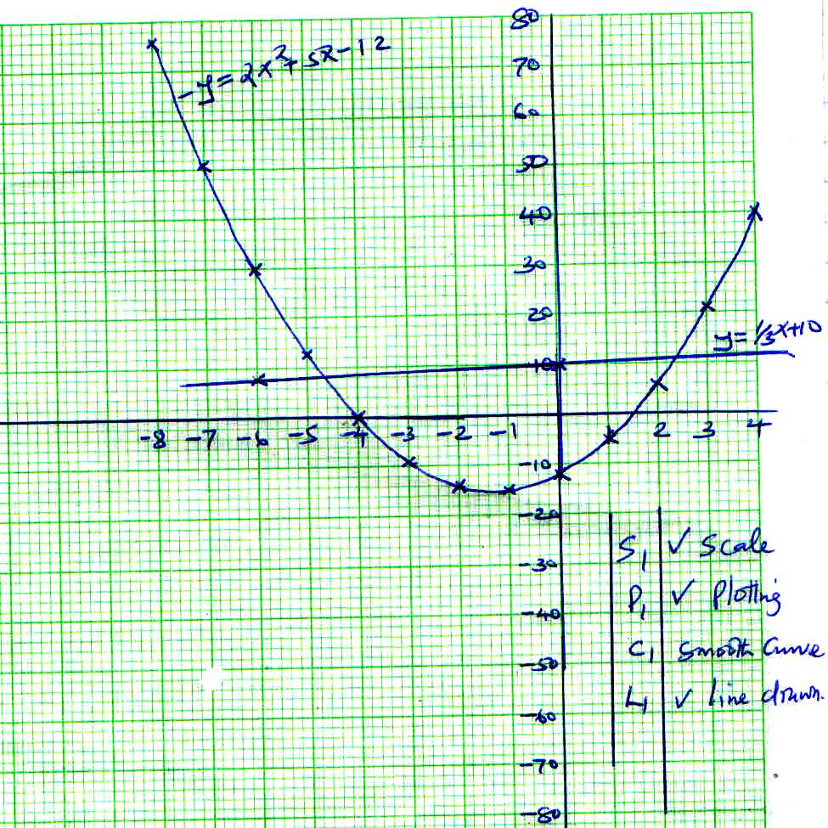 | B1  B1B1  B1B1  B1  B1  B1  B1  B1  B1
 | B1 – For half + correct values B1B1 for all values.  (b) (i) 2x² + 5x – 12 = y  2x² + 5x – 12 = 0  0 = y  x = -4 or 1.5  (ii) (2x² + 5x – 12 = y)3  (3x² + 7x –3 = 0)2  (6x² +15x – 36 = 3y)-  (6x² + 14x – 6 =0)  x-30=3y  y=$\frac{1}{3}x-10$x=-4.6, 2.4 | 10

