NAME……………………….……………………………………CLASS……ADM:.............
SCHOOL…………………………….……………… INDEX NUMBER…………………...

312/1
GEOGRAPHY Paper 1
DECEMBER, 2020
TIME: 2¾ HOURS

LANJET CLUSTER JOINT EVALUATION
Kenya Certificate of Secondary Education
312/1
GEOGRAPHY Paper 1
DECEMBER, 2020

INSTRUCTIONS TO STUDENTS
- This paper has two sections: A and B
- Answer ALL the questions in section A.
- In section B answer questions 6 and any other TWO questions.
- All the answers must be written on the foolscaps provided.
- Candidates must answer the questions in English.
FOR EXAMINER’S USE ONLY

Section | Questions | Maximum  Score | Candidate’s  Score
A | 1 - 5 | 25
B | 6 | 25
 |  | 25
 |  | 25
Total Score

This paper consists of 4 printed pages. Candidates should check the question paper to ascertain that all pages are printed as indicated and that no pages are missing.

SECTION A (Answer all questions from this section)
1. (a) Give the two main types of eclipses. (2 marks)
(b) State two characteristics of the oceanic crust. (2 marks)
2. (a) Outline two ways in which clouds are classified. (2 marks)
(b) State three ways in which wind affects the weather of a place. (3 marks)
3. (a) Define the term folding. (2 marks)
(b) The diagram below represents parts of a fold. Name the parts marked E, F and G. (3 marks)
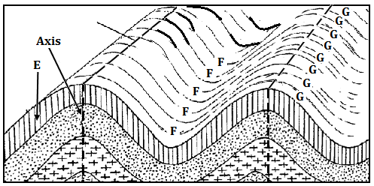
4. (a) Give two examples of mechanically formed sedimentary rocks. (2 marks)
(b) List three types of rock metamorphism. (3 marks)
5. (a) What is mechanical weathering. (2 marks)
(b) Give three causes of chemical weathering. (3 marks)
SECTION B (Answer question 6 and any other two questions)
6. Study the map of Yimbo provided and use it to answer the following questions.
(a) (i) Convert the map scale to a statement scale. (2 marks)
(ii) Give two evidences of water transport in the area represented. (2 marks)
(iii) In which hemisphere is the area covered by the map located? (1 mark)
(b) (i) What is the area in square kilometres of the region representing Busia district on the map? (2 marks)
(ii) Name two types of swamps in the area covered by the map. (2 marks)
(c) (i) Identify four types of natural vegetation in the area covered by the map. (4 marks)
(ii) Citing evidence from the map, give two economic activities carried out in the area covered by the map. (4 marks)
(d) (i) Using a vertical scale of 1cm to represent 20 metres, draw an accurate cross section along northing 83 from easting 26 to easting 32. On the cross section, mark and name: a hill, a river and Road C 506 (6 marks)
(ii) Calculate the vertical exaggeration of the cross section. (2 marks)
7. (a) What is faulting? (2 marks)
(b) Give two differences between normal and reversed faults. (4 marks)
(c) (i) Apart from escarpments, list four other features formed due to faulting. (4 marks)
(ii) With the aid of well labelled diagrams, describe how a horst is formed. (7 marks)
(d) Explain four ways in which features resulting from faulting influences human activities. (8 marks)
8. (a) Differentiate between natural and secondary vegetation. (2 marks)
(b) (i) List four main types of natural vegetation in Kenya. (4 marks)
(ii) Explain four factors that influence the distribution and type of natural vegetation in Kenya. (8 marks)
(c) Describe the characteristics of tropical monsoon forests. (5 marks)
(d) You intend to carry out a field study on natural vegetation in your sub county.
(i) State three reasons why you would prepare a route map. (3 marks)
(ii) Outline three characteristics of vegetation that you would study. (3 marks)
9. The diagram below shows a vertical section through the zones of underground water.
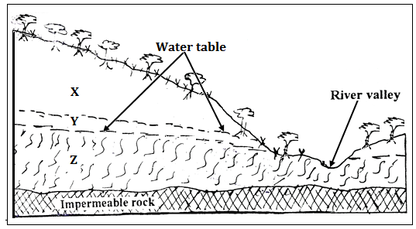

(a) (i) Name the parts zones marked X, Y and Z (3 marks)
(ii) State three major sources of ground water. (3 marks)
(b) Explain how the following factors influences the presence of underground water.
- Amount of rainfall (2 marks)

- Nature of rocks in an area (2 marks)

- Slope gradient (2 marks)
(c) Explain four conditions that lead to the formation of an artesian well. (8 marks)
(d) Your class is planning to carry out a field study in a Karst landscape.
(i) Give two reasons why it is important to seek permission from the school administration. (2 marks)
(ii) State three challenges that you are likely to encounter during the field study. (3 marks)

10. The diagram below shows a glacial erosional feature in lowlands.
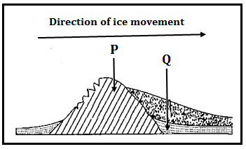
(a) (i) Name the parts marked P and Q. (2 marks)
(ii) Outline four factors that influence glacial deposition in lowlands. (4marks)

(b) Explain how the following processes of glacial erosion occur.

(i) Plucking. (4 marks)

(ii) Abrasion. (2 marks)

(c) Describe how a fiord is formed. (7 marks)

(d) Explain three ways through which glaciation influences agriculture. (6 marks)

