**NAME …………………………..……………….. DATE …………………………**

**INDEX NO. ……….……….…………………...…..… SIGNATURE ……………..…………..**

**312/1**

**GEOGRAPHY**

**PAPER 1**

**December, 2020**

**TIME: 2 ¾ HRS**

**SUKELLEMO JOINT EVALUATION TEST 2020**

*Kenya Certificate of Secondary Education*

**INSTRUCTIONS TO CANDIDATES**

1. Write your name and index number in the spaces provided above.
2. This paper has **TWO** sections: A and B.
3. Answer **ALL** the questions in section A. In section B answer **QUESTION** **6** and any other **TWO** questions from the section.
4. ALL answers **MUST** be written in the Answer Booklet provided.
5. Do not remove any pages from this booklet.
6. This paper consists of 4 printed pages. Candidates should check to ensure that all pages are printed as indicated and no questions are missing

**SECTION A**

***Answer all the questions in this section***

1. (a ) Explain the relationship between geography and mathematics (2mks)

(b) When the local time is 2:00 p.m. at longitude 45 $°E$, what is the longitude of a place whose local time is 8:00 P.M? (2mks)

1. (a) Give three examples of chemically formed sedimentary rocks (3mks)

(b) Describe how coral rocks are formed (3mks)

1. (a) List three external land forming processes which leads to formation of Lakes(3mks)

(b) State two ways in which lakes influence natural environment (2mks)

1. (a) The diagram below shows some of the surface features in a Karst scenery .Use it to answer questions (i) below

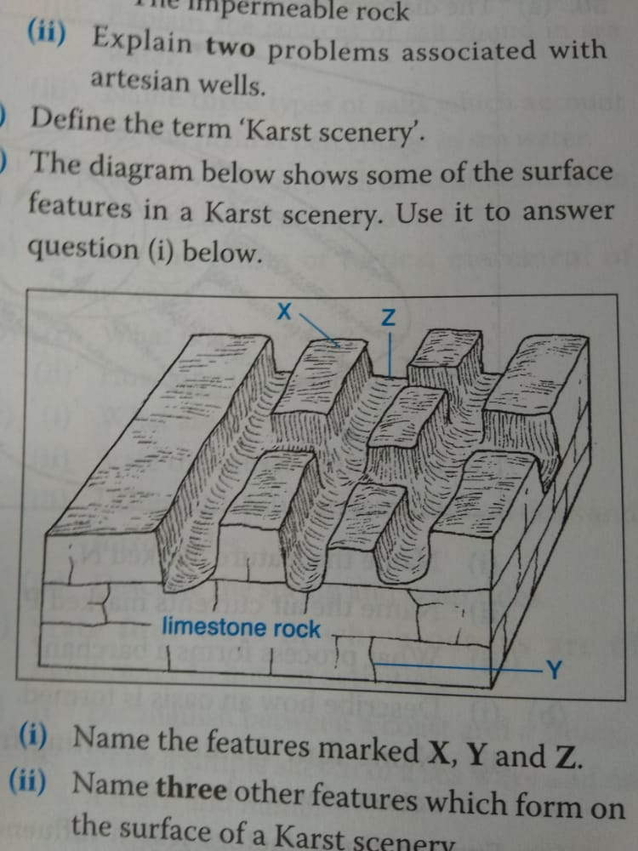

(i) Name the features marked X, Y and Z (3mks)

(ii) Name two other features, which form on the surface of a karst scenery (2mks)

1. Study the diagram below showing a soil profile. Use it to answer the questions that

Follow

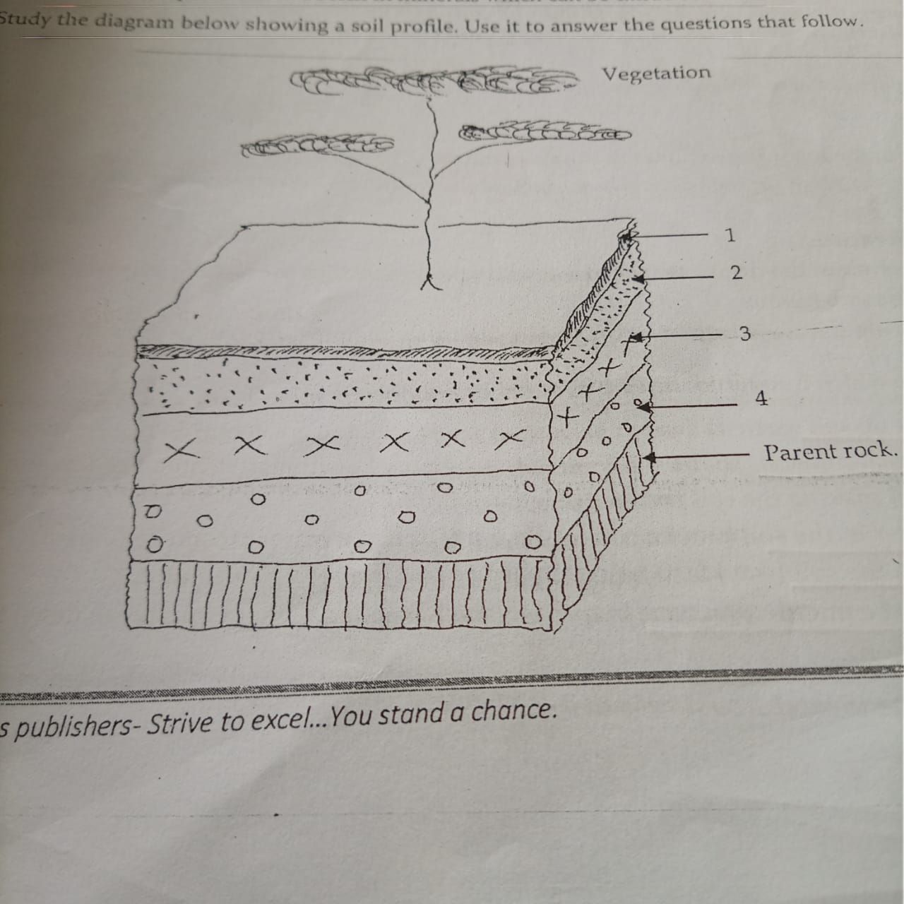

(i) Name the soil layers marked 2, 3 and 4 (3mks)

(ii) Give two factors that influence soil leaching (2mks)

**SECTION B**

***Answer question 6 and any other two questions from this section.***

6. Study the Map of Yimbo 1: 50,000 (Sheet 115/1) provided and answer the following questions.

a) i)Convert the representative scale given on the map into a statement scale. (1mk)

ii) Give the latitude and longitude of the southwest corner of the area covered by the map.(2mks)

iii) Give the magnetic declination as at January 1970? (1mk)

b) i)What is the height of Usengi hill? (1mk)

ii) What is the bearing of the Air Photo Principal point on grid reference 3274 from the trigonometrical station on grid reference 3980? (2mks)

iii) Describe the long profile of River Yala. (4mks)

c) i)Using a scale of 1cm to represent 20m draw a cross section along northing 99 between easting 16 and 22. (3mks)

ii) On the cross section mark and name the following.

A steep slope (1mk)

A seasonal river (1mk)

Thicket vegetation**.** (1mk)

iii) Calculate the gradient between grid reference 160990 and 220990. (2mks)

d) Explain **three** physical factors that have influenced the distribution of settlements in the area covered by the map. (6mks)

7. (a) Other than the sun name two other heavenly bodies that makes up the solar system(2mks)

(b) Explain the origin of the earth according to the passing star Theory (6mks)

(c) Use the diagram below to answer question (c) i , ii and iii

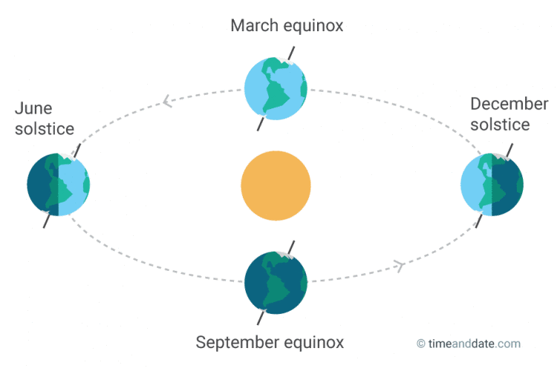

P

Q

R

(i) Name the solstice marked P. (1mk)

1. Identify the season represented in the region marked Q. (1mk)
2. Which date of the year is the sun overhead at R (1mk)

(d) Give three reasons why the earth has a spherical shape (3mks)

(e) State three effects of the rotation of the earth on its axis (3mks)

(f) The diagram below represents the structure of the earth. Use it to answer question (a)

H



1. Name :

(i) The layers marked E, F, G and H (4mks)

(ii) State four characteristics of the outer core (4mks)

8. a)(i) What is folding? (2mks)

(ii) Name **three** types of folds. (3mks)

(iii) Name **two** orogenies known in geological history. (2mks)

1. (i) Apart from Fold Mountains, name **two** other features resulting from folding. (2mks)

The following map shows the location of fold mountain ranges of the world.

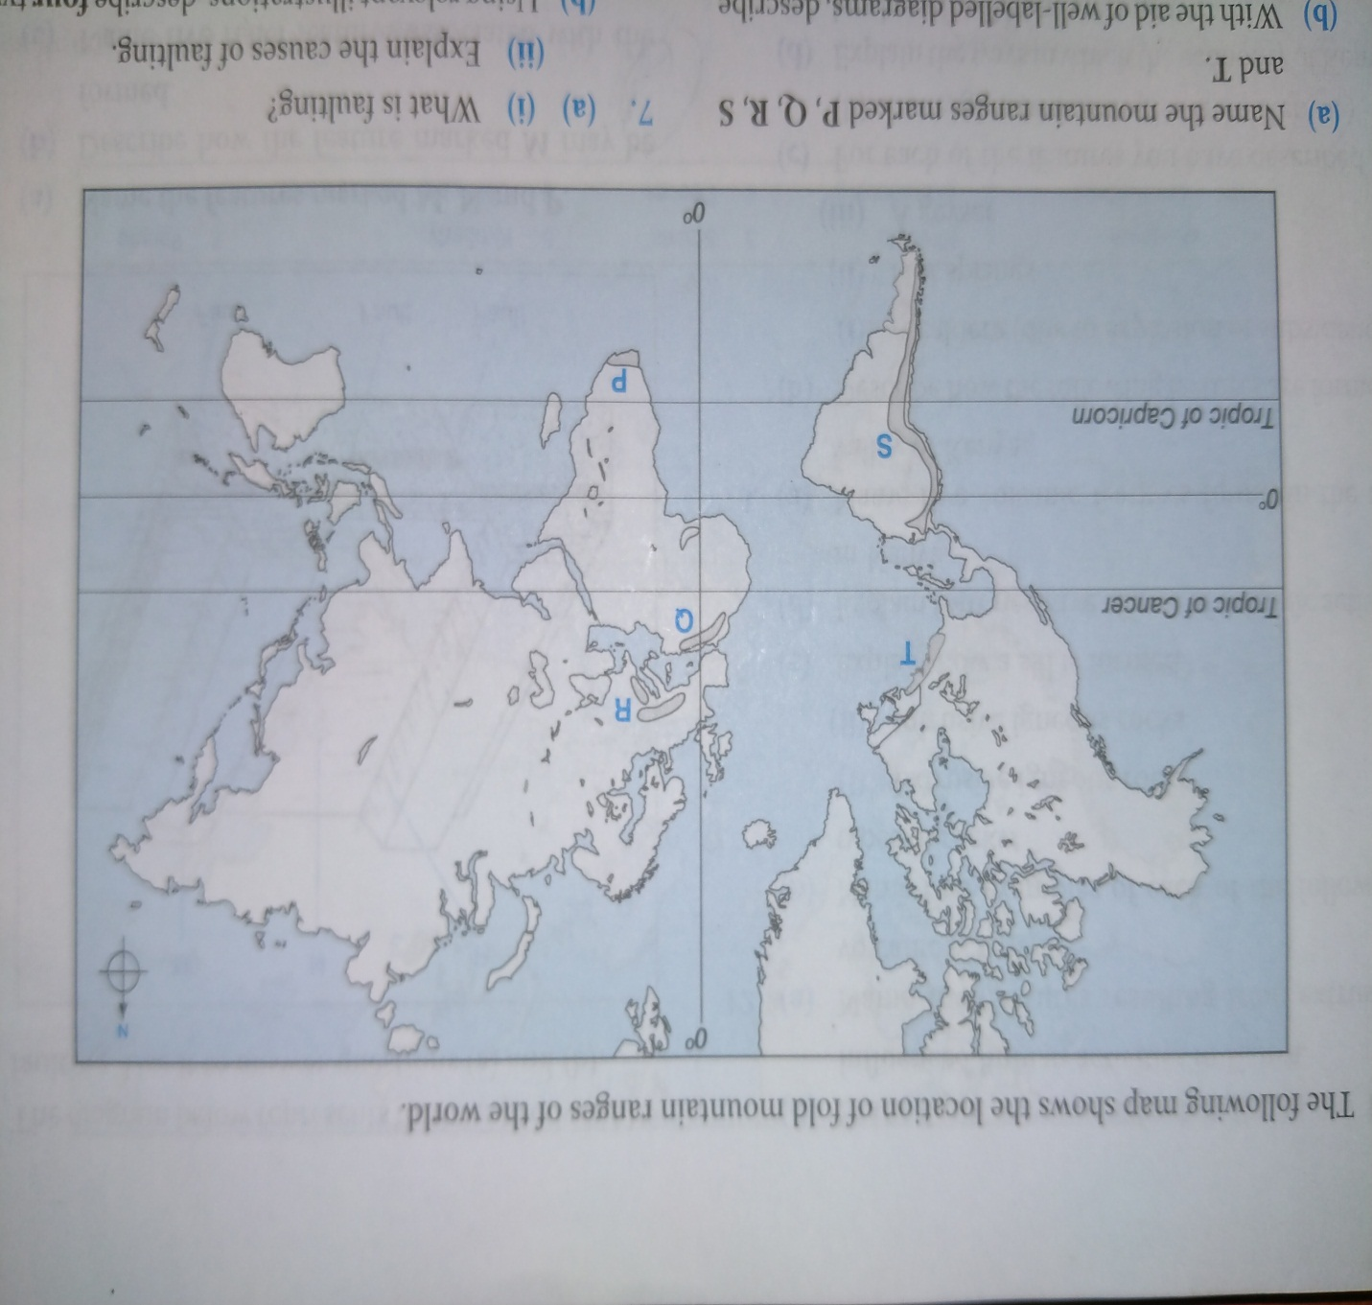

ii) Name the mountain ranges marked **P**,**Q**, **R**, **S** and **T.**  (5mks)

1. With well-labelled diagrams, use the Plate Tectonics theory to explain the formation of Fold

Mountains. (5mks)

1. Explain **three** ways in which folding influence human activities. (6mks)

9. a) i) Using a well-labeled diagram, show the main processes of the hydrological cycle. (5mks)

ii) Differentiate between a watershed and a catchment area. (2mks)

b) i) The diagram below shows a waterfall. Name the features marked X, Y and Z. (3mks)

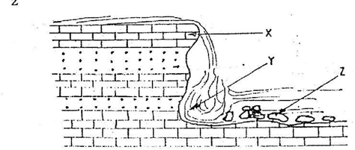

ii) State three ways in which a waterfall may form. (3mks)

b)The diagram below shows a type of a delta. Use it to answer the questions below.

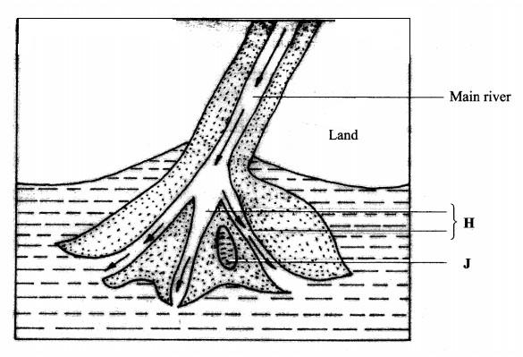

i) Name the type of the delta shown above (1mk)

ii) Identify the features marked **H** and **J**. (2mks)

iii) Describe the formation of the delta shown above. (3mks)

e) You are planning to carry out a field study on the lower course of a river

i) Give **two** reasons why you would require a route map (2mks)

ii) State **two** activities you would carry out to determine why deposition occurs at this stage (2mks)

iii) State **two** follow- up activities you would be involved in after the field study ( 2mks)

1. a) i) What is an ice sheet? (2mks)

ii) Give two reasons why there are no ice sheets in Kenya. (2mks)

b) Describe how a pyramidal peak is formed. (5mks)

c) The diagram below shows types of moraines in a valley glacier.

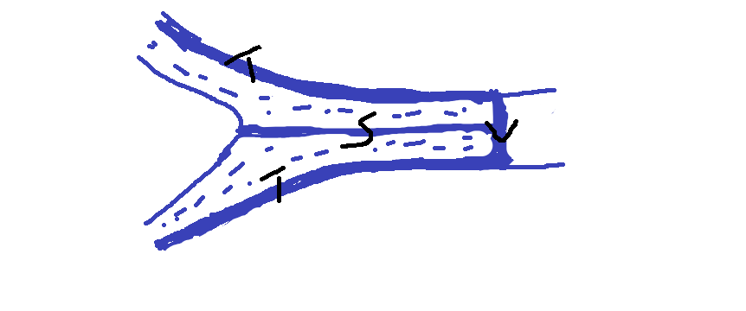

i)Name the type of moraine marked S, T and V. (3mks)

ii) Explain **three** effects of glaciated landscape in upland areas on human environment. (6mks)

d) Students from a school near Mt. Kenya were planning to carry out a field study on the glaciated features on the mountain.

(i) Give **three** reasons why it would be difficult to undertake the field study on glaciated features on the Mountain. (3mks)

(ii) Describe how the students would use a photograph of Mt. Kenya to identify the glaciated features on the Mountain. (2mks)

iii) Give **two** types of glaciers they would identify during your study. (2mks)