NAME ____________________________________ INDEX NO._______________

**SCHOOL _______________________________ SIGNATURE_______________ DATE _______________**

**312/2**

**GEOGRAPHY**

**PAPER 2**

**DECEMBER, 2020**

**TIME: 2¾ HOURS**

**SUKELLEMO JOINT MOCKS 2020**

**INSTRUCTIONS TO CANDIDATES**

* This paper has **two** sections: **A** and **B.**
* Answer **all** the questions in section **A**.
* Answer question **6** and any other **two** questions from Section **B**.
* Each question in section B must be answered in separate foolscaps.
* This paper consists of **6** printed pages.
* Candidates should check the question paper to ascertain that all pages are printed as indicated and that no questions are missing.

|  |  |  |  |  |  |  |  |
| --- | --- | --- | --- | --- | --- | --- | --- |
| **QUESTION** | **A** | **6** | **7** | **8** | **9** | **10** | **TOTAL** |
| **MARKS** |  |  |  |  |  |  |  |

**SECTION A**

***Answer all the questions from this section***

1. a) What is Mining? (2mks)

b) State three ways in which mining derelicts can be reclaimed. (3mks)

2. The diagram below represents some commercial fishing methods



  a) Name the fishing method marked K and L (2mks)

b) Give three reasons why marine fishing is not well developed in the Kenyan coast. (3mks)

 3. a) Name three marine national parks in Kenya. (3mks)

  b) Outline three ways game reserves are of benefit to the communities living near them. (3mks)

 4. a) Apart from air pollution list three other types of pollution. (3mks)

  b) State two factors which favoured growth of Kisumu as an urban centre. (2mks)

5. Highlight four problems that arise from population decline. (4mks)

# SECTION B

***Answer Question 6 and any other Two from this section.***

Q6. Use the photograph provided to answer the questions (a)

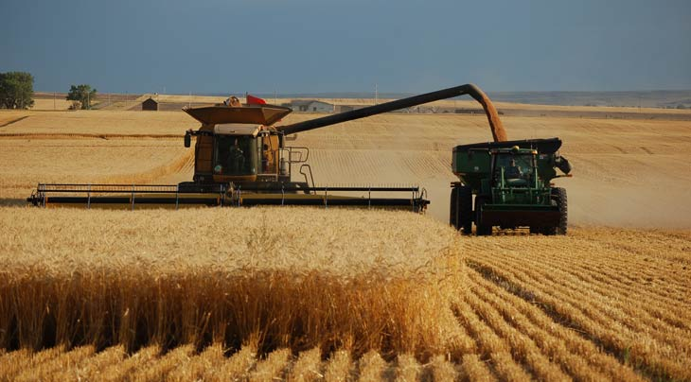

1. i) Name the activity in the photograph. (1mk)

i) Citing evidence, state the time of the day when this photograph was taken. (2mks)

b) i) Draw a sketch of the photograph given. On the sketch mark and name the main features. (5mks)

ii) State three physical conditions that favour the growing of the crop shown in the photograph. (3mks)

c) i) Name two counties in Kenya where Coffee is grown in large scale. (2mks)

ii) Describe systematically the processing of Coffee until it is ready for the market. (6mks)

d) Explain how Coffee growing in Kenya and Brazil differ under the following sub-headings;

i) Size of land (2mks)

ii) Land tenure (2mks)

iii) Marketing (2mks)

 7. (a) (i) Apart from coniferous forest, name two other types of natural forests. (2mks)

ii) State two characteristics of coniferous which favour their exploitation. (2mks)

b) Explain three factors that favour the growth of natural forests on the slopes of Mt. Kenya. (6mks)

( c)Use the map of Kenya below to answer questions (i) and (ii).

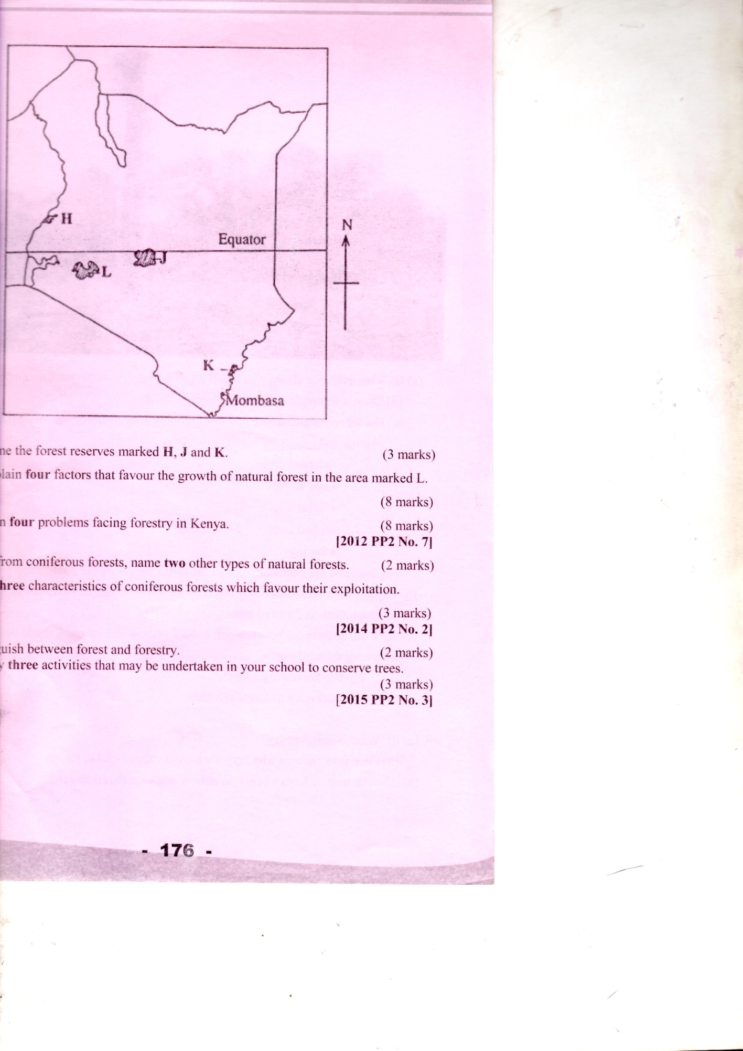

1. Name the forest reserves marked H, J and K. (3mks)

(ii) Explain three factors that favour the growth of natural forest in the area marked L. (6mks)

(d) Explain three problems facing forestry in Kenya. (6mks)

8. i) Differentiate between Pelagic fish and Demersal fish. (2mks)

ii) Name three types of pelagic fish. (3mks)

b) i) Describe three conditions for planktons to survive. (3mks)

ii) Define Fish farming. (2mks)

c) Explain four reasons why the government of Kenya is encouraging fish farming. (8mks)

d) Use the map below to answer question (i) and (ii).

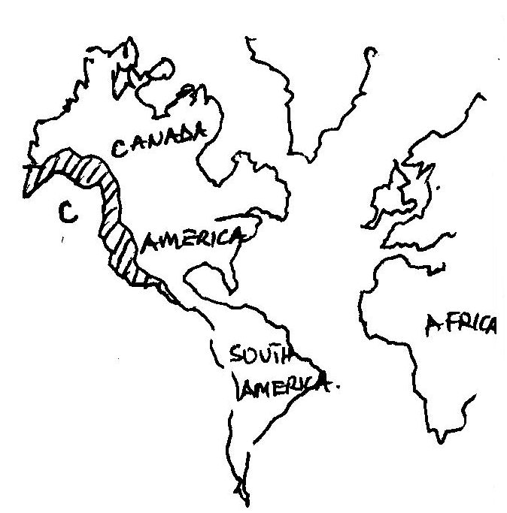

i) Name the fishing ground marked C. (1mk)

ii) Explain three physical conditions that have favoured the fishing ground named above. (6mks)

9. a) i) Define Biomass. (2mks)

ii) Give three examples of Biomass except Biogas. (3mks)

iii) Give four reasons why the use of Biogas is not widespread. (4mks)

b)i) Give four reasons why Nuclear Power is lacking in developing countries. (4mks)

ii) Explain three basic physical requirements of siting a Hydro Electricity project. (6mks)

c) You have been asked to carry out a field study in Loyangalani Wind Power Project.

i) How did you prepare for the field study? (3mks)

ii) State 3 benefits of the project to the surrounding community. (3mks)

10. a) i) What is Transport? (2mks)

ii) Identify three modes of transport. (3mks)

b) i) Give four advantages of Standard Gauge Railway (SGR) to Kenya. (4mks)

ii) Name four navigable rivers in Africa. (4mks)

c) Explain four problems facing river transport in Africa. (8mks)

d) i) Name two canals in Africa. (2mks)

ii) Define the term Containerisation. (2mks)