Name: ______________________________________________Adm. No_____________

Index No: ___________________________ School:_________________________
Candidate’s Sign______________________ Date: ____________________________

312/2

GEOGRAPHY
Paper 2

March /April 2020
Time: 2 ¾ Hours

ARISE AND SHINE TRIAL 1 EXAM
MARCH/APRIL-2020

312/2
GEOGRAPHY
Paper 2
March April 2020
Time: 2 ¾ Hours

Instructions to Candidates:
- This paper consists of two sections: A and B.
- Answer ALL questions in section A. In section B answer question 6 and any other TWO questions.
- All answers to be written on the answer booklet provided.
- Candidates should check the question paper to ascertain that all the pages are printed as indicated and that no questions are missing.

FOR EXAMINERS USE ONLY
1 | 2 | 3 | 4 | 5 | Total
GRAND TOTAL

6 | 7 | 8 | 9 | 10 | Total
SECTION A
Answer All Questions In This Section (25 Marks)
- (a) Name the two types of human settlements (2 marks)

Use sketch map below to answer question (b)
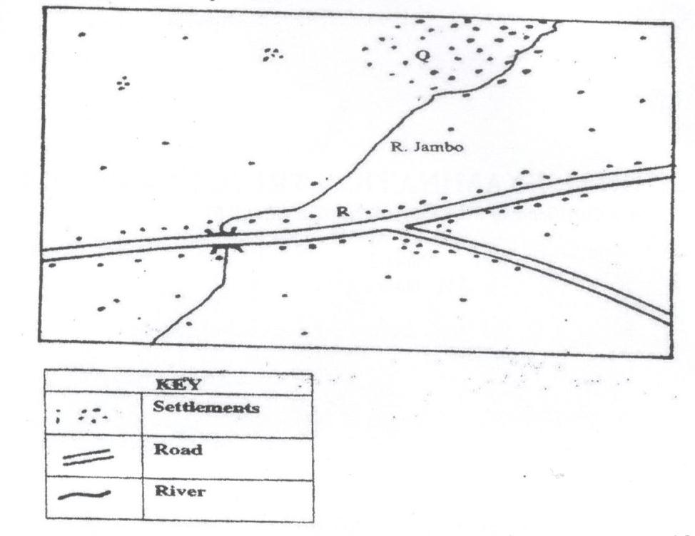
(b) Identify the settlement pattern marked Q and R. (2 marks)

- (a) State three characteristics of Jua Kali Industries in Kenya. (3 marks)
(b) Give three problems facing the Jua Kali Industries in Kenya. (3 marks)

- The table below represents information on population change in Kenya by province between years 2000 and 2005.
Province | Population in Millions
 | Years
 | 2000 | 2005
Nairobi | 2.229 | 2.751
Central | 3.882 | 4.038
Coast | 2.662 | 2.927
Eastern | 4.840 | 5.120
North-Eastern | 1.054 | 1.438
Nyanza | 4.598 | 4.916
Rift Valley | 7.386 | 8.366
Western | 5.532 | 3.885
Total | 30.183 | 33.441
- Which province had the highest change in population between 2000 and 2005? (3 marks)
- Calculate the percentage increase in population in Kenya between 2000 and 2005. (2 marks)

- (a) State three problems that are associated with low tourist season in Kenya. (3 marks)
(b) Name two main inland tourist attractions found in Kenya. (2 marks)

- (a) Distinguish between land reclamation and land rehabilitation. (2 marks)
(b) State three significances of irrigation farming in Kenya (3 marks)

SECTION B
Answer Question 6 and Any Other Two Questions in This Section.
- Study the photograph below and use it to answer the questions that follow:
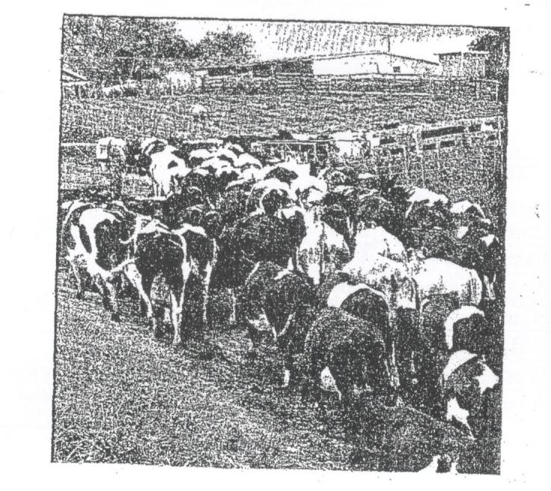
- (i) Identify the type of photograph shown. (1 mark)
(ii) Name the type of livestock farming practice represented by the photograph. (1 mark)
(iii) Draw a rectangle measuring 16cm by 9cm to represent the area of the photograph. On it, sketch and label the main features shown on the photograph. (5 marks)

- (i) State four reasons why zero grazing is more popular among the dairy farmers in the Kenya highlands. (4 marks)
(ii) State similarities between dairy farming in Kenya and Denmark. (3 marks)
(iii) Explain four challenges faced by dairy farmers in Kenya. (8 marks)

- State three steps being undertaken by the government to improve dairy farming in Kenya. (3 marks)

- (a) (i) Name three types of minerals. (3 marks)
(ii) Briefly explain any three factors influencing the occurrence of minerals. (6 marks)

(b) (i) Describe the stages involved in the processing of gold. (5 marks)
(ii) State any five contributions of soda ash to the economy of Kenya. (5 marks)

(c) Students from Kembu Day School carried a field study on mining of soda ash on Lake Magadi.
- State any two hypotheses for their study. (2 marks)
- State four problems they probably faced. (4 marks)

- (a) (i) Define energy. (2 marks)
(ii) List three renewable sources of energy. (3 marks)

(b) (i) State two advantages of solar energy. (2 marks)
(ii) Give four reasons why there has been a decline in the use of a coal as a source of energy. (4 marks)

(c) Explain four ways in which Kenya has benefited from development of the seven forks hydroelectric power projects. (8 marks)
(d) (i) Define energy crisis. (2 marks)
(ii) State four effects of the energy crisis in the world (4 marks)

- The map below shows the major fishing grounds in the world. Use it to answer the question.
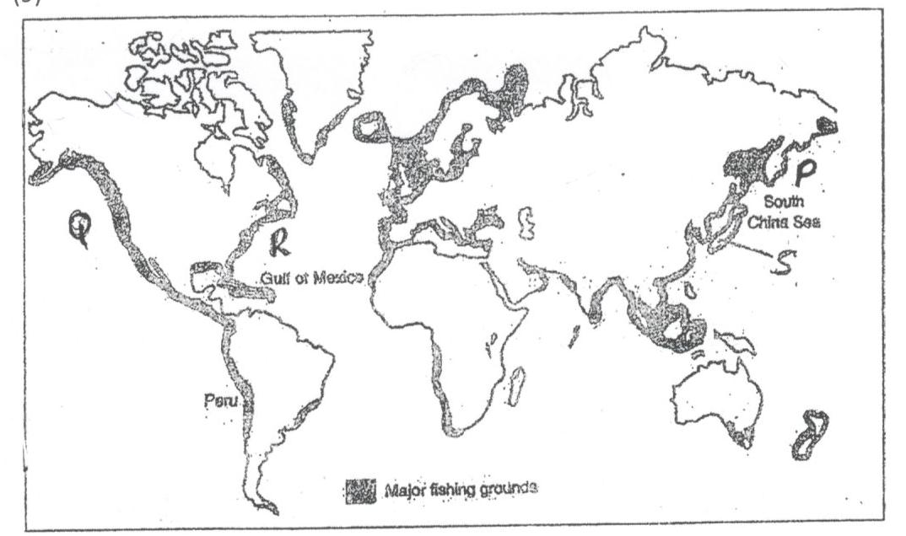

- (i) Name the fishing grounds marked P, Q and R (3 marks)
(ii) Explain four conditions that favour fishing in country marked S (8 marks)
- (i) Differentiate the term Pelagic and Dermarsal fish (2 marks)
(ii) Explain how ocean currents favour fishing in the shaded areas (4 marks)

- (i) State two methods used to preserve fish in Kenya. (2 marks)
(ii) Explain three human problems facing Marine fishing in East Africa. (6 marks)
- (a) (i) Define re-afforestation (2 marks)
(ii) State four reasons why afforestation should be encouraged in Kenya (4 marks)
(iii) Name three provinces in Canada where forestry in practiced on large scale. (3 marks)

(b) Explain three problems which hinder the Kenya government efforts to manage and conserve forest. (6 marks)
(c) Explain three factors that favour the growth of natural forest on the slopes of Mount Kenya (6 marks)
(d) Identify four factors that favour exploitation of forest in Canada. (4 marks)

