312/2
GEOGRAPHY
Paper 2
November, 2020
Time 2 hours 45 min.

MOKASA JOINT EXAMINATION
Kenya Certificate of Secondary Education
312/2
Paper 2
GEOGRAPHY

INSTRUCTIONS TO STUDENTS
- This paper has two sections A and B
- Answer ALL the questions in section A. In section B answer questions 6 and any other TWO questions.

SECTION A: 25 MARKS
Answer ALL questions in this section
1. (a) What is the relationship between Geography and Demography? (2 marks)

(b) State three reasons why it is important to study Geography. (3 marks)

2. Describe the deep shaft method of mining. (5 marks)

3. (a) Apart from draining swamps, name two other methods of land reclamation in
Kenya. (2 marks)

(b) State three aims of setting up the Perkerra irrigation scheme. (3 marks)

4. (a) Give two problems facing river transport in African. (2 marks)
Q

(b) The diagram below shows the Great Lakes and the St. Lawrence sea way. Use it
to answer the questions below.

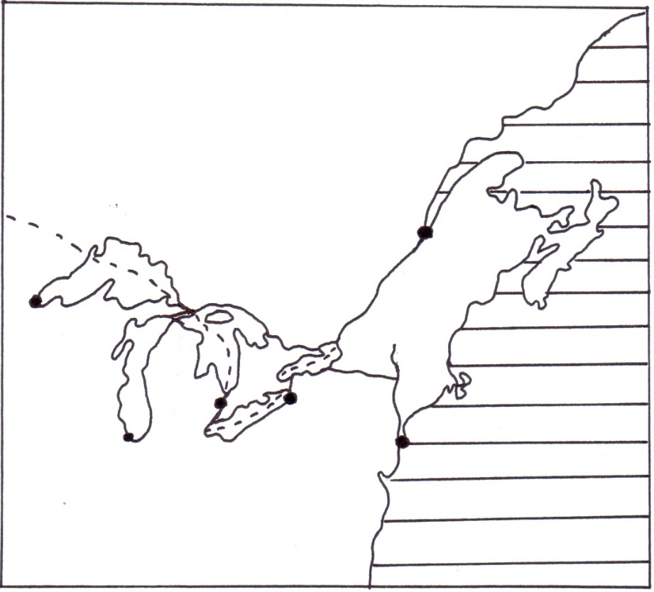
R
Q
P
CANADA
U.S.A
Lake Huron
River St. Lawrence
River Hudson
Atlantic Ocean
New York
Quebec
Chicago
M
Name the lakes P, Q and R.

5. (a) What is a Cottage Industry? (2 marks)
(b) Give three problems facing the Jua Kali industries in Kenya. (3 marks)

SECTION B
Answer question 6 and any other TWO questions from this section.

6. Study the photograph below and use it to answer question (a).

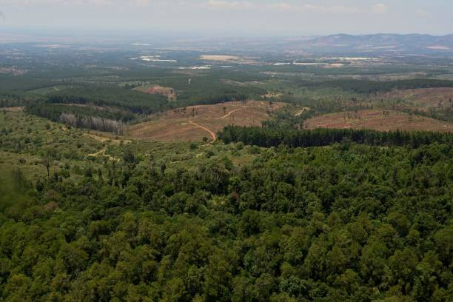

(a) (i) Identify the type of photograph shown above. (1 mark)

(ii) Describe the characteristics of the forest shown on the photograph.
(4 marks)

(iii) Draw a rectangle measuring 15 cm by 10 cm. On it, sketch and label five main features shown on the photograph. (5 marks)

(b) (i) Name two indigenous softwood tree species in Kenya. (2 marks)

(ii) Explain three problems facing forestry in Kenya. (6 marks)
(iii) State three factors favouring the development of softwood forests in Canada. (3 marks)

(c) Give four differences between softwood forests in Kenya and Canada.
(4 marks)

7. (a) (i) Identify three maize growing counties in Kenya. (3 marks)

(ii) State four physical conditions that favour growth of maize in Kenya.
(4 marks)

` (iii) Describe the stages of maize cultivation from land preparation to
harvesting. (6 marks)

(iv) State four problems facing plantation farming in tropical regions.
(4 marks)

(b) (i) Name two exotic dairy breeds reared in Kenya. (2 marks)

(ii) Explain three measures that the government of Kenya has taken to
promote dairy farming. (6 marks)

8. (a) What is fish farming? (2 marks)

(b) (i) Identify three types of fishing. (3 marks)

(ii) Describe the purse seining method of fishing. (4 marks)

(c) The map below shows the fishing grounds of the world. Use it to answer the questions below.

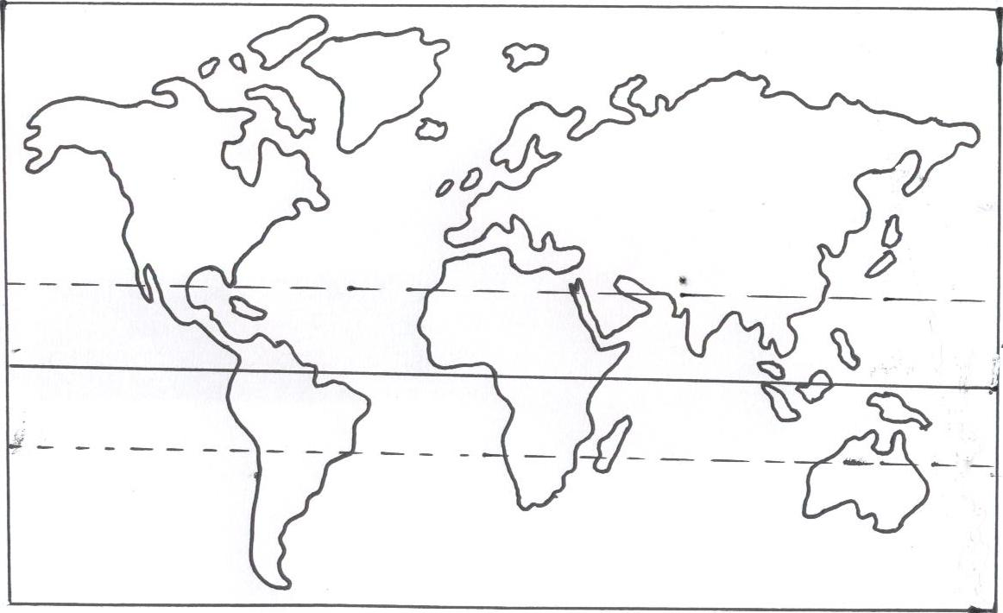
H
G
F
E

(i) Name the fishing grounds marked E, F, G and H. (4 marks)

(ii) Explain three physical factors which influence fishing in the fishing
Ground marked H. (6 marks)

(d) Why is fresh water fishing more developed in Kenya than marine fishing?
(6 marks)

9. (a) (i) What is population growth? (2 marks)

(ii) Explain three factors that have contributed to high population growth
rate in Kenya. (6 marks)

(b) State four reasons why it is important for a country to carry out a population census. (4 marks)

(c) Explain how the following factors have influenced population distribution in East Africa.

- Pests and diseases. (2 marks)

(ii) Government policy. (2 marks)

(d) (i) Apart from Eldoret, name three other agriculture collecting towns in
East Africa. (3 marks)

(ii) Explain three factors that have led to growth of Eldoret as a major town
in Kenya. (6 marks)

10. (a) (i) Differentiate between management and conservation of environment.
(2 marks)

(ii) State three reasons for management and conservation of the environment.
(3 marks)

(b) (i) Apart from floods, name three other natural hazards. (3 marks)
(ii) Give three causes of floods in the Kenyan lowland areas.(3 marks)
(iii) Explain three measures that the government of Kenya has taken to control floods. (6 marks)
(d) Your Geography class undertook a field study on environmental pollution in a major urban centre in Kenya.

- Name three types of pollution that you may have observed. (3 marks)

(ii) Give three effects of pollution you may have identified. (3 marks)

(iii) Give two methods of collecting data you may have used.
(2 marks)

