Name: ______________________________________Index No: ________________________

School:______________________________ Candidate’s Sign___________________

Adm.No__________________________________ Date: ____________________________

312/1
GEOGRAPHY
Paper 1

MARCH/APRIL 2020
Time: 2 ¾ Hours

ARISE AND SHINE TRIAL 1 EXAM
MARCH/APRIL-2020
312/1
GEOGRAPHY
Paper 1
March/April, 2020
Time: 2 ¾ Hours

Instructions to Candidates:
- This paper has two sections: A and B.
- Answer all questions in section A
- Answer question 6 and any two other questions from section B.
- This paper consist of 4 printed pages
- Candidates should check the question paper to ascertain that all the pages are printed as indicated and that no questions are missing
- Candidates should answer the questions in English.

FOR EXAMINERS USE ONLY

SECTION A
Question number | 1 | 2 | 3 | 4 | 5 | Sub Total
Marks
Grand total

SECTION B
Question number | 6 | 7 | 8 | 9 | 10 | Sub Total
Marks
SECTION A
Answer All Questions in This Section
- (a) What is a Stevenson screen? (2 marks)
(b) Name two forms of precipitation that commonly occur in Kenya (2 marks)

- (a) State three characteristics of the crust (3 marks)
(b) Give three reasons why the intensity of insolation is higher at equator than at Polar Regions. (3 marks)

- (a) Identify two theories used to describe the origin of Fold Mountains. (2 marks)
(b) Give three effects of Fold Mountains on climate. (3 marks)

- (a) Name two types of earth movements that occur within the earth’s crust. (2 marks)
(b) Name three tectonic plates (3 marks)

- (a) Define faulting (2 marks)
(b) State three effects of faulting on human environment (3 marks)

SECTION B
Answer Question 6 and Any Other Two Questions in This Section

- Study the map of Yimbo 1:50,000 (sheet 115/1) provided and answer the following questions
- What is the map name of the extract given? (1 mark)
- Name the type of boundaries in the map extract. (2 marks)
- Calculate the area of Mageta island (2 marks)
- (i) Using a scale of 1cm represent 20M, draw a cross-section from grid reference 270850 to 330850. (4 marks)
On it, mark and name the following features:
- Forest
- Hill
- River
- Swamp
(ii) Calculate the vertical exaggeration of the map. (2 marks)
- Describe the long profile of River Yala. (5 marks)
- Citing evidence from the map, explain the factors that influence trade in the area covered by the map. (6 marks)
- (a) Define the following
- Aridity (2 marks)
- Wind (2 marks)
(b) (i) Explain three ways in which wind erodes weathered materials in arid areas. (6 marks)
(ii) Name three features which develop under arid conditions as a result of wind erosion. (3 marks)
(c) State four factors which influence wind transportation in desert. (4 marks)
(d) (i) Apart from Wadis, name any three resultant features of water action in arid areas. (3 marks)
(ii) Describe the formation of a Wadi. (5 marks)

- (a) What is a glacier? (2 marks)
(b) Describe how the following glacial erosional processes occur.
- Plucking (3 marks)
- Abrasion (3 marks)
(c) The diagram below shows features on a glaciated lowland.
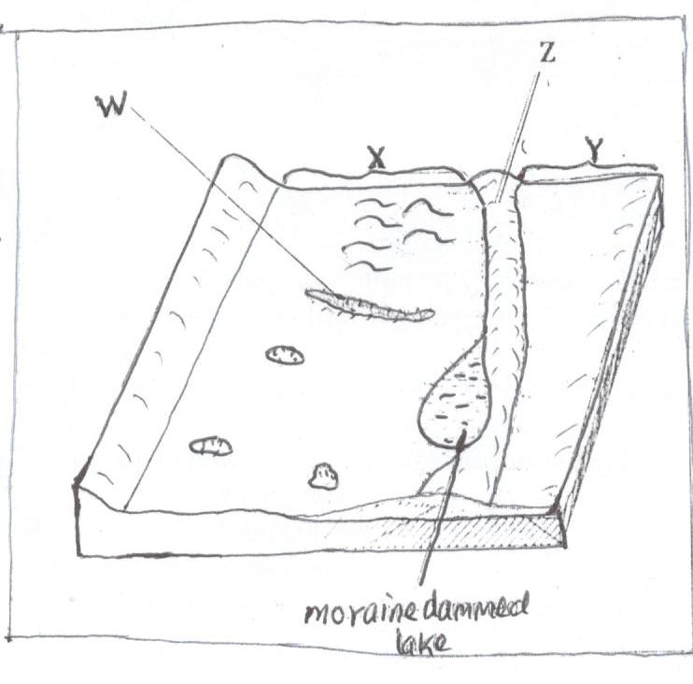
- Name the features marked W, X, Y and Z. (4 marks)
- Describe how a drumlin is formed. (5 marks)
(d) Explain four negative effects of glaciations in low-land areas. (8 marks)

- (a) (i) Define weathering (2 marks)
(ii) Explain the following processes of weathering
- Hydration (2 marks)
- Oxidation (2 marks)
- Frost action (3 marks)
(b) State three conditions that influence the process of Solifluction. (3 marks)
(c) Describe how an exfoliation dome is formed. (5 marks)
(d) Explain four physical factors that enhance movement of material along the slope due to gravity. (8 marks)

- (a) Define the term vegetation. (1 mark)
(b) Explain how the following factors influence the distribution of vegetation.
- Aspect (2 marks)
- Relief (4 marks)
(c) The map below shows world vegetation zone
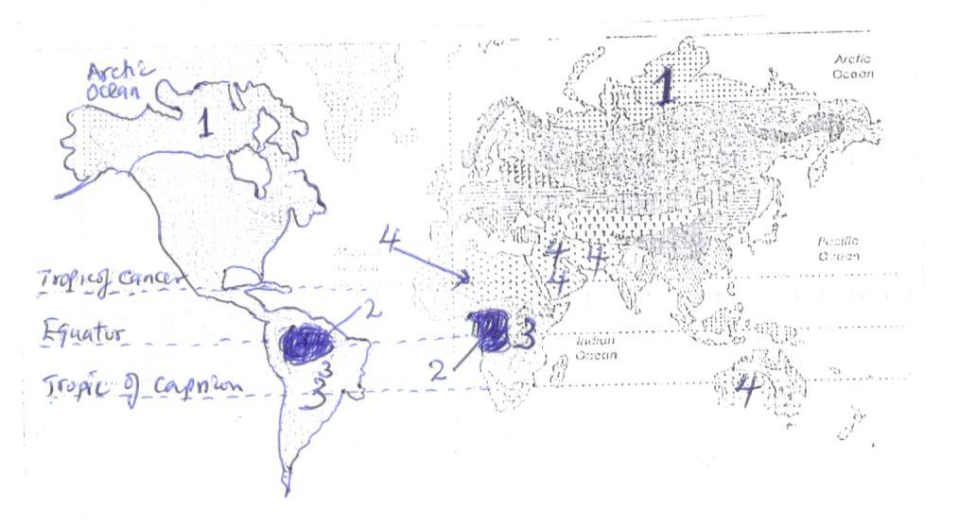
- Name vegetation type marked 1, 2, 3 and 4. (4 marks)
(d) Explain four ways in which trees in coniferous forests are adopted to the climatic conditions. (8 marks)
(e) A form four Geography class is planning to carry out a field study in Kakamega forest.
- State how they would use the following tools during the study.
- A tape recorder (1 mark)
- A sketch map (1 mark)
- A camera (1 mark)
- Give three methods they would use to collect the data during the study. (3 marks)

